KEY MESSAGES TO SHARE THIS WEEK
Updated Monday 1, June 2020
Thrive LDN has collated the following key messages which can be shared across all social media channels to help signpost appropriate resources and guidance with those in your community.
Click the image to enlarge and use across any channels you may be on.
Every Friday, Thrive LDN is putting together a Twitter thread of positive stories of Londoners coming together from the past week. You can find the most recent thread here.

- Digital IAPT webinars – for promotion
When times are uncertain, it's understandable to experience a rollercoaster of emotions.
Join the first weekly NHS-led online webinar focused on improving wellbeing with tools & ideas to improve mood:
1⃣ Managing Wellbeing
⌚️ Tue. 9 June, 4pm
🎫 Register https://bit.ly/2Xqe3E8
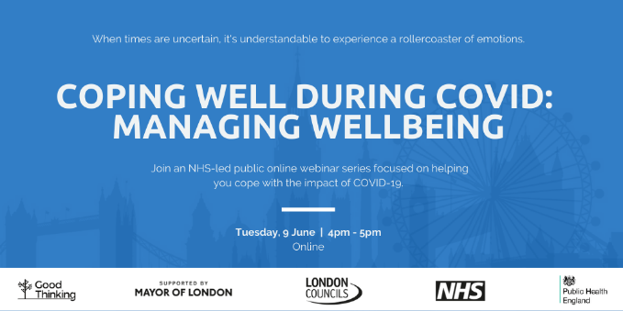

- Helplines
Things can feel very hard at times. Support is available for whatever you are going through, there is hope and you are not alone.
These helplines are free and confidential:
📞 @samaritans: 116 123
📞 @CruseCare: 0808 808 1677
📲 @GiveUsAShout: Text Shout to 85258
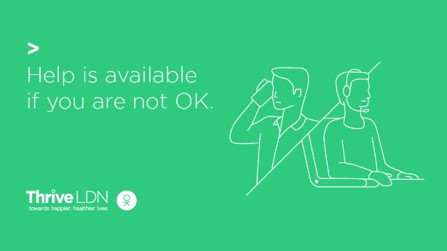

- Six ways to improve your wellbeing
It’s OK to not feel OK.
@ThriveLDN has created a set to ways you can help to improve your wellbeing at home, and tips on where you can find support.
Remember, you’re not alone – help is available. #LondonTogether
For more info visit www.thriveldn.co.uk/resources/six-ways-to-improve-your-wellbeing
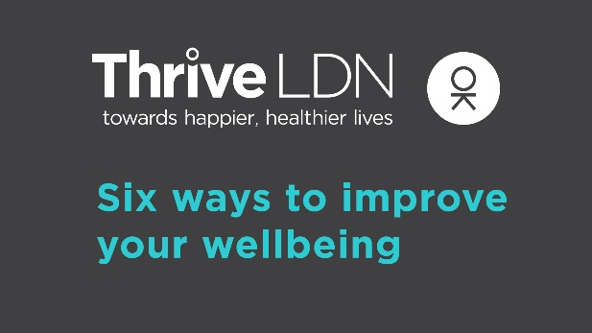

- Good Thinking resources
If you are feeling anxious, worried or stressed about #COVID19 it’s important that you are kind to yourself. There are a range of free apps available for Londoners from @GoodThinkingUK to help if you have anxiety, low mood, sleeping difficulties or stress.
www.good-thinking.uk
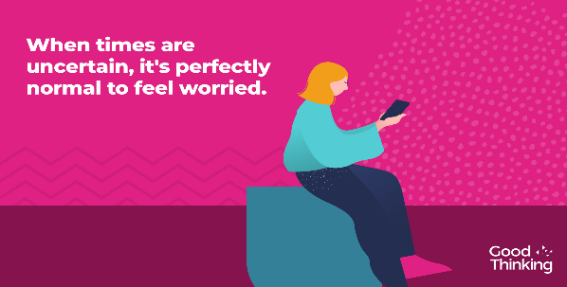

- #ZeroSuicideLDN
Living and working in London can be stressful, and right now for some it may be overwhelming. Would you be able to spot a colleague or friend in distress? There’s FREE 20 minute @Zer0Suicide online training to help.
Visit 👉 thriveldn.co.uk/zerosuicideldn

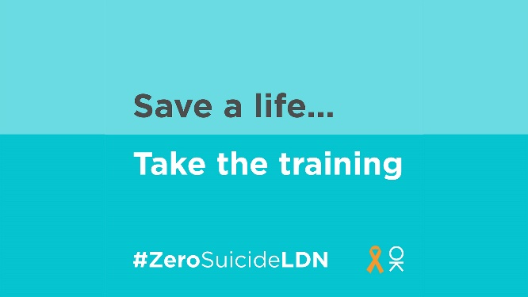

- Samaritan’s checking-in tips and advice
Social distancing and self-isolation rules are changing the way we keep in touch, but being physically distant doesn’t mean we can't stay connected. Have a look through @samaritans’ tips on how to check in with someone if you're worried about them.
https://www.samaritans.org/how-we-can-help/support-and-information/worried-about-someone-else/if-youre-worried-about-someone-else-during-coronavirus-outbreak/
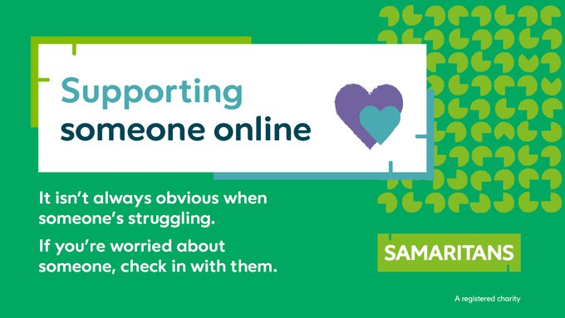

- Urgent support
Urgent mental health support is available 24/7 through NHS helplines. Please remember you are not alone and help is available.
Visit the NHS website and find your local helpline to get help
www.nhs.uk/using-the-nhs/nhs-services/mental-health-services/dealing-with-a-mental-health-crisis-or-emergency/

