KEY MESSAGES TO SHARE ON DIGITAL CHANNELS
Thrive LDN has collated the following key messages which can be shared across all social media channels to help signpost appropriate resources and guidance with those in your community.
Click the image to enlarge and use across digital channels.
1) Resilience Workshops
Calling all young Londoners... join @ThriveLDN's series of online workshops with @fandangoekid to explore experiences, challenges and issues faced during #COVID19.

🎨 The FREE workshops will experiment with typography, layouts & graphics.

Sign up here https://bit.ly/2Z3ECQ7

- NHS wellbeing HEALTH AND CARE WORKERS webinars
Join the first in a new #KeepingWell webinar series for health and care workers, whether at the #Frontline or in supporting services, on Thursday at 4pm.

Designed to help you manage your emotional health & wellbeing whilst looking after others. Register: https://thriveldn.co.uk/resources/keeping-well-for-health-and-care-workers-webinar-series/
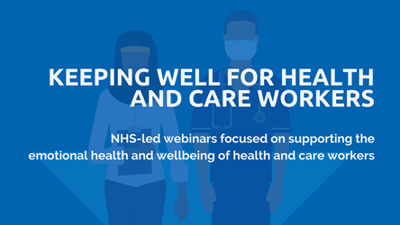

- NHS wellbeing PUBLIC webinars
🎢 When times are uncertain, it's understandable to experience a rollercoaster of emotions.
#CopingDuringCovid NHS-led public webinars will help you cope with the impact of COVID-19, incs:
1⃣ #Wellbeing
2⃣ #Anxiety
3⃣ #LowMood
4⃣ #Sleep
➡️ Full details thriveldn.co.uk/resources/coping-well-during-covid
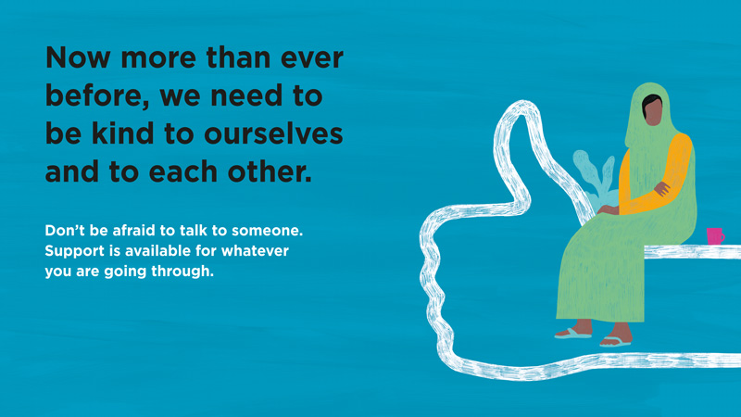

3) Supporting those adversely affected or distressed by the coronavirus outbreak – new guidance
NEW: @ThriveLDN guidance for those supporting people who have been adversely affected by COVID-19. Outlines #Psychosocial approaches in how to support the #MentalWellbeing of others, inc what supportive things to say and do for those most distressed.

➡️ www.thriveldn.co.uk/resources/supporting-those-adversely-affected-or-distressed-by-the-coronavirus-outbreak
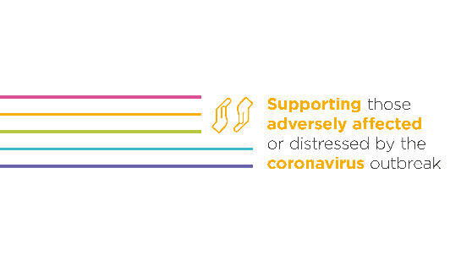
4) Good Thinking resources
When times are uncertain, it's perfectly normal to feel worried.
Help is available. There are a range of free apps from @GoodThinkingUK to help if you have anxiety, low mood, sleeping difficulties or stress.
➡️ www.good-thinking.uk
[+ ASSET 1 OR ASSET 2]

5) Helplines
Things can feel very hard at times. Support is available for whatever you are going through, there is hope and you are not alone.
These helplines are free and confidential:
📞 @samaritans: 116 123
📞 @CruseCare: 0808 808 1677
📲 @GiveUsAShout: Text Shout to 85258
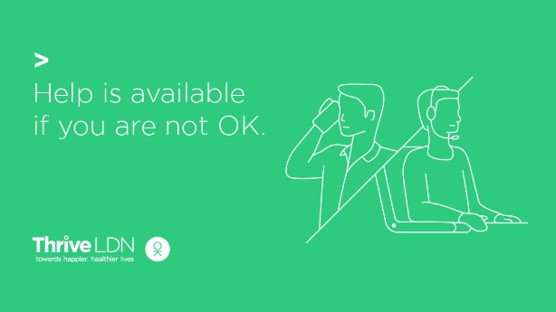

6) Six ways to improve wellbeing
It’s OK to not feel OK.
@ThriveLDN has created a set to ways you can help to improve your wellbeing at home, and tips on where you can find support.
Remember, you’re not alone – help is available. #LondonTogether
For more info visit www.thriveldn.co.uk/resources/six-ways-to-improve-your-wellbeing
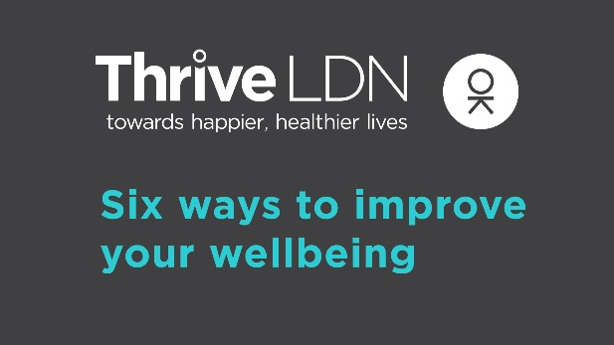

7) #ZeroSuicideLDN
Living and working in London can be stressful, and right now for some it may be overwhelming. Would you be able to spot a colleague or friend in distress? There’s FREE 20 minute @Zer0Suicide online training to help.
Visit 👉 thriveldn.co.uk/zerosuicideldn

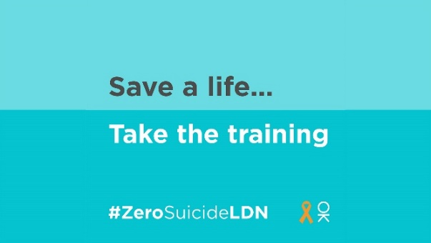

9) Urgent support
Urgent mental health support is available 24/7 through NHS helplines. Please remember you are not alone and help is available.
Visit the NHS website and find your local helpline to get help
www.nhs.uk/using-the-nhs/nhs-services/mental-health-services/dealing-with-a-mental-health-crisis-or-emergency/

