THRIVE LDN TOOLKIT – COVID-19 PUBLIC MENTAL HEALTH MESSAGING: WORKPLACE WELLBEING
July 2020 v0.2
The following toolkit is in relation to: Resources to help support your mental health and wellbeing in the workplace and to help support others.
Context
Many people who live and work in London are feeling anxious about coronavirus and how it might impact them, their loved ones and London’s businesses. These are challenging circumstances and it is normal to feel upset, anxious or confused at times.
As the coordination point for citywide public health messaging, Thrive LDN is encouraging all Londoners to think and talk more about mental health and wellbeing.
Contents
About this document 2
Support for having difficult conversations 2
ZSA training 2
Samaritans Wellbeing in the Workplace 3
Psychosocial approaches and psychological first aid 3
Managing your own mental health and wellbeing 4
Good Thinking 4
Samaritans Self-Help app 4
Coping Well During Covid webinars 5
What if I or a colleague needs further support? 5
What can I do to promote positive mental health and wellbeing? 6
Questions for Self-reflection 6
Tips for a Facilitated Session 6

About this document
This short guide collects some of the best practice from Thrive LDN partners to help you feel better equipped and more confident in:
1. Support for having difficult conversations
2. Managing your own mental health and wellbeing
Each training and support resource is accompanied by a suggested time in which you can take the training or familiarise yourself with the resource for later use. Feel free to explore each resource in whatever order you like in your own time, then take a look at the Questions for Self-reflection to consider what you’ve learned.
For managers or those wishing to take a team approach, there are also some Tips for a Facilitated Session.
Asking for help can be an important part of looking yourself and those around you. Help is available, with a range of support available now from Good Thinking, Every Mind Matters, and a series of NHS-led webinars.

Support for having difficult conversations

ZSA training
20 – 30 minutes to complete
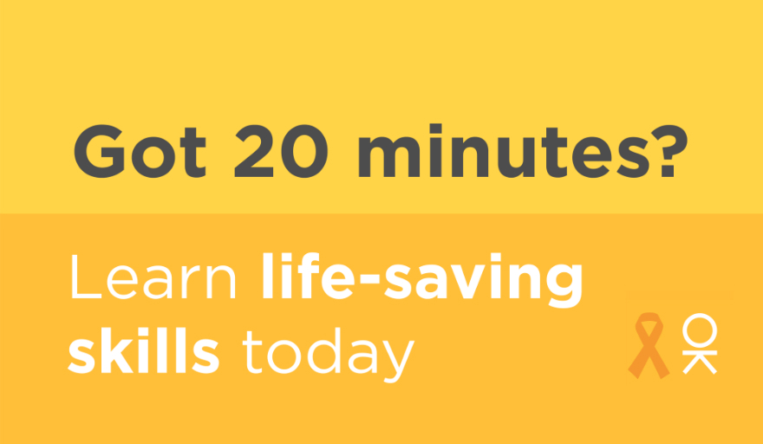
Many people struggle to cope at one point or another of their lives. Experiencing a range of emotions during these times is common. There’s free training which will equip you to be more confident in spotting the warning signs that someone may not be okay. The Zero Suicide Alliance’s online training is supporting people to be better prepared to help someone with suicidal thoughts and raise awareness of poor mental health. Taking the training could equip you to save a life, but the skills you learn also apply to listening and responding to anyone in distress or difficulty.
By July 2020, more than 124,000 Londoners had completed the training. With all of London working together, we can look out for one another and spot the signs.

Samaritans Wellbeing in the Workplace
Up to 90 minutes to complete, or 10 minutes per section
Wellbeing in the Workplace is an award-winning online learning tool from Samaritans that gives employees the skills to intervene when someone is struggling, actively listen and manage difficult conversations. It also helps staff to look after their own mental wellbeing.
The online training takes around 90 minutes to complete and it’s split into 10-minute sections, making it easy to dip in and out. Simply register here and benefit from an online learning programme which brings Samaritans’ listening and wellbeing expertise into the workplace.

Psychosocial approaches and psychological first aid
Up to 60 minutes to read the guidance and 3x 1-hour weekly study for the first aid training
Psychosocial support is a humane, supportive response to individuals and communities who are struggling and who may need support. Thrive LDN has developed guidance for people who are supporting communities and individuals who have been adversely affected by COVID-19 to help them to know the most supportive things to say and do for people who are distressed. You can also download a Look Listen Link A4 poster for your workplace.
Public Health England has launched a Psychological First Aid (PFA) training module, aimed at all frontline and essential workers and volunteers. The course teaches the key principles of giving psychological first aid in emergencies and aims to increase awareness and confidence to provide this support to people affected by COVID-19.

Managing your own mental health and wellbeing

Good Thinking
25–30 minutes to explore site and try the self-assessment
If you are feeling anxious, worried or stressed about COVID-19 it’s important that you are kind to yourself.
The NHS-approved digital mental wellbeing service, Good Thinking, promotes proactive self-care for the four most common mental health conditions: anxiety, low mood, sleeping difficulties and stress. It delivers a clinically validated self-assessment tool that provides personalised recommendations.
Take some time to explore the site and test out the self-assessment function to discover how Good Thinking works and what it can recommend.
Good Thinking has a range of mental wellbeing information sheets and workbooks for that you can work through in your own time. There are a number of modules for each workbook and activities for you to try out. Each module is free to download.

Samaritans Self-Help app
15 – 20 minutes to set up an account and explore the app
Samaritans have launched a Self-Help app featuring a mood tracker that allows people to record how they feel. It recommends evidence-based coping techniques based on how you’re feeling, as well as activities that others have found useful when experiencing similar feelings.
You can use online in your browser or install on a computer or smartphone. The app is not monitored by Samaritans volunteers, and they can't see what you write in it. Any feedback you leave on it via the sidebar will also remain anonymous.

Coping Well During Covid webinars
Each webinar is 60 minutes long
The Coping Well During Covid webinar series has been developed to support you if you are feeling anxious about coronavirus and how it is impacting you, your loved ones or your work.
Each 60-minute webinar is NHS-led and delivered by Emily Gardner, High Intensity Cognitive Behavioural Therapist, Richmond Wellbeing Service. Webinar topics include managing wellbeing, anxiety, low mood and sleeping difficulties and offer you the chance to explore ideas and tools to support your mental health and wellbeing in a clinically-led and evidenced-based way.

What if I or a colleague needs further support?
Asking for help can be an important part of looking yourself and those around you.
If you do not require urgent support but are still concerned about your mental health, contacting your GP is a good place to start. You can also refer yourself for free, non-urgent NHS psychological therapy services, also known as Improving Access to Psychological Therapies (IAPT) services, which provide evidence-based treatments for depression and anxiety.
You may feel more comfortable talking to someone you don’t know by using one of the following helplines:
- At a Loss can provide additional information and resources if you've been bereaved and need support, or if you are supporting someone who has been bereaved.
- The Black, African and Asian Therapy Network is the UK’s largest independent organisation specialises in working psychologically, with people who identify as Black, African, South Asian and Caribbean. Their website provides a list of local and free resources and services for people of minority background who are seeking help.
- Samaritans free, 24-hour listening service on 116 123 or email jo@samaritans.org.
- Shout is the UK's first 24/7 text messaging service for anyone in crisis. Text Shout at any time to 85258 to start a conversation.
- The Switchboard LGBT+ helpline is open daily from 10am-10pm on 0300 330 0630 or email chris@switchboard.lgbt.
- Young Minds have advice on supporting the mental health and wellbeing of young people and a dedicated parents’ helpline.

What can I do to promote positive mental health and wellbeing?
- Amplify and promote the positive interventions and activities of your staff and communities.
- Share training and awareness tools with colleagues e.g. suicide prevention training.
- Let the Thrive LDN team know what public mental health support would be helpful to you and let us know about planned activities you have around improving and managing the public’s mental health: Website: www.thriveldn.co.uk; Email: info@thriveldn.co.uk; social media: @ThriveLDN

Questions for Self-reflection
How do you feel about having difficult conversations with people who may be in distress or affected by the current circumstances around COVID?
- Has the training supported or changed the approach you might take?
- What is the most significant thing that you might do differently from now on?
- What other kind of support or advice would help you in having potential difficult conversations and supporting people through them?
What are the warning signs that someone may not be okay, and how can you help support them in that conversation?
How have any of the training and support above helped to enhanced your knowledge of self-care and good wellbeing?
Going forward, how might you use different resources and online tools to help support your mental health and wellbeing at work? Would they also have beneficial effects outside of work?

Tips for a Facilitated Session
As a manager, or as someone who would like to organise a team session around this training and support, you could:
- Host a mini-session, taking around 30 minutes to explore one of the resources above and then ask team members to respond to two or three of the questions for self-reflection above (whichever are most relevant to the particular resource).
Give team members the opportunity to write down their answers and then ask, with no pressure to respond, if anyone would like to share how they have reflected on the experience.
As a guiding principle, it’s important to encourage team members to focus on any changes or improvement to their ability to support their own mental wellbeing and the wellbeing of others in their role and also outside of work.
- Host a full session, taking approximately 3½ to 4 hours, in which to explore all of the resources above in their expected time, with a 15-minute break mid-way through to allow some rest and reflection.
Allow adequate time for a closing session (anything from 15–30 minutes depending on the size of the group) to ask team members to respond to all of the questions for self-reflection above. Give team members the opportunity to write down their answers and then ask, with no pressure to respond, if anyone would like to share how they have reflected on the experience.
- Allow team members to explore the different resources in their own time, then organise an opportunity (e.g. a half-hour session, or some dedicated time at a team meeting or similar event) for everyone to reflect on the experience and what they’ve learned, using the questions for self-reflection above as a guide.

