PROMOTING THRIVE LDN’S WORLD MENTAL HEALTH DAY FESTIVAL
Updated 6 October 2020

NEWSLETTER/ OFFLINE COPY
- Long copy [144 words]
London’s World Mental Health Day Festival
On Saturday, 10 October to mark World Mental Health Day 2020, the Mayor of London's Peer Outreach Team and Thrive LDN are hosting a young Londoner-led virtual festival. The festival programme is all about supporting young Londoners to build resilience and promote positive wellbeing.
The free online event will see various activities, workshops and performances to offer a platform for young people to discuss the challenges faced during COVID-19 and explore shared experiences of inequality and issues raised through the Black Lives Matter movement. It is an opportunity for young people to come together, from across London and beyond, to collectively overcome barriers and support one another.
You can register for the day and select any of the live workshops you wish to join.
You can also help promote the event by resharing Thrive LDN’s posts on social media via Twitter, Instagram & TikTok.

- Short copy [60 words]
London’s World Mental Health Day Festival
To mark World Mental Health Day 2020, Thrive LDN is working with City Hall’s Peer Outreach Team to co-develop a young Londoner-led virtual festival. This year's festival programme is all about supporting London’s young people to build resilience and promote positive wellbeing.
You can register for the day and select any of the live workshops you wish to join.

SOCIAL COPY
All collateral – including promotional videos: https://www.dropbox.com/sh/h0bgyuyd50jvgio/AAC7wSjlt7-4JGr702ucKQnBa?dl=0
Right click and open suggested images below to download.
Twitter | This Saturday is #WorldMentalHealthDay. @ThriveLDN is hosting a virtual young Londoner-led festival to mark the day.  The festival includes an exciting line-up of panel discussions, workshops and performances from more than 15 young artists.  Join in here: thriveldn.co.uk/campaigns/world-mental-health-day-2020/ | (Moving image – right click and selection ‘open link’ to download. The save image to use.)
Twitter | 📣#WMHD2020 update📣  @ThriveLDN and @MayorofLondon’s Peer Outreach Team have announced this year's line-up for their virtual World Mental Health Day Festival, 12pm-6.30pm on Sat 10 Oct.  Register now and select any of the live workshops you wish to join 👇  thriveldn.co.uk/campaigns/world-mental-health-day-2020/ | 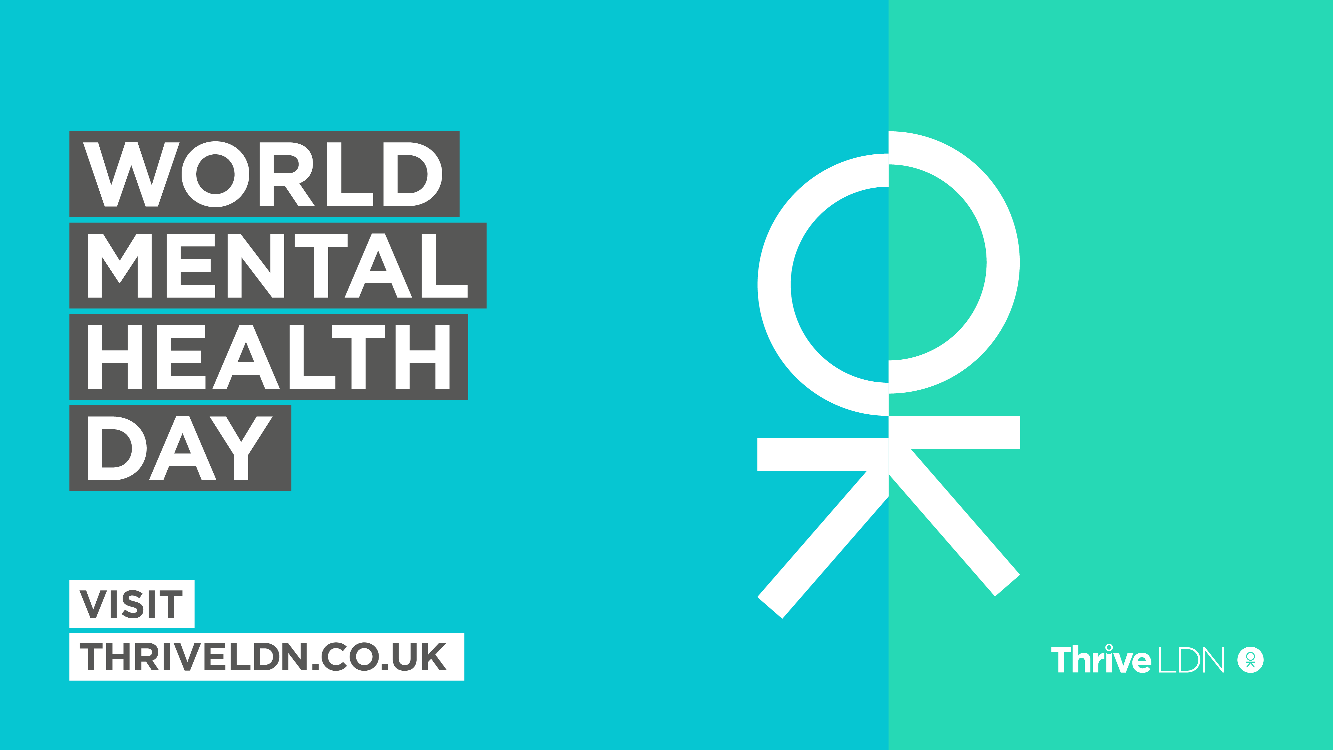
Instagram | 📣World Mental Health Day 2020📣  @ThriveLDN and the @mayorofldn’s Peer Outreach Team have announced this year's line-up for their virtual World Mental Health Day Festival on Saturday 10 October.  This year’s World Mental Health Day Festival programme is all about supporting you to build resilience and promote positive wellbeing. It is an opportunity for young people to come together to collectively overcome barriers and support one another.  Register now and select any of the live workshops you wish to join 👇  thriveldn.co.uk/campaigns/world-mental-health-day-2020/  [Link also via @ThriveLDN profile] | 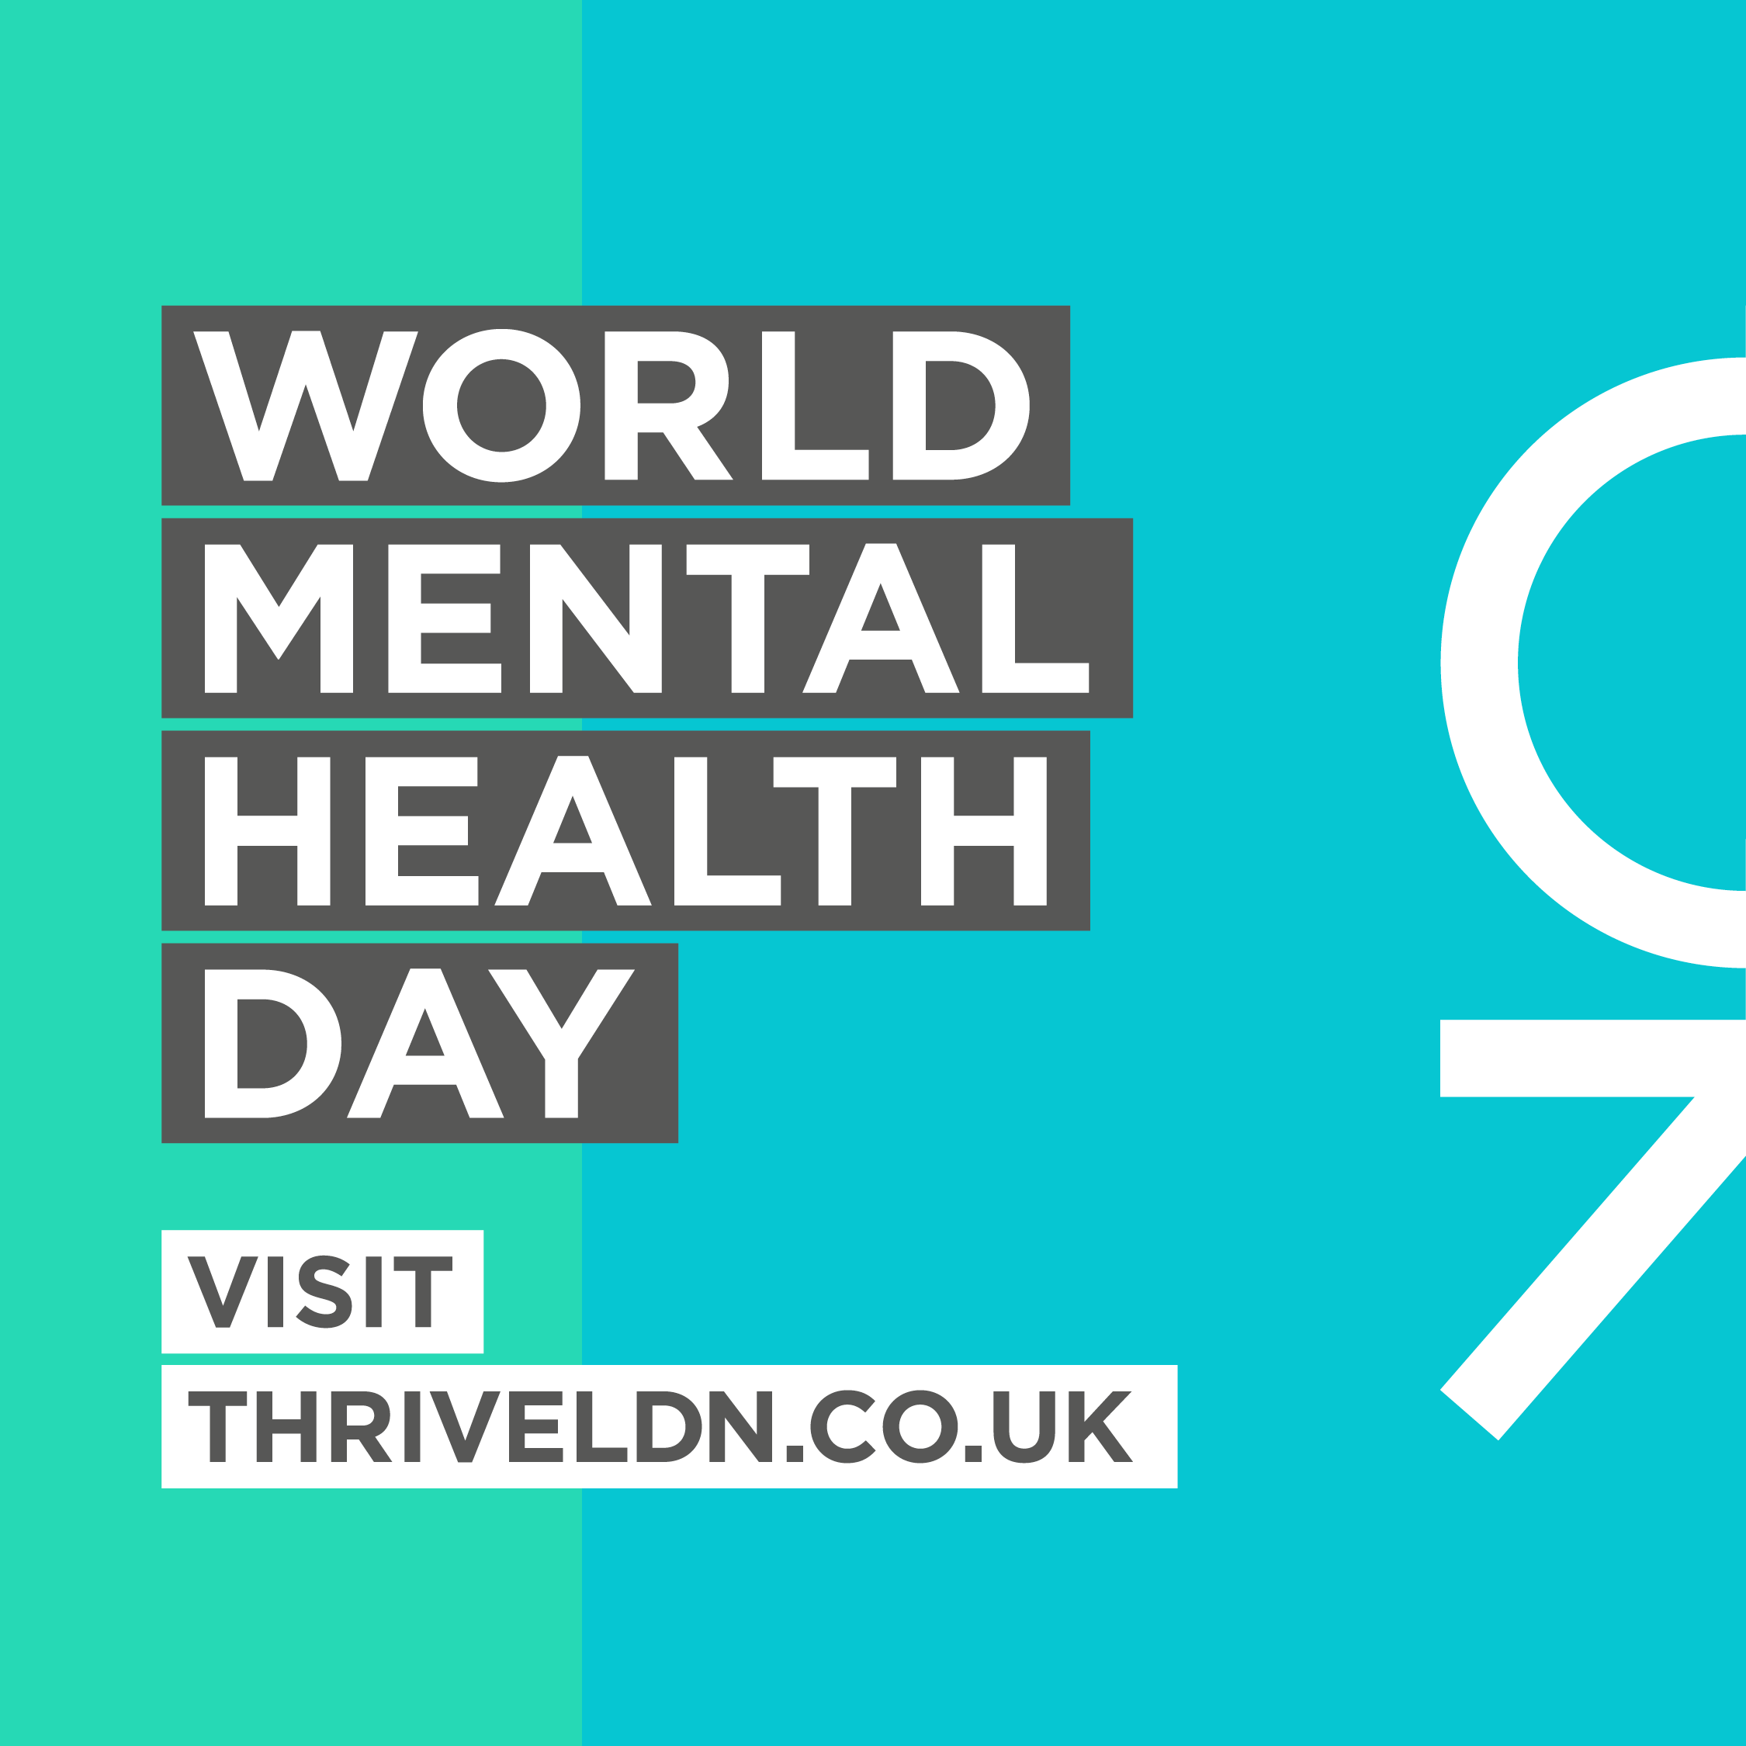
Facebook | Join a virtual World Mental Health Day Festival programme on Saturday, 10 October, designed to support you build resilience and promote positive wellbeing.  The various activities, workshops and performances offer a platform to discuss with other Londoners the challenges faced during COVID-19 and explore shared experiences of inequality and issues raised through the Black Lives Matter movement.  Register now and select any of the live workshops you wish to join 👇  thriveldn.co.uk/campaigns/world-mental-health-day-2020/ | Animated graphic download
TikTok | #ThriveLDN # WMHD2020 with @ThriveLDN | Spoken word workshop, promotional video for TikTok

