KEY MESSAGES TO SHARE ON DIGITAL CHANNELS
Updated Thursday, 15 October 2020
The below has been updated in view of London moving into Tier 2 Covid measures from 00:01, Saturday 17 October.
Thrive LDN has collated the following key messages which can be shared across all social media channels to help signpost appropriate resources and guidance with those in your community.
Images and videos: Right click the image and select ‘open link’ to download a full-size image to use across digital channels. Where relevant, videos have been added as links to download directly.
- Signposting to mental health and wellbeing resources
Twitter | It has never been more important for each of us to think and talk more about #MentalHealth and wellbeing, and to seek support when needed.  There are a range of free resources, online tools and helplines available to help you cope and stay well: https://thriveldn.co.uk/resources/tools-and-resources-to-help-your-mental-health-and-wellbeing/ | 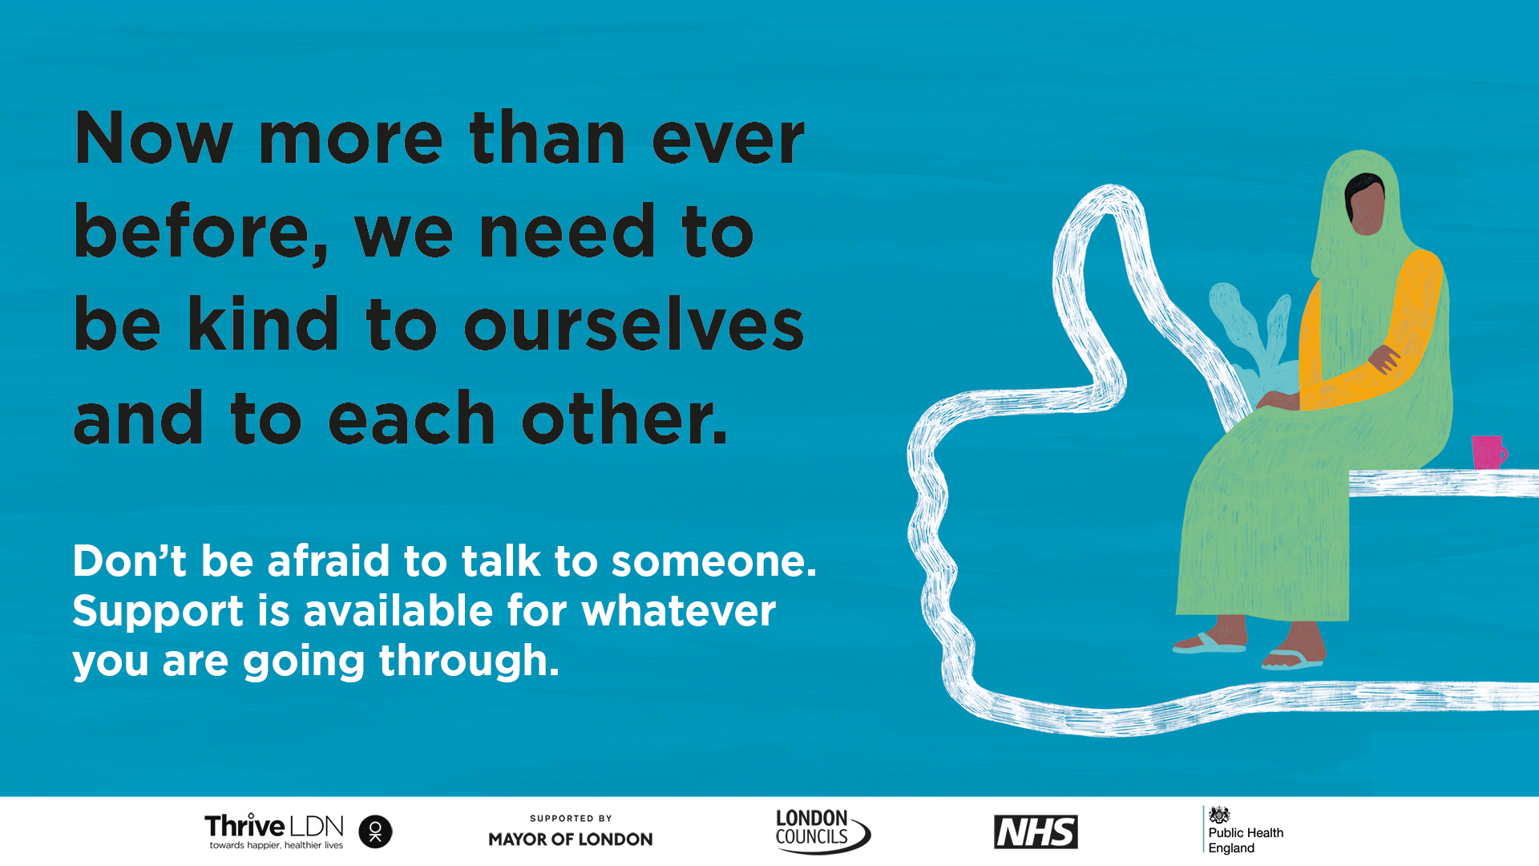
Instagram | Feeling worried or stressed is normal but it’s really important that we take care of our #MentalHealth and wellbeing as much as possible.  There are a range of free resources, online tools and helplines available to help you cope and stay well.  Visit @ThriveLDN and the links in their bio. | 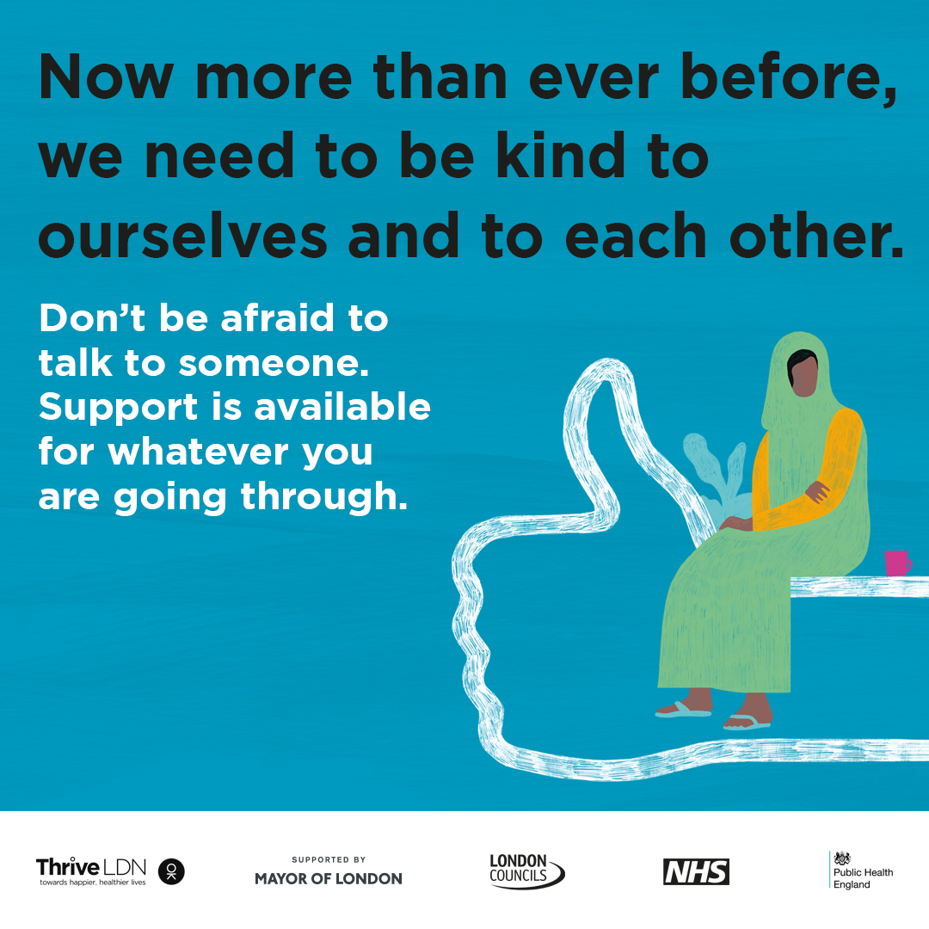
Instagram Stories | Just add picture and tag @ThriveLDN or if able, the link for users to swipe should be:  https://thriveldn.co.uk/resources/tools-and-resources-to-help-your-mental-health-and-wellbeing/ | 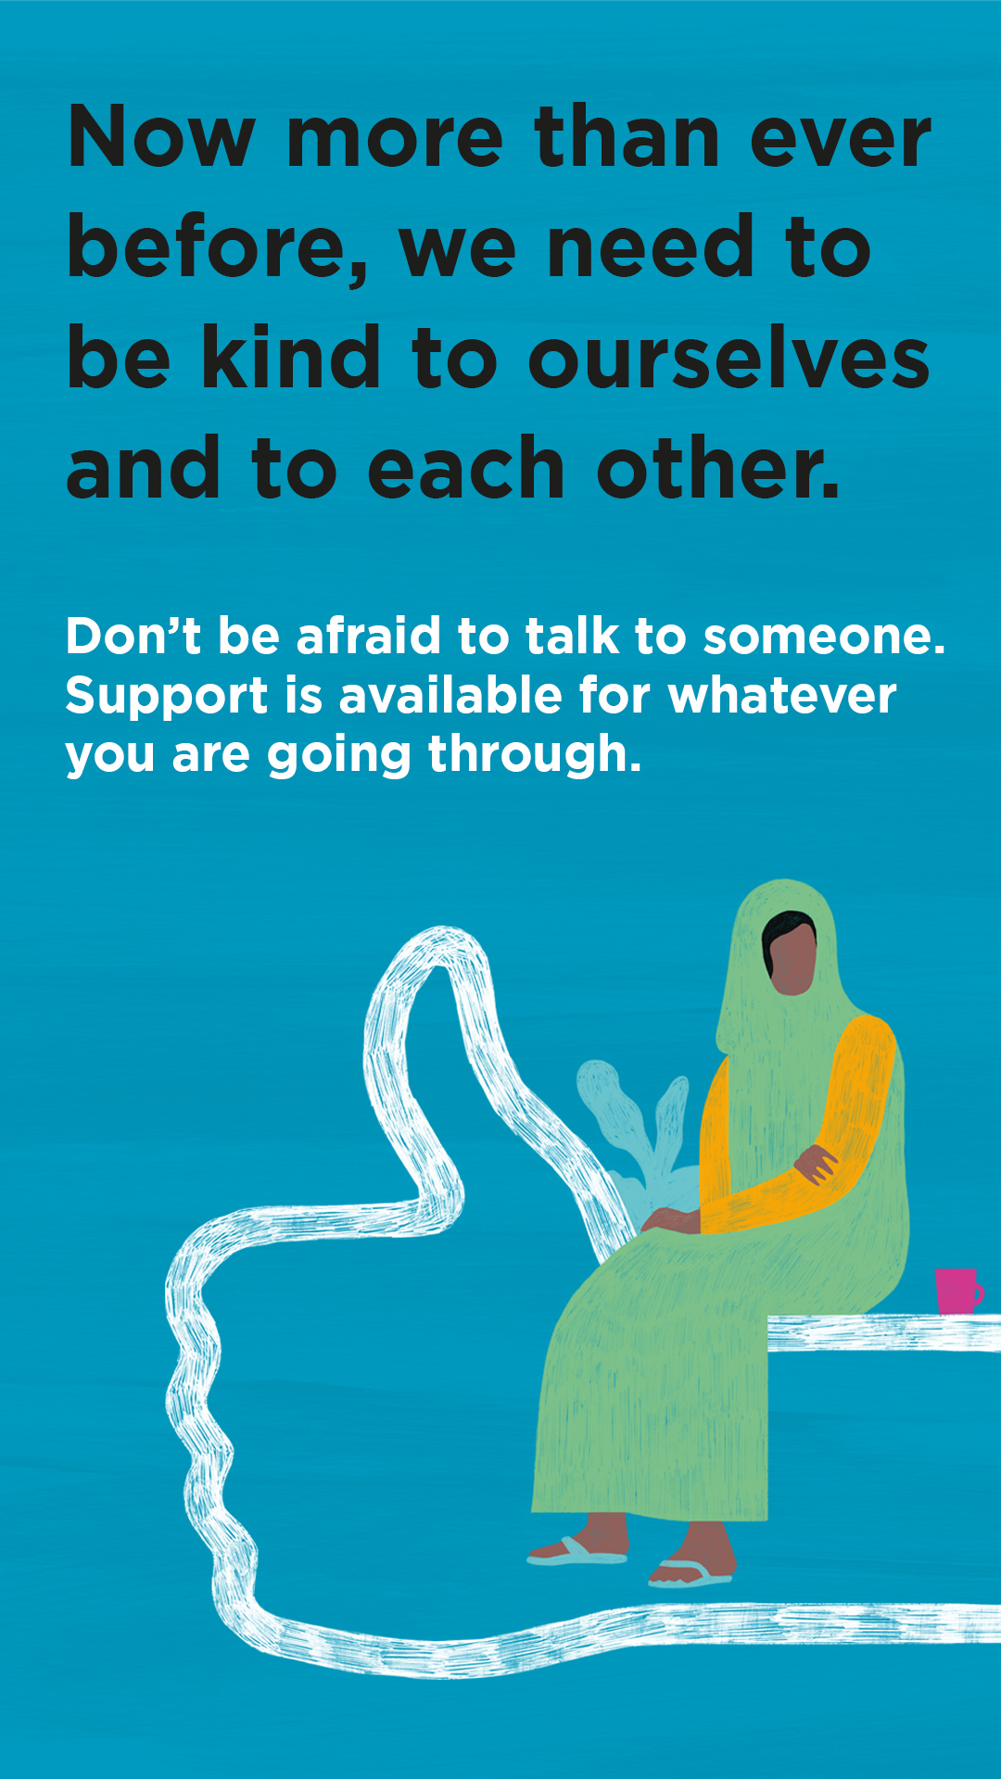
Facebook | Feeling worried or stressed is normal but it’s really important that we take care of our #MentalHealth and wellbeing as much as possible. For #MentalHealthAwarenessWeek, Thrive LDN has put together some helpful tips on keeping yourself well and ways to get support if you are finding it hard.
- Good Thinking digital wellbeing service
Twitter | Times may feel uncertain as London is in Tier 2 #COVID__19 measures and restrictions, and it's perfectly normal to feel worried.  @GoodThinkingUK has a range of FREE apps and resources to help with anxiety, low mood, sleeping difficulties or stress.  ➡️ www.good-thinking.uk | 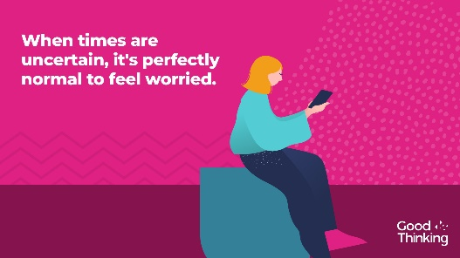  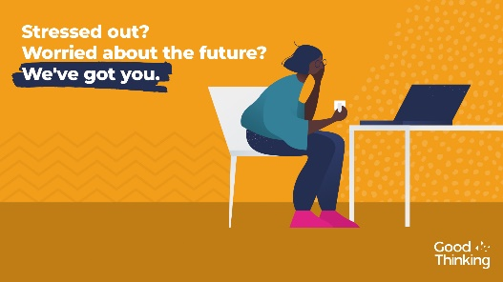
Instagram | When times are uncertain, it is perfectly normal to feel worried. Help is available. There are a range of free apps and resources from @goodthinkinguk to help if you have anxiety, low mood, sleeping difficulties or stress.  ➡️ www.good-thinking.uk  #MentalHealth #Wellbeing #London #Londoners #Support | 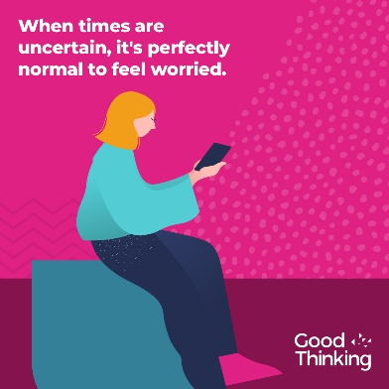
LinkedIn and Facebook | Times are uncertain as the government has announced that London will move into Tier 2 Covid measures, and it's perfectly normal to feel worried.  @GoodThinkingUK help and support is available if you have anxiety, low mood, sleep difficulties or stress.  There's lots you can do to build resilience, stay positive and boost mood. With more than 120 online resources, including wellbeing information sources; guides to improving mental health; courses on and offline; mobile apps and other therapy approaches, Good Thinking also provides articles, podcasts, worksheets and a self-assessment tool.  Visit: www.good-thinking.uk | 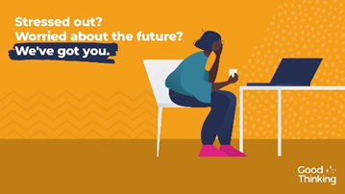
- Wellbeing guidance in 27 languages
Twitter | It's normal to feel stressed or worried in these difficult times.  That’s why @ThriveLDN, @DOTW_UK & @MayorofLondon have teamed up to create six practical steps to help you cope and stay well.  Available to download in English and 26 other languages: https://www.doctorsoftheworld.org.uk/wellbeing-guidance | 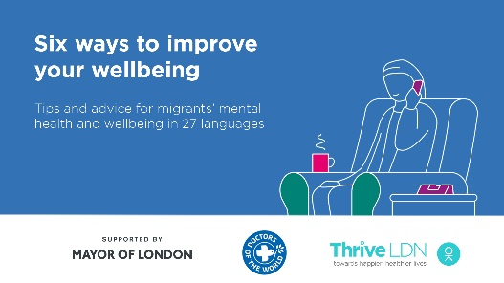  Video link: https://thriveldn.co.uk/wp-content/uploads/2020/09/Wellbeing-Guidance-FINAL.mp4  (open link, then right click and ‘save as’ to download)
Instagram | It's normal to feel stressed or worried in these difficult times.  @ThriveLDN, @dotw_uk & @mayorofldn have teamed up to create six practical steps to help you cope and keep well.  Available to download for free in English and 26 other languages: https://www.doctorsoftheworld.org.uk/wellbeing-guidance  Remember, it is OK not to feel OK.  #MentalHealth #ThriveLDN | 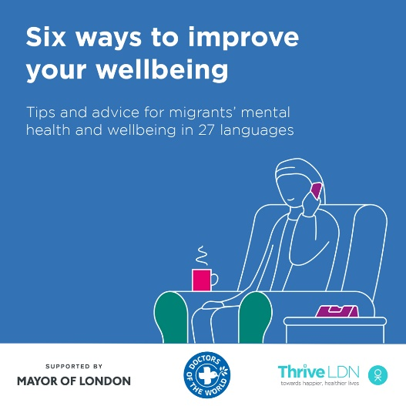  Video link: https://thriveldn.co.uk/wp-content/uploads/2020/09/Wellbeing-Guidance-FINAL.mp4  (open link, then right click and ‘save as’ to download)
Facebook | It's normal to feel stressed or worried in these difficult times.  Thrive LDN, Doctors of the World UK and the Mayor of London have teamed up to create six practical steps to help you cope and keep well.  Available to download for free in English and 26 other languages: https://www.doctorsoftheworld.org.uk/wellbeing-guidance  Remember, it is OK not to feel OK.  #MentalHealth #ThriveLDN #Support #Wellbeing | Video link: https://thriveldn.co.uk/wp-content/uploads/2020/09/Wellbeing-Guidance-FINAL.mp4  (open link, then right click and ‘save as’ to download)  Partner accounts to tag:  Thrive LDN  Mayor of London  Doctors of the World UK
- NHS wellbeing webinar series
Twitter | It's normal to feel stressed or worried in challenging times. Explore @HealthyLDN's new NHS Wellbeing Webinars:  1⃣ #WorkingFromHome & Staying Well  2⃣ Anxiety  3⃣ Low Mood  Each clinically led webinar offers strategies to support your wellbeing.  ➡️ https://thriveldn.co.uk/resources/coping-well-during-covid/ | 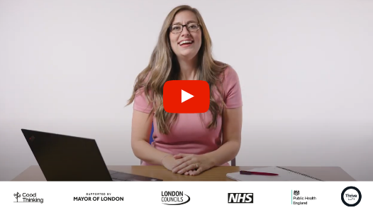  Partner accounts to tag: @HealthyLDN @NHSEnglandLDN @PHE_London @londoncouncils @MayorofLondon
Twitter | The NHS #CopingWellDuringCovid webinar series has provided Londoners with support in areas such as managing anxiety, sleeping better & working from home and staying well.  You can watch the full series back now via the @ThriveLDN website: thriveldn.co.uk/resources/coping-well-during-covid | Partner accounts to tag: @HealthyLDN @NHSEnglandLDN @PHE_London @londoncouncils @MayorofLondon
Twitter | 🎢 When times are uncertain, it's understandable to experience a rollercoaster of emotions.  Watch @HealthyLDN's #CopingDuringCovid webinars - here to help you cope with the impact of COVID-19, covering:  1⃣ #Wellbeing  2⃣ #Anxiety  3⃣ #LowMood  4⃣ #Sleep  ➡️ https://thriveldn.co.uk/resources/coping-well-during-covid/ | Partner accounts to tag: @HealthyLDN @NHSEnglandLDN @PHE_London @londoncouncils @MayorofLondon
Instagram | The NHS #CopingDuringCovid webinar series has provided Londoners with support in areas such as managing anxiety, sleeping better & working from home and staying well.  You can watch the full series back now via the @ThriveLDN website 👉 thriveldn.co.uk/resources/coping-well-during-covid | 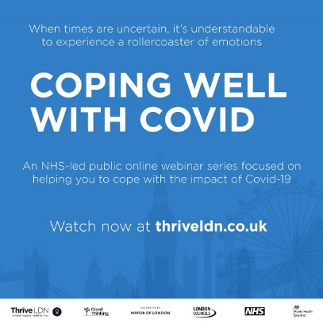
- #ZeroSuicideLDN campaign
Twitter | Living and working in London can be stressful, and right now for some it may be overwhelming. Would you be able to spot a colleague or friend in distress? There’s FREE 20 minute @Zer0Suicide online training to help.  Visit 👉 thriveldn.co.uk/zerosuicideldn | #ZeroSuicideLDN campaign collateral
Instagram | Living and working in London can be stressful, and right now for some it may be overwhelming. Would you be able to spot a colleague or friend in distress? There’s FREE 20 minute online training provided by the @zerosuicidealliance to help.  Visit 👉 thriveldn.co.uk/zerosuicideldn  Save a life... take the training today.  #ZeroSuicideLDN #London #LifeInLondon #WeAreLDN #OKLDN #SuicidePrevention #Teamwork #Together #ZeroSuicideAlliance #Londoners #MentalHealth #OnlineTraining | #ZeroSuicideLDN campaign collateral
Facebook | Living and working in London can be stressful, and right now for some it may be overwhelming. Would you be able to spot a colleague or friend in distress? There’s FREE 20 minute online training provided by the Zero Suicide Alliance to help.  Visit 👉 thriveldn.co.uk/zerosuicideldn  Save a life... take the training today.  #ZeroSuicideLDN #London #LifeInLondon #WeAreLDN #OKLDN #SuicidePrevention #Teamwork #Together #ZeroSuicideAlliance #Londoners #MentalHealth #OnlineTraining | #ZeroSuicideLDN campaign collateral  Partner accounts to tag:  Thrive LDN  Zero Suicide Alliance  Mayor of London

