SUPPORTING LONDONERS’ MENTAL HEALTH AND WELLBEING
REFRESHED SIGNPOSTING COMMUNICATIONS TOOLKIT

September 2020
About this toolkit
This toolkit has been updated to support partners considering the government’s new coronavirus (COVID-19) safety rules and also in light of the UK CMOs recommending that the UK COVID-19 alert level move from level 3 to level 4.
This communications toolkit is designed for London partners, including health and care organisations, local authorities, and third sector bodies. This is a resource for you to adapt and to use locally when communicating to the general public about available resources and services to support resilience, mental health and wellbeing.
It builds on the signposting and engagement work undertaken by Thrive LDN and partners since March 2020.
Thrive LDN
On behalf of Public Health England Office for London, Thrive LDN is coordinating the public mental health response to COVID-19 in London to support the mental health and resilience of Londoners.
For any queries about this pack, please contact Thrive LDN communications lead, James Ludley (07795 665680 / james.ludley@nhs.net).
For general information about Thrive LDN’s work please contact info@thriveldn.co.uk.

Contents

1. Context and background 3
1.1 What we know about the impact of COVID-19 on Londoners’ mental health and wellbeing 3
2. Suggested standard text for mental health signposting 4
2.1 Standard text for partner’s webpage 4
2.2 Standard text for newsletters and/or offline copy 6
2.3 Standard text for social media 7
3. Further resources and tools to share 12
3.1 Psychosocial approaches and psychological first aid 12
3.2 Workplace Wellbeing resources and training 14
Appendix A: London’s Improving access to psychological therapies (IAPT) services 15
Appendix B: The spectrum of support for Londoners 19

Context and background

1.1 What we know about the impact of COVID-19 on Londoners’ mental health and wellbeing
Thrive LDN has been coordinating the public mental health response to COVID-19 on behalf of Public Health England Office for London and wider partners since lockdown and response measures were put in place in March 2020.
When assessing the mental health and wellbeing implications of COVID-19, it is important to consider the broad picture of mental health and the factors which affect it:
- We know that poor mental health is both a cause and consequence of inequality and prevalence is often much higher in the communities facing most inequalities, including people living in poverty or those who have experienced discrimination or adversity.
- Many Londoners entered the pandemic from positions of disadvantage and increasing evidence shows that the pandemic has affected the mental health of sections of the population differently, depending on their circumstances.
- COVID-19 and response measures have resulted in an increase in known risk factors for mental health problems, such as social isolation and loss of income. Together with the exposure of racial and ethnic disparities in the incidence of COVID-19, uncertainty for the future and an economic downturn, the pandemic requires a sustained, efficient, and equitable public mental health response.
Research and evidence suggest the pandemic has widened mental health inequalities; groups that had the poorest mental health pre-crisis had the largest deterioration in mental health during lockdown.
Furthermore, many Londoners with no history of accessing mental health services have been impacted by COVID-19, either through loneliness, anxiety, bereavement or in some cases trauma, or from adjusting to social distancing or life after lockdown, alongside financial and job stresses.
However, the London response to COVID-19 has largely been rooted in community action, resulting in innovation and transformation at a scale and speed never seen before. It is vital that we listen to and strengthen communities to protect public mental health and build strength and resilience, now and during future phases of the pandemic.
Collectively we must encourage Londoners to seek help and support where appropriate. While in recent years we have seen a positive change in attitudes and greater public understanding of the issues surrounding mental health, many Londoners are not seeking the support available early enough.
The following messages in this toolkit are designed to support improved and appropriate signposting and encourage help-seeking behaviour. When adapting and using the messages in this toolkit, and when encouraging other people and organisations to do so, it is important to communicate to Londoners, especially those who have been marginalised and discriminated against, that:
- It is normal and okay to feel upset, anxious or confused at times
- It is a positive and constructive thing to seek help and ask for support
- Help is available if they feel they are becoming overwhelmed
Details of a range of resources and organisations that can help build and support resilience and offer helpful advice and guidance, as well as details of IAPT services can be found in the appendices (pages 12-20).

Suggested standard text for mental health signposting
This standard text can be adapted for local websites (either as a resource/section or news article). The suggested social media posts can be used and adapted for partner channels. The text in red needs to be localised or removed as relevant.

2.1 Standard text for partner’s webpage
This standard text can be adapted for local websites.
STARTS
Tools and resources to help your mental health and wellbeing
It is normal and okay to feel upset, anxious or confused at times.
It is understandable that you might be feeling anxious and worried about coronavirus and that it could be affecting your mental health. You might be struggling with the idea of new safety measures or loneliness because of these. You might be stressed about your job and finances. For those with an existing mental health condition, such as anxiety, depression or post-traumatic stress disorder (PTSD), this might be a particularly difficult time.
It has never been more important for each of us to think and talk more about mental health and wellbeing, and to seek support when needed. In London, there are a range of free resources, online tools, and helplines available to help you cope and stay mentally healthy.
You should know that even though things can feel very hard at times, support is available for whatever you are going through.
Simple ways to improve your wellbeing
Doctors of the World, in partnership with Thrive LDN, have put together a list of little things you can do to keep yourself well and some useful ways to get support if you are finding it hard. The guidance is available in English and 26 other languages to support migrant communities.
If you’re feeling anxious or stressed about work, housing or financial difficulties, then explore the helpful range of resources and guidance on City Hall's Hub.
Available support now - online tools to help your mental health
The NHS-approved digital mental wellbeing service, Good Thinking, promotes proactive self-care for the four most common mental health conditions: anxiety, low mood, sleeping difficulties and stress. Take the clinically validated self-assessment tool to get a better understanding of what you’re going through, helpful resources and if necessary, relevant treatment options.
To help build resilience and maintain good wellbeing, there’s a range of resources for everyone at Every Mind Matters. Including an interactive quiz, the Your Mind Plan, to get top tips and advice relevant for you.
NHS wellbeing webinars
A collection of NHS Coping Well During Covid webinars are available if you are feeling anxious about coronavirus and how it is impacting you, your loved ones or your work. The 60-minute sessions will guide you through ideas and tools to support your mental health and wellbeing in an evidenced based and interactive way.
The webinar topics include managing wellbeing, anxiety, low mood, sleeping difficulties, and mindfulness. Additionally, there are also specific webinars on:
- Working from home and staying well – aimed at helping you consider the challenges created by home working, helping you to find a better home working life balance, enabling you to find it easier to separate working from home life.
- Managing financial anxiety – delivered in partnership with Money A&E and Mental Health and Money Advice, this webinar provides you with some really practical advice to support you with your financial concerns as well as some strategies to manage your wellbeing.
- BAME Wellbeing – delivered in partnership with David Truswell, this webinar considers the challenges Black, Asian and minority ethnic communities face and some techniques and strategies to support wellbeing now and as lockdown restrictions ease.
NHS psychological treatments
If you do not require urgent support but are still concerned about your mental health, contacting your GP is a good place to start.
You can also refer yourself for free, non-urgent NHS psychological therapy (IAPT) services which provide evidence-based treatments for depression and anxiety. These services are open in London [or borough] if you feel like you may need further, professional support. You can find your local service here.
You can include a reference to local service from the table below in Appendix A OR embed a map of services using the following code:
<iframe src="https://www.google.com/maps/d/embed?mid=1BMX7m_7Gl0aHR7-GwPVvSfOGt6WFyZAT" width="640" height="480"></iframe>
Getting urgent help for mental health
A mental health emergency should be taken as seriously as a physical one. You will not be wasting anyone's time. If you have an existing mental health condition and an assigned care team or care worker, then it’s important to contact them.
NHS urgent mental health helplines are for people of all ages. You can call for:
- 24-hour advice and support - for you, your child, your parent or someone you care for
- help to speak to a mental health professional
- an assessment to help decide on the best course of care
Alternatively, when life is tough the Samaritans are here to listen at any time of the day or night. You can talk to them about anything that's troubling you, no matter how difficult.
- Call free on 116 123 or visit the Samaritans website.
Shout offers confidential 24/7 crisis text support for times when you need immediate assistance.
- Text SHOUT to 85258 or visit Shout Crisis Text Line.
The bereavement care charity Cruse is helping families affected by coronavirus.
- Call free on 0808 808 1677 or visit the Cruse website.
ENDS

2.2 Standard text for newsletters and/or offline copy
This standard text can be adapted for e-newsletters and bulletins. We advise that it becomes a standing item during periods when more restrictive safety measures are in place as the first wave of coronavirus showed many people experience heightened anxiety. Below is both a full and concise post.
[FULL – 160 words] Resources to help your mental health and wellbeing
Right now, it has never been more important for each of us to think and talk more about mental health and wellbeing, and to seek support when needed.
There is support available for whatever you are going through. In London, there is a range of support available now from Good Thinking, Every Mind Matters, and NHS wellbeing webinars.
Alternatively, your GP can advise you about helpful treatments and local mental health services.
Or if you may feel more comfortable talking to someone you don’t know by using one of the following helplines:
- Samaritans are here when life is difficult. They won’t judge you or tell you what to do, they’re here to listen so you don’t have to face it alone. Call the free, 24-hour listening service on 116 123 or email jo@samaritans.org.
- Shout is the UK 's first 24/7 text messaging service for anyone in crisis. Text Shout at any time to 85258 to start a conversation with a trained volunteer.
[CONCISE – 52 words] Resources to help your mental health and wellbeing
It is normal and okay to feel upset, anxious or confused at times.
Support is available, with a range of free resources and online tools available to help you cope and stay mentally healthy.
If you feel more comfortable talking to someone you don’t know by using one of the following helplines.

2.3 Standard text for social media
We have collated the following five key messages which can be shared across all social media channels to help signpost appropriate resources and guidance with those in your organisation and networks.
Images and videos: Right click the image and select ‘open link’ to download a full-size image to use across digital channels. Where relevant, videos have been added as links to download directly.
- Signposting to mental health and wellbeing resources
Twitter | It has never been more important for each of us to think and talk more about #MentalHealth and wellbeing, and to seek support when needed.  There are a range of free resources, online tools and helplines available to help you cope and stay well: https://thriveldn.co.uk/resources/tools-and-resources-to-help-your-mental-health-and-wellbeing/ | 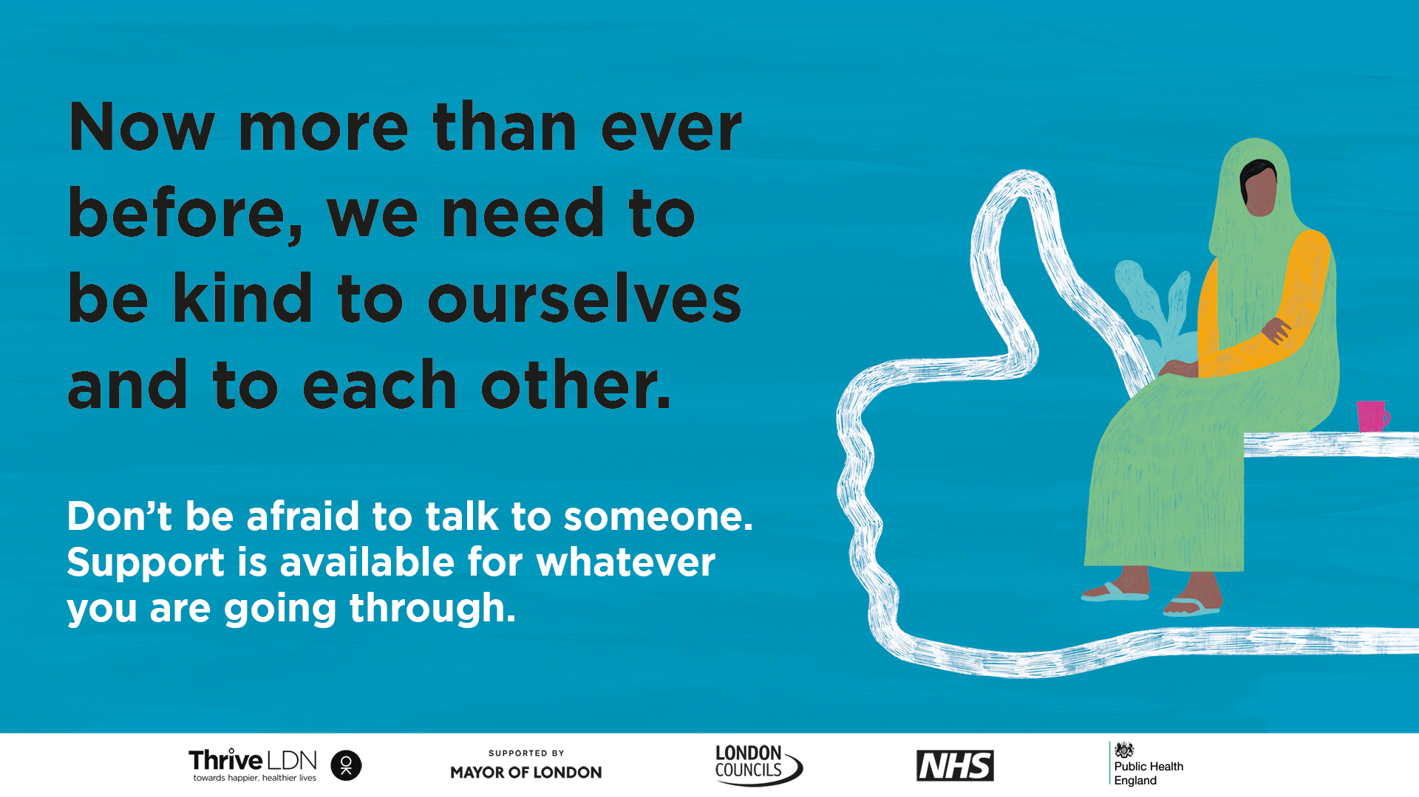
Instagram | Feeling worried or stressed is normal but it’s really important that we take care of our #MentalHealth and wellbeing as much as possible.  There are a range of free resources, online tools and helplines available to help you cope and stay well.  Visit @ThriveLDN and the links in their bio.
Instagram Stories | Just add picture and tag @ThriveLDN or if able, the link for users to swipe should be:  https://thriveldn.co.uk/resources/tools-and-resources-to-help-your-mental-health-and-wellbeing/ | 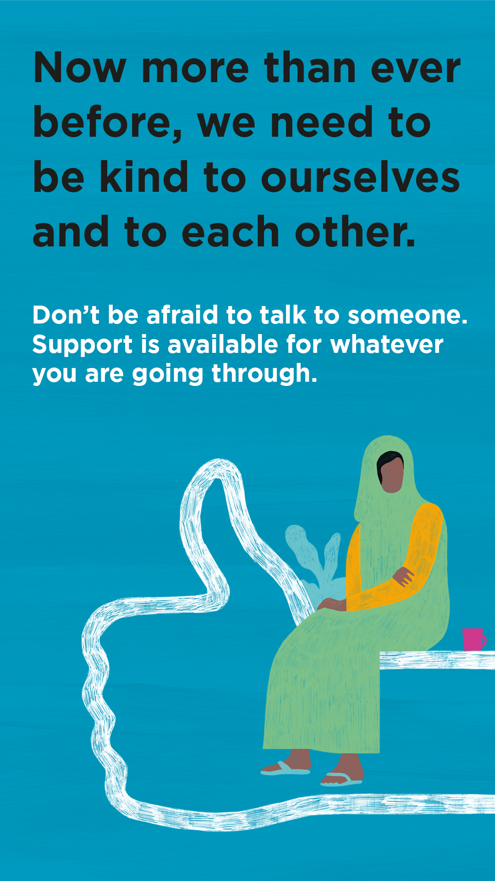
Facebook | Feeling worried or stressed is normal but it’s really important that we take care of our #MentalHealth and wellbeing as much as possible. For #MentalHealthAwarenessWeek, Thrive LDN has put together some helpful tips on keeping yourself well and ways to get support if you are finding it hard.
- Good Thinking digital wellbeing service
Twitter | Times may feel uncertain as London is in Tier 2 #COVID__19 measures and restrictions, and it's perfectly normal to feel worried.  @GoodThinkingUK has a range of FREE apps and resources to help with anxiety, low mood, sleeping difficulties or stress.  ➡️ www.good-thinking.uk | 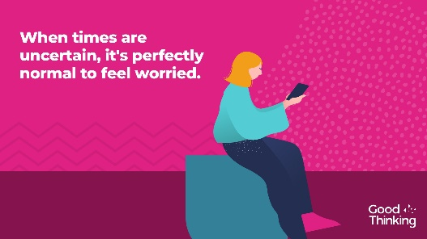
Instagram | When times are uncertain, it is perfectly normal to feel worried. Help is available. There are a range of free apps and resources from @goodthinkinguk to help if you have anxiety, low mood, sleeping difficulties or stress.  ➡️ www.good-thinking.uk  #MentalHealth #Wellbeing #London #Londoners #Support | 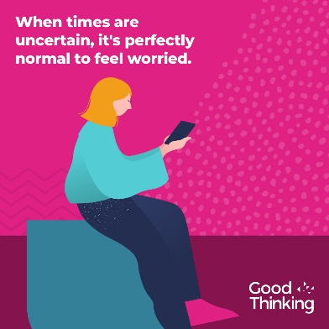
LinkedIn and Facebook | Times are uncertain as the government has announced that London will move into Tier 2 Covid measures, and it's perfectly normal to feel worried.  @GoodThinkingUK help and support is available if you have anxiety, low mood, sleep difficulties or stress.  There's lots you can do to build resilience, stay positive and boost mood. With more than 120 online resources, including wellbeing information sources; guides to improving mental health; courses on and offline; mobile apps and other therapy approaches, Good Thinking also provides articles, podcasts, worksheets and a self-assessment tool.  Visit: www.good-thinking.uk
- Wellbeing guidance in 27 languages
Twitter | It's normal to feel stressed or worried in these difficult times.  That’s why @ThriveLDN, @DOTW_UK & @MayorofLondon have teamed up to create six practical steps to help you cope and stay well.  Available to download in English and 26 other languages: https://www.doctorsoftheworld.org.uk/wellbeing-guidance | 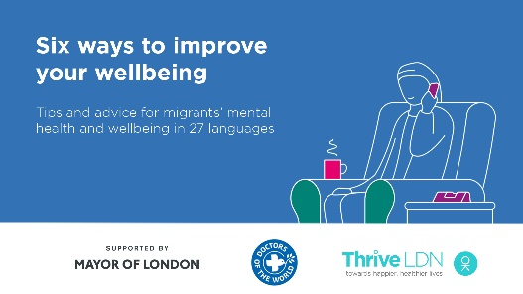  Video link: https://thriveldn.co.uk/wp-content/uploads/2020/09/Wellbeing-Guidance-FINAL.mp4  (open link, then right click and ‘save as’ to download)
Instagram | It's normal to feel stressed or worried in these difficult times.  @ThriveLDN, @dotw_uk & @mayorofldn have teamed up to create six practical steps to help you cope and keep well.  Available to download for free in English and 26 other languages: https://www.doctorsoftheworld.org.uk/wellbeing-guidance  Remember, it is OK not to feel OK.  #MentalHealth #ThriveLDN | 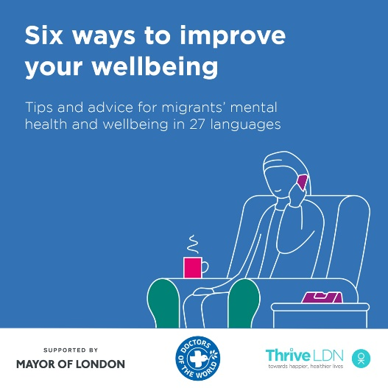  Video link: https://thriveldn.co.uk/wp-content/uploads/2020/09/Wellbeing-Guidance-FINAL.mp4  (open link, then right click and ‘save as’ to download)
Facebook | It's normal to feel stressed or worried in these difficult times.  Thrive LDN, Doctors of the World UK and the Mayor of London have teamed up to create six practical steps to help you cope and keep well.  Available to download for free in English and 26 other languages: https://www.doctorsoftheworld.org.uk/wellbeing-guidance  Remember, it is OK not to feel OK.  #MentalHealth #ThriveLDN #Support #Wellbeing | Video link: https://thriveldn.co.uk/wp-content/uploads/2020/09/Wellbeing-Guidance-FINAL.mp4  (open link, then right click and ‘save as’ to download)  Partner accounts to tag:  Thrive LDN  Mayor of London  Doctors of the World UK
- NHS wellbeing webinar series
Twitter | It's normal to feel stressed or worried in challenging times. Explore @HealthyLDN's new NHS Wellbeing Webinars:  1⃣ #WorkingFromHome & Staying Well  2⃣ Anxiety  3⃣ Low Mood  Each clinically led webinar offers strategies to support your wellbeing.  ➡️ https://thriveldn.co.uk/resources/coping-well-during-covid/ | 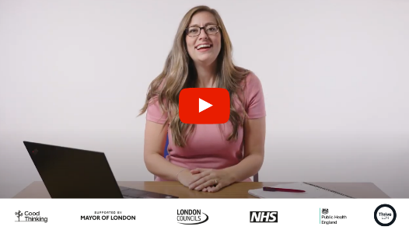  Partner accounts to tag: @HealthyLDN @NHSEnglandLDN @PHE_London @londoncouncils @MayorofLondon
Twitter | The NHS #CopingWellDuringCovid webinar series has provided Londoners with support in areas such as managing anxiety, sleeping better & working from home and staying well.  You can watch the full series back now via the @ThriveLDN website: thriveldn.co.uk/resources/coping-well-during-covid | Partner accounts to tag: @HealthyLDN @NHSEnglandLDN @PHE_London @londoncouncils @MayorofLondon
Twitter | 🎢 When times are uncertain, it's understandable to experience a rollercoaster of emotions.  Watch @HealthyLDN's #CopingDuringCovid webinars - here to help you cope with the impact of COVID-19, covering:  1⃣ #Wellbeing  2⃣ #Anxiety  3⃣ #LowMood  4⃣ #Sleep  ➡️ https://thriveldn.co.uk/resources/coping-well-during-covid/ | Partner accounts to tag: @HealthyLDN @NHSEnglandLDN @PHE_London @londoncouncils @MayorofLondon
Instagram | The NHS #CopingDuringCovid webinar series has provided Londoners with support in areas such as managing anxiety, sleeping better & working from home and staying well.  You can watch the full series back now via the @ThriveLDN website 👉 thriveldn.co.uk/resources/coping-well-during-covid
- #ZeroSuicideLDN campaign
Twitter | Living and working in London can be stressful, and right now for some it may be overwhelming. Would you be able to spot a colleague or friend in distress? There’s FREE 20 minute @Zer0Suicide online training to help.  Visit 👉 thriveldn.co.uk/zerosuicideldn | #ZeroSuicideLDN campaign collateral
Instagram | Living and working in London can be stressful, and right now for some it may be overwhelming. Would you be able to spot a colleague or friend in distress? There’s FREE 20 minute online training provided by the @zerosuicidealliance to help.  Visit 👉 thriveldn.co.uk/zerosuicideldn  Save a life... take the training today.  #ZeroSuicideLDN #London #LifeInLondon #WeAreLDN #OKLDN #SuicidePrevention #Teamwork #Together #ZeroSuicideAlliance #Londoners #MentalHealth #OnlineTraining | #ZeroSuicideLDN campaign collateral
Facebook | Living and working in London can be stressful, and right now for some it may be overwhelming. Would you be able to spot a colleague or friend in distress? There’s FREE 20 minute online training provided by the Zero Suicide Alliance to help.  Visit 👉 thriveldn.co.uk/zerosuicideldn  Save a life... take the training today.  #ZeroSuicideLDN #London #LifeInLondon #WeAreLDN #OKLDN #SuicidePrevention #Teamwork #Together #ZeroSuicideAlliance #Londoners #MentalHealth #OnlineTraining | #ZeroSuicideLDN campaign collateral  Partner accounts to tag:  Thrive LDN  Zero Suicide Alliance  Mayor of London

Further resources and tools to share

3.1 Psychosocial approaches and psychological first aid
Psychosocial support is a humane, supportive response to individuals and communities who are struggling and who may need support. Thrive LDN has developed guidance for people who are supporting communities and individuals who have been adversely affected by COVID-19 to help them to know the most supportive things to say and do for people who are distressed.
You can also download a Look, Listen, Link A4 poster for your community or faith centre, public and patient area, and/or workplace. Please share with community groups.
Public Health England has launched a Psychological First Aid (PFA) training module, aimed at all frontline and essential workers and volunteers. The course teaches the key principles of giving psychological first aid in emergencies and aims to increase awareness and confidence to provide this support to people affected by COVID-19.

Sharing psychosocial guidance on social media
Twitter | Guidance on providing humane, supportive and practical help to those affected by COVID-19.  @ThriveLDN’s #Psychosocial guidance is for those working in the community, outlining the most supportive things to say and do for people who are distressed.  ➡️ www.thriveldn.co.uk/resources/supporting-those-adversely-affected-or-distressed-by-the-coronavirus-outbreak/ | Thrive LDN psychosocial approaches and general guidance – digital assets  Includes social media collateral and an A4 poster
Instagram | @ThriveLDN has developed a new resource for people who are supporting communities and individuals who have been adversely affected by COVID-19.  Adapted from WHO psychological first aid guide for field workers, the purpose of the guidance is to help those working in the community to know the most supportive things to say and do for people who are very distressed. It is helpful for all frontline and essential workers and volunteers.  Explore the guidance: www.thriveldn.co.uk/looklistenlink | Thrive LDN psychosocial approaches and general guidance – digital assets
Facebook | Thrive LDN has developed a new resource for people who are supporting communities and individuals who have been adversely affected by COVID-19.  Adapted from WHO psychological first aid guide for field workers, the purpose of the guidance is to help those working in the community to know the most supportive things to say and do for people who are very distressed. It is helpful for all frontline and essential workers and volunteers.  Explore the guidance: www.thriveldn.co.uk/looklistenlink | Thrive LDN psychosocial approaches and general guidance – digital assets

3.2 Workplace Wellbeing resources and training
We have put together a short guide which collates some of the best practice from Thrive LDN partners to help support managers and team leaders feel better equipped and more confident in:
1. Having difficult conversations about mental health and wellbeing
2. Managing your own mental health and wellbeing
Each training and support resource is accompanied by a suggested time to allocate for the training or to become familiarised with the resource for later use. It also includes a Questions for Self-reflection section to consider learnings from the training.

Appendix A: London’s Improving access to psychological therapies (IAPT) services

Improving access to psychological therapies (IAPT) is primarily for people who have mild to moderate mental health difficulties, such as depression, anxiety, phobias and post-traumatic stress disorder. These conditions are treated using a variety of therapeutic techniques, such as cognitive behavioural therapy (CBT) and interpersonal therapy (IPT).

With the first wave of coronavirus posing particular challenges to the mental health and wellbeing of Londoners, IAPT services in London have been refreshed and all are open to receive new referrals. Find your local Improving access to psychological therapies (IAPT) service here or using the table below.
1a. STP | 1b. CCG | 1c. Trust | 2. IAPT Service
NCL | Barnet | Whittington Health NHS Trust | Let's Talk IAPT  https://www.whittington.nhs.uk/default.asp?c=10191&print=1
NCL | Camden | Camden and Islington NHS Foundation trust | iCope: Camden Psychological Therapies and Wellbeing Service (Camden iCope)  https://www.icope.nhs.uk/camden-islington/
NCL | Enfield | Whittington Health NHS Trust | LET'S TALK IAPT -Improving Access to Psychological Therapies (IAPT) in Enfield and Haringey  https://www.whittington.nhs.uk/default.asp?c=10191&print=1
NCL | Haringey | Whittington Health NHS Trust | Let's Talk Haringey IAPT  https://www.whittington.nhs.uk/default.asp?c=10191&print=1
NCL | Islington | Camden & Islington NHS Foundation Trust | iCope: Islington Psychological Therapies and Wellbeing Service (islington iCope)  https://www.icope.nhs.uk/camden-islington/
NEL | Barking & Dagenham | North East London NHS Foundation Trust | Talking Therapies (IAPT), Barking & Dagenham  https://nelft.nhs.uk/services-talking-therapies
NEL | City & Hackney | Homerton University Hospital | City & Hackney Psychology  https://www.elft.nhs.uk/service/301/City--Hackney-Psychology
NEL | Havering | North East London NHS Foundation Trust | Havering Talking Therapies (IAPT)  https://nelft.nhs.uk/services-talking-therapies
NEL | Newham | East London NHS Foundation Trust | Newham Talking Therapies  https://www.elft.nhs.uk/service/197/Newham-Talking-Therapies
NEL | Redbridge | North East London Foundation trust | Talking Therapies Redbridge  https://nelft.nhs.uk/services-talking-therapies
NEL | Tower Hamlets | East London Foundation Trust | Tower Hamlets Talking Therapies  https://www.elft.nhs.uk/service/425/Tower-Hamlets-Talking-Therapies
NEL | Waltham Forrest | North East London NHS Foundation Trust | Waltham Forest Talking Therapies  https://nelft.nhs.uk/services-talking-therapies
NWL | Central London (Westminster) | Central and Northwest London NHS Foundation Trust | CNWL Talking Therapies Service Westminster - (one services for CLCCG)  https://www.cnwl.nhs.uk/services/mental-health-services/adult-and-older-adult/westminster-talking-therapies
NWL | Ealing | West London Mental Health Trust | Ealing IAPT  https://westlondon.nhs.uk/service/iapt/
NWL | Hammersmith and Fulham CCG | West London Mental Health Trust | Back on Track  https://westlondon.nhs.uk/service/iapt/
NWL | Harrow | Central and North West London NHS Foundation Trust (CNWL) | Harrow Talking Therapies (IAPT) Service  https://www.cnwl.nhs.uk/services/mental-health-services/adult-and-older-adult/harrow-talking-therapies
NWL | Hillingdon | Central and North West London NHS Foundation Trust (CNWL) | Hillingdon talking therapies  https://www.cnwl.nhs.uk/services/mental-health-services/adult-and-older-adult/hillingdon-talking-therapies
NWL | Hounslow | West London Mental Health Trust | Hounslow IAPT Service  https://westlondon.nhs.uk/service/iapt/
NWL | NHS Brent | Central and North West London NHS Foundation Trust (CNWL) | Brent Talking Therapies  https://www.cnwl.nhs.uk/services/mental-health-services/adult-and-older-adult/brent-talking-therapies
NWL | West London CCG (Kensington & Chelsea) | Central and Northwest London NHS Foundation Trust | Community Living Well – Psychological Therapies  https://www.cnwl.nhs.uk/services/mental-health-services/kensington-and-chelsea-talking-therapies-service-community-living-well
SEL | Bexley | Mind in Bexley | Mind in Bexley IAPT  https://mindinbexley.org.uk/iapt
SEL | Bromley | Bromley health care | Talk Together Bromley  https://www.talktogetherbromley.co.uk/
SEL | Greenwich | Oxleas NHS Foundation Trust | Time to Talk - Greenwich  http://oxleas.nhs.uk/services/service/greenwich-time-to-talk/
SEL | Lambeth | South London and Maudsley NHS Foundation Trust | Lambeth Talking Therapies Service  https://www.slam.nhs.uk/our-services/service-finder-details?CODE=SU0469
SEL | Lewisham | South London and Maudsley NHS Foundation Trust | IAPT Lewisham (Lee Health Centre)  https://www.slam.nhs.uk/our-services/service-finder-details?CODE=SU0468
SEL | Southwark | South London and Maudsley NHS Foundation Trust | Talking Therapies Southwark  https://www.slam.nhs.uk/our-services/service-finder-details?CODE=SU0094
SEL | Croydon | South London and Maudsley NHS Foundation Trust | Croydon IAPT Psychological Therapies Service  https://www.slam.nhs.uk/our-services/service-finder-details?CODE=SU0489
SWL | Kingston | Camden and Islington NHS Foundation trust | Kingston iCope  https://www.icope.nhs.uk/kingston/
SWL | Merton | South West London & St. George’s NHS Trust | Merton Uplift  https://www.mertonuplift.nhs.uk/
SWL | Richmond | East London NHS Foundation Trust | Richmond Wellbeing Service  https://www.richmondwellbeingservice.nhs.uk/
SWL | Sutton | South West London & St. George’s NHS Trust | Sutton Uplift  https://www.suttonuplift.co.uk/
SWL | Wandsworth | South West London & St. George’s NHS Trust | Talk Wandsworth  https://www.talkwandsworth.nhs.uk/

Appendix B: The spectrum of support for Londoners
It is important to reassure Londoners that it is normal to feel upset, anxious or confused at times. There are a range of resources that can help build individual and collective resilience and many different organisations and providers offer helpful advice and guidance on subjects including self-isolation and managing home working.
To help Londoners find the right and appropriate support for them it is useful to promote the range of support on offer to Londoners. Internally (i.e. not public facing), we may think of this as forming the following spectrum from upstream support to crisis services:
 | Who for? | Pathway / source of support
- Building resilience and supporting ourselves and others to feel mentally healthy (self-care) | Everyone | - Thrive LDN  - Every Mind Matters  - Good Thinking, signposts to a range of online resources designed to help manage low mood, anxiety, stress, and sleep problems  - NHS wellbeing webinars, recorded during the first wave and available to view online  For children and young people:  - Kooth  - YoungMinds  - The Mix
- Supporting those who are concerned about their mental health, including issues that have emerged as a result of the pandemic. | Those with emerging issues (including those specifically related to the pandemic and lockdown) | - Good Thinking  - NHS wellbeing webinars  - Local IAPT, non-urgent NHS psychological ‘talking’ therapy services. Londoners may be able to self-refer to some services.  - Contact your GP who will be able to refer to clinical services or to support offered locally by voluntary sector providers.  - Cruse, the bereavement care charity is helping families affected by coronavirus.  - Samaritans, the free listening service is available at any time of the day or night on 116 123.  For BAME communities:  - The Black, African and Asian Therapy Network is the UK’s largest independent organisation specialises in working psychologically with people who identify as Black, African, South Asian and Caribbean. Their website provides a list of local and free resources and services for people of minority background who are seeking help.  For LGBTQ+ Londoners:  - The Switchboard LGBT+ helpline is open daily from 10am-10pm on 0300 330 0630 or email chris@switchboard.lgbt
a) Supporting those who are struggling with chronic anxiety, depression or PTSD.  b) Additionally, serious mental illness (SMI) like psychosis, eating disorders and personality disorders. [Not for IAPT] | Existing issues (with existing care team/worker) | - Local IAPT [a only – not for SMI]  - Contact your key worker / MH support team [a & b]
 | Those with a new clinical need | - Contact your GP or use the NHS 111 service [a & b]
- Supporting those in crisis and who need urgent care | Those anticipating or experiencing crisis. | - NHS 111 online  - NHS 24*7 (all age) crisis lines operated by local mental health trusts  - Text SHOUT to 85258  - Call Samaritans on 116123

Institute for Fiscal Studies (2020) The mental health effects of the first two months of lockdown and social distancing during the Covid-19 pandemic in the UK

