KEY MESSAGES TO SHARE ON DIGITAL CHANNELS
Updated Monday, 16 November 2020
Thrive LDN has collated the following key messages which can be shared across all social media channels to help signpost appropriate resources and guidance with those in your community.
Images and videos: Right click the image and select ‘open link’ to download a full-size image to use across digital channels. Where relevant, videos have been added as links to download directly.
- Wellbeing guidance in 27 languages
Twitter | It's normal to feel stressed or worried in these difficult times.  That’s why @ThriveLDN, @DOTW_UK & @MayorofLondon have teamed up to create six practical steps to help you cope and stay well.  Available to download in English and 26 other languages: https://www.doctorsoftheworld.org.uk/wellbeing-guidance | 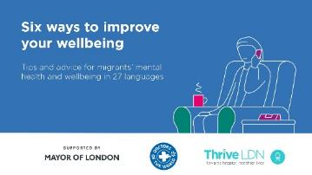  Video link: https://thriveldn.co.uk/wp-content/uploads/2020/09/Wellbeing-Guidance-FINAL.mp4  (open link, then right click and ‘save as’ to download)
Instagram | It's normal to feel stressed or worried in these difficult times.  @ThriveLDN, @dotw_uk & @mayorofldn have teamed up to create six practical steps to help you cope and keep well.  Available to download for free in English and 26 other languages: https://www.doctorsoftheworld.org.uk/wellbeing-guidance  Remember, it is OK not to feel OK.  #MentalHealth #ThriveLDN | 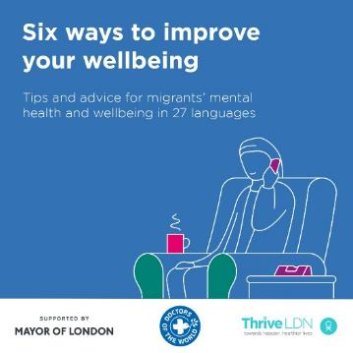  Video link: https://thriveldn.co.uk/wp-content/uploads/2020/09/Wellbeing-Guidance-FINAL.mp4  (open link, then right click and ‘save as’ to download)
Facebook | It's normal to feel stressed or worried in these difficult times.  Thrive LDN, Doctors of the World UK and the Mayor of London have teamed up to create six practical steps to help you cope and keep well.  Available to download for free in English and 26 other languages: https://www.doctorsoftheworld.org.uk/wellbeing-guidance  Remember, it is OK not to feel OK.  #MentalHealth #ThriveLDN #Support #Wellbeing | Video link: https://thriveldn.co.uk/wp-content/uploads/2020/09/Wellbeing-Guidance-FINAL.mp4  (open link, then right click and ‘save as’ to download)  Partner accounts to tag:  Thrive LDN  Mayor of London  Doctors of the World UK
- Zero Suicide LDN
Twitter | Living and working in London can be stressful, and right now for some it may be overwhelming. Would you be able to spot a colleague or friend in distress? There’s FREE 20 minute @Zer0Suicide online training to help.  Visit 👉 thriveldn.co.uk/zerosuicideldn | #ZeroSuicideLDN campaign collateral  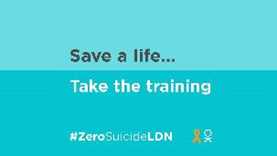
Instagram | Living and working in London can be stressful, and right now for some it may be overwhelming. Would you be able to spot a colleague or friend in distress? There’s FREE 20 minute online training provided by the @zerosuicidealliance to help.  Visit 👉 thriveldn.co.uk/zerosuicideldn  Save a life... take the training today.  #ZeroSuicideLDN #London #LifeInLondon #WeAreLDN #OKLDN #SuicidePrevention #Teamwork #Together #ZeroSuicideAlliance #Londoners #MentalHealth #OnlineTraining | #ZeroSuicideLDN campaign collateral  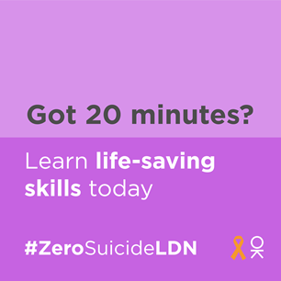
Facebook | Living and working in London can be stressful, and right now for some it may be overwhelming. Would you be able to spot a colleague or friend in distress? There’s FREE 20 minute online training provided by the Zero Suicide Alliance to help.  Visit 👉 thriveldn.co.uk/zerosuicideldn  Save a life... take the training today.  #ZeroSuicideLDN #London #LifeInLondon #WeAreLDN #OKLDN #SuicidePrevention #Teamwork #Together #ZeroSuicideAlliance #Londoners #MentalHealth #OnlineTraining | #ZeroSuicideLDN campaign collateral  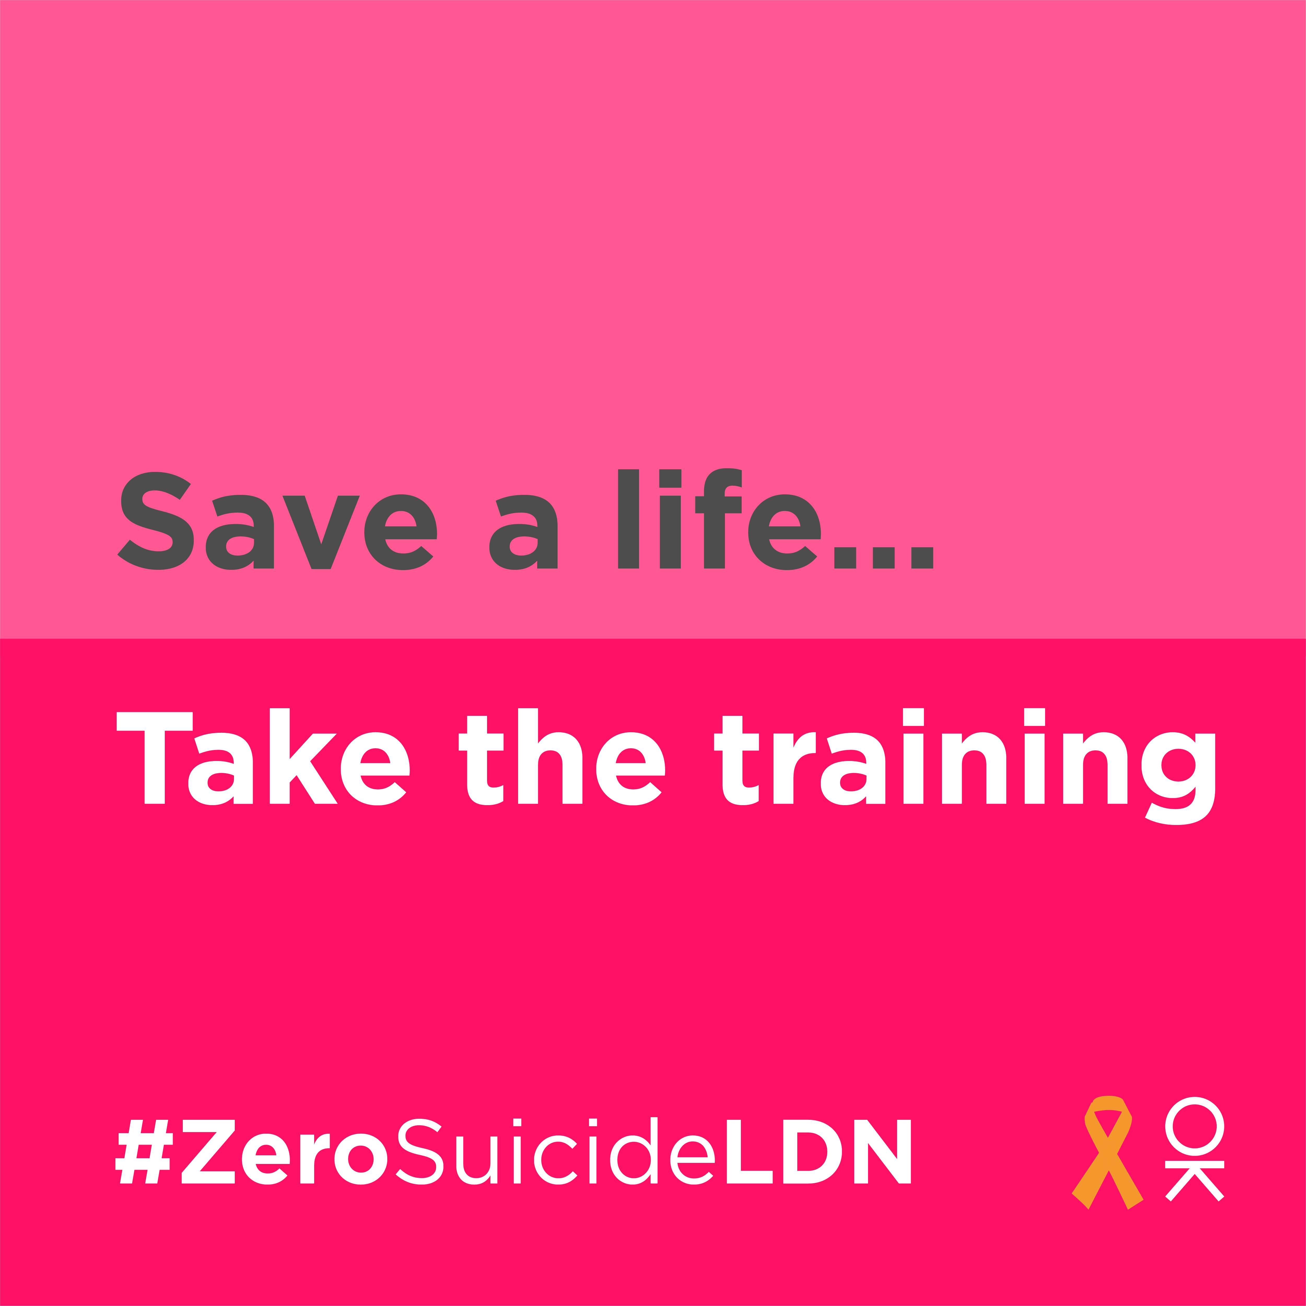  Partner accounts to tag:  Thrive LDN  Zero Suicide Alliance  Mayor of London
- Signposting to mental health and wellbeing resources
Twitter | As we move back into lockdown, it has never been more important to think & talk more about #MentalHealth & wellbeing, and to seek support when needed.  There are a range of free resources, online tools & helplines available to help you cope and stay well: https://thriveldn.co.uk/resources/tools-and-resources-to-help-your-mental-health-and-wellbeing/ | 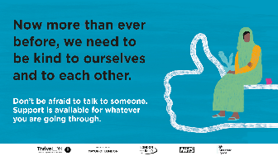
Instagram | Feeling worried or stressed is normal but, as we move back into lockdown, it’s really important that we take care of our #MentalHealth and wellbeing as much as possible.  There are a range of free resources, online tools and helplines available to help you cope and stay well.  Visit @ThriveLDN and the links in their bio. | 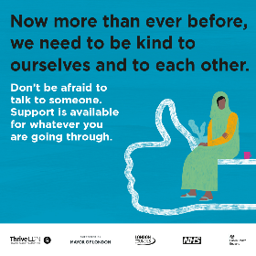
Instagram Stories | Just add picture and tag @ThriveLDN or if able, the link for users to swipe should be:  https://thriveldn.co.uk/resources/tools-and-resources-to-help-your-mental-health-and-wellbeing/ | 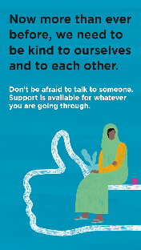
Facebook | Feeling worried or stressed is normal but, as we move back into lockdown, it’s really important that we take care of our #MentalHealth and wellbeing as much as possible.  Thrive LDN has put together some helpful tips on keeping yourself well and ways to get support if you are finding it hard.  To find out more, visit: https://thriveldn.co.uk/resources/tools-and-resources-to-help-your-mental-health-and-wellbeing/
- NHS wellbeing webinar series
Twitter | It's normal to feel stressed or worried in challenging times.  As we move back into lockdown, @HealthyLDN's new NHS Wellbeing Webinars offer strategies to support your wellbeing.  1⃣ #WorkingFromHome & Staying Well  2⃣ Anxiety  3⃣ Low Mood  ➡️ https://thriveldn.co.uk/resources/coping-well-during-covid/ | 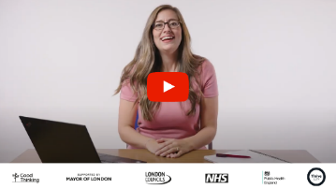  Partner accounts to tag: @HealthyLDN @NHSEnglandLDN @PHE_London @londoncouncils @MayorofLondon
Twitter | The NHS #CopingWellDuringCovid webinar series has provided Londoners with support in areas such as managing anxiety, sleeping better & working from home and staying well.  You can watch the full series back now via the @ThriveLDN website: thriveldn.co.uk/resources/coping-well-during-covid | Partner accounts to tag: @HealthyLDN @NHSEnglandLDN @PHE_London @londoncouncils @MayorofLondon
Instagram | It's normal to feel stressed or worried in challenging times. As we move back into lockdown, it’s important to remember that help is available.  The NHS #CopingDuringCovid webinar series has provided Londoners with support in areas such as managing anxiety, sleeping better & working from home and staying well.  You can watch the full series back now via the @ThriveLDN website 👉 thriveldn.co.uk/resources/coping-well-during-covid
- Good Thinking – digital wellbeing serivce
Twitter | Times may feel uncertain as we move back into lockdown to help tackle #COVID19, and it's perfectly normal to feel worried.  @GoodThinkingUK has a range of FREE apps and resources to help with anxiety, low mood, sleeping difficulties or stress.  ➡️ www.good-thinking.uk | 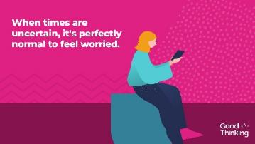  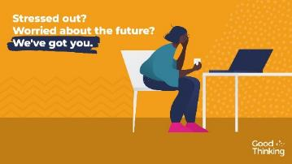
Instagram | Times may be uncertain, as we move back into a temporary lockdown to support Covid measures, and it's perfectly normal to feel worried.  There are a range of free apps and resources from @goodthinkinguk to help if you have anxiety, low mood, sleeping difficulties or stress.  ➡️ www.good-thinking.uk  #MentalHealth #Wellbeing #London #Londoners #Support #Covid19 #Coronavirus | 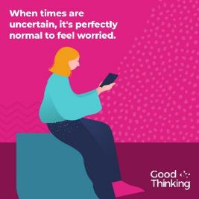
LinkedIn and Facebook | Times may be uncertain, as we move back into a temporary lockdown to support Covid measures, and it's perfectly normal to feel worried.  @GoodThinkingUK help and support is available if you have anxiety, low mood, sleep difficulties or stress.  There's lots you can do to build resilience, stay positive and boost mood. With more than 120 online resources, including wellbeing information sources; guides to improving mental health; courses on and offline; mobile apps and other therapy approaches, Good Thinking also provides articles, podcasts, worksheets and a self-assessment tool.  Visit: www.good-thinking.uk | 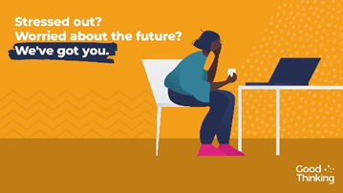
- Good Thinking – specific self care week resources
Twitter | It’s #SelfCareWeek and we want to remind you to take care of your physical health and mental wellbeing.  @GoodThinkingUK offers content to help lower your stress, including apps, articles, and podcasts. Try the self-assessment ➡️ www.good-thinking.uk/stress-self-assessment @SelfCareForum | 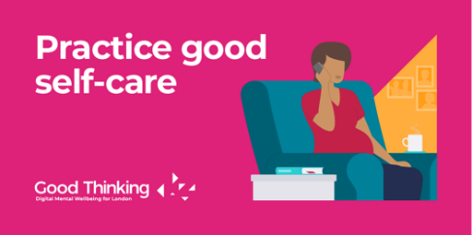
Twitter | #SelfCareWeek is a time to celebrate health and wellbeing, to take stock and think about how to better look after ourselves and our families, especially in such uncertain times.  Meditation takes you places ➡️ www.good-thinking.uk/resources/meditainment @SelfCareForum | 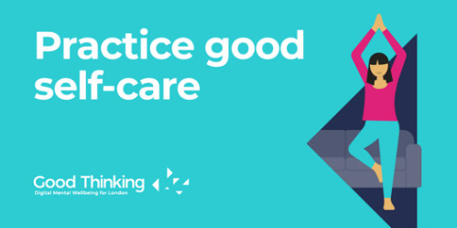
Twitter | It’s #SelfCareWeek – time to stop and think about #SelfCareForLife and protecting your mental wellbeing.  Boost your mood with @GoodThinkingUK by visiting: www.good-thinking.uk/low-mood @SelfCareForum
Twitter | Social interaction is essential to our health and wellbeing. Stay connected to friends and family, especially in these uncertain times.  During #SelfCareWeek, find tools to understand your stress better: www.good-thinking.uk/stress @SelfCareForum | 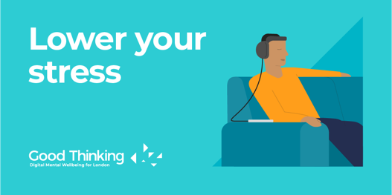

Resilience messaging
1. Now more than ever before we need to be kind to ourselves and to each other
Now more than ever before we need to be kind to ourselves and to each other.  There are a range of resources available on the @thriveldn website to help you to look after your wellbeing at home. Explore these for yourself or share with others.  👉 thriveldn.co.uk/resources | 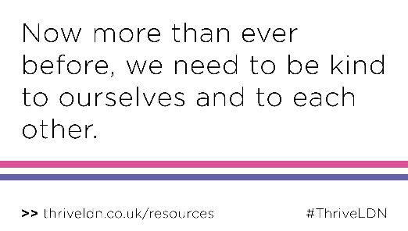
Now more than ever before we need to be kind to ourselves and to each other.  There are a range of resources available on the @thriveldn website to help you to look after your wellbeing at home. Explore these for yourself or share with others.  👉 thriveldn.co.uk/resources | 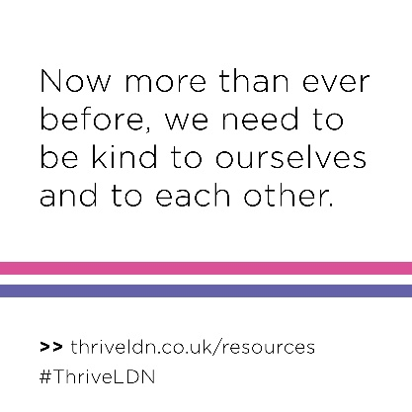
2. It’s OK not to be OK
It’s OK not to be OK.  It’s important to know that it is normal and okay to feel upset, anxious or confused at times.  There are a range of resources available on the @thriveldn website to help you to look after your wellbeing at home.  👉 thriveldn.co.uk/resources | 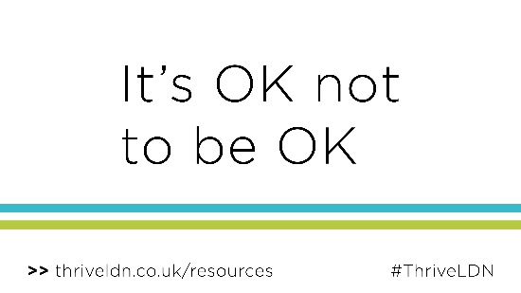
It’s OK not to be OK.  It’s important to know that it is normal and okay to feel upset, anxious or confused at times.  There are a range of resources available on the @thriveldn website to help you to look after your wellbeing at home.  👉 thriveldn.co.uk/resources | 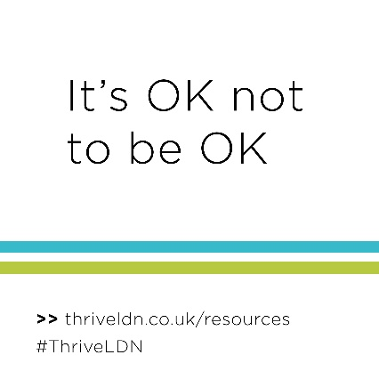
3. There is always hope
There is always hope.  You should know that even though things can feel very hard at times, support is available for whatever you are going through.  Find a range of resources on @thriveldn's website to help you to look after your wellbeing.  👉 thriveldn.co.uk/resources | 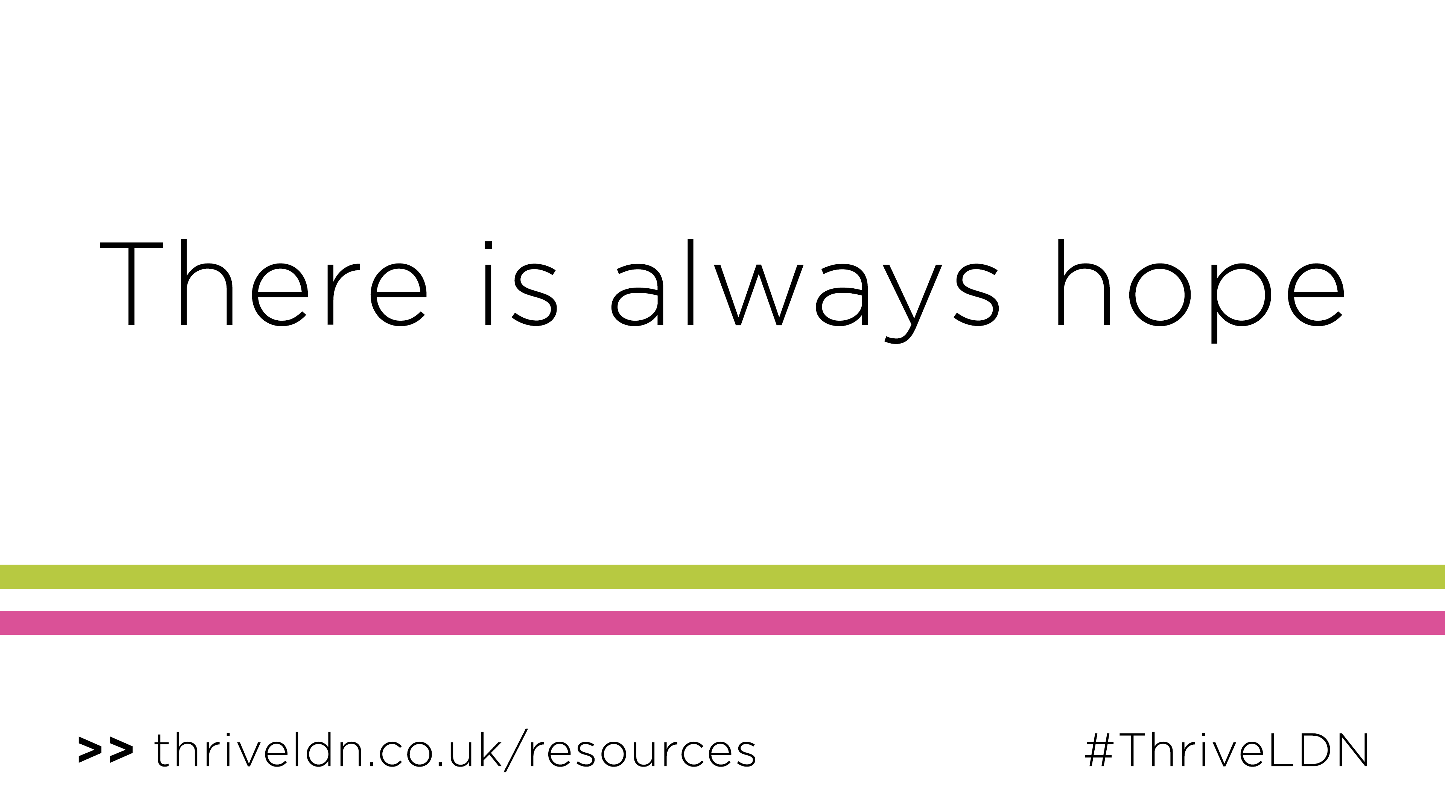
There is always hope.  You should know that even though things can feel very hard at times, support is available for whatever you are going through.  Find a range of resources on @thriveldn's website to help you to look after your wellbeing.  👉 thriveldn.co.uk/resources | 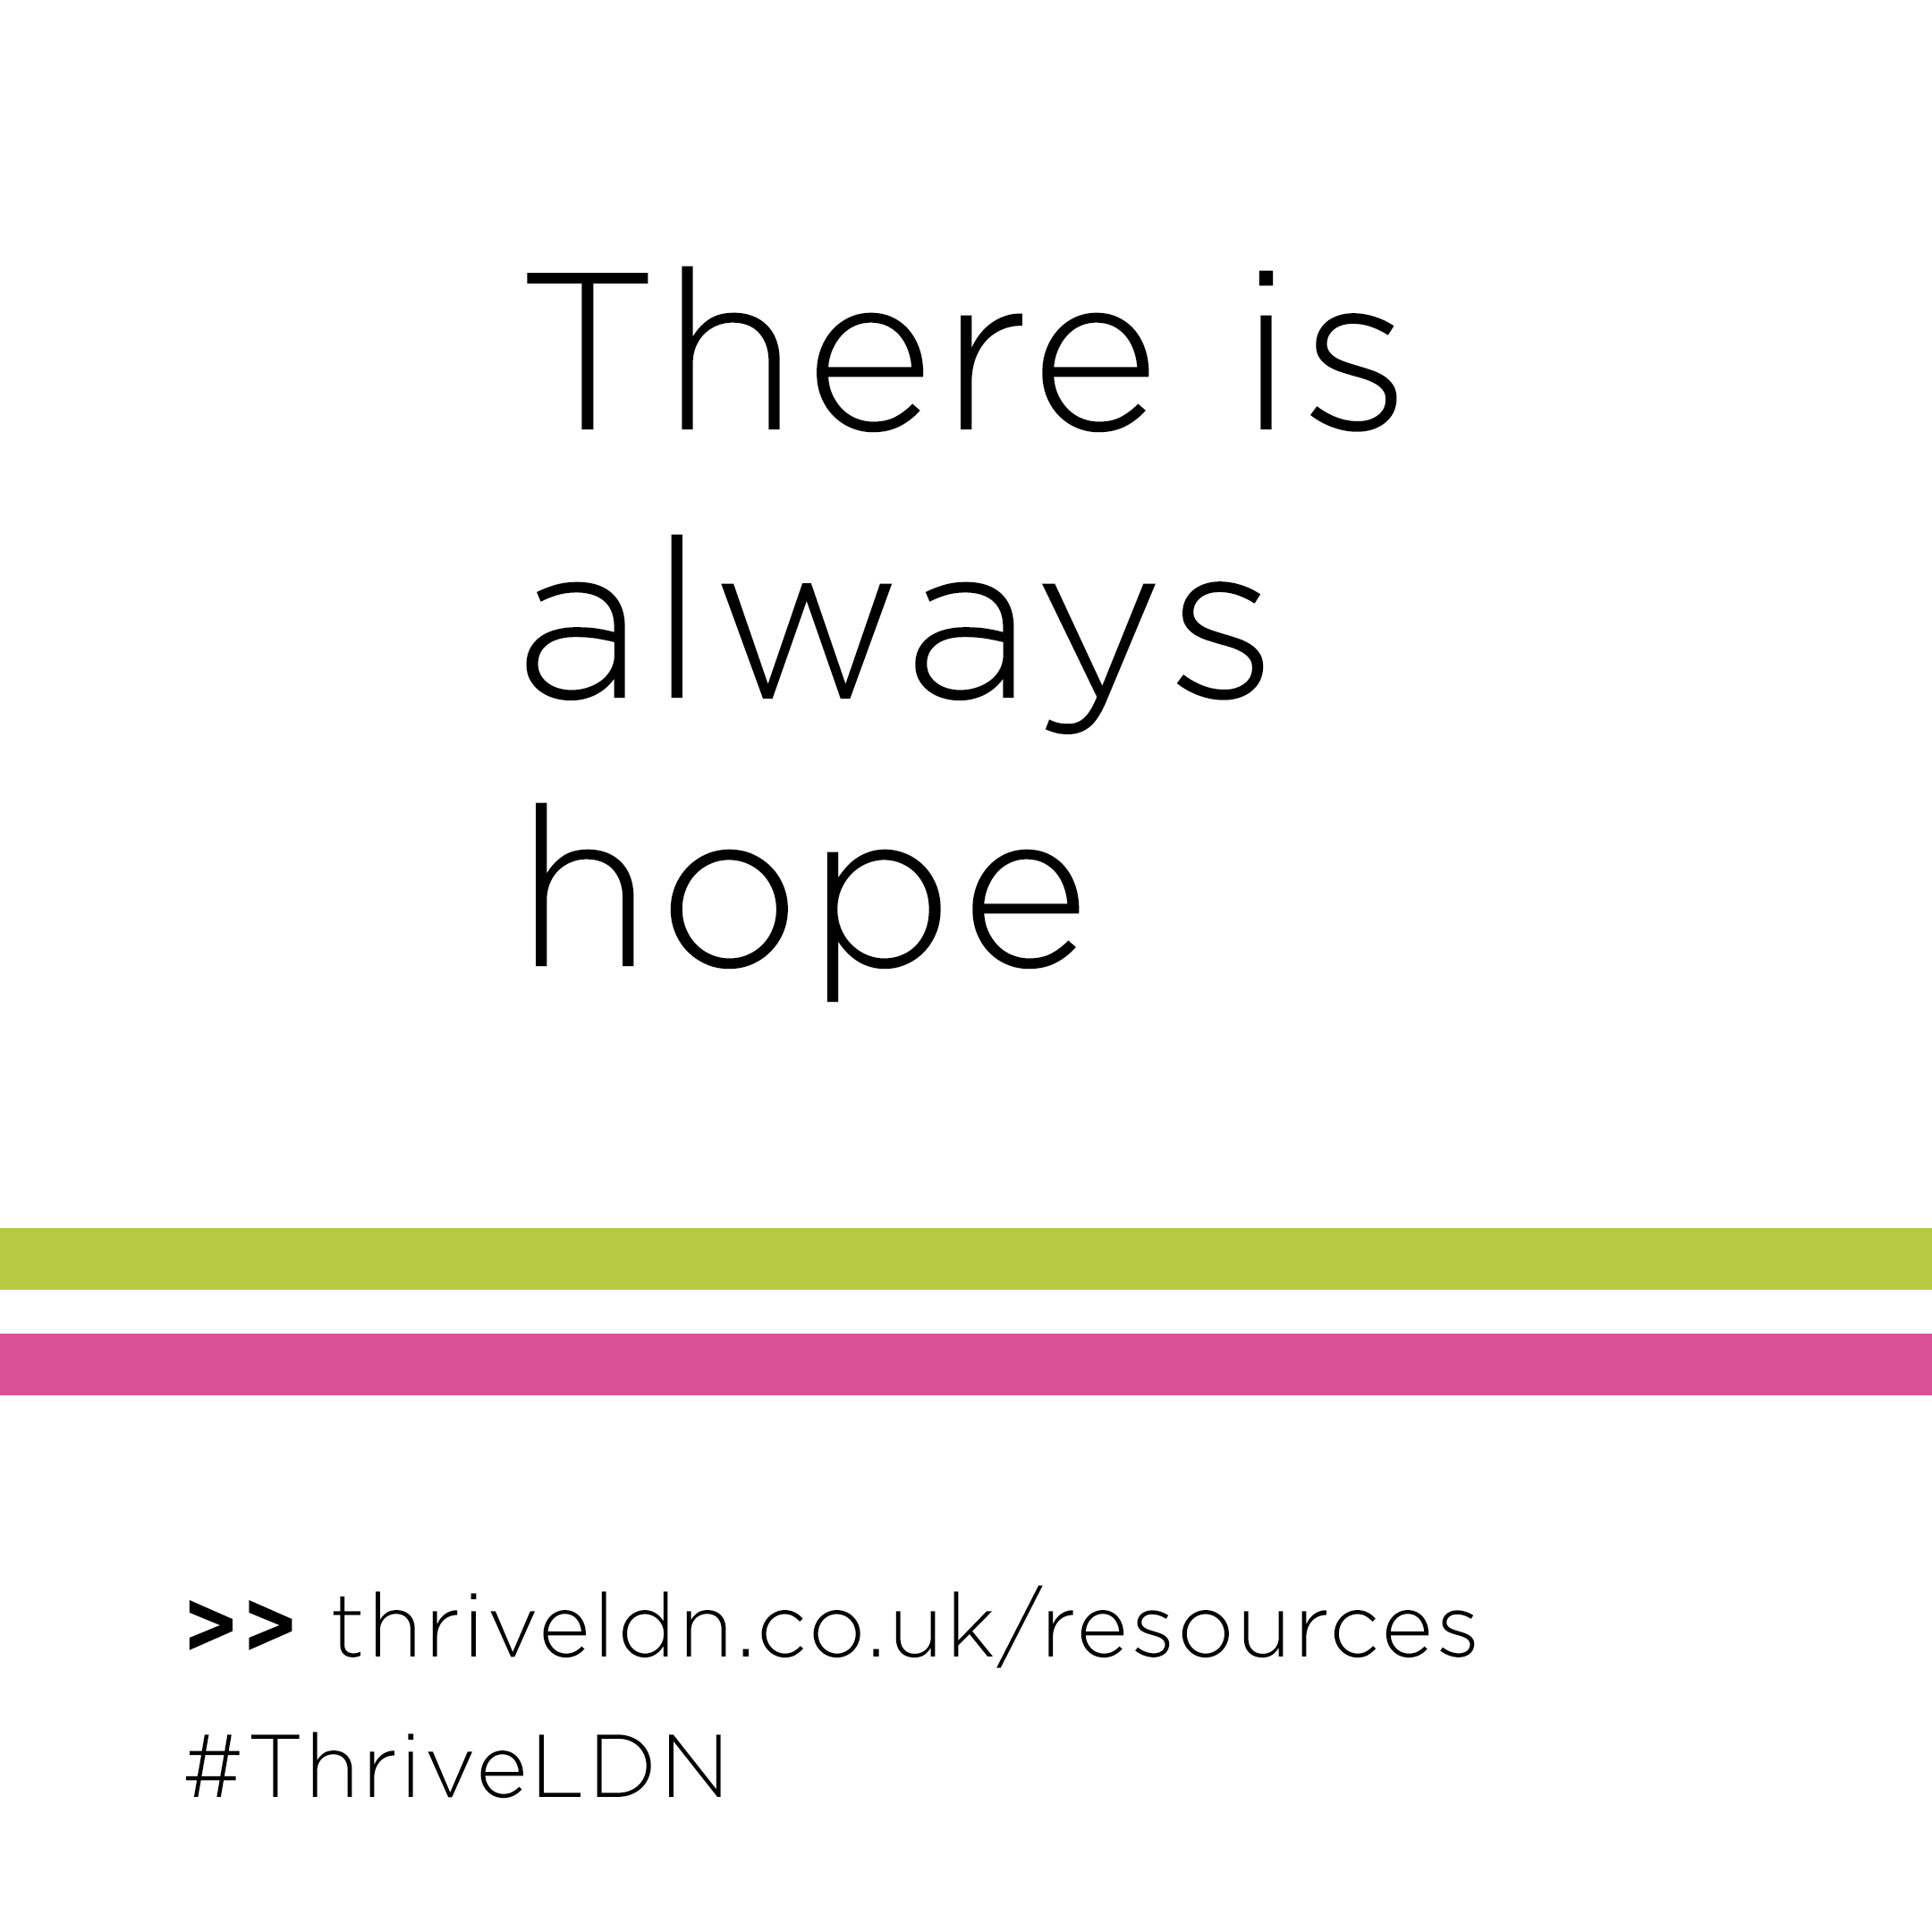
4. We don't know how, but we know we'll get through this together
Whatever happens, we know we'll get through this together.  There are a range of resources available on the @thriveldn website to help you to look after your wellbeing at home.  👉 thriveldn.co.uk/resources | 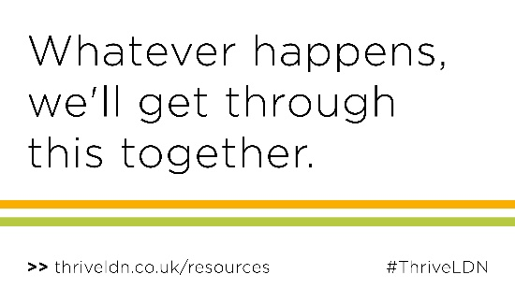
Whatever happens, but we know we'll get through this together.  There are a range of resources available on the @thriveldn website to help you to look after your wellbeing at home.  👉 thriveldn.co.uk/resources | 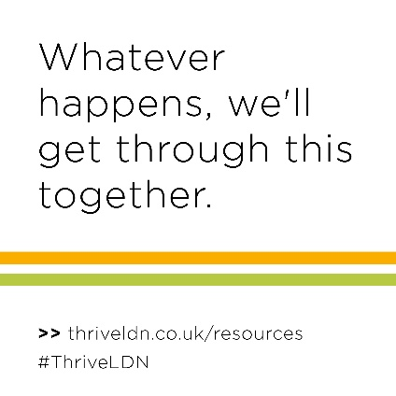

Community-specific support
1. LGBT+ Community
Twitter | Lockdown means staying apart from our loved ones to help bring #Covid19 back under control. If you are in the LGBT+ community & need support, help is available.  @lgbtfriend is providing #MentalHealth support for LGBT+ Londoners throughout the pandemic 👉https://londonfriend.org.uk/support/
Instagram | Lockdown means staying apart from our loved ones to help bring #Covid19 back under control. If you are in the LGBT+ community & need support, help is available.  @londonfriendlgbt are providing #MentalHealth support for LGBT+ Londoners throughout the Covid-19 pandemic.  Check out the links in the bio for signposting to support. | 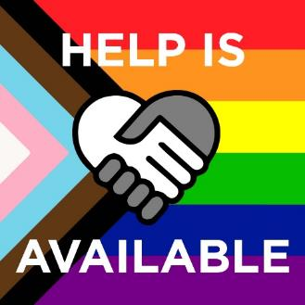
2. Older people
Twitter | Lockdown may mean staying apart from our loved ones to help bring #Covid19 back under control.  @GoodThinkingUK has created an advice guide for older Londoners on looking after yourself at home and where to find further support, if needed.  www.good-thinking.uk/coronavirus/advice-for/older-people
Instagram | Lockdown means staying apart from our loved ones to help bring #Covid19 back under control. For those of us living alone or away from families, this can be particularly hard.  @ goodthinkinguk has created an advice guide for older Londoners on looking after yourself at home and where to find further support.  For more information, visit: www.good-thinking.uk/coronavirus/advice-for/older-people/ | 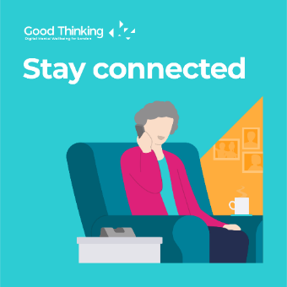
Facebook | Lockdown means staying apart from our loved ones to help bring #Covid19 back under control. For those of us living alone or away from families, this can be particularly hard.  Good Thinking has created an advice guide for older Londoners on looking after yourself at home and where to find further support.  For more information, visit: https://www.good-thinking.uk/coronavirus/advice-for/older-people/
3. Supporting BAME communities
Twitter | We know that Black, Asian and minority ethnic communities have been disproportionately affected by #Covid19.  @HealthyLDN's webinar with David Truswell looks at these challenges, and techniques and strategies to support wellbeing.  Watch the full webinar: https://youtu.be/QFqZPuyyqZ4 | 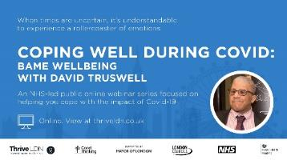
Instagram | We know that Black, Asian and minority ethnic communities have been disproportionately affected by #Covid19.  This NHS-led webinar with David Truswell considers the challenges Black, Asian and minority ethnic communities face and some techniques and strategies to support wellbeing.  Watch the full webinar now on YouTube here: https://youtu.be/QFqZPuyyqZ4  To see the full set of #CopingDuringCovid webinars, find the link in @thriveldn’s bio. | 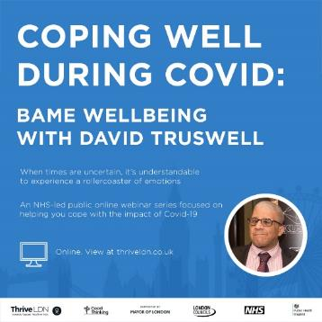
Facebook | We know that Black, Asian and minority ethnic communities have been disproportionately affected by #Covid19.  This NHS-led webinar with David Truswell considers the challenges Black, Asian and minority ethnic communities face and some techniques and strategies to support wellbeing.  Watch the full webinar now on Thrive LDN’s YouTube channel, here: https://youtu.be/QFqZPuyyqZ4
4. Young Londoners and students
Twitter | Being away from home in a new environment during lockdown can be stressful. But remember, It's OK not to be OK.  @GoodThinkingUK has created an advice guide for students on how to stay mentally healthy at university.  👉 https://www.good-thinking.uk/how-stay-mentally-healthy-university/
Instagram | Being away from home in a new environment during lockdown can be stressful. But remember, It's OK not to be OK.  @goodthinkinguk has created an advice guide for students on how to stay mentally healthy at university.  👉 https://www.good-thinking.uk/how-stay-mentally-healthy-university/
Facebook | Being away from home in a new environment during lockdown can be stressful. But remember, It's OK not to be OK.  Good Thinking has created an advice guide for students on how to stay mentally healthy at university.  👉 https://www.good-thinking.uk/how-stay-mentally-healthy-university/

