Supporting European Londoners’ mental health and wellbeing
GOOD THINKING COMMUNICATIONS TOOLKIT
December 2020
About this toolkit
This communications toolkit is designed for London partners, including health and care organisations, local authorities, and third sector bodies. This is a resource for you to adapt and to use locally when communicating to the general public, particularly European Londoners throughout the COVID-19 pandemic, Brexit and winter months about available resources and services to support resilience, mental health and wellbeing.
It builds on the signposting and engagement work undertaken by Thrive LDN and partners since March 2020.
Recommendation: Please incorporate our messages and assets into your communications channels over the weeks and months ahead.
Context
Research and evidence suggest the pandemic has widened mental health inequalities; groups that had the poorest mental health pre-crisis had the largest deterioration in mental health during lockdown.
Furthermore, many Londoners with no history of accessing mental health services have been impacted by COVID-19, either through loneliness, anxiety, bereavement or in some cases trauma, or from adjusting to social distancing or life after lockdown, alongside financial and job stresses.
Collectively we must encourage Londoners (especially European Londoners coping with the UK leaving the EU/ Brexit) to seek help and support where appropriate.
This campaign
We are signposting our target audience to the Good Thinking website. While in recent years we have seen a positive change in attitudes and greater public understanding of the issues surrounding mental health, many Londoners are not seeking the support available early enough. Good Thinking provides an alternative to traditional health services, it can be accessed 24/7, online from anywhere in London. Visitors to the site can download and access tools and tips to suit their needs. We have included translated copy and messages provided by Doctors of the World and Thrive LDN in this toolkit.

CONTENT

Cover email to networks and partners

Dear colleague/friend
We are getting in touch to ask you to promote our campaign to support the mental health of European Londoners and migrant communities in the lead up to BREXIT on 31 December, coupled with coping with the pandemic and other restrictions.

Our campaign is a partnership between the Mayor of London and Good Thinking (London’s free online NHS mental health service)

We are living in challenging times, be that coping with the impact of the COVID-19 pandemic or dealing with uncertainty because of Brexit. Many European Londoners have said they are worried about having to apply for the EU Settlement Scheme and feel anxious about their futures. We hope that you will help cascade our messages and help signpost our European friends and colleagues to online support for their wellbeing.

You will find a range of social media graphics, assets and messaging in this toolkit. We have also provided copy for use in newsletters, leaflets and websites.

If you have any specific questions about the campaign, please contact jessica.simpson2@nhs.net

Many thanks for your support!

Web and intranet copy

Looking after your mental health is important

We are living in challenging times, be that coping with the impact of the COVID-19 pandemic or dealing with uncertainty because of Brexit. Many European Londoners have said they are worried about having to apply for the EU Settlement Scheme and feel anxious about their futures.

Everyday challenges at home or work can affect how we feel and can sometimes cause us to worry or lose sleep. Over time, these problems can start to build up, make us feel stressed and affect us emotionally. Feeling scared, anxious, down, worried or being unable to sleep during unsettling times is normal but this also can have a negative impact on you and the people around you. If this sounds like you or someone you work, live or spend time with, please visit www.good-thinking.uk at any time to help manage these feelings and keep your mind healthy.

Good Thinking is a free, NHS approved, digital health service to support people living, working and studying in London who are looking for ways to improve how they feel every day. It offers safe tips, ideas and tools to help with your wellbeing including advice for managing anxiety, depression, stress and sleep.

It is an anonymous service, and you can access it from your phone or laptop in the privacy of your home whenever you want or need to. You have the option to go straight to some self-help tools or you can answer three simple questions about how you are feeling and depending on your answers, Good Thinking will recommend tools for you to explore on your own. There are over 120 sources of help available including mobile apps, websites, downloadable guides and more information about health services to consider.

Our advice right now? Visit www.good-thinking.uk now and have a look around, you never know when it might become useful to you or someone you care about.

If you want to get wider advice about BREXIT and how it affects you please check out the Mayor of London’s European Hub for the latest updates including how to get help and support throughout the pandemic.

Simple ways to improve your wellbeing
Doctors of the World, in partnership with the Mayor of London and Thrive LDN, have put together a list of little things you can do to keep yourself well and some useful ways to get support if you are finding it hard. The guidance is available in English and 26 other languages to support migrant communities.
If you’re feeling anxious or stressed about work, housing or financial difficulties, then explore the helpful range of resources and guidance on City Hall's Hub.

Getting urgent help for mental health
A mental health emergency should be taken as seriously as a physical one. You will not be wasting anyone's time. If you have an existing mental health condition and an assigned care team or care worker, then it’s important to contact them.
NHS urgent mental health helplines are for people of all ages. You can call for:
- 24-hour advice and support - for you, your child, your parent or someone you care for
- help to speak to a mental health professional
- an assessment to help decide on the best course of care
Alternatively, when life is tough the Samaritans are here to listen at any time of the day or night. You can talk to them about anything that's troubling you, no matter how difficult.
- Call free on 116 123 or visit the Samaritans website.
Shout offers confidential 24/7 crisis text support for times when you need immediate assistance.
- Text SHOUT to 85258 or visit Shout Crisis Text Line.
The bereavement care charity Cruse is helping families affected by coronavirus.
- Call free on 0808 808 1677 or visit the Cruse website.

Social media assets

All graphics are available to download here

Suggested messages and posts are outlined below. Partners are encouraged to use the assets and graphics regularly and to overlay with suggested posts below.

- Good Thinking digital wellbeing service
Twitter | Times may feel uncertain as London deals with the implications of BREXIT, and it's perfectly normal to feel worried.  @GoodThinkingUK has a range of FREE apps and resources to help with anxiety, low mood, sleeping difficulties or stress.  ➡️ www.good-thinking.uk | 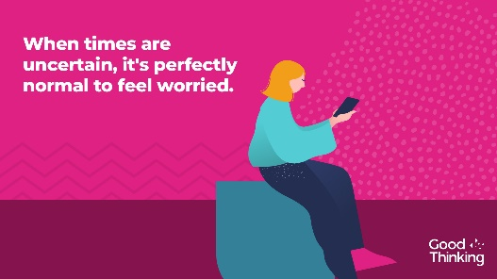  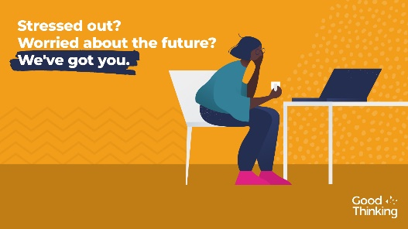
Instagram | When times are uncertain, it is perfectly normal to feel worried. Help is available. There are a range of free apps and resources from @goodthinkinguk to help if you have anxiety, low mood, sleeping difficulties or stress.  ➡️ www.good-thinking.uk  #MentalHealth #Wellbeing #London #Londoners #Support | 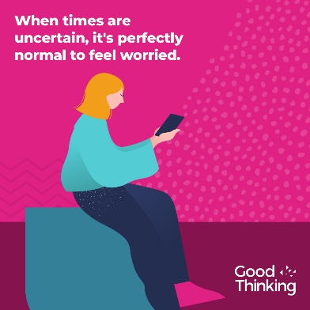
LinkedIn and Facebook | Times are uncertain as Londoners deal with will Covid-19 measures, the impact of BREXIT and other challenges, it's perfectly normal to feel worried.  @GoodThinkingUK help and support is available if you have anxiety, low mood, sleep difficulties or stress.  There's lots you can do to build resilience, stay positive and boost mood. With more than 120 online resources, including wellbeing information sources; guides to improving mental health; courses on and offline; mobile apps and other therapy approaches, Good Thinking also provides articles, podcasts, worksheets and a self-assessment tool.  Visit: www.good-thinking.uk
- Wellbeing guidance in 27 languages
Twitter | It's normal to feel stressed or worried in these difficult times.  That’s why @ThriveLDN, @DOTW_UK & @MayorofLondon have teamed up to create six practical steps to help you cope and stay well.  Available to download in English and 26 other languages: https://www.doctorsoftheworld.org.uk/wellbeing-guidance | 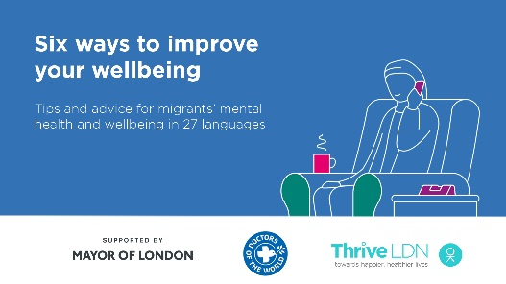  Video link: https://thriveldn.co.uk/wp-content/uploads/2020/09/Wellbeing-Guidance-FINAL.mp4  (open link, then right click and ‘save as’ to download)
Instagram | It's normal to feel stressed or worried in these difficult times.  @ThriveLDN, @dotw_uk & @mayorofldn have teamed up to create six practical steps to help you cope and keep well.  Available to download for free in English and 26 other languages: https://www.doctorsoftheworld.org.uk/wellbeing-guidance  Remember, it is OK not to feel OK.  #MentalHealth #ThriveLDN | 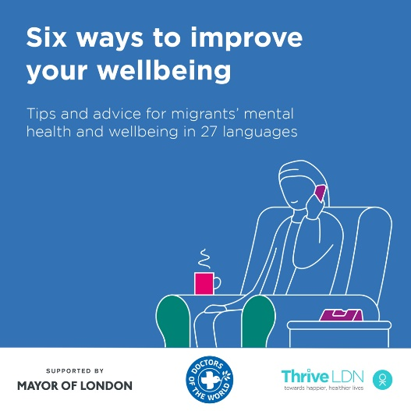  Video link: https://thriveldn.co.uk/wp-content/uploads/2020/09/Wellbeing-Guidance-FINAL.mp4  (open link, then right click and ‘save as’ to download)
Facebook | It's normal to feel stressed or worried in these difficult times.  Thrive LDN, Doctors of the World UK and the Mayor of London have teamed up to create six practical steps to help you cope and keep well.  Available to download for free in English and 26 other languages: https://www.doctorsoftheworld.org.uk/wellbeing-guidance  Remember, it is OK not to feel OK.  #MentalHealth #ThriveLDN #Support #Wellbeing | Video link: https://thriveldn.co.uk/wp-content/uploads/2020/09/Wellbeing-Guidance-FINAL.mp4  (open link, then right click and ‘save as’ to download)  Partner accounts to tag:  Thrive LDN, MoL, DoW

Social media thread content
Accompanying graphics are available to download here

Theme | Message
Normalising mental health | It’s OK to not feel OK during challenging times. Find help and advice to keep yourself well www.good-thinking.uk #LondonTogether
Anxiety and worry | Lots of people are feeling anxious and uncertain because of the impact of COVID-19 or Brexit, many are worried about friends and family in other parts of the world. Visit www.good-thinking.uk to help manage these feelings and keep your mind healthy. #LondonTogether
Uncertainty | These are challenging and uncertain times for everyone, but some people are finding it harder than others because of their personal circumstances. Some of us are feeling worried and uncertain about our future. Visit www.good-thinking.uk for some tips and advice.
Loneliness | Many of us are feeling lonely and finding it difficult being far away from our loved ones. It’s normal to feel these things, because none of us are superhuman. Visit www.good-thinking.uk for some tips and advice. #LondonTogether
Belonging | Now more than ever, we want all Londoners regardless of where you were born or what language you speak, to know that you are not alone, and help is available for whatever you are feeling. Visit here to help manage these feelings and keep your mind healthy. #LondonTogether
Family | This has been a tough year for everyone but some of us have not seen family or friends because of restricted travel. You are not alone. Visit www.good-thinking.uk for some tips and advice to manage feelings of isolation or loneliness #LondonTogether
Support | Feeling troubled and wondering how you can get help to manage over the weeks and months ahead? Visit @MayorofLondon hub for advice about #COVID and #BREXIT
Fatigue | Feeling worn out by uncertainty and unknowns? It’s been a tough year, you can find advice and tips about how to keep yourself well on www.good-thinking.uk website. @MayorofLondon

Translated Mental Health Messaging

ENGLISH
[SOCIAL AD COPY]
- Look after yourself during COVID-19. Talk to your family and friends or access mental health support online.
LINK COPY: You Are Not Alone
- It’s okay if you don’t feel okay. Please know you are not alone and help is available. Read our mental health advice.
LINK COPY: Get Mental Health Advice
[GRAPHIC / OR Link to DOTW resource]

It’s okay if you don’t feel okay. Help is available.

During this difficult time, we must open up and talk about our mental health.

Reach out to family and friends to see how they’re doing.

If you’re struggling, tell someone you trust, or access support online.

You’re not alone.

For more information visit:

#LondonTogether

BULGARIAN

[SOCIAL AD COPY]
- Грижете се за себе си по време на COVID-19. Разговаряйте със семейството и приятелите си или използвайте онлайн подкрепа за психичното здраве.
LINK COPY: Вие не сте сами
- Няма проблем, ако не се чувствате добре. Знайте, че не сте сами и има помощ. Прочетете нашите съвети за психичното здраве.
LINK COPY: Получете съвети относно психичното здраве
[GRAPHIC / OR Link to DOTW resource]

Няма проблем, ако не се чувствате добре. Има налична помощ.

В тези трудни времена трябва да бъдем искрени и да разговаряме за нашето психично здраве.

Обърнете се към семейството и приятелите си, за да разберете как се справят те.

Ако изпитвате трудности, кажете на някого, на когото вярвате или се обърнете към онлайн подкрепа.

Вие не сте сами.

За повече информация, посетете:

#LondonTogether

POLISH

[SOCIAL AD COPY]
- Dbaj o siebie podczas pandemii COVID-19. Porozmawiaj z rodziną i znajomymi lub skontaktuj się online z ośrodkiem pomocy w zakresie zdrowia psychicznego.
LINK COPY: Nikt nie jest sam
- To normalne, że nie czujesz się dobrze. Wiedz, że nikt nie jest sam i każdy może uzyskać pomoc. Przeczytaj nasze porady dotyczące zdrowia psychicznego.
LINK COPY: Uzyskaj poradę dotyczącą zdrowia psychicznego
[GRAPHIC / OR Link to DOTW resource]

To normalne, że nie czujesz się dobrze. Możesz skorzystać z pomocy.

W tym trudnym czasie musimy otworzyć się i porozmawiać o naszym zdrowiu psychicznym.

Skontaktuj się z rodziną i znajomymi, żeby dowiedzieć się jak sobie radzą.

Jeśli nie radzisz sobie, powiedz o tym komuś, komu ufasz, lub skorzystaj ze wsparcia online.

Nikt nie jest sam.

Aby uzyskać więcej informacji, odwiedź stronę:

#LondonTogether

PORTUGUESE

[SOCIAL AD COPY]
- Cuide de si mesmo durante a pandemia da COVID-19. Fale com familiares e amigos ou entre em contato com o Serviço de Saúde Mental online.
LINK COPY: Estamos Aqui Para Si
- Está ansioso? Não tem mal. É importante que saiba que não está sozinho e que há ajuda disponível. Leia os nossos conselhos sobre saúde mental.
LINK COPY: Obtenha aconselhamento na área da Saúde Mental
[GRAPHIC / OR Link to DOTW resource]

Está ansioso? Não tem mal. Há ajuda disponível.

Durante este período difícil, é importante falar abertamente sobre os nossos sentimentos e a nossa saúde mental.

Entre em contato com os seus familiares e amigos para saber como estão.

Se se sentir vulnerável, fale sobre isso com alguém em quem confia ou procure ajuda online.

Estamos aqui para si.

Para mais informações, visite:

#LondonTogether

ROMANIAN
[SOCIAL AD COPY]
- Aveți grijă de dumneavoastră pe perioada bolii COVID-19. Discutați cu familia sau cu prietenii dv. sau accesați serviciile de sănătate mintală online.
LINK COPY: Nu sunteți singuri
- Este normal să nu vă simțiți bine. Trebuie să știți că nu sunteți singuri și că puteți cere ajutor. Citiți recomandările noastre privind sănătatea mintală.
LINK COPY: Accesați recomandările privind sănătatea mintală
[GRAPHIC / OR Link to DOTW resource]

Este normal să nu vă simțiți bine. Puteți cere ajutor.

În această perioadă dificilă, trebuie să avem curaj și să vorbim despre sănătatea noastră mintală.

Luați legătura cu familia și cu prietenii dumneavoastră și întrebați-i cum se simt.

Dacă se confruntă cu probleme, spuneți unei persoane de încredere sau accesați un serviciu de suport online.

Nu sunteți singuri.

Pentru mai multe informații, dați clic pe:

#LondonTogether

SPANISH

[SOCIAL AD COPY]
- Cuídese durante la pandemia del COVID-19. Hable con su familia y amigos o contacte con el apoyo online de salud mental.
LINK COPY: Usted no está solo(a)
- Es normal que no se sienta bien. Por favor recuerde que no está solo(a) y que hay ayuda disponible. Lea nuestras recomendaciones de salud mental.
LINK COPY: Consiga Asesoramiento de Salud Mental
[GRAPHIC / OR Link to DOTW resource]

Es normal que no se sienta bien. Recuerde que hay ayuda disponible.

Durante estos tiempos difíciles es importante hablar abiertamente sobre nuestros sentimientos y nuestra salud mental.

Comuníquese con su familia y amigos para saber cómo se encuentran.

Si lo está pasando mal, cuénteselo a alguien en quien confíe o contacte con el apoyo online.

Usted no está solo(a).

Para más información, visite:

#LondonTogether

Institute for Fiscal Studies (2020) The mental health effects of the first two months of lockdown and social distancing during the Covid-19 pandemic in the UK

