SUPPORTING LONDONERS’ MENTAL HEALTH AND WELLBEING
PUBLIC MENTAL HEALTH COMMUNICATIONS TOOLKIT
Updated Wednesday, 13 January 2021
This toolkit has been updated for use throughout the national lockdown period.
Context
A fundamental part of the public mental health response to the pandemic needs to be continuing to normalise what Londoners’ are experiencing and supporting them build on the strength and resilience they already have.
The three main things we need to be mindful of continue to be:
(1) increased anxiety for various reasons;
(2) increased loneliness and social isolation; and
(3) potential reduction in support available from voluntary/ community sector.

Additionally:
- If deaths involving COVID-19 continue to rise over the coming weeks, this could be reflected in the number of people seeking bereavement support. We have published a guide on coping with sudden bereavement and accessing support services during the pandemic.
- We also know that contact to mental health crisis support tends to increase in January, particularly from vulnerable and/ or isolated groups and we may see the number of Londoners seeking support for a mental health crisis increase.

In this toolkit
To help partners, please explore the below web copy and digital messaging for your own communications to help signpost Londoners to appropriate resources and guidance during this time.
Ctrl + Click on link to go directly to:
- Suggested standard text for public mental health signposting
- Key messages to share on digital channels – including:
  - National lockdown public mental health messaging – emerging issues:
    - Financial anxiety and personal difficulties
    - Support for sudden bereavement
    - Mental health and wellbeing signposting
  - Resilience messaging
  - Suicide prevention messaging

SUGGESTED STANDARD TEXT FOR PUBLIC MENTAL HEALTH SIGNPOSTING
This standard text can be adapted for local websites (either as a resource/section or news article). The suggested social media posts can be used and adapted for partner channels. The text in red needs to be localised or removed as relevant.

2.1 Standard text for partner’s webpage
This standard text can be adapted for local websites.
STARTS
Tools and resources to help your mental health and wellbeing
It is normal and okay to feel upset, anxious or confused at times.
You might be feeling anxious and worried about coronavirus and that it could be affecting your mental health. In London, there are a range of free resources, online tools, and helplines available to help you cope and stay mentally healthy.
You should know that even though things can feel very hard at times, support is available for whatever you are going through.
Simple ways to improve your wellbeing
Thrive LDN has put together a list of little things you can do to keep yourself well and some useful ways to get support if you are finding it hard.
If you’re feeling anxious or stressed about work, housing or financial difficulties, then explore the helpful range of resources and guidance on City Hall's Hub.
Available support now - online tools to help your mental health
The NHS-approved digital mental wellbeing service, Good Thinking, promotes proactive self-care for the four most common mental health conditions: anxiety, low mood, sleeping difficulties and stress. Take the clinically validated self-assessment tool to get a better understanding of what you’re going through, helpful resources and if necessary, relevant treatment options.
To help build resilience and maintain good wellbeing, there’s a range of resources for everyone at Every Mind Matters. Including an interactive quiz, the Your Mind Plan, to get top tips and advice relevant for you.
A collection of NHS Coping Well During Covid webinars are available if you are feeling anxious about coronavirus and how it is impacting you, your loved ones or your work. The 60-minute sessions will guide you through ideas and tools to support your mental health and wellbeing in an evidenced based and interactive way.
Support is available to help you manage debt and personal difficulties
If you are worried about money or need impartial advice, there is support and information available for you. Ask for help if you need it.
Debt Free London help on a wide range of issues, including council tax, rent arrears, utility bills and benefit overpayments. Call 0800 808 5700 or visit their website for other ways to get in touch.
Turn2us can provide advice with accessing crisis grants, benefits, debt, housing, and legal issues, call on 0808 802 2000.
The Trussell Trust can provide advice when facing financial difficulties, as well as helping you find your local foodbank for an emergency food parcel. You can call on 0808 208 2138.
NHS psychological treatments
If you do not require urgent support but are still concerned about your mental health, contacting your GP is a good place to start.
You can also refer yourself for free, non-urgent NHS psychological therapy (IAPT) services which provide evidence-based treatments for depression and anxiety. These services are open in London [or borough] if you feel like you may need further, professional support. You can find your local service here.
Getting urgent help for mental health
A mental health emergency should be taken as seriously as a physical one. You will not be wasting anyone's time. If you have an existing mental health condition and an assigned care team or care worker, then it’s important to contact them.
NHS urgent mental health helplines are for people of all ages. You can call for:
- 24-hour advice and support - for you, your child, your parent or someone you care for
- help to speak to a mental health professional
- an assessment to help decide on the best course of care
Alternatively, when life is tough the Samaritans are here to listen at any time of the day or night. You can talk to them about anything that's troubling you, no matter how difficult. Call free on 116 123 or visit the Samaritans website.
Shout offers confidential 24/7 crisis text support for times when you need immediate assistance. Text SHOUT to 85258 or visit Shout Crisis Text Line.
The bereavement care charity Cruse is helping families affected by coronavirus. Call free on 0808 808 1677 or visit the Cruse website.
ENDS

2.2 Standard text for newsletters and/or offline copy
This standard text can be adapted for e-newsletters and bulletins. We advise that it becomes a standing item during periods when more restrictive safety measures are in place as people experience heightened anxiety. Below is both a full and concise post.
[CONCISE – 60 words] Resources to help your mental health and wellbeing
It is perfectly normal to feel upset, anxious or confused at times. Whatever you are feeling is valid.
Support is available through a range of free resources and online tools to help you cope and stay mentally well. If you need urgent help or feel more comfortable talking to someone you don’t know, then use one of the following helplines.
[FULL – 160 words] Resources to help your mental health and wellbeing
Right now, it has never been more important for each of us to think and talk more about mental health and wellbeing, and to seek support when needed.
There is support available for whatever you are going through. In London, there is a range of support available now from Good Thinking, Every Mind Matters, and NHS wellbeing webinars.
Alternatively, your GP can advise you about helpful treatments and local mental health services.
Or if you may feel more comfortable talking to someone you don’t know by using one of the following helplines:
- Samaritans are here when life is difficult. They won’t judge you or tell you what to do, they’re here to listen so you don’t have to face it alone. Call the free, 24-hour listening service on 116 123 or email jo@samaritans.org.
- Shout is the UK 's first 24/7 text messaging service for anyone in crisis. Text Shout at any time to 85258 to start a conversation with a trained volunteer.
KEY MESSAGES TO SHARE ON DIGITAL CHANNELS
Downloading images and videos: Right click the image and select ‘open link’ to download a full-size image to use across digital channels. Where relevant, videos have been added as links to download directly.
All resources are also available to download directly from the Thrive LDN Comms Toolkit Dropbox account: https://www.dropbox.com/sh/bfio0xcbfp87w4b/AAAVXBbp-Xt78PNEAvXV5hyFa?dl=0
In this document (Ctrl + Click on link to go directly to that section):
- National lockdown public mental health messaging – emerging issues:
  - Financial anxiety and personal difficulties
  - Support for sudden bereavement
  - Mental health and wellbeing signposting
- Resilience messaging
- Suicide prevention training and #ZeroSuicideLDN campaign

Emerging issues:
Financial anxiety and personal difficulties
As a priority over the coming weeks, we are encouraging partners to signpost to information on how to manage financial anxiety and uncertainty, alongside resources which support mental health and wellbeing.
Those who are in debt or in personal difficulty are more likely to be at risk of poor mental health and experience suicidal ideation than people who have no debt. The below helps provide simple and clear messages to help people find support and keep themselves well, despite any sudden and complex situation they may find themselves in.
In partnership with Thrive LDN, Debt Free London is expanding its free debt advice service to operate 24 hours a day throughout January in response to the unfolding crisis around personal finances.
Twitter | If you are worried about money or need free, impartial advice, there is support available.  @DebtFreeLDN’s advice line is open 24 hours a day during January. Ask for help if you need it.  📞 Call free on 0800 808 5700 at any time.  More information 👉 https://thriveldn.co.uk/2021/01/11/debt-free-london-to-offer-debt-and-money-advice-24-hours-a-day-in-response-to-the-coronavirus-crisis/
Instagram and | If you are worried about money or need free, impartial advice, there is support available. Ask for help if you need it.  Thrive LDN are working with Debt Free London to ensure their advice line is open 24 hours a day during January. If you need advice or support, you can call for free at any time on 0800 808 5700.  Or watch an NHS wellbeing webinar on financial anxiety with @moneyaande & Money and Mental Health: https://thriveldn.co.uk/resources/coping-well-during-covid/ [or link via @ThriveLDN bio]
Facebook | If you are worried about money or need free, impartial advice, there is support available. Ask for help if you need it.  Thrive LDN are working with Debt Free London to ensure their advice line is open 24 hours a day during January. If you need advice or support, you can call for free at any time on 0800 808 5700.  Or watch an NHS wellbeing webinar on financial anxiety with @moneyaande & Money and Mental Health: https://thriveldn.co.uk/resources/coping-well-during-covid/ | Accounts to tag:  @ThriveLDN  @DebtFreeLondon
Further signposting for financial and personal wellbeing support
Twitter  General signposting for money worries | If you are worried about money or need free, impartial advice, there is support available. Ask for help if you need it.  @DebtFreeLDN 0800 808 5700  @CAPuk 0800 328 0006  Watch an NHS wellbeing webinar on financial anxiety w/@moneyaande & @mentalhealthuk: https://thriveldn.co.uk/resources/coping-well-during-covid/#chapter-4 | 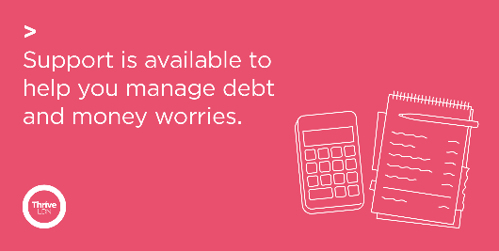
Instagram  General signposting for money worries | If you are worried about money or need impartial advice, there is support available. Ask for help if you need it.  Debt Free London: 0800 808 5700  @capuk_org: 0800 328 0006  Or watch an NHS wellbeing webinar on financial anxiety with @moneyaande & Money and Mental Health: https://thriveldn.co.uk/resources/coping-well-during-covid/ | 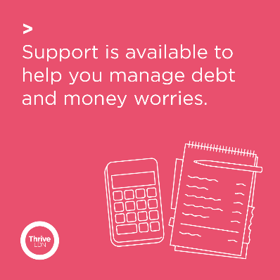
Twitter  General signposting for personal difficulties | If you find yourself in urgent financial or personal need, there is support and information available for you. Please seek help if you need it.  💷 @turn2us_org: 0808 802 2000  🏘️ @Shelter: 0344 515 1540  🥫 @TrussellTrust: 0808 208 2138  More via @LDN_gov: https://www.london.gov.uk/coronavirus/financial-support-during-coronavirus | 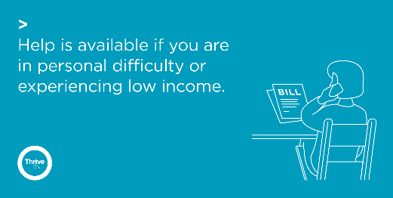
Instagram  General signposting for personal difficulties | If you find yourself in urgent financial or personal need, there is support and information available for you. Please seek help if you need it.  💷 @turn2us_org: 0808 802 2000  🏘️ @sheltercharity: 0344 515 1540  🥫 @ trusselltrust: 0808 208 2138  More via @ ldn_gov: https://www.london.gov.uk/coronavirus/financial-support-during-coronavirus | 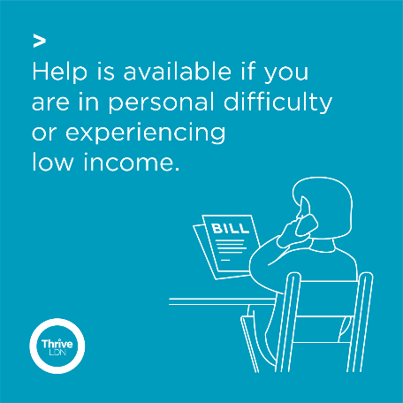
Twitter  Money Advice Service | The Coronavirus (Covid-19) may have had an impact on your finances. If you’re looking for money guidance but don’t know where to start, you’re not alone. The Money Advice Service have a tool to help.  Find out more 👉  moneyadviceservice.org.uk/en/tools/money-navigator-tool
Instagram and  Facebook  Money Advice Service | The Coronavirus (Covid-19) may have had an impact on your finances. If you’re looking for money guidance but don’t know where to start, you’re not alone. The Money Advice Service have a tool to help.  Find out more 👉  moneyadviceservice.org.uk/en/tools/money-navigator-tool | 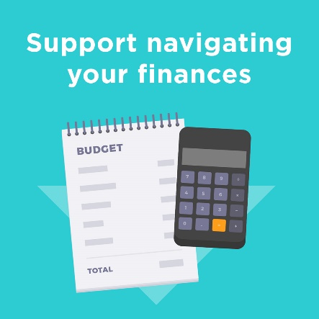

Support for sudden bereavement
Images and videos: Right click the image and select ‘open link’ to download a full-size image to use across digital channels.
All resources are also available to download directly from the Thrive LDN Comms Toolkit Dropbox account: https://www.dropbox.com/sh/bfio0xcbfp87w4b/AAAVXBbp-Xt78PNEAvXV5hyFa?dl=0
Twitter | Bereavement is one of the most challenging things that we can experience, affecting us all. @ThriveLDN's new resource is there to help if you, or someone you are supporting, is grieving the sudden death of someone close.  👉https://thriveldn.co.uk/resources/support-after-sudden-bereavement | 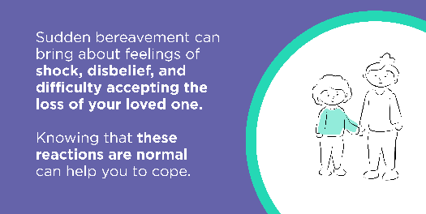  Other options available within the Thrive LDN Comms Toolkit Dropbox
Instagram | Bereavement is one of the most challenging things that we can experience, affecting every one of us.  @ThriveLDN's new resource is there to help if you, or someone you are supporting, is grieving the sudden death of someone close.  👉 https://thriveldn.co.uk/resources/support-after-sudden-bereavement | 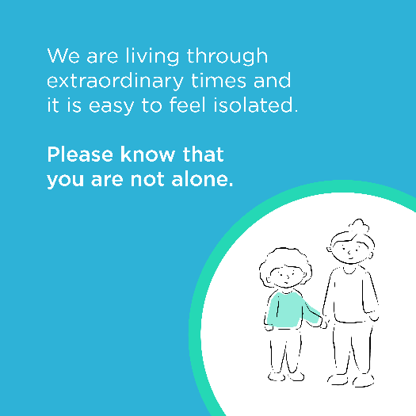  Other options available within the Thrive LDN Comms Toolkit Dropbox
Instagram story | Link / swipe to https://thriveldn.co.uk/resources/support-after-sudden-bereavement using the following images:  https://www.dropbox.com/sh/bfio0xcbfp87w4b/AADWRX8N6LX9-1YJv2NF7Pv9a/Thrive%20LDN%20Bereavement%20Toolkit/Instagram%20story%20tall?dl=0&subfolder_nav_tracking=1  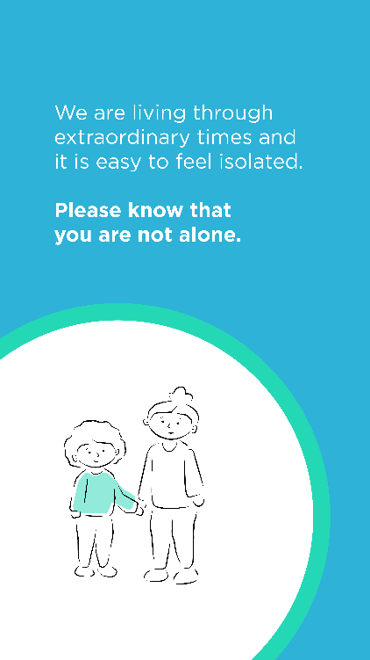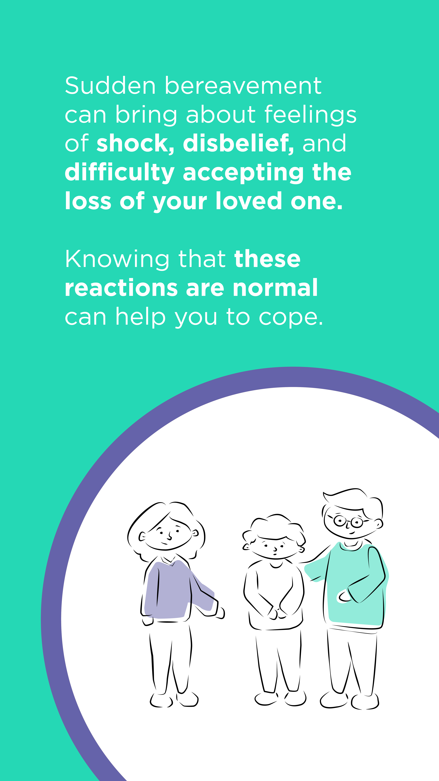

Mental health and wellbeing signposting
In this section:
- Support for health and care workers
- Support for parents/carers
- Loneliness and support for those on their own/vulnerable
- Crisis helplines
- Supporting Londoners’ feeling of uncertainty
- Support for Young Londoners
- Ways to Wellbeing resources – general
- Every Mind Matters
Support for health and care workers
Twitter | #OurNHSPeople are truly the best of us. Thank you for everything you do to protect us and keep our city safe.  Right now, it is vital that you look after yourself, recognise the emotional challenges of your work and ask for support when you need it.  ➡️ www.good-thinking.uk/coronavirus/advice-for/healthcare-professionals/
Twitter | It's more important than ever for #OurNHSPeople to look after their mental health and reach out for support when needed.  If you work for the NHS and feel overwhelmed, help is at hand from @GoodThinkingUK: www.good-thinking.uk/coronavirus/advice-for/healthcare-professionals/ | 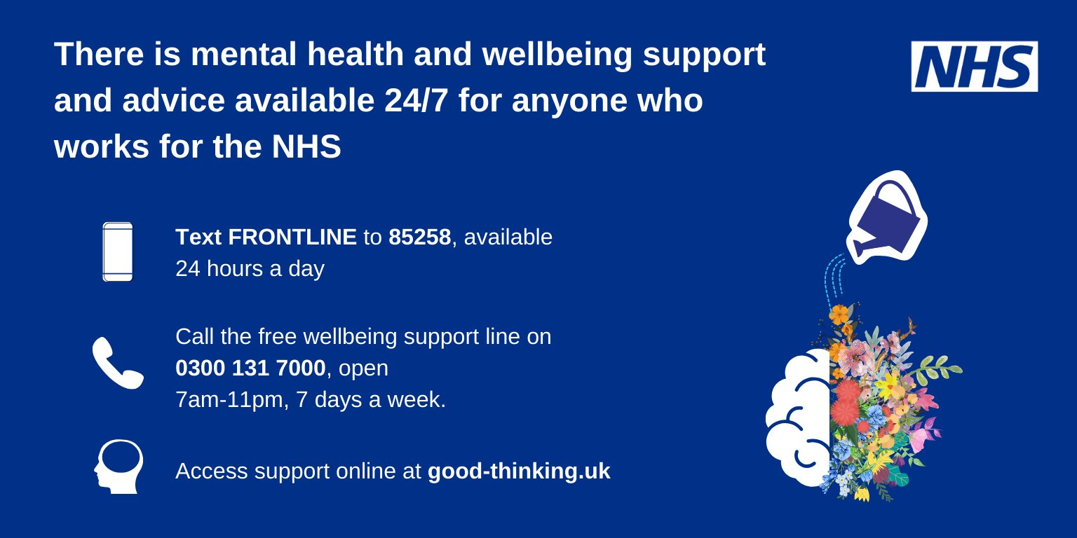
Support for parents/carers
Twitter | Children and teenagers might be experiencing a range of emotions because of the coronavirus outbreak.  @ThriveLDN and @GoodThinkingUK have a handy guide and videos for parents and carers to help guide their children through uncertain times: https://thriveldn.co.uk/resources/advice-for-parents-and-carers/
Loneliness and support for those on their own/vulnerable
Twitter | How are you staying connected during lockdown?  👋 Wave at your neighbours  🤳 Video call a friend  📞 If talking to a friendly stranger is easier, then call:  @TheSilverLineUK on 0800 4708090, for friendship & advice for older people.  @samaritans on 116 123, there to listen 24/7.
Twitter | Nobody should feel alone. Help is available from local @NHSVolResponder during the coronavirus pandemic.  If you, or someone you know or someone you care for, would like to register for support from the volunteers call 0808 196 3646 (8am to 8pm, 7 days a week). | 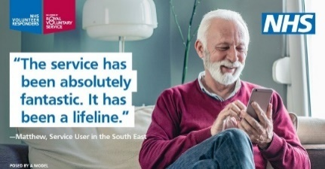
Twitter | We need to harness the energy in each community to help neighbours, friends and those who require more support at this challenging time. We will get through this together.  Read @ThriveLDN’s guide on how you can safely support others: https://thriveldn.co.uk/2020/12/21/supporting-others-in-your-community/  #LondonTogether | 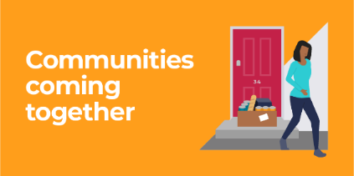
Instagram | We need to harness the energy in each community to help neighbours, friends and those who require more support at this challenging time.  Could you join the #NHSVolunteerResponders to help the most vulnerable people through the #Coronavirus outbreak? Explore @royalvolservice for details.  Or read @ThriveLDN’s guide on how you can safely support others – link in their bio or via www.thriveldn.co.uk.  We will get through this together.  #LondonTogether | 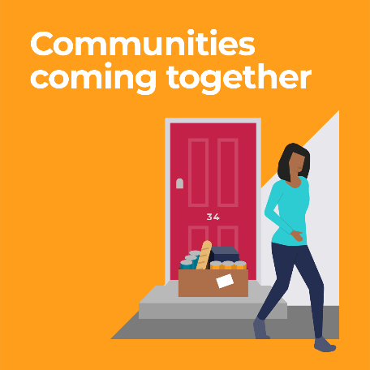
Crisis helplines
Twitter | Things can feel very hard at times. Support is available for whatever you are going through, there is hope and you are not alone.  These helplines are free and confidential:  📲 @GiveUsAShout: Text Shout to 85258  📞 @samaritans: 116 123  📞 @CruseCare: 0808 808 1677 | 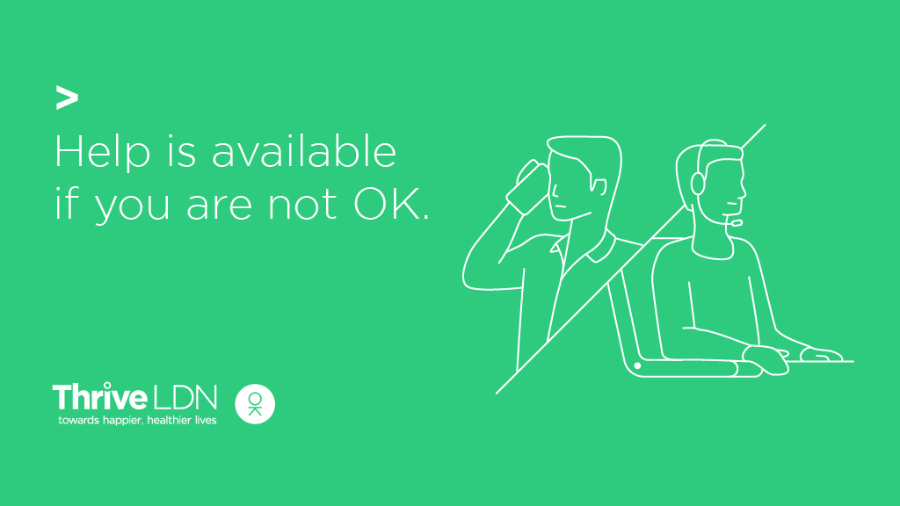
Instagram | Things can feel very hard at times.  Support is available for whatever you are going through, there is hope and you are not alone.  These helplines are free and confidential:  📞@samaritans: 116 123  📲 @ giveusashoutinsta: Text Shout to 85258  📞 @ crusecare: 0808 808 1677 | 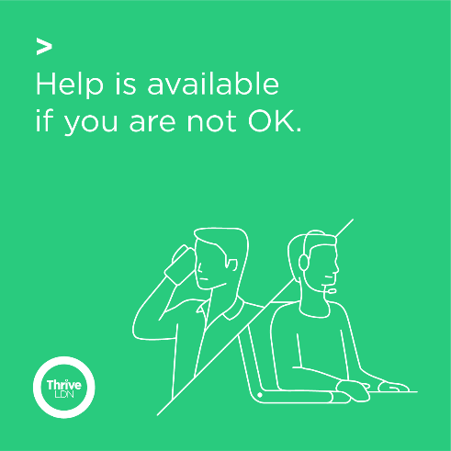
Twitter | Urgent mental health support is available 24/7 through NHS helplines. Please remember you are not alone and help is available.  Visit the NHS website and find your local helpline to get help.  https://www.nhs.uk/using-the-nhs/nhs-services/mental-health-services/where-to-get-urgent-help-for-mental-health/
Supporting Londoners’ feeling of uncertainty
Twitter | It’s okay to feel how you’re feeling right now. If that’s anxious or worried, this is perfectly normal when times are uncertain.  Find advice and NHS-approved apps via London's digital mental wellbeing service, @GoodThinkingUK.  ➡️ www.good-thinking.uk  #MentalHealth #Wellbeing | 1  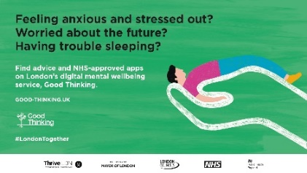  2  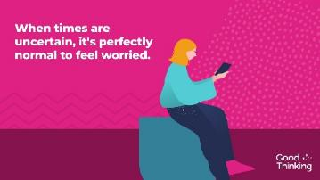  3
Instagram | For many of us, this period of uncertainty is challenging. Remember though, it's perfectly normal to feel anxious or worried when times are uncertain. Be kind on yourself.  Whether you are experience anxiety, low mood, stress or experiencing difficulty sleeping, you can find advice and NHS-approved apps from London's digital mental wellbeing service, @goodthinkinguk.  ➡️ www.good-thinking.uk | 1  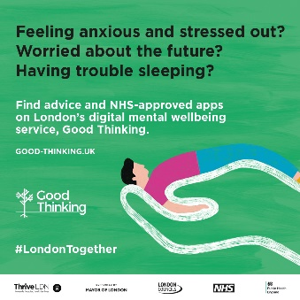  2  3
Twitter / Facebook  Brexit | Worried about #Brexit? Support is available for whatever you are going through.  Find simple ways you can look after your own mental health and the wellbeing of those you care about from:  ➡️@GoodThinkingUK  ➡️@mentalhealth  Or read @ThriveLDN's Brexit blog: https://thriveldn.co.uk/2020/12/24/dealing-with-the-stress-and-uncertainty-of-brexit/
Support for Young Londoners
Twitter  Young Londoners | Young Londoners, if you need support there are people and services who are ready to help:  @TheMixUK- support for under 25s  @GoodThinkingUK- digital wellbeing tools  @YoungMindsUK- text YM to 85258  #Childline- call 0800 1111  Remember, we'll get through this together. | 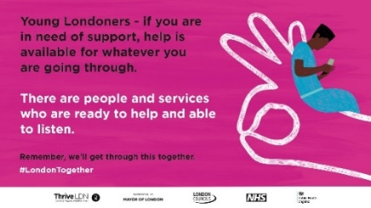
Instagram  Young Londoners | Young Londoners - if you need support, there are people and services who are ready to help.  📲 @youngmindsuk - text YM to 85258  📞 @childline_official - call free on 0800 1111  💻 @themixuk - visit themix.org.uk  💻 @goodthinkinguk – visit www.good-thinking.uk  Remember, we'll get through this together.  #LondonTogether #MentalHealth #Wellbeing  #London #HelpIsAvailable #Support  #YoungLondoners | 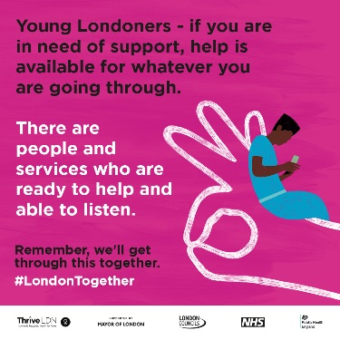
Twitter  Support for students | For students, Covid-19 may bring worry and uncertainty. But remember that you are not alone, and support is always available.  Check out #StudentSpace from @StudentMindsOrg for wellbeing resources and advice to help get you through Coronavirus.  👉 studentspace.org.uk

Ways to Wellbeing resources - general
Twitter | Right now, it has never been more important to take time to look after ourselves & to seek support when needed.  @ThriveLDN has created a pack of little things you can do to keep yourself well & some useful ways to get support if you are finding it hard 👉 thriveldn.co.uk/resources/ways-to-improve-your-wellbeing | VIDEO:  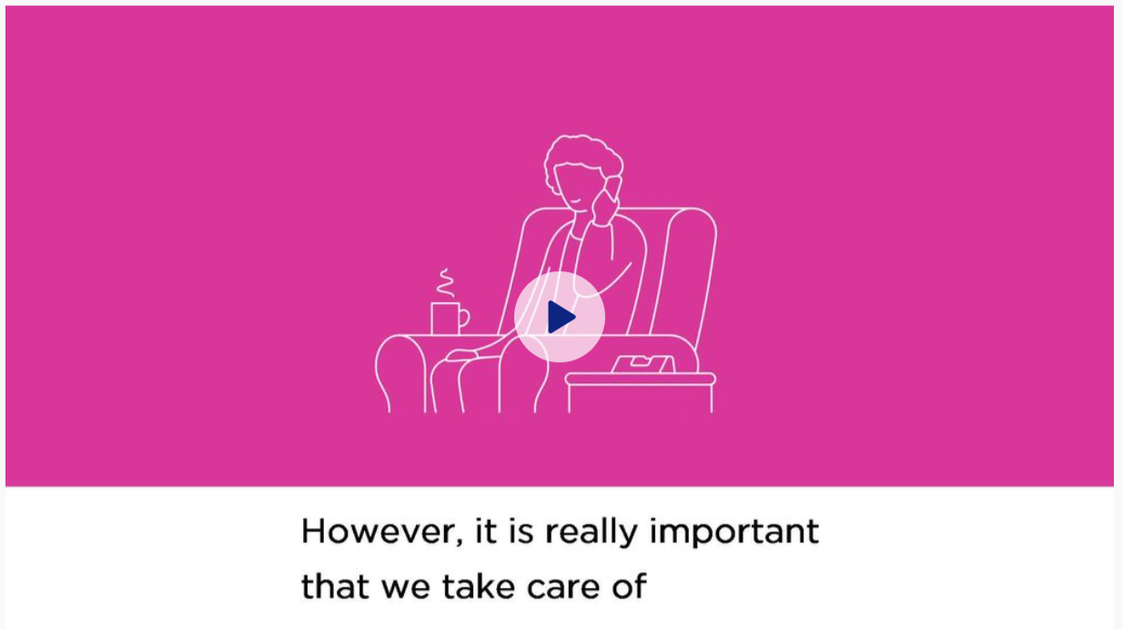  Download here.
Instagram | Feeling worried or stressed is normal during challenging times. However, it is really important that we take care of our mental health and wellbeing as much as possible.  @thriveldn has created a pack of little things you can do to keep yourself well and some useful ways to get support if you are finding it hard. The resource includes where to get help for urgent financial or personal need.  Don’t be afraid to ask for help if you need it. Follow the link in our bio to find out more, or search 'Thrive LDN' in your browser.  #MentalHealth #Wellbeing #Covid19 #Coronavirus #London #Londoners #LondonTogether #Support #HelpIsAvailable | VIDEO:  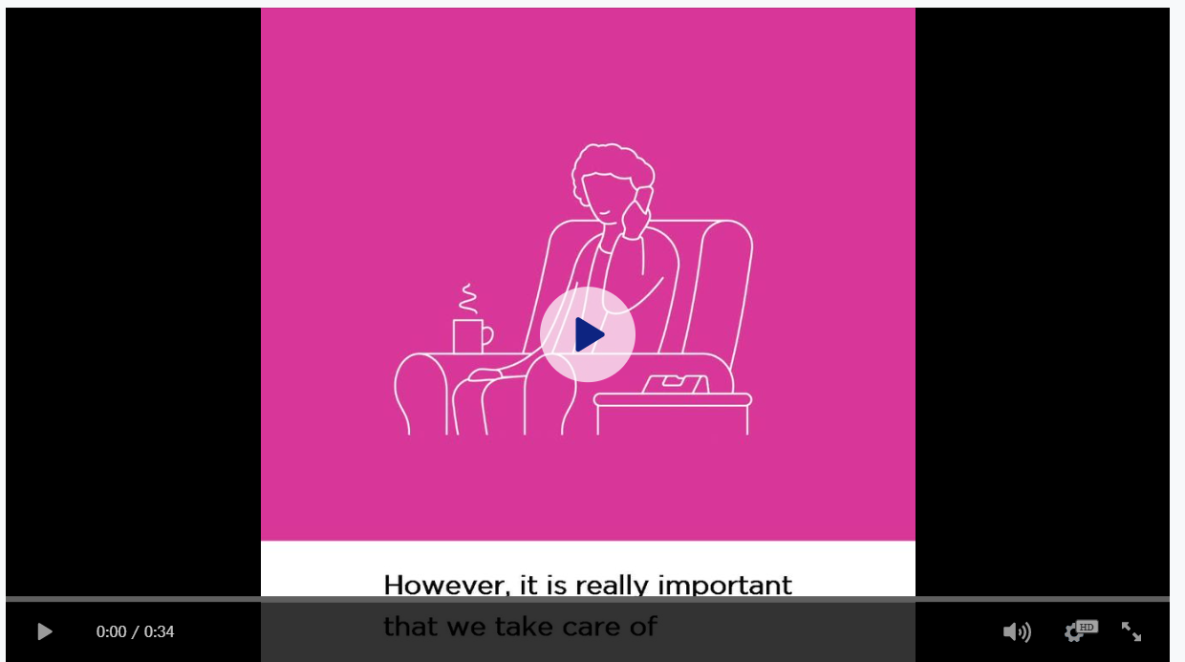  Download here.
Facebook | Feeling worried or stressed is normal during challenging times. However, it is really important that we take care of our mental health and wellbeing as much as possible.  Thrive LDN has created a pack of little things you can do to keep yourself well and some useful ways to get support if you are finding it hard. Including on where to get urgent financial or personal support and information.  👉 www.thriveldn.co.uk/resources/ways-to-improve-your-wellbeing | VIDEO:  Download here.
Be kind to yourself, find time to do something you enjoy
Twitter | It’s OK to treat yourself to the things that make you smile and make you feel good.  Don’t be hard on yourself. Make yourself a hot drink, watch a film, read a book, or try a crossword.  Read @ThriveLDN's full set of tips on managing your wellbeing 👉 thriveldn.co.uk/resources/ways-to-improve-your-wellbeing/ | 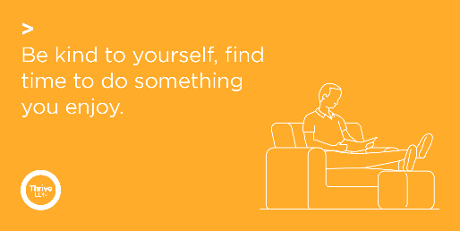
Instagram | It’s OK to treat yourself to the things that make you smile and make you feel good.  Don’t be hard on yourself. Make yourself a hot drink, watch a film, read a book, or try a crossword. You may want to limit your intake of daily news as too much coverage can be overwhelming and make you stressed.  Visit @goodthinkinguk, London’s digital wellbeing service, for free, NHS approved digital tools to help manage anxiety, low mood, sleeping difficulties or stress.  @ThriveLDN has created a little set of ways we can all look after our mental health and wellbeing whilst we stay home to save lives. You can read the full set of tips on their website. Follow the link in their bio to find out more. | 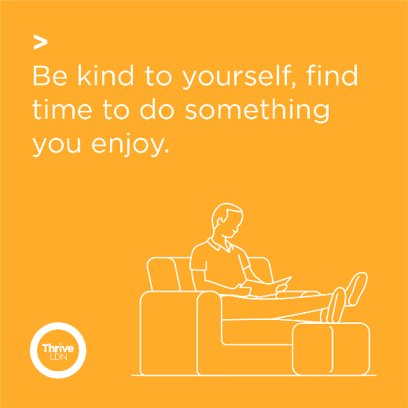
Connect with others, by phone, text, social media, write a letter or smile at your neighbours
Twitter | Tackling Covid-19 has meant many of us seeing loved ones less. It’s important that we stay connected. Get in touch with family and friends to share your thoughts and have a chat.  Read @ThriveLDN's full set of tips on managing your wellbeing 👉 thriveldn.co.uk/resources/ways-to-improve-your-wellbeing/ | 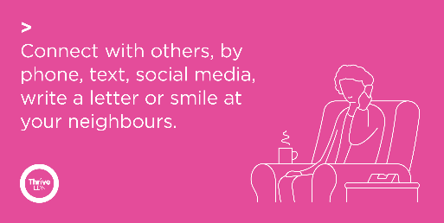
Instagram | Tackling Covid-19 has meant many of us seeing loved ones less. It’s important that we stay connected. Get in touch with family and friends to share your thoughts and have a chat.  @ThriveLDN has created a little set of ways we can all look after our mental health and wellbeing whilst we stay home to save lives. You can read the full set of tips on their website. Follow the link in their bio to find out more. | 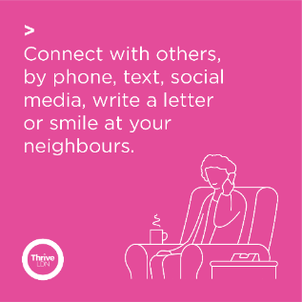
Find different ways of staying active
Twitter | Being active reduces stress and helps us sleep better.  Having an exercise routine which you can do at home or locally outdoors is good for both our physical and mental health.  Read @ThriveLDN's full set of tips on managing your wellbeing 👉 thriveldn.co.uk/resources/ways-to-improve-your-wellbeing/
Instagram | Being active reduces stress and helps us sleep better.  If you have access to a garden or it is safe for you to visit your local park, then get some fresh air, go for at least a 20-minute walk or a run.  If getting out and moving around is not easy or possible for you, keep moving about indoors as often or as much as you can. Having an exercise routine which you can do at home or locally outdoors is really important and will help give a positive influence on our self-esteem and self-worth.  @ThriveLDN has created a little set of ways we can all look after our mental health and wellbeing whilst we stay home to save lives. You can read the full set of tips on their website. Follow the link in their bio to find out more. | 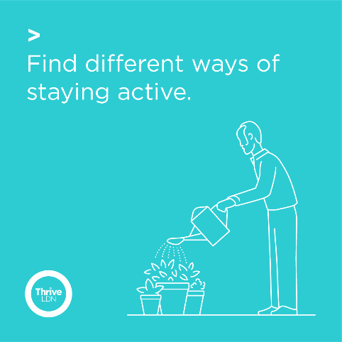
Twitter | Moving your body is good for your mind too.  Whether it's a daily walk, yoga in your living room or following an online workout video, getting active can help to relieve stress and improve your mood.  Visit #EveryMindMatters for more tips 👉 http://nhs.uk/oneyou/every-mind-matters/
Twitter | No matter how much you do, physical activity is good for your body and mind.  For tools, tips and special offers to move more every day, visit the NHS Better Health website 👉 nhs.uk/better-health/get-active/

Resilience messaging
Images and videos: Right click the image and select ‘open link’ to download a full-size image to use across digital channels.
All resources are also available to download directly from the Thrive LDN Comms Toolkit Dropbox account: https://www.dropbox.com/sh/bfio0xcbfp87w4b/AAAVXBbp-Xt78PNEAvXV5hyFa?dl=0
1. Be patient, great things take time
Twitter | Right now, things can feel difficult and progress might seem slow. It is natural for you to feel overwhelmed - but you're not alone.  @ThriveLDN has put together a range of tools and resources to help you to manage your #MentalHealth & #Wellbeing.  👉 thriveldn.co.uk/resources/tools-and-resources-to-help-your-mental-health-and-wellbeing/
Instagram | We know, especially at the moment, that things can feel difficult and progress might seem slow. How you feel is valid – and we hope you can find comfort in knowing that lots of people will be feeling the same.  @ThriveLDN has put together a collection of tools and resources to help you to manage your #MentalHealth and #Wellbeing.  Find the link in @ThriveLDN’s bio.
2. Nature helps us feel grounded
Twitter 1 | Remember - it’s OK to treat yourself to the things that make you smile and make you feel good. Now is the time to really make yourself a priority.  Spending time in your local park or nearby green space can have a positive impact on wellbeing, even during winter. #WelcomeWinter
Twitter 2 | Research shows that spending at least 20 minutes a day in our local park can have a positive impact on our wellbeing.  @ThriveLDN & @PHE_London are partnering with @theroyalparks #WelcomeWinter campaign to encourage everyone to safely connect with nature.  royalparks.org.uk/media-centre/press-releases/uks-locked-down-city-dwellers-encouraged-to-take-a-daily-walk-in-their-park-to-stay-well-over-winter
Instagram | There is so much going on right now. It is natural for you to feel overwhelmed - and you're not alone.  But remember - it’s OK to treat yourself to the things that make you smile and make you feel good. Many people are connecting with nature to cope during these challenging times and feel more grounded.  @theroyalparks #WelcomeWinter campaign is reminding us all how to spend time outdoors or in nearby green space to boost our wellbeing, even during the winter months.  Research shows that going for at least a 20-minute walk can have a positive impact on our #MentalHealth. So, try it today!  Find more via @ThriveLDN’s bio.
3. Focus on what you can do, not on what you cannot
Twitter | Learning to accept that there are things you cannot control can be a big step in resolving whatever problems you may be having.  The NHS #CopingDuringCovid webinar series has lots of handy advice on managing anxiety, lack of sleep, low mood and more.  👉 thriveldn.co.uk/resources/coping-well-during-covid/
Instagram | We all have much more control over what we do than how we feel. Focus on what you can do, not on what you cannot.  Learning to accept that there are things that you cannot control can be a big step in learning how to manage and resolve whatever problems you may be having.  Talk to someone when you’re struggling, do a little more self-care than you usually do, and be honest with yourself and others about how you’re feeling.  The NHS-led #CopingWellDuringCovid webinar series has lots of handy advice on managing anxiety, lack of sleep, low mood & more  👉 thriveldn.co.uk/resources/coping-well-during-covid/ or link in @ThriveLDN bio.
4. You are powerful
Twitter | Remember that, whatever you are going through, you are powerful. Take a breath. You've got this.  But if you ever need some support, @ThriveLDN has put together a range of tools and resources to help you to manage your #MentalHealth and #Wellbeing.  👉 thriveldn.co.uk/resources/tools-and-resources-to-help-your-mental-health-and-wellbeing/
Instagram | Remember that, whatever you are going through, you are powerful.  But if you ever need some support or if something is affecting you, even if you feel it’s something ‘small’ or ‘trivial’, you should reach out for help.  @ThriveLDN has put together a collection of tools and resources to help you to manage your #MentalHealth and #Wellbeing.  👉 thriveldn.co.uk/resources/tools-and-resources-to-help-your-mental-health-and-wellbeing/ or link in @ThriveLDN bio.
5. Rest is part of recovery
Twitter | Don’t be hard on yourself. Rest and relaxation are part of a good self-care routine. If you are struggling right now then reach out for help and talk to someone you trust.  There are a range of tools and resources to help you to manage your wellbeing: thriveldn.co.uk/resources/tools-and-resources-to-help-your-mental-health-and-wellbeing/
Instagram | We all have mental health, and the majority of us will struggle with it at some point. So, know that what you're going through is not your fault. Don’t be hard on yourself. Rest and relaxation are part of a good self-care routine.  If you are struggling right now, then reach out for help and talk to someone you trust. Or speak to a friendly stranger via @ samaritanscharity or @ giveusashoutinsta.  There are a range of tools and resources to help you to manage your wellbeing on the @ThriveLDN website – link in bio.

Suicide prevention training
Images and videos: Right click the image and select ‘open link’ to download a full-size image to use across digital channels.
All resources are also available to download directly from the Thrive LDN Comms Toolkit Dropbox account: https://www.dropbox.com/sh/bfio0xcbfp87w4b/AAAVXBbp-Xt78PNEAvXV5hyFa?dl=0
Twitter | Living and working in London can be stressful, and right now for some it may be overwhelming. Would you be able to spot a colleague or friend in distress? There’s FREE @Zer0Suicide online training to help.  Visit 👉 thriveldn.co.uk/zerosuicideldn  #ZeroSuicideLDN | #ZeroSuicideLDN campaign collateral  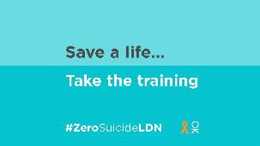
Instagram | Living and working in London can be stressful, and right now for some it may be overwhelming. Would you be able to spot a colleague or friend in distress? There’s FREE online training provided by the @zerosuicidealliance to help.  Visit 👉 thriveldn.co.uk/zerosuicideldn  Save a life... take the training today.  #ZeroSuicideLDN #London #LifeInLondon #WeAreLDN #OKLDN #SuicidePrevention #Teamwork #Together #ZeroSuicideAlliance #Londoners #MentalHealth #OnlineTraining | #ZeroSuicideLDN campaign collateral  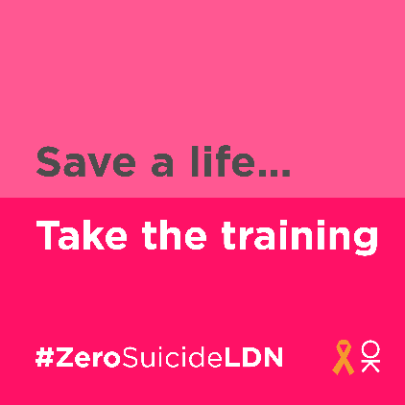
Facebook | Living and working in London can be stressful, and right now for some it may be overwhelming. Would you be able to spot a colleague or friend in distress? There’s FREE online training provided by the Zero Suicide Alliance to help.  Visit 👉 thriveldn.co.uk/zerosuicideldn  Save a life... take the training today.  #ZeroSuicideLDN #London #LifeInLondon #WeAreLDN #OKLDN #SuicidePrevention #Teamwork #Together #ZeroSuicideAlliance #Londoners #MentalHealth #OnlineTraining | #ZeroSuicideLDN campaign collateral  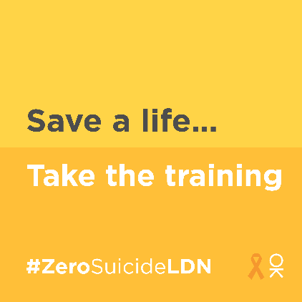  Partner accounts to tag:  Thrive LDN  Zero Suicide Alliance  Mayor of London

