PUBLIC MENTAL HEALTH RESPONSE TO COVID-19: THRIVE LDN COMMUNICATIONS TOOLKIT
Updated Monday, 12 April 2021
- This toolkit has been updated for use throughout the pre-election period.
- We have identified emerging issues for partners to consider which can be shared at this time.
Using this toolkit
Please explore the below web copy and digital messaging for your own communications to help signpost Londoners to appropriate resources and guidance during this time.
To download high quality images and videos: Right click the image and select ‘open link’ to download a full-size image to use across digital channels.
All resources are also available to download directly from the Thrive LDN Comms Toolkit Dropbox account: https://www.dropbox.com/sh/bfio0xcbfp87w4b/AAAVXBbp-Xt78PNEAvXV5hyFa?dl=0

In this document (Ctrl + Click on link to go directly to that section):
- Key messages to share on digital channels

- NHS wellbeing webinars – running until 5 May

- New article: Dealing with change as lockdown restrictions ease
- Reassurances and support moving out of lockdown

- Building Londoners’ emotional resilience (including BSL resources)

- Support for sudden bereavement

- Suicide prevention training

- Suggested content for web and newsletters:

- Standard text for newsletters and/or offline copy

NHS wellbeing webinars – running until Wed, 5 May
The following is suggested copy for web pages and newsletters
- 125 words
NHS wellbeing webinars return for a new series
Thrive LDN and partners are running another series of live wellbeing webinars designed to support people with the emotional impact of the pandemic.
Two live webinars will take place each week, on Tuesdays and Wednesdays until the 5th of May. The free, hour-long sessions are led and delivered by Emily Gardner, Cognitive Behavioural Therapist, East London NHS Foundation Trust.
Led by a trained NHS professional, the webinars offer you the chance to explore ideas and strategies to support your mental health and wellbeing, in a safe and welcoming environment. Topics include managing wellbeing, low mood and burnout, worry and fear, and sleeping difficulties, as well as keeping well whilst working from home, and mindfulness.
To register and explore the full schedule, visit Thrive LDN’s website.
- 300 words
NHS wellbeing webinars return for a new series
Thrive LDN and partners are running another series of live wellbeing webinars designed to support people with the emotional impact of the pandemic.
The coronavirus pandemic has had a huge impact on our wellbeing, with many people feeling anxious about its impact on them and their loved ones. Many also have concerns about as we ease out of lockdown and the future.
Two live webinars will take place each week, on Tuesdays and Wednesdays until the 5th of May. The free, hour-long sessions start from the principle that it’s normal and okay to feel upset, anxious or confused at times. However, there are things we can all do to support our mental health and wellbeing during this challenging time.
The Coping Well During Covid webinars are led and delivered by Emily Gardner, Cognitive Behavioural Therapist, East London NHS Foundation Trust. Topics include managing wellbeing, low mood and burnout, worry and fear, and sleeping difficulties, as well as working from home, and mindfulness.
Whether you are joining the webinars for the first time or took part in the webinars when they were first launched and are looking for a refresher, they will offer you the chance to explore ideas and strategies to support your mental health and wellbeing, in a safe and welcoming environment, led by a clinician.
As one participant said: “It was excellent. Emily presented the information in an engaging, caring, fun, non-judgemental, open and supportive manner. I had been a little apprehensive in advance but soon felt at ease because of the way the information was conveyed.”
Live webinars take place on Tuesdays at 12.30pm and Wednesdays at 4pm. So, you can pick either a lunchtime or afternoon session each week. To register and explore the full schedule, visit Thrive LDN’s website.
Webinar schedule:
- Managing Wellbeing – webinar recording now online
- Working from Home and Staying Well – webinar recording now online
- Managing Worry and Fear
- Tue 13 April, 12.30pm
- Wed 14 April, 4pm
- Managing Low Mood and Burnout
- Tue 20 April, 12.30pm
- Wed 21 April, 4pm
- Sleeping Better
- Tue 27 April, 12.30pm
- Wed 28 April, 4pm
- Mindfulness
- Tue 04 May, 12.30pm
- Wed 05 May, 4pm

Content for digital channels
To download high quality images and videos: Right click the image and select ‘open link’ to download a full-size image to use across digital channels.
All resources are also available to download directly from the Thrive LDN Comms Toolkit Dropbox account: https://www.dropbox.com/sh/bfio0xcbfp87w4b/AAAVXBbp-Xt78PNEAvXV5hyFa?dl=0
You can download bespoke graphics for each of the above topics:
- Wide (Twitter and Facebook compatible)
- Square (Instagram feed compatible)
- Tall (Instagram stories compatible)
- x2 promotional videos for the series
Coping Well During Covid webinar series
Twitter | Join a series of clinically led, live NHS wellbeing webinars for lots of useful advice on managing low mood, worry and fear, burnout, sleeping better and more.  The free webinars run weekly on Tuesdays & Wednesdays until 5 May.  Register via @ThriveLDN 👇  http://thriveldn.co.uk/resources/coping-well-during-covid/ | Static image:  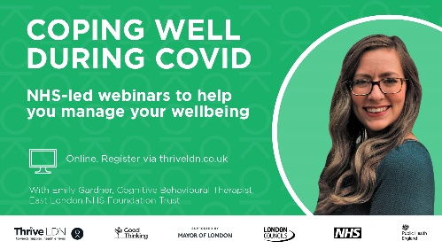  Or video:  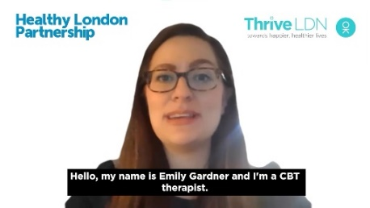
Instagram | When times are uncertain, it’s understandable to experience a rollercoaster of emotions.  As we pass the milestone of one year since the first lockdown, @ThriveLDN and partners are relaunching another series of NHS Coping Well During Covid webinars designed to support you deal with the impact of the pandemic.  Live webinars take place on Tuesdays at 12.30pm and Wednesdays at 4pm until the 5th May. So, you can pick either a lunchtime or afternoon session each week.  Topics include managing wellbeing, low mood and burnout, and sleeping difficulties, as well as working from home and mindfulness.  Register for FREE now 👇  http://thriveldn.co.uk/resources/coping-well-during-covid/  You can also find the link in @ThriveLDN’s bio.  #CopingWellDuringCovid #London #LowMood #Sleep #Sleeplessness #Wellbeing #MentalHealth #Anxiety | Static image:  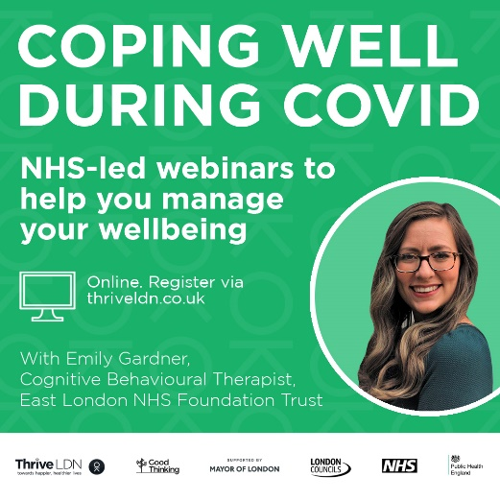  Or video:  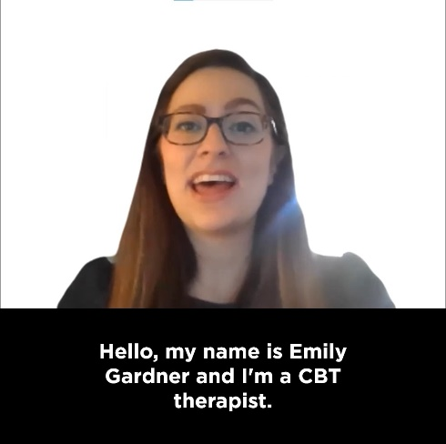
Facebook | When times are uncertain, it’s understandable to experience a rollercoaster of emotions.  As we pass the milestone of one year since the first lockdown, Thrive LDN and partners are relaunching another series of NHS Coping Well During Covid webinars designed to support you deal with the impact of the pandemic.  Live webinars take place on Tuesdays at 12.30pm and Wednesdays at 4pm. So, you can pick either a lunchtime or afternoon session each week.  Topics include managing wellbeing, low mood and burnout, and sleeping difficulties, as well as working from home and mindfulness.  Register for FREE now 👇  http://thriveldn.co.uk/resources/coping-well-during-covid/ | Static image:  Or video:  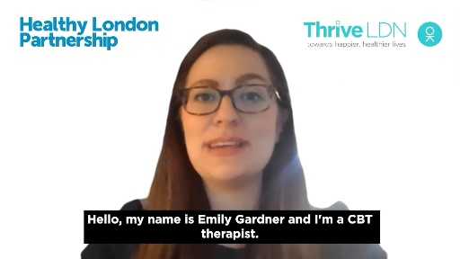

New article: Dealing with change as lockdown restrictions ease
To download high quality images and videos: Right click the image and select ‘open link’ to download a full-size image to use across digital channels.
All resources are also available to download directly from the Thrive LDN Comms Toolkit Dropbox account: https://www.dropbox.com/sh/bfio0xcbfp87w4b/AAAVXBbp-Xt78PNEAvXV5hyFa?dl=0
Thrive LDN’s new blog article discusses the possible emotions and concerns Londoners may be dealing with as we come out of lockdown, and some tools and resources that may help.
Visit: https://thriveldn.co.uk/2021/04/12/dealing-with-change-as-lockdown-restrictions-ease/
Twitter 1 | You may have a mix of feelings and emotions as we begin to ease out of lockdown. Whatever you’re feeling is valid.  It's normal to feel upset, anxious or confused. But help and support are available if you need it. Read @ThriveLDN's latest blog for more 👇  https://thriveldn.co.uk/2021/04/12/dealing-with-change-as-lockdown-restrictions-ease/ | 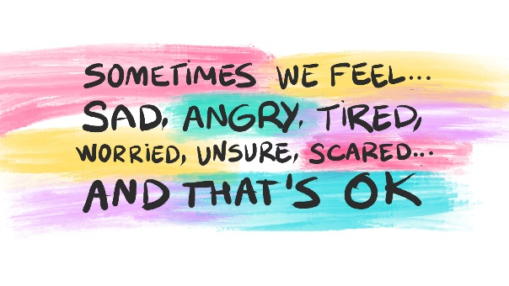
Instagram | You may have a mix of feelings and emotions as we begin to ease out of lockdown. Whatever you’re feeling is valid.  For many, the chance to socialise is welcome. For others, a source of anxiety. Whatever you’re feeling is valid. It’s OK not to feel OK – but remember, support is available.  @ThriveLDN's latest blog talks through the possible emotions and concerns Londoners may be dealing with as we come out of lockdown, and some tools and resources that may help if you are finding things hard.  Follow the link in @ThriveLDN’s bio. | 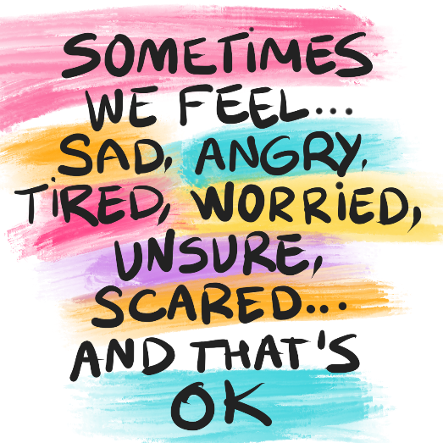
Facebook | You may have a mix of feelings and emotions as we begin to ease out of lockdown. Whatever you’re feeling is valid.  For many, the chance to socialise is welcome. For others, a source of anxiety. Whatever you’re feeling is valid. It’s OK not to feel OK – but remember, support is available.  Thrive LDN's latest blog talks through the possible emotions and concerns Londoners may be dealing with as we come out of lockdown, and some tools and resources that may help if you are finding things hard.  https://thriveldn.co.uk/2021/04/12/dealing-with-change-as-lockdown-restrictions-ease/ | Accounts to tag: @thriveldn
Reassurances and support moving out of lockdown
A fundamental part of the public mental health response to the pandemic needs to be continuing to normalise what Londoners’ are experiencing and supporting them build on the strength and resilience they already have.
To download high quality images and videos: Right click the image and select ‘open link’ to download a full-size image to use across digital channels.
All resources are also available to download directly from the Thrive LDN Comms Toolkit Dropbox account: https://www.dropbox.com/sh/bfio0xcbfp87w4b/AAAVXBbp-Xt78PNEAvXV5hyFa?dl=0
Support available from Thrive LDN
Twitter 1 | When times are uncertain, it’s understandable to experience a rollercoaster of emotions.  Remember, there are a range of free resources, online tools, and helplines available to help you deal with uncertainty and stay mentally healthy.  Find out more 👇  http://thriveldn.co.uk/resources/tools-and-resources-to-help-your-mental-health-and-wellbeing | 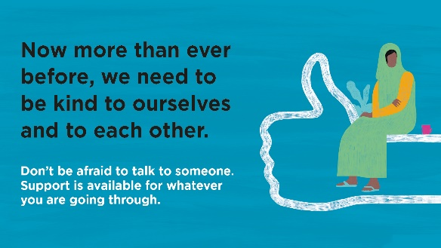
Instagram | When times are uncertain, it’s understandable to experience a rollercoaster of emotions.  Remember, there are free resources, online tools, and helplines available to help you deal with uncertainty and stay mentally healthy.  @ThriveLDN's website has a range of resources to help you help your mental health and wellbeing, and some ways to get support if you are finding things hard.  Follow the link in @ThriveLDN’s bio. | 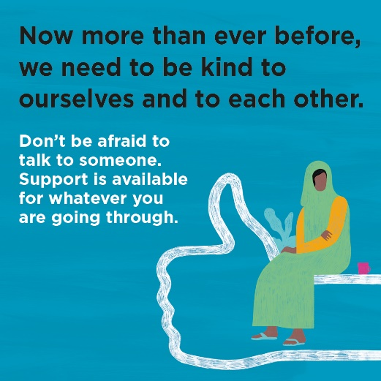
Facebook | When times are uncertain, it’s understandable to experience a rollercoaster of emotions.  Remember, there are a range of free resources, online tools, and helplines available to help you deal with uncertainty and stay mentally healthy.  Thrive LDN's website has a range of resources to help you help your mental health and wellbeing, and some ways to get support if you are finding things hard.  Find out more 👇  http://thriveldn.co.uk/resources/tools-and-resources-to-help-your-mental-health-and-wellbeing | Accounts to tag: @thriveldn
Good Thinking – London’s digital wellbeing service
Twitter | When times are uncertain or things are changing, it is perfectly normal to feel worried.  London’s digital wellbeing service, @GoodThinkingUK, has a range of free apps & resources to help if you have anxiety, low mood, sleeping difficulties or stress.  ➡️ www.good-thinking.uk | 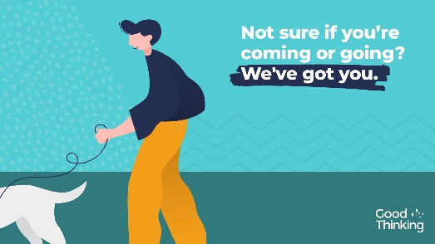  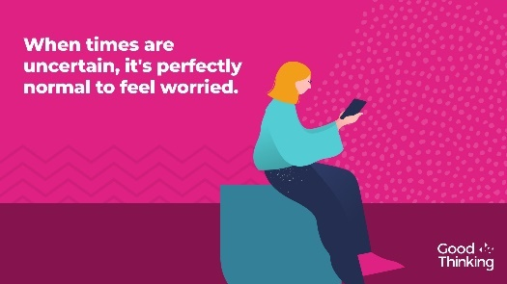
Instagram | When times are uncertain or things are changing, it is perfectly normal to feel worried.  London’s digital wellbeing service, @goodthinkinguk, provides a range of free apps, blogs, videos and resources to help if you have anxiety, low mood, sleeping difficulties or stress.  ➡️ www.good-thinking.uk  #MentalHealth #Wellbeing #London #Londoners #Support | 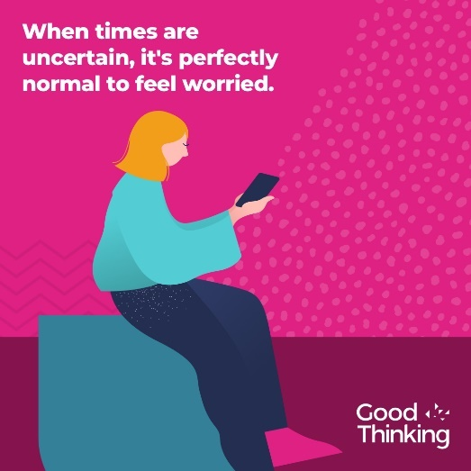
Facebook | When times are uncertain or things are changing, it is perfectly normal to feel worried.  London’s digital wellbeing service, Good Thinking, provides Londoners with a range of free apps and resources to help if you have anxiety, low mood, sleeping difficulties or stress.  ➡️ www.good-thinking.uk

Building Londoners’ emotional resilience (resources include BSL interpretation)
A fundamental part of the public mental health response to the pandemic needs to be continuing to normalise what Londoners’ are experiencing and supporting them build on the strength and resilience they already have. The following can be used over the coming month for what may be a challenging period as we approach anniversary points of the pandemic.
To download high quality images and videos: Right click the image and select ‘open link’ to download a full-size image to use across digital channels.
All resources are also available to download directly from the Thrive LDN Comms Toolkit Dropbox account: https://www.dropbox.com/sh/bfio0xcbfp87w4b/AAAVXBbp-Xt78PNEAvXV5hyFa?dl=0
Building Emotional Resilience with Dr Radha – now with BSL
Twitter | Resilience is our ability to bounce back and adapt to stressful circumstances.  @ThriveLDN's worked with NHS GP & wellbeing expert @DrRadhaModgil to give you invaluable ideas and tips on how to stay resilient.  Now available with #BritishSignLanguage 👋  www.thriveldn.co.uk/resources/emotional-resilience | Static image:  Or video:  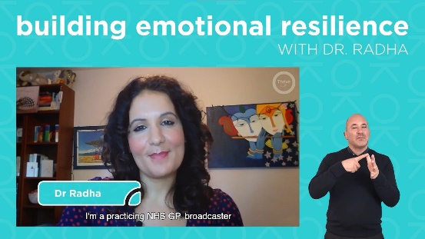
Instagram | Our ability to adapt well to the stress of life, as well as being able to bounce back from adversity, crises or trauma, is often referred to as emotional resilience.  Several Londoners told @dr_radha what tops up their resilience: “I take the first and the last hour of the day and don’t use any technology. Small things like that can make a difference.”  Take 20-minutes to learn more and hear expert advice from Dr Radha on how to stay resilient.  Link available via @ThriveLDN or www.thriveldn.co.uk/emotionalresilience  Also available in #BritishSignLanguage #BSL | Static image:  Or video:  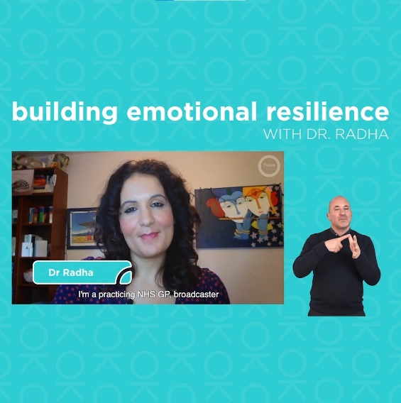
Facebook | Our ability to adapt well to the stress of life, as well as being able to bounce back from adversity, crises or trauma, is often referred to as emotional resilience.  Did you know there are simple things you can do to top up your resilience reserves when you’re running low?  Take 20-minutes to learn more and hear advice from Dr Radha, NHS GP and wellbeing expert, on how to stay resilient: www.thriveldn.co.uk/emotionalresilience  Also available in #BritishSignLanguage #BSL | Static image:  Or video:

Support for sudden bereavement
To download high quality images and videos: Right click the image and select ‘open link’ to download a full-size image to use across digital channels.
All resources are also available to download directly from the Thrive LDN Comms Toolkit Dropbox account: https://www.dropbox.com/sh/bfio0xcbfp87w4b/AAAVXBbp-Xt78PNEAvXV5hyFa?dl=0
Twitter | Bereavement is one of the most challenging things that we can experience, affecting us all.  @ThriveLDN's resource is there to help if you, or someone you are supporting, is grieving the sudden death of someone close. Remember, you're not alone.  👉 https://thriveldn.co.uk/resources/support-after-sudden-bereavement | 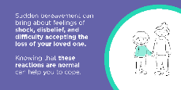  Other options available within the Thrive LDN Comms Toolkit Dropbox
Instagram | Bereavement is one of the most challenging things that we can experience, affecting every one of us.  If you have experienced loss for any reason, the anniversary of the first lockdown may well intensify your feelings and emotions.  Please know that you are not alone. Help and specialist advice is available.  Explore @ThriveLDN's resource to help if you, or someone you are supporting, is grieving the sudden death of someone close.  Visit: thriveldn.co.uk/bereavement | 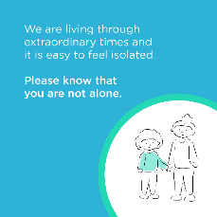  Other options available within the Thrive LDN Comms Toolkit Dropbox
Instagram story | Link / swipe to https://thriveldn.co.uk/resources/support-after-sudden-bereavement using the following images:  https://www.dropbox.com/sh/bfio0xcbfp87w4b/AADWRX8N6LX9-1YJv2NF7Pv9a/Thrive%20LDN%20Bereavement%20Toolkit/Instagram%20story%20tall?dl=0&subfolder_nav_tracking=1  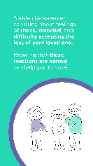
Suicide prevention training
To download high quality images and videos: Right click the image and select ‘open link’ to download a full-size image to use across digital channels.
All resources are also available to download directly from the Thrive LDN Comms Toolkit Dropbox account: https://www.dropbox.com/sh/bfio0xcbfp87w4b/AAAVXBbp-Xt78PNEAvXV5hyFa?dl=0
Twitter | Living and working in London can be stressful, and right now for some it may be overwhelming. Would you be able to spot a colleague or friend in distress? There’s FREE @Zer0Suicide online training to help.  Visit 👉 www.thriveldn.co.uk/zerosuicideldn  #ZeroSuicideLDN | #ZeroSuicideLDN campaign collateral
Instagram | Living and working in London can be stressful, and right now for some it may be overwhelming. Would you be able to spot a colleague or friend in distress? There’s FREE online training provided by the @zerosuicidealliance to help.  Visit 👉 thriveldn.co.uk/zerosuicideldn  Save a life... take the training today.  #ZeroSuicideLDN #London #LifeInLondon #WeAreLDN #OKLDN #SuicidePrevention #Teamwork #Together #ZeroSuicideAlliance #Londoners #MentalHealth #OnlineTraining | #ZeroSuicideLDN campaign collateral  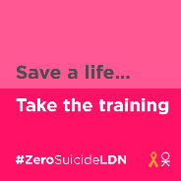
Facebook | Living and working in London can be stressful, and right now for some it may be overwhelming. Would you be able to spot a colleague or friend in distress? There’s FREE online training provided by the Zero Suicide Alliance to help.  Visit 👉 thriveldn.co.uk/zerosuicideldn  Save a life... take the training today.  #ZeroSuicideLDN #London #LifeInLondon #WeAreLDN #OKLDN #SuicidePrevention #Teamwork #Together #ZeroSuicideAlliance #Londoners #MentalHealth #OnlineTraining | #ZeroSuicideLDN campaign collateral  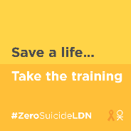  Partner accounts to tag:  Thrive LDN  Zero Suicide Alliance  Mayor of London

Suggested content for web and newsletters
- Standard text for newsletters and/or offline copy
This standard text can be adapted for e-newsletters and bulletins. We advise that it becomes a standing item during periods when more restrictive safety measures are in place as people experience heightened anxiety. Below is both a full and concise post.
[CONCISE – 60 words] Resources to help your mental health and wellbeing
It is perfectly normal to feel upset, anxious or confused at times. Whatever you are feeling is valid.
Support is available through a range of free resources and online tools to help you cope and stay mentally well. If you need urgent help or feel more comfortable talking to someone you don’t know, then use one of the following helplines.
[FULL – 200 words] Resources to help your mental health and wellbeing
It has never been more important for each of us to think and talk more about mental health and wellbeing, and to seek support when needed.
Our ability to adapt well to the stress of life, as well as being able to bounce back from adversity, crises or trauma, is often referred to as emotional resilience. Watch a new 20-minute training video, hosted by Dr Radha Modgil, NHS GP and campaigner for wellbeing, on how to keep your resilience ‘topped up’ through various simple techniques.
There is support available for whatever you are going through. In London, there is a range of support available now from Good Thinking, Every Mind Matters, and NHS wellbeing webinars.
Or if you feel more comfortable talking to someone you do not know, then try the following helplines:
- Samaritans are here when life is difficult. They won’t judge you or tell you what to do, they’re here to listen so you don’t have to face it alone. Call the free, 24-hour listening service on 116 123.
- Shout is the UK 's first 24/7 text messaging service for anyone in crisis. Text Shout at any time to 85258 to start a conversation with a trained volunteer.

