PUBLIC MENTAL HEALTH RESPONSE TO COVID-19: THRIVE LDN COMMUNICATIONS TOOLKIT
Updated Thursday, 15 July 2021
- This toolkit has been updated for use in line with the easing of social restrictions from Monday 19th July.
- We have identified emerging issues for partners to consider which can be shared at this time.
Using this toolkit
Please explore the below web copy and digital messaging for your own communications to help signpost Londoners to appropriate resources and guidance during this time.
To download high quality images and videos: Right click the image and select ‘open link’ to download a full-size image to use across digital channels.
All resources are also available to download directly from the Thrive LDN Comms Toolkit Dropbox account: https://www.dropbox.com/sh/bfio0xcbfp87w4b/AAAVXBbp-Xt78PNEAvXV5hyFa?dl=0

In this document (Ctrl + Click on link to go directly to that section):
- Key messages to share on digital channels

- Reassurances and support moving out of lockdown

- In loving memory of Londoners lost

- Support for sudden bereavement
- SIGNSS – a mental health conversation starter

- Building Londoners’ emotional resilience (including BSL resources)

- Suicide prevention training

- Suggested content for web and newsletters:

- Standard text for newsletters and/or offline copy
Reassurances and support moving out of lockdown
A fundamental part of the public mental health response to the pandemic needs to be continuing to normalise what Londoners’ are experiencing and supporting them build on the strength and resilience they already have.
To download high quality images and videos: Right click the image and select ‘open link’ to download a full-size image to use across digital channels.
All resources are also available to download directly from the Thrive LDN Comms Toolkit Dropbox account: https://www.dropbox.com/sh/bfio0xcbfp87w4b/AAAVXBbp-Xt78PNEAvXV5hyFa?dl=0
Support available from Thrive LDN
Twitter 1 | Easing out of lockdown will allow us to get back to the people and things we love, but it's OK if you feel worried about going "back to normal".  @ThriveLDN has a range of free resources available to help you deal with uncertainty & stay mentally healthy.  http://thriveldn.co.uk/resources/tools-and-resources-to-help-your-mental-health-and-wellbeing | 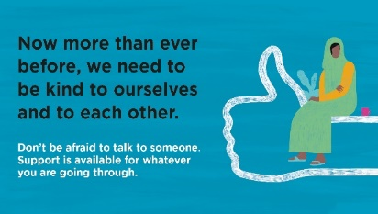
Instagram | Easing out of lockdown will allow us to get back to the people and things we love, but it's OK if you feel worried about going "back to normal".  Remember, there are free resources, online tools, and helplines available to help you deal with uncertainty and stay mentally healthy.  @ThriveLDN's website has a range of resources to help you help your mental health and wellbeing, and some ways to get support if you are finding things hard.  Follow the link in @ThriveLDN’s bio. | 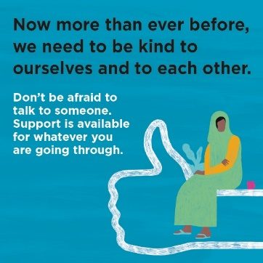
Facebook / LinkedIn | Easing out of lockdown will allow us to get back to the people and things we love, but it's OK if you feel worried about going "back to normal".  Remember, there are a range of free resources, online tools, and helplines available to help you deal with uncertainty and stay mentally healthy.  Thrive LDN's website has a range of resources to help you help your mental health and wellbeing, and some ways to get support if you are finding things hard.  Find out more 👇  http://thriveldn.co.uk/resources/tools-and-resources-to-help-your-mental-health-and-wellbeing | 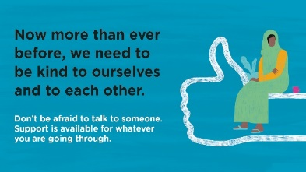  Accounts to tag: @thriveldn

Looking out for other Londoners
Twitter 1 | Easing out of lockdown will allow us to get back to the people and things we love, but going "back to normal" may also bring worry or concern for many of us.  London works best when we all look out for each other. Take some time to check in with friends, colleagues & loved ones. | 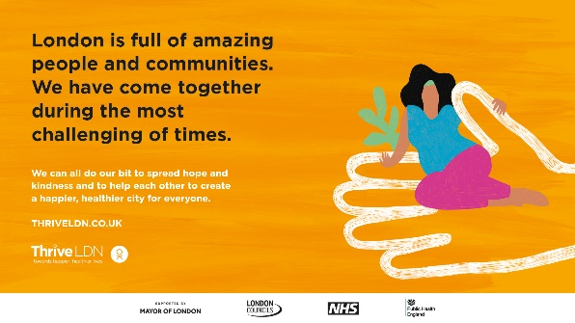
Instagram | Easing out of lockdown will allow us to get back to the people and things we love, but going "back to normal" may also bring worry or concern for many of us.  London is full of amazing people and communities who have pulled together throughout the pandemic. Our city works best when we all look out for each other.  Whilst returning to normal, make sure to take some time to check in with friends, colleagues & loved ones.
Facebook / LinkedIn | Easing out of lockdown will allow us to get back to the people and things we love, but going "back to normal" may also bring worry or concern for many of us.  London is full of amazing people and communities who have pulled together throughout the pandemic. Our city works best when we all look out for each other.  Whilst returning to normal, make sure to take some time to check in with friends, colleagues & loved ones.  www.thriveldn.co.uk | Accounts to tag: @thriveldn

Good Thinking – London’s digital wellbeing service
Twitter | When times are uncertain or things are changing, it is perfectly normal to feel worried.  London’s digital wellbeing service, @GoodThinkingUK, has a range of free apps & resources to help if you have anxiety, low mood, sleeping difficulties or stress.  ➡️ www.good-thinking.uk | 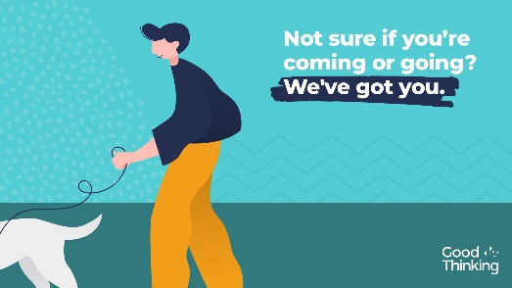  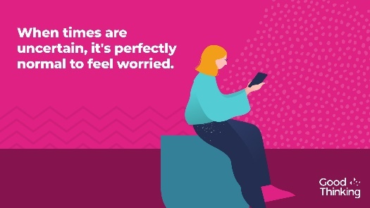
Instagram | When times are uncertain or things are changing, it is perfectly normal to feel worried.  London’s digital wellbeing service, @goodthinkinguk, provides a range of free apps, blogs, videos and resources to help if you have anxiety, low mood, sleeping difficulties or stress.  ➡️ www.good-thinking.uk  #MentalHealth #Wellbeing #London #Londoners #Support | 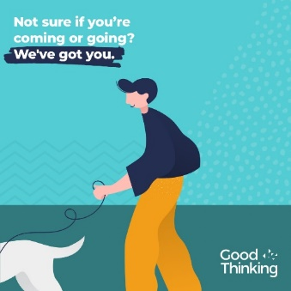  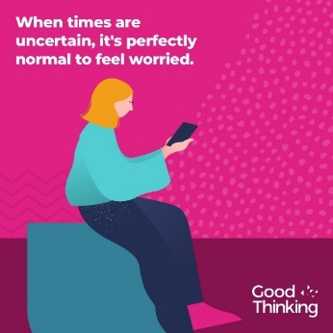
Facebook | When times are uncertain or things are changing, it is perfectly normal to feel worried.  London’s digital wellbeing service, Good Thinking, provides Londoners with a range of free apps and resources to help if you have anxiety, low mood, sleeping difficulties or stress.  ➡️ www.good-thinking.uk

In loving memory of Londoners Lost
To download high quality images and videos: Right click the image and select ‘open link’ to download a full-size image to use across digital channels.
You can download a full toolkit for the In Loving Memory of Londoners Lost campaign here.
Twitter | Many of us will have been affected by losing someone close to us. For each and every one of us, our journey of grief will be unique.  If you find that you’re struggling with your grief, @ThriveLDN’s website also has a range of resources that can help 👇  https://thriveldn.co.uk/campaigns/london-remembers/ | Twitter  Or choose a different ‘wide’ image
Facebook and LinkedIn | Many of us will have been affected by losing someone close to us or someone we know over the past year. But remember, there is no one way to grieve.  For each and every one of us, our journey of grief will be unique. There are no rules about how you should feel, or how long it will take. Emotions do not follow each other in a tidy line.  If you find that you’re struggling with your grief, please talk to someone about getting professional support. Thrive LDN’s website also has a range of resources that can help.  https://thriveldn.co.uk/campaigns/london-remembers/ | Facebook and LinkedIn  Or choose a different ‘wide’ image
Instagram | Many of us will have been affected by losing someone close to us or someone we know over the past year. But remember, there is no one way to grieve.  For each and every one of us, our journey of grief will be unique. There are no rules about how you should feel, or how long it will take. Emotions do not follow each other in a tidy line.  If you find that you’re struggling with your grief, please talk to someone about getting professional support. Thrive LDN’s website also has a range of resources that can help.  https://thriveldn.co.uk/campaigns/london-remembers/ | Instagram  Or choose a different ‘square’ image

Support for sudden bereavement
To download high quality images and videos: Right click the image and select ‘open link’ to download a full-size image to use across digital channels.
All resources are also available to download directly from the Thrive LDN Comms Toolkit Dropbox account: https://www.dropbox.com/sh/bfio0xcbfp87w4b/AAAVXBbp-Xt78PNEAvXV5hyFa?dl=0
Twitter | Bereavement is one of the most challenging things that we can experience, affecting us all.  @ThriveLDN's resource is there to help if you, or someone you are supporting, is grieving the sudden death of someone close. Remember, you're not alone.  👉 https://thriveldn.co.uk/resources/support-after-sudden-bereavement | 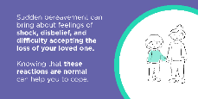  Other images available within the Thrive LDN Comms Toolkit Dropbox
Instagram | Bereavement is one of the most challenging things that we can experience, affecting every one of us.  Grief is a natural process, but it can also be very difficult and isolating – even as London eases lockdown restrictions. You may feel like you are coping and then be hit by waves of grief some considerable time after experiencing a loss.  Please know that you are not alone. Help and specialist advice is available.  Explore @ThriveLDN's resource to help if you, or someone you are supporting, is grieving the sudden death of someone close.  Visit: thriveldn.co.uk/bereavement | 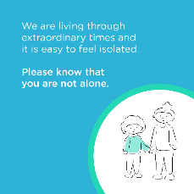  Other options available within the Thrive LDN Comms Toolkit Dropbox
Instagram story | Link / swipe to https://thriveldn.co.uk/resources/support-after-sudden-bereavement using the following images:  https://www.dropbox.com/sh/bfio0xcbfp87w4b/AADWRX8N6LX9-1YJv2NF7Pv9a/Thrive%20LDN%20Bereavement%20Toolkit/Instagram%20story%20tall?dl=0&subfolder_nav_tracking=1  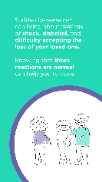
SIGNSS – a mental health conversation starter
Thrive LDN is delighted to launch a new conversation starter tool to support faith and community leaders to engage in mental health communications with their members.
The resource – SIGNSS – has been developed through engagement with community leaders across London. It aims to normalise conversations about mental health. The ultimate goal is to encourage help-seeking behaviour and signpost people to support. It has been developed for Thrive LDN by psychologist and Public Health specialist Dr Pamela Nkyi.
- All content is available to download from Thrive LDN’s communications Dropbox account
Twitter | Talking about #MentalHealth isn’t always easy. But as we begin to recover from the pandemic, these conversations are so important.  Explore @ThriveLDN's community conversation starter for tips and prompts to help you get your community talking 👇  www.thriveldn.co.uk/resources/thrive-ldn-mental-health-conversation-starter/ | 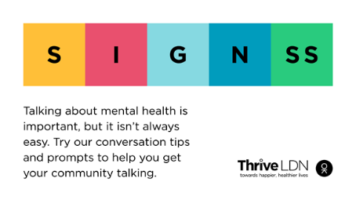
Instagram | Talking about mental health is important, but it isn’t always easy. But as we begin to recover from the pandemic, these conversations are so important.  @ThriveLDN's new conversation starter tool is designed to support you to engage in mental health conversations.  Led by psychologist and public health specialist Dr Pamela Nkyi and developed through engagement with community leaders across London, SIGNSS aims to normalise conversations about mental health.  Follow the link in @ThriveLDN’s bio.  #SIGNSS #CreateTheSpace #GetTalking #LetsTalkMentalHealth #MentalHealthAwarenessWeek | 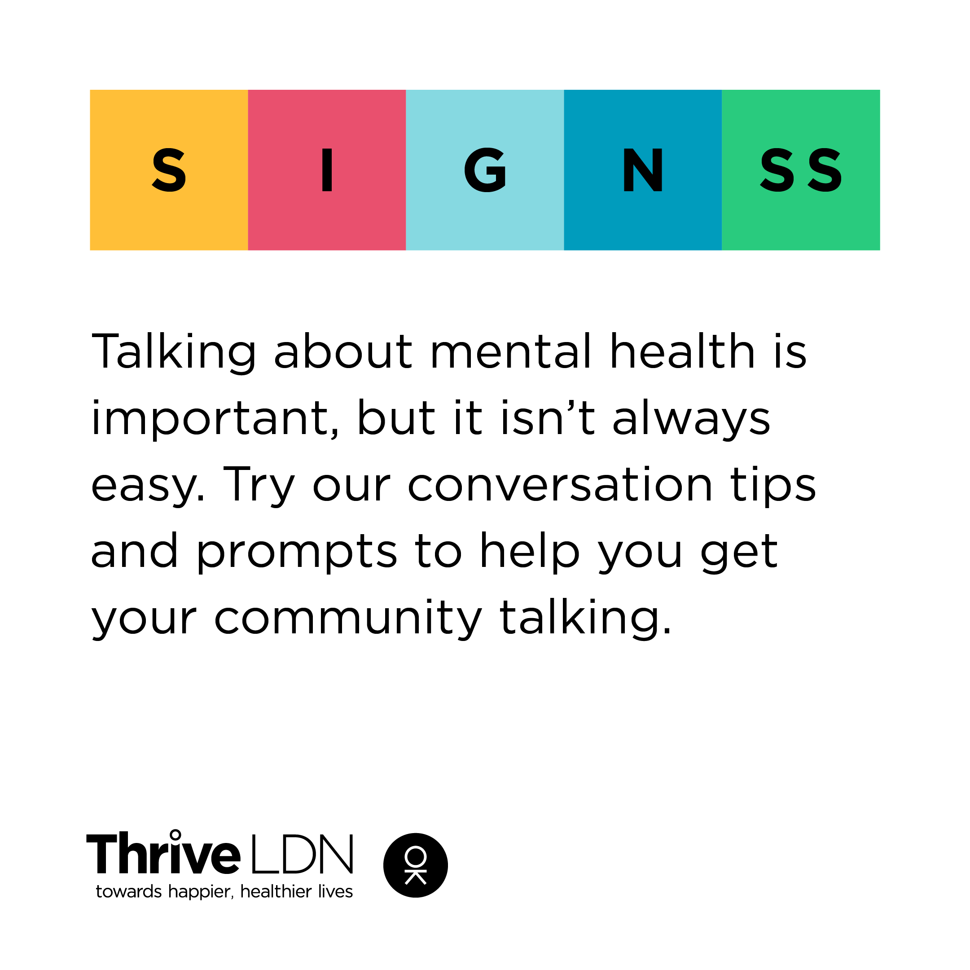  Move images avaialble from Thrive LDN’s Dropbox
Facebook | Talking about mental health is important, but it isn’t always easy. @ThriveLDN's new conversation starter tool is designed to support faith and community leaders to engage in mental health conversations with their members.  Led by psychologist and public health specialist Dr Pamela Nkyi and developed through engagement with community leaders across London, SIGNSS aims to normalise conversations about mental health.  www.thriveldn.co.uk/resources/thrive-ldn-mental-health-conversation-starter/ | 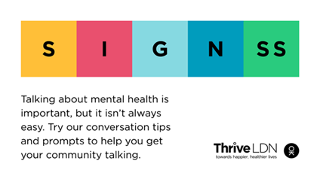  Accounts to tag: @thriveldn

Building Londoners’ emotional resilience (resources include BSL interpretation)
A fundamental part of the public mental health response to the pandemic needs to be continuing to normalise what Londoners’ are experiencing and supporting them build on the strength and resilience they already have. The following can be used over the coming month for what may be a challenging period as we approach anniversary points of the pandemic.
To download high quality images and videos: Right click the image and select ‘open link’ to download a full-size image to use across digital channels.
All resources are also available to download directly from the Thrive LDN Comms Toolkit Dropbox account: https://www.dropbox.com/sh/bfio0xcbfp87w4b/AAAVXBbp-Xt78PNEAvXV5hyFa?dl=0
Building Emotional Resilience with Dr Radha – now with BSL
Twitter | As lockdown restrictions ease, we can all build our resilience to help us bounce back and adapt to stressful and changing circumstances.  @ThriveLDN & NHS GP @DrRadhaModgil have created a short 20-minute video on how to keep your resilience 'topped up'.  www.thriveldn.co.uk/resources/emotional-resilience | Static image: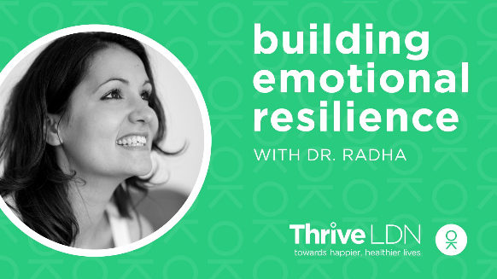  Or video:  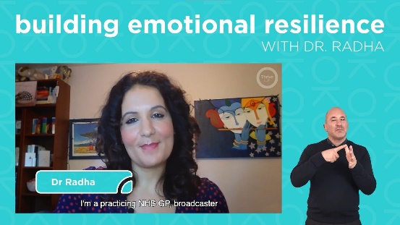
Instagram | For some of us, the easing of lockdown and the return to ‘normal’ will understandably be stressful.  @ThriveLDN have worked with @dr_radha on a short video to share tools, tips and Londoners’ experiences on what we can all do to help boost our resilience and adapt to stressful and changing circumstances.  Link available via @ThriveLDN or www.thriveldn.co.uk/emotionalresilience  Also available in #BritishSignLanguage #BSL | Static image:  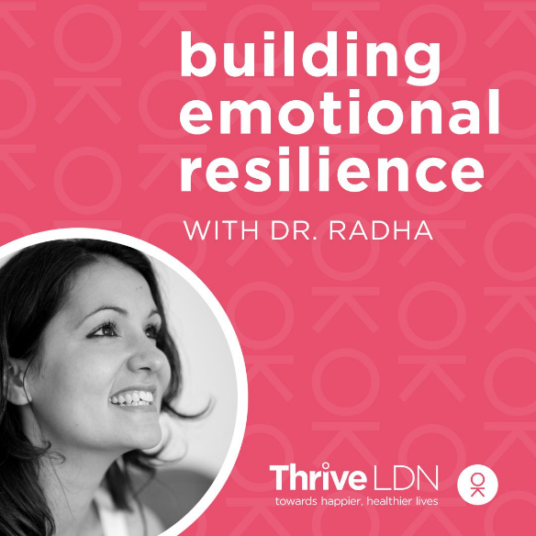  Or video:  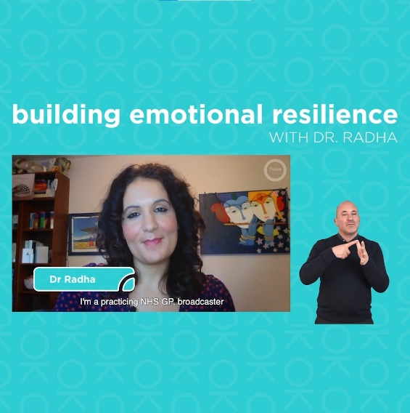
Facebook | For some of us, the easing of lockdown and the return to ‘normal’ will understandably be stressful.  Thrive LDN have worked with NHS GP and wellbeing export, Dr Radha Modgil, on a short video to share tools, tips and Londoners’ experiences on what we can all do to help boost our resilience and adapt to stressful and changing circumstances.  www.thriveldn.co.uk/emotionalresilience  Also available in #BritishSignLanguage #BSL | Static image:  Or video:

Suicide prevention training
To download high quality images and videos: Right click the image and select ‘open link’ to download a full-size image to use across digital channels.
All resources are also available to download directly from the Thrive LDN Comms Toolkit Dropbox account: https://www.dropbox.com/sh/bfio0xcbfp87w4b/AAAVXBbp-Xt78PNEAvXV5hyFa?dl=0
Twitter | Living and working in London can be stressful, and right now for some it may be overwhelming. Would you be able to spot a colleague or friend in distress? There’s FREE @Zer0Suicide online training to help.  Visit 👉 www.thriveldn.co.uk/zerosuicideldn  #ZeroSuicideLDN | #ZeroSuicideLDN campaign collateral  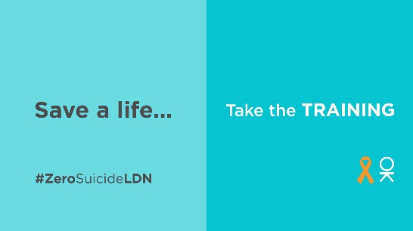
Instagram | Living and working in London can be stressful, and right now for some it may be overwhelming. Would you be able to spot a colleague or friend in distress? There’s FREE online training provided by the @zerosuicidealliance to help.  Visit 👉 thriveldn.co.uk/zerosuicideldn  Save a life... take the training today.  #ZeroSuicideLDN #London #LifeInLondon #WeAreLDN #OKLDN #SuicidePrevention #Teamwork #Together #ZeroSuicideAlliance #Londoners #MentalHealth #OnlineTraining | #ZeroSuicideLDN campaign collateral  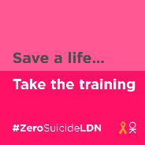
Facebook | Living and working in London can be stressful, and right now for some it may be overwhelming. Would you be able to spot a colleague or friend in distress? There’s FREE online training provided by the Zero Suicide Alliance to help.  Visit 👉 thriveldn.co.uk/zerosuicideldn  Save a life... take the training today.  #ZeroSuicideLDN #London #LifeInLondon #WeAreLDN #OKLDN #SuicidePrevention #Teamwork #Together #ZeroSuicideAlliance #Londoners #MentalHealth #OnlineTraining | #ZeroSuicideLDN campaign collateral  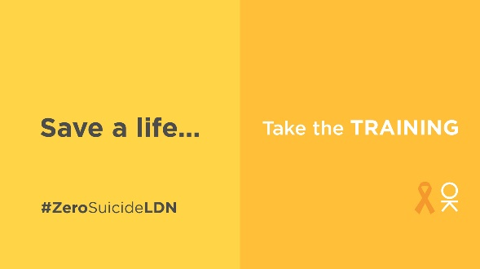  Partner accounts to tag:  Thrive LDN  Zero Suicide Alliance  Mayor of London

Suggested content for web and newsletters
- Standard text for newsletters and/or offline copy
This standard text can be adapted for e-newsletters and bulletins. We advise that it becomes a standing item during periods when more restrictive safety measures are in place as people experience heightened anxiety. Below is both a full and concise post.
Short videos to support this content are available from our Communications Dropbox

[CONCISE – 70 words] Resources to help your mental health and wellbeing
Easing out of lockdown will allow us to get back to the people and things we love, but it's OK if you feel worried about going ‘back to normal’.
Support is available through a range of free resources and online tools to help you cope and stay mentally well. If you need urgent help or feel more comfortable talking to someone you don’t know, then use one of the following helplines.
[FULL – 200 words] Resources to help your mental health and wellbeing
Easing out of lockdown will allow us to get back to the people and things we love, but it's OK if you feel worried about going "back to normal". Feelings of post-lockdown anxiety are likely to pass with time as we get used to the ‘new normal’ but it's important to do what we can to take care of our mental health.
The NHS’ Every Mind Matters website has tips to cope with anxiety about coming out of lockdown.
Remember, there is support available for whatever you are going through. In London, there is a range of support available now from Good Thinking, Thrive LDN, and NHS wellbeing webinars.
Or if you feel more comfortable talking to someone you do not know, then try the following helplines:
- Samaritans are here when life is difficult. They won’t judge you or tell you what to do, they’re here to listen so you don’t have to face it alone. Call the free, 24-hour listening service on 116 123.
- Shout is the UK 's first 24/7 text messaging service for anyone in crisis. Text Shout at any time to 85258 to start a conversation with a trained volunteer.

