PUBLIC MENTAL HEALTH RESPONSE TO COVID-19: THRIVE LDN COMMUNICATIONS TOOLKIT
Updated Monday, 20 September
Using this toolkit
Please explore the below web copy and digital messaging for your own communications to help signpost Londoners to appropriate resources and guidance during this time.
To download high quality images and videos: Right click the image and select ‘open link’ to download a full-size image to use across digital channels.
All resources are also available to download directly from the Thrive LDN Comms Toolkit Dropbox account: https://www.dropbox.com/sh/bfio0xcbfp87w4b/AAAVXBbp-Xt78PNEAvXV5hyFa?dl=0
In this document (Ctrl + Click on link to go directly to that section):
- Key messages to share on digital channels

- Never Alone LDN – Thrive LDN’s World Mental Health Day Festival 2021
- Easy-to-access wellbeing resources and tools for Londoners
- Good Thinking, London’s digital wellbeing service
- Free bereavement and loss webinars in Sept and Oct
- Support for sudden bereavement
- Suicide prevention training

Never Alone LDN – Thrive LDN’s World Mental Health Day Festival 2021
Never Alone LDN – Thrive LDN’s World Mental Health Day Festival 2021
Twitter (1) | The #NeverAloneLDN festival by @ThriveLDN brings together some of London's best young performers, panel discussions, conversations, workshops, screenings & more at @RichMixLondon.  Events run from 27th September to 10th October.  Register for FREE now 👇  www.thriveldn.co.uk/campaigns/neveraloneldn | 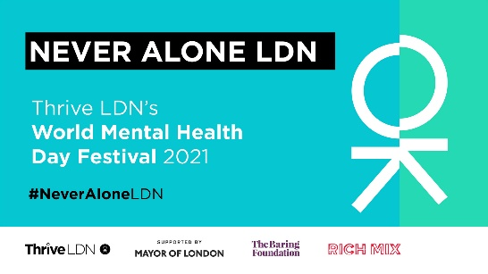  Or add a GIF
Twitter (2) | For #WorldMentalHealthDay2021, @ThriveLDN's #NeverAloneLDN festival at @RichMixLondon will be bringing together some of London's best young performers, panel discussions, conversations, workshops, screenings and much more.  More info and FREE tickets👇  www.thriveldn.co.uk/campaigns/neveraloneldn | Or add a GIF
Facebook and LinkedIn | For World Mental Health Day 2021, Thrive LDN's #NeverAloneLDN festival at Rich Mix London will be bringing together some of London's best young performers, panel discussions, conversations, workshops, screenings and much more.  There will be two full live days of action on Monday 27th September and Monday 4th October, which will be filmed and brought together into a special cinema screening and YouTube simulcast for World Mental Health Day, Sunday 10th October.  More info and FREE tickets via the Thrive LDN website 👇  www.thriveldn.co.uk/campaigns/neveraloneldn
Instagram | For World Mental Health Day 2021, @thriveldn’s Never Alone LDN festival at @richmixlondon will be bringing together some of London's best young performers, panel discussions, conversations, workshops, screenings and much more.  There will be two full live days of action on Monday 27th September and Monday 4th October, which will be filmed and brought together into a special cinema screening and YouTube simulcast for World Mental Health Day, Sunday 10th October.  More info and FREE tickets via the Thrive LDN website 👇  thriveldn.co.uk  You can also find the link in @thriveldn's bio.  #WorldMentalHealthDay #NeverAloneLDN #WorldMentalHealthDay2021 #WMHD2021 #ThriveLDN #MentalHealth #Wellbeing #Performance #LiveEvents #Cinema #PerformingArts #Discussion #Conversation | 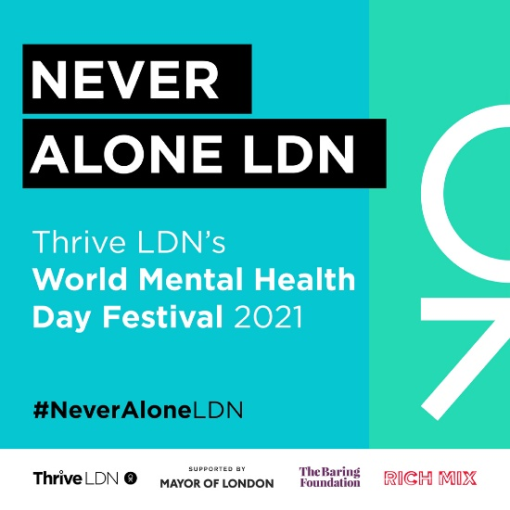
Standard text for newsletters and/or offline copy  This standard text can be adapted for websites, e-newsletters and other bulletins.  Localise text in red. | (100 words)  Join the Never Alone LDN festival this World Mental Health Day  To mark World Mental Health Day 2021, Thrive LDN is holding a festival of activities co-developed with young Londoners called Never Alone LDN. The activities look at how young Londoners can come together to overcome the challenges we face and reflect on the experiences of young Londoners during the pandemic.  Young people are encouraged to come together for a range of film screenings, live music performances, creative workshops, and panel discussions, all held at Rich Mix, east London.  The programme will see four separate free-to-attend events and highlights will also be streamed through Thrive LDN’s YouTube channel on WMHD.  (285 words)  Join the Never Alone LDN festival this World Mental Health Day  To mark World Mental Health Day 2021, Thrive LDN is holding a festival of activities co-developed with young Londoners called Never Alone LDN. The activities look at how young Londoners can come together to overcome the challenges we face and reflect on the experiences of young Londoners during the pandemic.  Young people will come together and share a message of hope through a range of film screenings, live music performances, creative workshops, and panel discussions, all held at Rich Mix, a dynamic arts centre and creative hub in the heart of east London. The activities provide an opportunity for young people to come together and highlight positive individual and collective stories.  The festival programme will see four separate free-to-attend events held at Rich Mix. Click on the links below for more information and to register:  - Monday, 27 September from 4pm: Never Alone LDN: Hear It – an afternoon featuring some of London’s best young spoken word performers, poets and musicians.  - Monday, 4 October from 12.30pm: Never Alone LDN: Speak It – an afternoon featuring panel discussions, speeches, in conversations, workshops and more.  - Monday, 4 October from 7pm: Never Alone LDN: Express It – a filmed open mic event, giving talented young Londoners a chance to perform on stage.  - Sunday, 10 October from 3.30pm: Never Alone LDN: See It – a film screening that brings together performances, panels discussions and conversations filmed over the series of Never Alone LDN events, to celebrate World Mental Health Day.  - Sunday 10 October from 4pm: Never Alone LDN: See It (online) - For those who cannot make it to Rich Mix, register to receive the simulcast link and information about the festival directly.  For all information and the latest line up, visit Thrive LDN’s website.

World Mental Health Day 2021 sees CLASP’s Walking Out of Darkness event return
Also on World Mental Health Day, Thrive LDN is a supporting partner for mental health charity CLASP’s Walking Out of Darkness event.
The charity walk will start at 10am from Battersea Park, London, on Sunday, 10 October 2021.
This year’s Walking Out of Darkness walk is dedicated to mental health charities across London. The event’s aim is to unite people to assist, fundraise and support mental health charities. Participants can choose a charity of their choice to fundraise for or simply just join people from around the country, walking in unity across London.
Read more about this here.
Help promote the event by quickly resharing on social media: Twitter, Instagram, Facebook.

Wellbeing resources and tools for Londoners
Thrive LDN has launched a new dedicated space on its website, packed with resources to help promote positive mental wellbeing for individuals and for those wanting to find out how to support others.
It is an easy-to-access one-stop of wellbeing resources and tools for Londoners. It has been designed around those factors we know protect mental health, from taking care of yourself, and maintaining social contacts, to creativity and being in nature. It also includes first-hand stories from people sharing their own experiences and some of the difficulties and challenges they have faced.
A fundamental part of the public mental health response to the pandemic needs to be continuing to normalise what Londoners are experiencing and supporting them build on the strength and resilience they already have. Please use this new area of the Thrive LDN website to support this.
To download high quality images and videos: Right click the image and select ‘open link’ to download a full-size image to use across digital channels.
All resources are also available to download directly from the Thrive LDN Comms Toolkit Dropbox account.
General wellbeing resources
Twitter 1 | As we begin to recover from the pandemic, however you’re feeling right now is valid.  Whether you’re looking for yourself, or to help a friend or others in your community, @ThriveLDN has simple tools, ideas and inspiration to help improve our wellbeing.  https://thriveldn.co.uk/help-yourself-and-others | 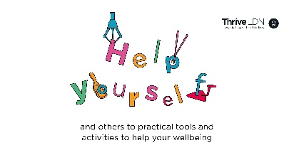
Facebook / LinkedIn | As we begin to recover from the pandemic, however you’re feeling right now is valid.  Thrive LDN has created a space to help promote your mental wellbeing or find out how to support others.  Building on insights learned during the pandemic, it’s packed with resources and tools for Londoners, designed around those factors we know protect mental health, from taking care of yourself, and maintaining social contacts, to creativity and being in nature. You’ll also find first-hand experiences from people sharing how they have overcome the challenges they have faced.  Whether you’re looking for yourself, or to help a friend or others in your community, explore simple tools, ideas and inspiration, tried and tested to help improve wellbeing.  Find out more 👇  https://thriveldn.co.uk/help-yourself-and-others | 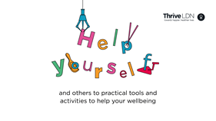  Accounts to tag: @thriveldn
Instagram | As we begin to recover from the pandemic, however you’re feeling right now is valid.  @ThriveLDN has created a space to help promote your mental wellbeing or find out how to support others.  Building on insights learned during the pandemic, it’s packed with resources and tools, designed around those factors we know protect mental health, from taking care of yourself, and maintaining social contacts, to creativity and being in nature. You’ll also find first-hand experiences from people sharing how they have overcome the challenges they have faced.  Whether you’re looking for yourself, or to help a friend or others in your community, explore simple tools, ideas and inspiration, tried and tested to help improve wellbeing.  Find out more 👇  Follow the link in @ThriveLDN’s bio. | Square (feed):  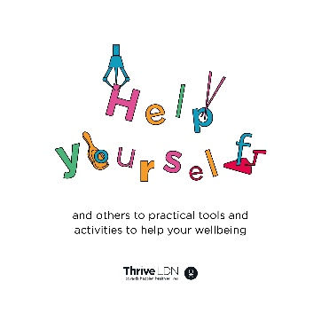  Tall (stories):  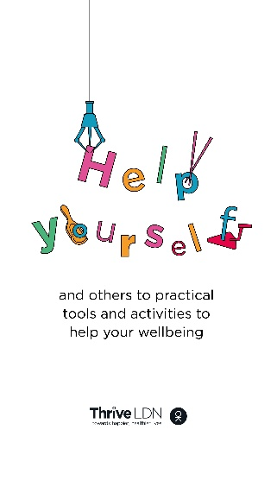
Standard text for newsletters and/or offline copy  This standard text can be adapted for websites, e-newsletters and other bulletins.  Localise text in red. | 300 words: STARTS  Find ideas, inspiration, and resources to help yourself and others with Thrive LDN  For many of us, the pandemic has been the most challenging period of our lives. The effects of the covid crisis continue to have an impact on many people’s mental health and wellbeing.  For some, the return to ‘normal life’ may bring its own concerns and anxieties. It is also understandable if you’re feeling worried about the future. You may also be concerned for others in your family or neighbourhood.  As London begins to recover, however you’re feeling right now is valid.  Public conversations around mental health have come a long way in recent years but there is still so much further to go. To help Londoners and communities at this time, Thrive LDN – the citywide mental health and wellbeing movement – has launched a dedicated space on its website to help promote positive mental wellbeing, both for individuals but also for those looking out for others in the community.  Whether looking for yourself, or to help a friend or others in your community, you can find ideas, inspiration, and resources to help improve wellbeing. The tools and resources focus on things that enable good wellbeing, from social connections, keeping active and self-care, to tools for those volunteering in the community.  Thrive LDN also building from insights learned throughout the pandemic, and provide a space to share Londoners’ experiences and to raise challenges which people have faced for supporting their mental health and wellbeing.  [Local spokesperson] said: “We know the factors that help our wellbeing. Positive parenting early in life, strong social connections and a sense of belonging all protect our mental health and help us bounce back from adversity. There are other factors, perhaps less well known, that boost our wellbeing – taking care of ourselves, keeping active, being in nature, expressing our creativity.”  ENDS  115 words: STARTS  Find ideas, inspiration, and resources to help yourself and others  Many people are finding the effects of the pandemic continue to impact their mental health. To help people build resilience, Thrive LDN has launched a new dedicated space on its website, packed with resources to help promote positive mental wellbeing for individuals and for those wanting to find out how to support others.  It is an easy-to-access range of wellbeing resources and tools for Londoners. It has been designed around those factors we know protect mental health and also includes first-hand stories from people sharing their own experiences and some of the difficulties and challenges they have faced.  Explore everything on the Thrive LDN website.  ENDS

Good Thinking – London’s digital wellbeing service
Twitter | When times are uncertain or things are changing, it is perfectly normal to feel worried.  London’s digital wellbeing service, @GoodThinkingUK, has a range of free apps & resources to help if you have anxiety, low mood, sleeping difficulties or stress.  ➡️ www.good-thinking.uk | 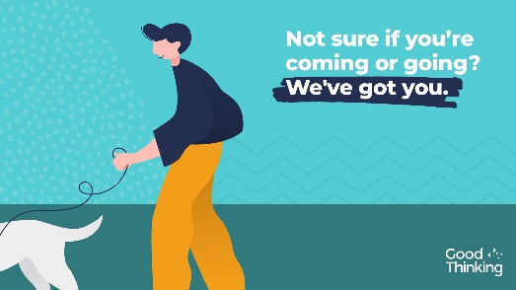  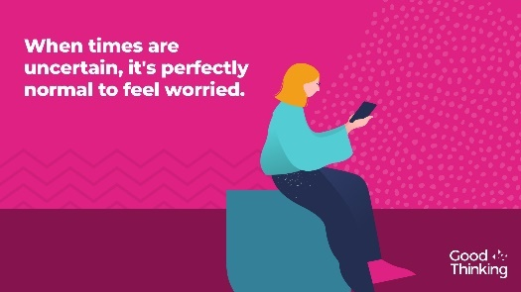
Instagram | When times are uncertain or things are changing, it is perfectly normal to feel worried.  London’s digital wellbeing service, @goodthinkinguk, provides a range of free apps, blogs, videos and resources to help if you have anxiety, low mood, sleeping difficulties or stress.  ➡️ www.good-thinking.uk  #MentalHealth #Wellbeing #London #Londoners #Support | 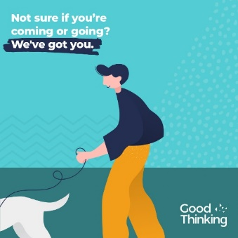  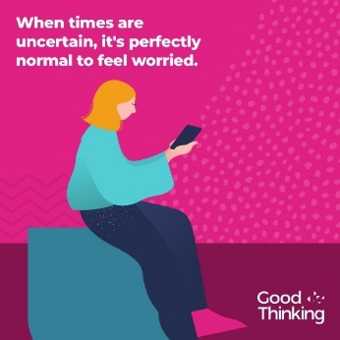
Facebook | When times are uncertain or things are changing, it is perfectly normal to feel worried.  London’s digital wellbeing service, Good Thinking, provides Londoners with a range of free apps and resources to help if you have anxiety, low mood, sleeping difficulties or stress.  ➡️ www.good-thinking.uk

Free bereavement and loss webinars in Sept and Oct
To download high quality images and videos: Right click the image and select ‘open link’ to download a full-size image to use across digital channels.
All resources are also available to download directly from the Thrive LDN Comms Toolkit Dropbox account.
Twitter | During Sept and Oct, join a free-to-attend, @CruseCare one-hour webinar on Bereavement and Loss Awareness.  The webinars are designed to boost knowledge and confidence for those who encounter bereaved people in the course of their jobs or voluntary roles.  https://thriveldn.co.uk/resources/bereavement-webinars | Twitter  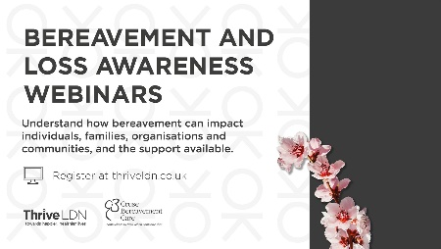
Facebook and LinkedIn | If you or colleagues are supporting those who are bereaved or in a frontline or community role, you may find it hard to find the right words or know what to say.  To support you, Thrive LDN is working in partnership with Cruse Bereavement Care to deliver free, one-hour webinars on Bereavement and Loss Awareness during September and October.  Registration is free, via the Thrive LDN website: https://thriveldn.co.uk/resources/bereavement-webinars/  Dates  - Thursday 23rd September, 2.00pm  - Tuesday 28th September, 11.00am  - Wednesday 6th October, 11.00am  - Wednesday 13th October, 2.00pm [this session will have live British Sign Language interpretation] | Facebook and LinkedIn
Instagram | If you or colleagues are supporting those who are bereaved or in a frontline or community role, you may find it hard to find the right words or know what to say.  To support you, Thrive LDN is working in partnership with Cruse Bereavement Care to deliver free, one-hour webinars on Bereavement and Loss Awareness during September and October.  Registration is free, via the @ThriveLDN website.  By joining one of the five available sessions, you can better understand how bereavement impacts individuals, families, organisations and communities – and the support available.  #MentalHealth #Bereavement #Grief #Support #London #Community #WorkplaceTraining #Frontline #Webinar #BritishSignLanguage #BSL | Instagram  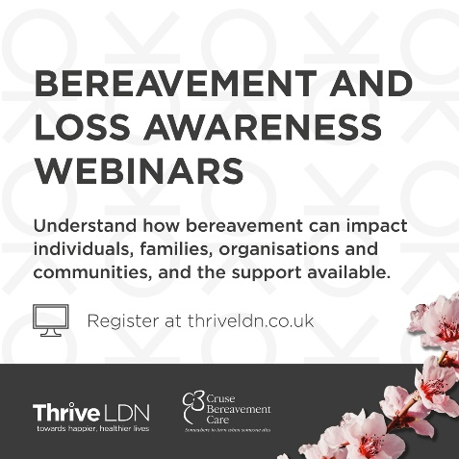
Support for sudden bereavement
To download high quality images and videos: Right click the image and select ‘open link’ to download a full-size image to use across digital channels.
All resources are also available to download directly from the Thrive LDN Comms Toolkit Dropbox account.
Twitter | Bereavement is one of the most challenging things that we can experience, affecting us all.  If you find that you’re struggling with your grief, @ThriveLDN’s website also has a range of resources that can help 👇  https://thriveldn.co.uk/campaigns/london-remembers/ | 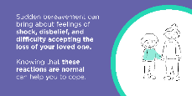  Other images available within the Thrive LDN Comms Toolkit Dropbox
Instagram | Bereavement is one of the most challenging things that we can experience, affecting every one of us.  Many of us will have been affected by losing someone close to us or someone we know over the past year. But remember, there is no one way to grieve.  For each and every one of us, our journey of grief will be unique. There are no rules about how you should feel, or how long it will take. Emotions do not follow each other in a tidy line.  If you find that you’re struggling with your grief, please talk to someone about getting professional support. Thrive LDN’s website also has a range of resources that can help.  Visit @ThriveLDN for a range of resources that can help. | 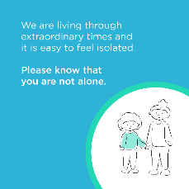  Other options available within the Thrive LDN Comms Toolkit Dropbox

Suicide prevention training
To download high quality images and videos: Right click the image and select ‘open link’ to download a full-size image to use across digital channels.
All resources are also available to download directly from the Thrive LDN Comms Toolkit Dropbox account: https://www.dropbox.com/sh/bfio0xcbfp87w4b/AAAVXBbp-Xt78PNEAvXV5hyFa?dl=0
Twitter (1) | We all need to look out for one another. That's why we are supporting #ZeroSuicideLDN to encourage everyone to take free, online training to know what to do if a loved one, colleague, or stranger is in crisis.  Learn to save a life today...  Visit 👉 www.thriveldn.co.uk/ZeroSuicideLDN | 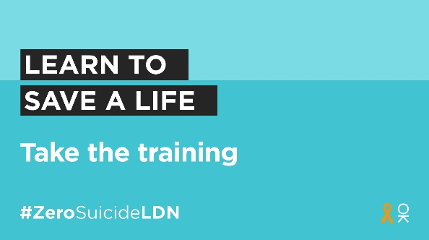
Twitter (2) | Living and working in London can be stressful, and right now for some it may be overwhelming.  Would you be able to spot a colleague or friend in distress? There’s FREE @Zer0Suicide online training to help.  Visit 👉 www.thriveldn.co.uk/zerosuicideldn  #ZeroSuicideLDN | 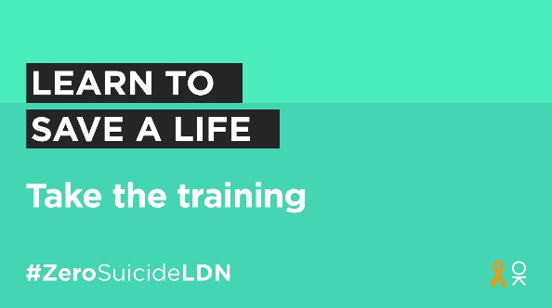
Twitter (3) | It’s never been more important to think and talk more about mental health. That’s why we are taking @Zer0Suicide’s free suicide prevention training, to learn what to do if a loved one, colleague, or stranger is at risk of suicide.  You can too. Visit 👉 www.thriveldn.co.uk/zerosuicideldn | 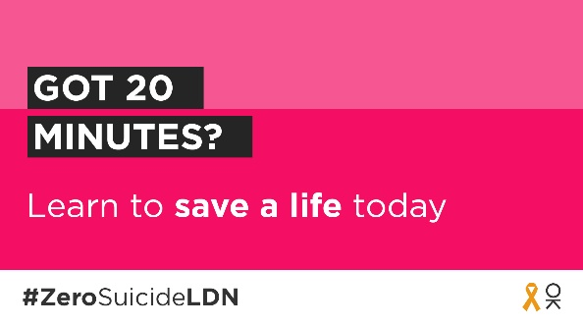
Instagram | Living and working in London can be stressful, and right now for some it may be overwhelming. Would you be able to spot a colleague or friend in distress? There’s FREE online training provided by the @zerosuicidealliance to help.  Visit 👉 thriveldn.co.uk/zerosuicideldn or find details in @ThriveLDN bio.  Learn to save a life today...take the training.  #ZeroSuicideLDN #London #LifeInLondon #WeAreLDN #OKLDN #SuicidePrevention #Teamwork #Together #ZeroSuicideAlliance #Londoners #MentalHealth #OnlineTraining | 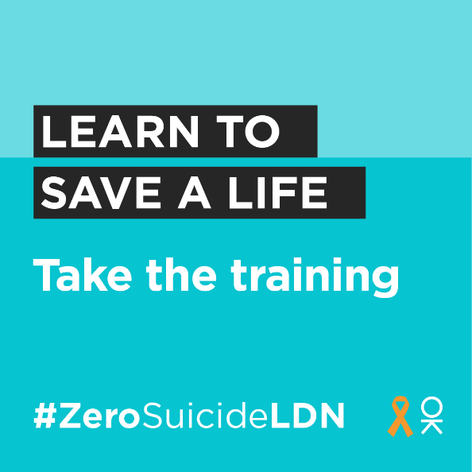
Facebook | Living and working in London can be stressful, and right now for some it may be overwhelming. Would you be able to spot a colleague or friend in distress?  That is why we want to encourage Londoners to take the Zero Suicide Alliance’s free, online training to know what to do if a loved one, colleague or stranger is in crisis.  Learn to save a life today...take the training. Visit: www.thriveldn.co.uk/zerosuicideldn | 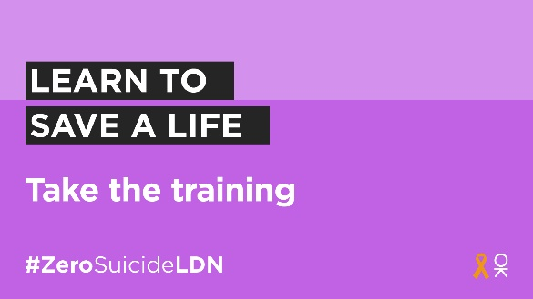  Partner accounts to tag:  Thrive LDN  Zero Suicide Alliance  Mayor of London
LinkedIn | It’s never been more important to think and talk more about mental health. The Zero Suicide Alliances free suicide prevention training is a really helpful way to learn what to do if a loved one, colleague, or stranger is in a crisis or at risk of suicide.  Learn to save a life today, visit Thrive LDN’s website for more details: www.thriveldn.co.uk/zerosuicideldn
Standard text for newsletters and/or offline copy  This standard text can be adapted for websites, e-newsletters and other bulletins.  Localise text in red. | More than 250,000 Londoners have accessed suicide prevention training as part of the #ZeroSuicideLDN campaign  Suicide is the leading cause of death in people aged 15–29, and the biggest killer of men under 49 in the UK. In London, the sad truth is suicide is the cause of death of around 12 Londoners every week.  Launched in September 2019, to mark World Suicide Prevention Day, the citywide #ZeroSuicideLDN campaign has seen more than a quarter of a million people across the capital access free, online suicide prevention training.  Developed by the Zero Suicide Alliance, the free, online training takes around 20 minutes to complete and is designed to show how to have a direct and honest conversation about suicide and mental health with friends and family. The training also helps to break the stigma of talking about mental health, suicidal thoughts and bereavement.  [Local spokesperson] said: “[Organisation] has supported the #ZeroSuicideLDN campaign and we want to help it go even further. Please don’t just take the free 20 minute online training, but tell your friends and families about it too.  “We know that living and working in London can be stressful, and right now for some it may be overwhelming. That is why we want to encourage as many people as possible to take free, online training to know what to do if a loved one, colleague or stranger is in crisis.”  Dr Jacqui Dyer MBE, mental health equalities advisor for NHS England and co-lead of Thrive LDN, said: “Through the Zero Suicide London campaign, we have helped more than a quarter of a million Londoners know that there is nothing to be feared in talking about suicide and mental health. By doing so, we are working towards a city that is stigma free, where people can have a more direct and honest conversation about suicide with fellow Londoners in a safe and sensitive way.  “World Suicide Prevention Day is an opportunity to remember that it has never been more important for each of us to think and talk more about mental health and wellbeing. Especially considering the challenges so many Londoners have faced because of the pandemic.  “Together, by encouraging even more Londoners to take the Zero Suicide Alliance’s free online training, we can support people to talk openly about suicide and suicide bereavement.”  To find out more about these resources and the suicide prevention training, visit www.thriveldn.co.uk/zerosuicideldn.
Newsletter copy  100 words | This World Suicide Prevention Day take free, online training and be prepared to save a life  We know that living and working in London can be stressful, and right now for some it may be overwhelming. That is why we want to encourage Londoners to support the #ZeroSuicideLDN campaign and take free, online training to know what to do if a loved one, colleague or stranger is in crisis.  World Suicide Prevention Day is an opportunity to remember that it has never been more important for each of us to think and talk more about mental health and wellbeing. Especially considering the challenges so many Londoners have faced because of the pandemic.  For full details visit: www.thriveldn.co.uk/campaigns/zerosuicideldn

New resource to support witnesses of suicide
Research suggests that around a third of suicides take place outside the home, in a public location. This means that the impact of suicide can reach far beyond friends and family to those who may have been at, or first to, the location.
Thrive LDN, the regional lead in London for suicide prevention, has teamed up with the Support after Suicide Partnership (SASP) and Grassroots in Brighton to develop First Hand, a resource for anyone affected by witnessing a suicide, when they did not know the person who has died.
The new resource is now available as a digital download from the SASP website. Additionally, World Suicide Prevention Day sees the launch of a new website, developed by Grassroots, which covers the content of the resource and more, visit www.first-hand.org.uk to explore further.
Please include the below in your communications scheduling on WSPD and adapt for longer term promotion.
Twitter | First Hand has been developed by @ThriveLDN, @AfterSuicideUK and @GrassrootsSP to support anyone who has witnessed the suicide of someone they do not know.  If this is you, please know that there is help and support available to you, you’re not alone: www.supportaftersuicide.org.uk/resource/first-hand/
Facebook / LinkedIn | “If you've never experienced trauma before, you've got no idea how your body or your mind is going to react to it. It's so important that you communicate with people. It can be quite a scary thing to go through and the more support you can get, the safer you're going to be.”  Jack witnessed a suicide on his way to work in London. If this has happened to you, you can find advice and support in First Hand.  First Hand is a new resource for anyone affected by witnessing a suicide, when they did not know the person who has died. This may be because someone happened to be at a particular location, or because their job involves responding to these incidents.  Download from www.supportaftersuicide.org.uk/resource/first-hand/.
Standard text for newsletters and/or offline copy | Support for anyone who witnesses a suicide  First Hand is a new resource for anyone affected by witnessing a suicide, when they did not know the person who has died. This may be because someone happened to be at a particular location, or because their job involves responding to these incidents.  Witnessing a suicide is stressful and traumatic. The brain’s response to this can lead to physical and emotional changes that can affect everyone differently. There is no ‘right’ way to feel and to react, just as there is no set timetable for when you will have your strongest response.  People who have experienced this, and the professionals who take care of them, have shared some advice:  - Take each day as it comes and allow yourself as much time as you need to process and recover.  - Look after yourself, try to stick to a routine of sleeping and eating. Get fresh air and stay active. Avoid drugs and alcohol as a way to cope.  - Talk to others. If you do not want to talk to people you know, or the incident happened at work and you do not want to talk to managers, there are many organisations who are there to support you, listed in First Hand.  - Most people will be able to recover and move on. If that doesn’t happen for you, talk to your GP. You might find that you are still having strong reactions some weeks after the incident, or you might be struggling to get back into your normal routine. Your GP will be able to help to work out what else you might need to recover.  Finally, remember that you are not alone. Many people talk of just how stressful and upsetting it can be and through their words and with their guidance, First Hand collects advice and information that we hope can help and support you – now and in the future.  Simon Blake OBE, chair of Support after Suicide Partnership, said: “We were delighted to work with Thrive LDN and Grassroots to develop this guidance for people who have witnessed a suicide. Recent years have seen the development of support for families and friends who have been bereaved by suicide, but for those impacted by the suicide of someone they did not know, there has been a huge gap in understanding and help. We hope that First Hand is just the start of more conversations about the impact of witnessing a suicide and particularly for those who face this as part of their daily working life.”  Download First Hand from Support after Suicide Partnership. You can find more resources to support your wellbeing on the Thrive LDN website.  If you feel that you need help straight away, or you feel very distressed, please contact our friends at Samaritans on 116 123. They have a huge amount of experience in listening to and helping people like you. They are always open and calling is free of charge.
Newsletters/ intranet | New resource available to support people who witness a suicide  Research suggests that around a third of suicides take place outside the home, in a public location. This means that the impact of suicide can reach far beyond friends and family to those who may have been at, or first to, the location.  Thrive LDN, the regional lead in London for suicide prevention, has teamed up with the Support after Suicide Partnership (SASP) and Grassroots in Brighton to develop First Hand, a resource for anyone affected by witnessing a suicide, when they did not know the person who has died.  First Hand aims to support people to make sense of their physical and psychological reactions after what is a traumatic and shocking experience. It has been developed together with people with lived experience, both in their day to day lives and in their professional duties.  Download First Hand from Support after Suicide Partnership. You can find more resources to support your wellbeing on the Thrive LDN website.

