THRIVE LDN COMMUNICATIONS TOOLKIT
Updated Tuesday, 10 May
About this toolkit
We have designed this toolkit for London partners, including health and care organisations, local authorities, and third sector organisations. This is a resource for you to adapt and to use locally when communicating to the general public about available resources and services to support resilience, mental health and wellbeing.
Using this document
Please explore the copy and digital messaging below for your own communications to help signpost Londoners to appropriate resources and guidance during this time.
To download high quality images and videos: Right click the image and select ‘open link’ to download a full-size image to use across digital channels.
All resources are also available to download directly from the Thrive LDN Comms Toolkit Google Drive account.
About Thrive LDN
Thrive LDN is a citywide movement to ensure all Londoners have an equal opportunity to good mental health and wellbeing. We are supported by the Mayor of London and London Health Board partners.
As part of our role, we coordinate public mental health communications and campaigns across the capital to support all Londoners to access information, advice and support which supports their mental health and wellbeing.
For any queries about this pack, please contact Thrive LDN Digital Communications Lead, Glyn Cridland (020 8148 5130 / glyn.cridland@nhs.net).
In this document (Ctrl + Click on link to go directly to that section):

Mental Health Awareness Week – loneliness
- Support for those experiencing loneliness
- Thrive LDN panel discussion – before Thursday 12th February
Tools, ideas and inspiration for better wellbeing linked to protective factors
- Tools, ideas and inspiration for better wellbeing linked to protective factors

Helping with displaced Ukrainians’ concerns or worries
- Helping with displaced Ukrainians’ concerns or worries

SIGNSS – a mental health conversation starter
- SIGNSS – a mental health conversation starter

General signposting support for Londoners
- Building Emotional Resilience with Dr Radha – now with BSL
- Support for Young Londoners
- Support with money worries
- Normalising Londoners’ experience

Zero Suicide LDN - suicide prevention training
- Zero Suicide LDN

Standard text/copy for newsletter and websites
- Standard text/copy for newsletter and websites

Mental Health Awareness Week - loneliness
The following messages have been developed for immediate use.
Mental Health Awareness Week (MHAW) is an annual event hosted by the Mental Health Foundation. Taking place this year between 9th -15th May 2022, the theme of the week is ‘loneliness’. The week offers scope to explore the impact of loneliness and the role our communities and connections with others can play in tackling the epidemic of loneliness.
You can find more information about the week on the Mental Health Foundation’s website
Support for those experiencing loneliness
Twitter 1 | We all get lonely at some point. To help ease that feeling, you can try:  👋 Waving at your neighbours  🤳 Video calling family  🍃 Taking a stroll with a friend  📞 If talking to a friendly stranger is easier, call 24/7:  @TheSilverLineUK on 0800 4708090  @samaritans on 116 123 | 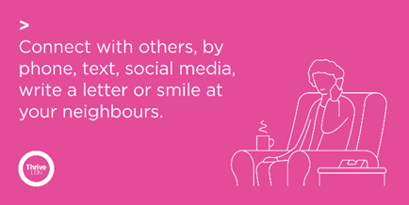
Twitter 2 | There’s no need to feel alone. Help is available from @NHSVolResponder for those who need it or are finding it hard.  If you, or someone you know or someone you care for, would like to register for support, then:  1⃣ Call 0808 196 3646 (8am to 8pm)  2⃣ Visit https://nhsvolunteerresponders.org.uk/services | 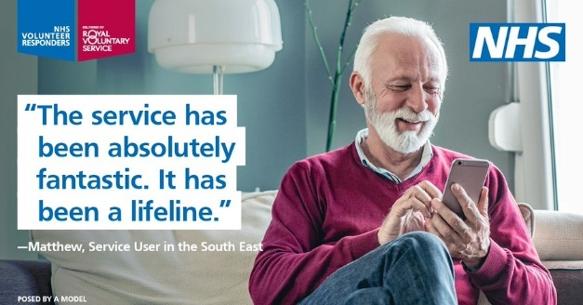
To download high quality images and videos: Right click the image and select ‘open link’ to download a full-size image to use across digital channels. All resources are also available to download directly from the Thrive LDN Comms Toolkit Google Drive account.

Thrive LDN panel discussion – before Thursday 12th February
For Mental Health Awareness week, the Greater London Authority (GLA), in partnership with Thrive LDN, is holding an event to explore loneliness in the context of the cost of living crisis in London.

This event will explore the link between financial hardship and loneliness and how actors in London can help reduce and prevent rises in severe loneliness and negative impacts on mental health and wellbeing as many Londoners face a cost of living crisis.
Twitter | To support this year's #MentalHealthAwarenessWeek of loneliness @LDN_Health, @ThriveLDN and @neighbourlylab are hosting a virtual panel discussion on loneliness in the context of the cost of living crisis in London.  📅 Thursday 12th May, 11.00am  ℹ️ +🎟️ https://thriveldn.co.uk/campaigns/mhaw2022/ | 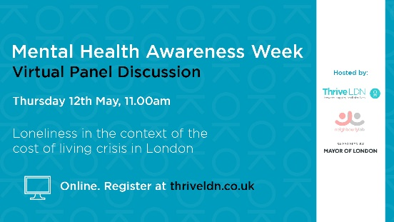
Facebook | For #MentalHealthAwarenessWeek, the Greater London Authority (GLA), in partnership with Thrive LDN and Neighbourly Lab, is holding an event to explore loneliness in the context of the cost of living crisis in London.  This event will explore the link between financial hardship and loneliness and how actors in London can help reduce and prevent rises in severe loneliness and negative impacts on mental health and wellbeing as many Londoners face a cost of living crisis.  Thursday 12th May, 11.00am  + https://thriveldn.co.uk/campaigns/mhaw2022/ | 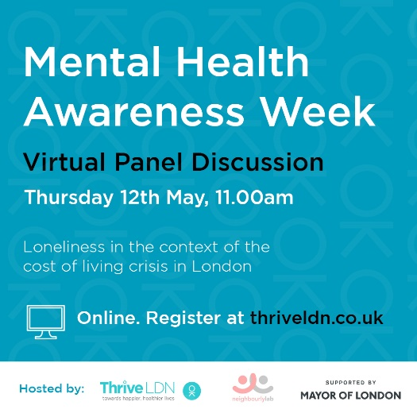
Instagram | For #MentalHealthAwarenessWeek, the Greater London Authority (GLA), in partnership with @thriveldn and Neighbourly Lab, is holding an event to explore loneliness in the context of the cost of living crisis in London.  This event will explore the link between financial hardship and loneliness and how actors in London can help reduce and prevent rises in severe loneliness and negative impacts on mental health and wellbeing as many Londoners face a cost of living crisis.  Thursday 12th May, 11.00am  - + Find the link in @thriveldn’s bio, or visit: https://thriveldn.co.uk/campaigns/mhaw2022/

Tools, ideas and inspiration for better wellbeing linked to protective factors
The following messages have been developed for immediate use.
To download high quality images and videos: Right click the image and select ‘open link’ to download a full-size image to use across digital channels. All resources are also available to download directly from the Thrive LDN Comms Toolkit Google Drive account.
Tools, ideas and inspiration for better wellbeing
Thrive LDN has a dedicated space on its website packed with resources to help promote positive mental wellbeing for individuals and for those wanting to find out how to support others. The range of resources include many from London’s digital wellbeing service, Good Thinking.

It is an easy-to-access one-stop of wellbeing resources and tools for Londoners. It has been designed around those factors we know protect mental health, from taking care of yourself, and maintaining social contacts, to creativity and being in nature. It also includes first-hand stories from people sharing their own experiences and some of the difficulties and challenges they have faced.
Twitter 1 | Right now, things may feel uncertain, and it's OK to feel anxious or worried.  Whether you’re looking for yourself, or to help a friend or others in your community, @ThriveLDN and @GoodThinkingUK have ideas and resources to help improve our wellbeing.  www.thriveldn.co.uk/help-yourself-and-others | 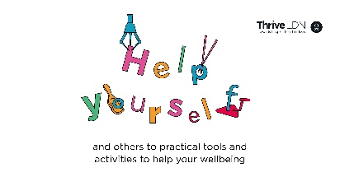
Facebook / LinkedIn | These past two years have been challenging for everyone, and every Londoner will have been affected in a different way. As things continue to feel uncertain, however you’re feeling right now is valid.  Thrive LDN has created a space to help promote your mental wellbeing or find out how to support others.  It is packed with resources and tools for you, designed around those factors we know protect mental health, from taking care of yourself, and maintaining social contacts, to creativity and being in nature. The range of resources include many from London’s digital wellbeing service, Good Thinking.  You’ll also find first-hand experiences from people sharing how they have overcome the challenges they have faced.  Whether you’re looking for yourself, or to help a friend or others in your community, explore simple tools, ideas and inspiration, tried and tested to help improve wellbeing.  Find out more: https://thriveldn.co.uk/help-yourself-and-others | Accounts to tag: @thriveldn
Instagram | These past two years have been challenging for everyone, and every Londoner will have been affected in a different way. As things continue to feel uncertain, however you’re feeling right now is valid.  @ThriveLDN has created a space to help promote your mental wellbeing or find out how to support others.  It is packed with resources and tools for you, designed around those factors we know protect mental health, from taking care of yourself, and maintaining social contacts, to creativity and being in nature. The range of resources include many from London’s digital wellbeing service, @goodthinkinguk.  You’ll also find first-hand experiences from people sharing how they have overcome the challenges they have faced.  Whether you’re looking for yourself, or to help a friend or others in your community, explore simple tools, ideas and inspiration, tried and tested to help improve wellbeing.  Find out more 👇  Follow the link in @ThriveLDN’s bio. | Square (feed):  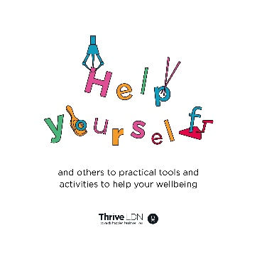  Tall (stories):  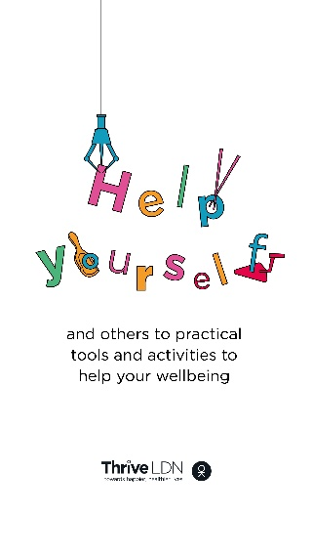

Helping with displaced Ukrainians’ concerns or worries
Many displaced Ukrainians have suffered traumatic experiences and may be feeling loss and sadness about the past, and be fearful and anxious about the future. Many will be deeply worried about other family members and friends who either haven’t been able to leave Ukraine, or are displaced elsewhere.
To help assist the many organisations continuing to support those who have been affected, Thrive LDN has put together some helpful resources & online training offers for volunteers & professionals
To download high quality images and videos: Right click the image and select ‘open link’ to download a full-size image to use across digital channels. All resources are also available to download directly from the Thrive LDN Comms Toolkit Google Drive account.
Helping with displaced Ukrainians’ concerns or worries
Twitter | Londoners have been working hard to support those affected by the Ukraine crisis, particularly displaced people settling into new lives in the UK. @ThriveLDN have put together some helpful resources & online training offers for volunteers & professionals.  https://thriveldn.co.uk/resources/supporting-wellbeing-of-displaced-ukrainians/ | 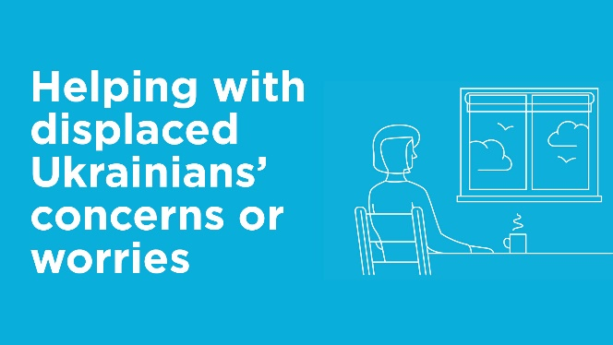
Instagram | Londoners have been working hard to support those affected by the Ukraine crisis, particularly in helping displaced people settle into new lives in the UK.  To help assist the many organisations continuing to support those who have been affected, @ThriveLDN has put together some helpful resources & online training offers for volunteers & professionals.  https://thriveldn.co.uk/resources/supporting-wellbeing-of-displaced-ukrainians/ | 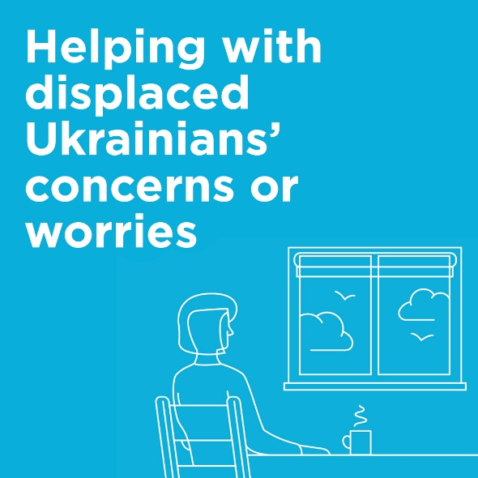
Facebook | Londoners have been working hard to support those affected by the Ukraine crisis, particularly in helping displaced people settle into new lives in the UK.  To help assist the many organisations continuing to support those who have been affected, Thrive LDN has put together some helpful resources & online training offers for volunteers & professionals.  https://thriveldn.co.uk/resources/supporting-wellbeing-of-displaced-ukrainians/
Standard text for newsletters and/or offline copy  This standard text can be adapted for websites, e-newsletters and other bulletins. | 115 words:  Resources to help support the mental health and wellbeing of Ukrainian refugees  We know that there are many people and organisations continuing to support those who have been affected by the Ukraine crisis.  Thrive LDN and partners have put together a short guide to help families in London create a safe and welcoming environment for displaced Ukrainians arriving to the UK.  Outlined in the guidance are some simple dos and don’ts, based on the experiences of other groups of refugees. The guidance highlights how kindness, patience, and empathy will be vital for creating a safe and welcoming environment and avoid the potential for further harm.  The guidance also contains further information on assisting displaced Ukrainians to access professional support, including NHS mental health and wider community support services.  https://thriveldn.co.uk/resources/supporting-wellbeing-of-displaced-ukrainians/

SIGNSS – a mental health conversation starter
Thrive LDN is delighted to present a conversation starter tool to support faith and community leaders to engage in mental health communications with their members.
The resource – SIGNSS – has been developed through engagement with community leaders across London. It aims to normalise conversations about mental health. The ultimate goal is to encourage help-seeking behaviour and signpost people to support. It has been developed for Thrive LDN by psychologist and Public Health specialist Dr Pamela Nkyi.
To download high quality images and videos: Right click the image and select ‘open link’ to download a full-size image to use across digital channels. All resources are also available to download directly from the Thrive LDN Comms Toolkit Google Drive account.
Twitter 1 | Talking about #MentalHealth is important, but it isn’t always easy.  @ThriveLDN's new community conversation starter toolkit gives you the tips and prompts to help you get your community talking 👇  www.thriveldn.co.uk/resources/thrive-ldn-mental-health-conversation-starter/  #SIGNSS #CreateTheSpace #LetsTalkMentalHealth | 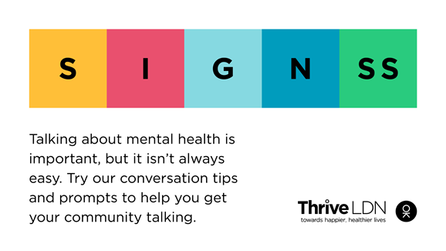
Instagram | Talking about mental health is important, but it isn’t always easy. @ThriveLDN's new conversation starter tool is designed to support faith and community leaders to engage in mental health conversations with their members.  Led by psychologist and public health specialist Dr Pamela Nkyi and developed through engagement with community leaders across London, SIGNSS aims to normalise conversations about mental health.  Follow the link in @ThriveLDN’s bio.  #SIGNSS #CreateTheSpace #GetTalking #LetsTalkMentalHealth #MentalHealthAwarenessWeek | 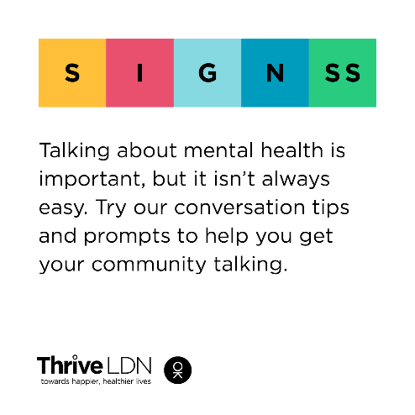
Facebook | Talking about mental health is important, but it isn’t always easy. @ThriveLDN's new conversation starter tool is designed to support faith and community leaders to engage in mental health conversations with their members.  Led by psychologist and public health specialist Dr Pamela Nkyi and developed through engagement with community leaders across London, SIGNSS aims to normalise conversations about mental health.  www.thriveldn.co.uk/resources/thrive-ldn-mental-health-conversation-starter/ | Accounts to tag: @thriveldn
General public mental health signposting
To download high quality images and videos: Right click the image and select ‘open link’ to download a full-size image to use across digital channels. All resources are also available to download directly from the Thrive LDN Comms Toolkit Google Drive account.
Building Emotional Resilience with Dr Radha – now with BSL
A fundamental part of the public mental health response to the pandemic needs to be continuing to normalise what Londoners are experiencing and supporting them to build on the strength and resilience they already have.
Twitter | As we move into the summer months, now is the perfect time for us to make active, positive changes to help improve our personal resilience and wellbeing.  @ThriveLDN's worked with NHS GP & wellbeing expert @DrRadhaModgil to give you ideas on how to stay resilient: www.thriveldn.co.uk/resources/emotional-resilience | Static image:  Or video:  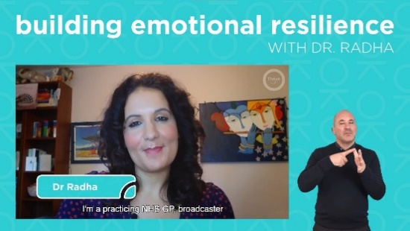
Instagram | As we move into the summer months, now is the perfect time for us to make active, positive changes to help improve our personal resilience and wellbeing.  @thriveldn has worked with NHS GP & wellbeing expert @dr_radha to give you invaluable ideas & tips on how to stay resilient.  Take 20 minutes today to learn more and hear expert advice from Dr Radha on how to stay resilient.  Link available via @ThriveLDN’s bio, or www.thriveldn.co.uk/emotionalresilience  Also available in #BritishSignLanguage #BSL | Static image:  Or video:  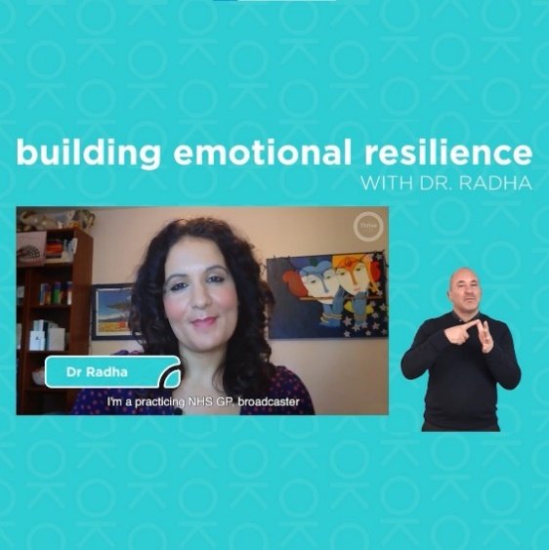
Facebook and LinkedIn | As we move into the summer months, now is the perfect time for us to make active, positive changes to help improve our personal resilience and wellbeing.  Our ability to adapt well to the stress of life, as well as being able to bounce back from adversity, crises or trauma, is often referred to as emotional resilience.  Did you know there are simple things you can do to top up your resilience reserves when you’re running low?  Take 20-minutes to learn more and hear advice from Dr Radha, NHS GP and wellbeing expert, on how to stay resilient: www.thriveldn.co.uk/emotionalresilience  Also available in #BritishSignLanguage #BSL | Static image:  Or video:  Accounts to tag: @thriveldn

Support for Young Londoners
Twitter | Young Londoners, if you need support there are people and services who are ready to help:  📢 @GoodThinkingUK - has a range of free digital wellbeing apps.  💻 @TheMixUK - support for under 25s  📲 @YoungMindsUK - text YM to 85258  📞 #Childline - call 0800 1111 | 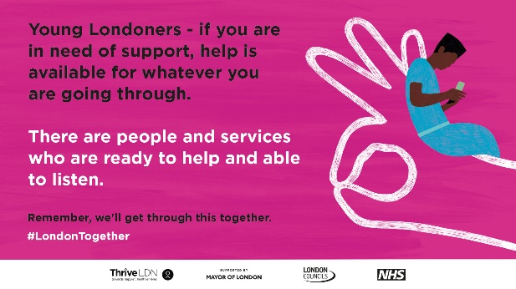
Instagram | Young Londoners - if you need support, there are people and services who are ready to help.  📲 @youngmindsuk - text YM to 85258  📞 @childline_official - call free on 0800 1111  💻 @themixuk - visit themix.org.uk  💻 @GoodThinkingUK- digital wellbeing tools  Remember, we'll get through this together.  #MentalHealth #Wellbeing  #London #HelpIsAvailable #Support  #YoungLondoners | 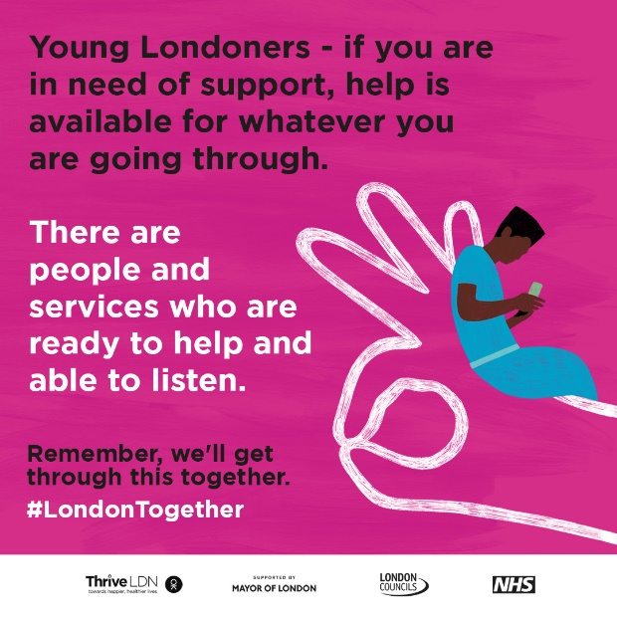

Support with money worries
Twitter 1 | For some Londoners right now, worrying about money may feel overwhelming or leaving you feeling very anxious.  If you are worried about money or need free, impartial advice, @DebtFreeLDN’s advice line is there to help 24/7.  Call 0800 808 5700 or visit http://debtfree.london | 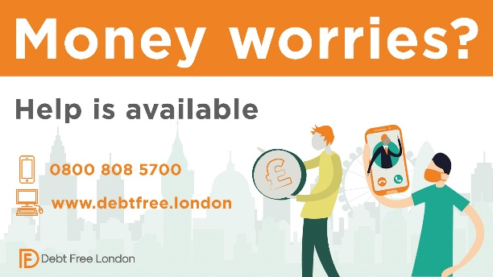
Instagram | For some Londoners right now, worrying about money may feel overwhelming or leaving you feeling very anxious.  If you are worried about money or need free, impartial advice, @debtfreeldn’s advice line is there to help 24/7.  Call 0800 808 5700 or visit debtfree.london
Facebook / LinkedIn | For some Londoners right now, worrying about money may feel overwhelming or leaving you feeling very anxious.  If you are worried about money or need free, impartial advice, Debt Free London’s advice line is there to help.  Call free on 0800 808 5700 or visit www.debtfree.london
Twitter – supporting debt and money  worries | If you are worried about money or need impartial advice, there is support available. Ask for help if you need it.  @DebtFreeLDN 0800 808 5700  @CAPuk 0800 328 0006  📽️ Watch an NHS wellbeing webinar on #FinancialAnxiety with @moneyaande and @mentalhealthuk: https://thriveldn.co.uk/resources/coping-well-during-covid/#managing-financial-anxiety | 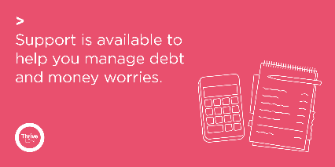
Twitter – personal difficulty | If you find yourself in urgent financial or personal need, there is support and information available for you. Please seek help if you need it.  💷 @turn2us_org: 0808 802 2000  🏘️ @Shelter: 0344 515 1540  🥫 @TrussellTrust: 0808 208 2138  More via @LDN_gov: https://www.london.gov.uk/coronavirus/financial-support-during-coronavirus | 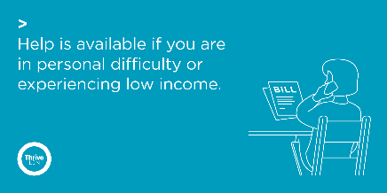

Normalising Londoners’ experience
Twitter | It has never been more important for each of us to think and talk more about mental health and wellbeing, and to seek support when needed.  If you are struggling right now, ask for help or talk to someone you trust. Explore a range of resources to help. 👇  www.thriveldn.co.uk/resources/tools-and-resources-to-help-your-mental-health-and-wellbeing | 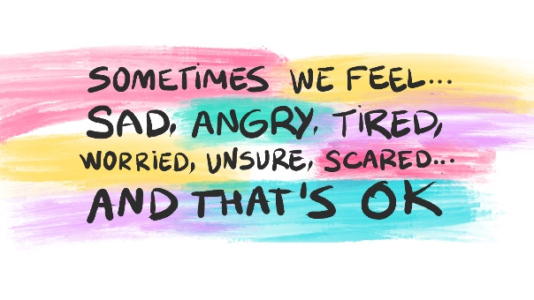
Instagram 1 | We know that there are people who may want extra help right now.  It has never been more important for each of us to think and talk more about mental health and wellbeing, and to seek support when needed..  There are some sources of support and some useful ways to get support if you are finding it hard from @ThriveLDN.  Find the link in @ThriveLDN’s bio. | 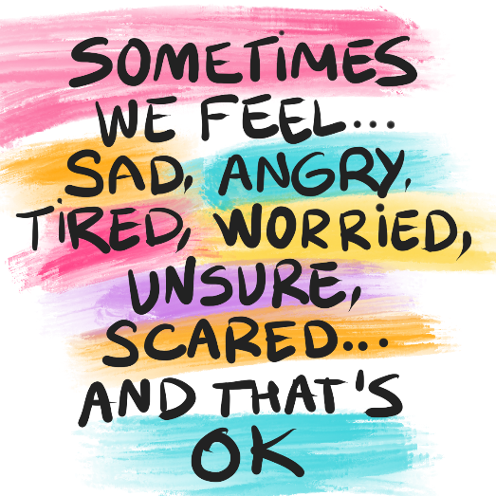
Instagram 2 | Remember that, whatever you are going through, you are powerful.  But if you ever need some support or if something is affecting you, even if you feel it’s something ‘small’ or ‘trivial’, you should reach out for help.  @ThriveLDN has put together a collection of tools and resources to help you to manage your #MentalHealth and #Wellbeing.  👉 Link in @ThriveLDN bio.
Facebook 2 | We all have mental health, and the majority of us will struggle with it at some point, even before COVID-19. Know that what you're going through is not your fault. Don’t be hard on yourself.  If you are struggling right now, then reach out for help and talk to someone you trust.  We know that there are people who may need extra help. Find a range of resources to help you to manage your wellbeing: www.thriveldn.co.uk/resources/tools-and-resources-to-help-your-mental-health-and-wellbeing

Zero Suicide LDN - suicide prevention training
Sadly, around 11 people a week take their own life in London. Thrive LDN is leading a campaign to get Londoners to take the FREE online suicide prevention training. We’ve partnered with the Zero Suicide Alliance, who have created a training program to help people to be able to identify warning signs and to feel comfortable having conversations about suicide.
To download high quality images and videos: Right click the image and select ‘open link’ to download a full-size image to use across digital channels. All resources are also available to download directly from the Thrive LDN Comms Toolkit Google Drive account.
Twitter (1) | Living and working in London can be stressful, and right now for some it may be overwhelming. Would you be able to spot a colleague or friend in distress? There’s FREE @Zer0Suicide online training to help.  Visit 👉 www.thriveldn.co.uk/zerosuicideldn  #ZeroSuicideLDN | 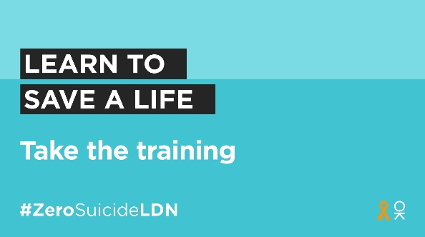
Twitter (2) | For some Londoners right now, worries over money or debt may be overwhelming.  Would you be able to spot a neighbour or friend in distress? There’s FREE @Zer0Suicide online training to help.  Visit👉 www.thriveldn.co.uk/ZeroSuicideLDN  #ZeroSuicideLDN | 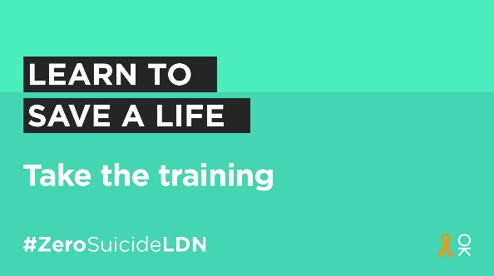
Instagram | Living and working in London can be stressful, and right now for some it may be overwhelming. Would you be able to spot a colleague or friend in distress? There’s FREE online training provided by the @zerosuicidealliance to help.  Visit 👉 thriveldn.co.uk/zerosuicideldn  Save a life... take the training today.  #ZeroSuicideLDN #London #LifeInLondon #WeAreLDN #OKLDN #SuicidePrevention #Teamwork #Together #ZeroSuicideAlliance #Londoners #MentalHealth #OnlineTraining | 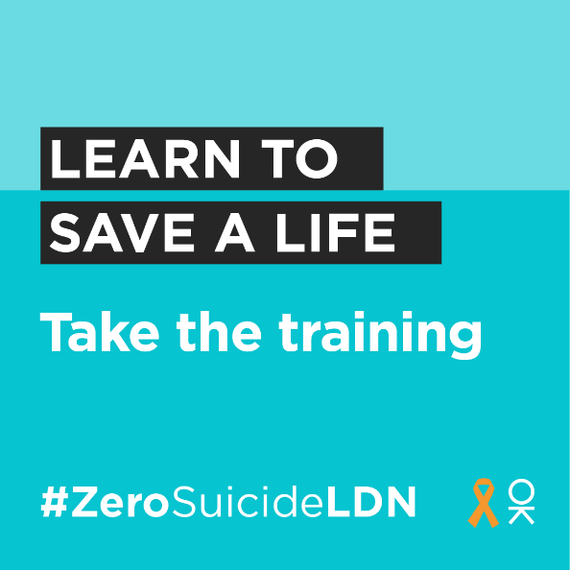
Facebook | Living and working in London can be stressful, and right now for some it may be overwhelming. Would you be able to spot a colleague or friend in distress? There’s FREE online training provided by the Zero Suicide Alliance to help.  Visit 👉 thriveldn.co.uk/zerosuicideldn  Save a life... take the training today.  #ZeroSuicideLDN #London #LifeInLondon #WeAreLDN #OKLDN #SuicidePrevention #Teamwork #Together #ZeroSuicideAlliance #Londoners #MentalHealth #OnlineTraining | 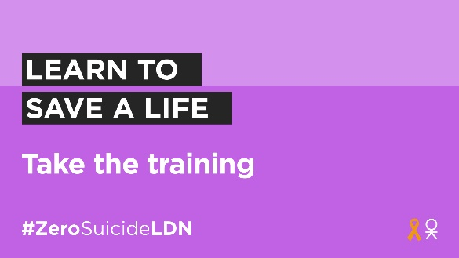  Partner accounts to tag:  Thrive LDN  Zero Suicide Alliance  Mayor of London
LinkedIn | Right now, things may feel uncertain for many people. From feelings of loneliness to worries over money, all of which can become overwhelming.  Would you be able to spot a neighbour or friend in distress? There is free online training provided by the Zero Suicide Alliance that can help you to know what to do if a loved one, colleague or stranger is in crisis.  Learn to save a life today, visit Thrive LDN’s website for more details: www.thriveldn.co.uk/zerosuicideldn

Suggested standard text for mental health signposting

Standard text for webpage
This standard text can be adapted for local websites (either as a resource/section or news article). The text in red needs to be localised or removed as relevant.
STARTS
Tools and resources to help your mental health and wellbeing
It is normal and okay to feel upset, anxious or confused at times.
You might be feeling worried about coronavirus, or the additional uncertainty of world events might be increasing your feelings of anxiety and stress.
It has never been more important for each of us to think and talk more about mental health and wellbeing, and to seek support when needed. In London, there are a range of free resources, online tools, and helplines available to help you cope and stay mentally healthy.
You should know that even though things can feel very hard at times, support is available for whatever you are going through.
Simple ways to improve your wellbeing
Doctors of the World, in partnership with Thrive LDN, have put together a list of little things you can do to keep yourself well and some useful ways to get support if you are finding it hard. The guidance is available in English and 35 other languages to support migrant communities.
If you’re feeling anxious or stressed about work, housing or financial difficulties, then explore the helpful range of resources and guidance on City Hall's Hub [or include reference to local services].
Available support now - online tools to help your mental health
The NHS-approved digital mental wellbeing service, Good Thinking, promotes proactive self-care for the four most common mental health conditions: anxiety, low mood, sleeping difficulties and stress. Take the clinically validated self-assessment tool to get a better understanding of what you’re going through or workbooks that contain expert advice, helpful resources and if necessary, relevant treatment options.
To help build resilience and maintain good wellbeing, there’s a range of resources for everyone at Every Mind Matters. Including an interactive quiz, the Your Mind Plan, to get top tips and advice relevant for you.
A collection of NHS Coping Well During Covid webinars are available if you are feeling anxious about coronavirus and how it is impacting you, your loved ones or your work. The 60-minute sessions will guide you through ideas and tools to support your mental health and wellbeing in an evidenced based and interactive way.
Support is available to help you manage debt and personal difficulties
If you are worried about money or need impartial advice, there is support and information available for you. Ask for help if you need it.
Debt Free London help on a wide range of issues, including council tax, rent arrears, utility bills and benefit overpayments. Call 0800 808 5700 or visit their website for other ways to get in touch.
Turn2us can provide advice with accessing crisis grants, benefits, debt, housing, and legal issues, call on 0808 802 2000.
The Trussell Trust can provide advice when facing financial difficulties, as well as helping you find your local foodbank for an emergency food parcel. You can call on 0808 208 2138.
NHS psychological treatments
If you do not require urgent support but are still concerned about your mental health, contacting your GP is a good place to start.
You can also refer yourself for free, non-urgent NHS psychological therapy (IAPT) services which provide evidence-based treatments for depression and anxiety. These services are open in London [or borough] if you feel like you may need further, professional support. You can find your local service here.
Getting urgent help for mental health
A mental health emergency should be taken as seriously as a physical one. You will not be wasting anyone's time. If you have an existing mental health condition and an assigned care team or care worker, then it’s important to contact them.
NHS urgent mental health helplines are for people of all ages. You can call for:
- 24-hour advice and support - for you, your child, your parent or someone you care for
- help to speak to a mental health professional
- an assessment to help decide on the best course of care
Alternatively, when life is tough the Samaritans are here to listen at any time of the day or night. You can talk to them about anything that's troubling you, no matter how difficult.
- Call free on 116 123 or visit the Samaritans website.
Shout offers confidential 24/7 crisis text support for times when you need immediate assistance.
- Text SHOUT to 85258 or visit Shout Crisis Text Line.
The bereavement care charity Cruse is helping families affected by coronavirus.
- Call free on 0808 808 1677 or visit the Cruse website.
ENDS

Standard text for newsletters and/or offline copy
This standard text can be adapted for e-newsletters and bulletins. We advise that it becomes a standing item during periods when more restrictive safety measures are in place as the first wave of coronavirus showed many people experience heightened anxiety. Below is both a full and concise post.
[FULL – 170 words] Resources to help your mental health and wellbeing
Right now, it has never been more important for each of us to think and talk more about mental health and wellbeing, and to seek support when needed.
There is support available for whatever you are going through. In London, there is a range of support available now from Thrive LDN, Good Thinking, Every Mind Matters, and NHS wellbeing webinars.
Alternatively, your GP can advise you about helpful treatments and local mental health services.
Or if you may feel more comfortable talking to someone you don’t know by using one of the following helplines:
- Samaritans are here when life is difficult. They won’t judge you or tell you what to do, they’re here to listen so you don’t have to face it alone. Call the free, 24-hour listening service on 116 123 or email jo@samaritans.org.
- Shout is the UK 's first 24/7 text messaging service for anyone in crisis. Text Shout at any time to 85258 to start a conversation with a trained volunteer.
[CONCISE – 52 words] Resources to help your mental health and wellbeing
It is normal and okay to feel upset, anxious or confused at times.
Support is available, with a range of free resources and online tools available to help you cope and stay mentally healthy. If you feel more comfortable talking to someone you don’t know, you can use one of the following helplines.

