SUGGESTED COPY FOR GREAT MENTAL HEALTH DAY
Updated Wednesday, 14 December 2022
About this toolkit
We hope that our introductory campaign toolkit gives you time to consider how you might get involved with Great Mental Health Day (GMHD), either leading up to the day or on Friday, 27 January 2023 itself.
If you’ve not yet downloaded the full GMHD toolkit, you can do so from the Thrive LDN website.
The toolkit outlines Great Mental Health Day and how you can get involved. At this stage we’d be grateful for your support in considering how you might mark the day, as well as spreading awareness about Great Mental Health Day with your networks and on social media to help encourage Londoners to get involved.
This document outlines the suggested copy that can be used across communications in the lead up to the day.
A further campaign toolkit will be published on W/C 9TH January 2023 which will include additional messaging, campaign graphics and borough logos.
Key Messages
- London is celebrating its second Great Mental Health Day on Friday, 27 January 2023.
- Great Mental Health Day 2023 will celebrate the power of community kindness and tell the story of how we’ve come together for one another across London.
- The aim of the day is to get Londoners talking about mental health, destigmatise asking for help and to raise awareness of the great support available across the region.
- The Thrive LDN website will host information about any events that are taking place as part of the day, as well as an interactive map where Londoners can find local services and support.
- Londoners can get involved using the hashtag #GreatMentalHealth to share their own stories, experiences and plans for the day across all social media platforms.
Help with this pack
For any queries about the day please contact Thrive LDN communications team at Rebecca.downer1@nhs.net

Great Mental Health Day 2023
Channel | Suggested copy | Suggested digital asset (right click to ‘open link’ and download high resolution version)
Twitter 1 | London is marking Great Mental Health Day on Fri 27 Jan 2023, aiming to get us talking about mental health, highlight local support and events, and reflecting on celebrate kindness.  See @ThriveLDN for more about #GreatMentalHealth and how you can join in: www.thriveldn.co.uk/greatmentalhealth | 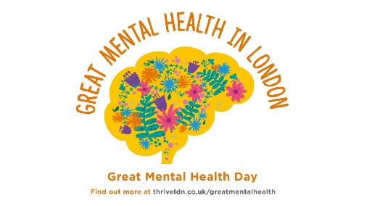  Alt text: A graphic of a floral brain with the words Great Mental Health in London written across the top. Below is Great Mental Health Day and the website address for more information.
Twitter 2 | For Great Mental Health Day 2023 (27/01/23) we're asking:  1⃣ In three words, what does #GreatMentalHealth mean to you?  2⃣ How have you been supporting others in your community?  3⃣ What examples of community kindness have touched you?  To find out more: www.thriveldn.co.uk/greatmentalhealth
Twitter 3 | The countdown to Great Mental Health Day 2023 has started!  This year we’re celebrating the power of community kindness and telling the story of how we’ve come together for one another across London.  Find out how you can join in www.thriveldn.co.uk/greatmentalhealth
Twitter 4 | London’s Great Mental Health Day is back on Friday 27th January 2023!  This year we want to tell the story of how we’ve come together for one another across London and celebrate those who have made a difference.  Who will you be celebrating in your community?  #GreatMentalHealth
Instagram | We’re delighted to be supporting Great Mental Health Day when it returns on Friday, 27 January 2023.  In a year that’s remained challenging for many of us, it has been our communities, friends and families which have played the most important role in in getting us through difficult times together. That’s why Great Mental Health Day 2023 will celebrate the power of community kindness and tell the story of how we’ve come together for one another across London.  With plans already taking shape for what promises to be an action-packed day, we’re asking you to think about how you’d like to get involved and celebrate Great Mental Health Day 2023.  Follow the link in @ThriveLDN’s bio to find out more about #GreatMentalHealth and how you can join in. | 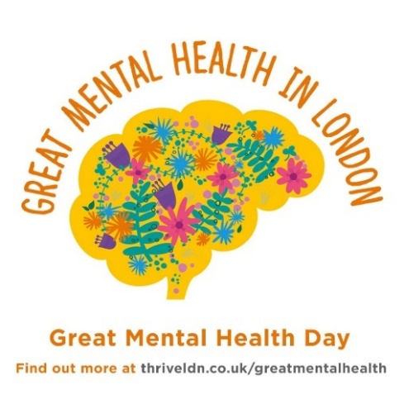  Alt text: A graphic of a floral brain with the words Great Mental Health in London written across the top. Below is Great Mental Health Day and the website address for more information.
Instagram story | Add the following link to the suggest graphic:  https://thriveldn.co.uk/communications/campaign/great-mental-health-day-2023/ | 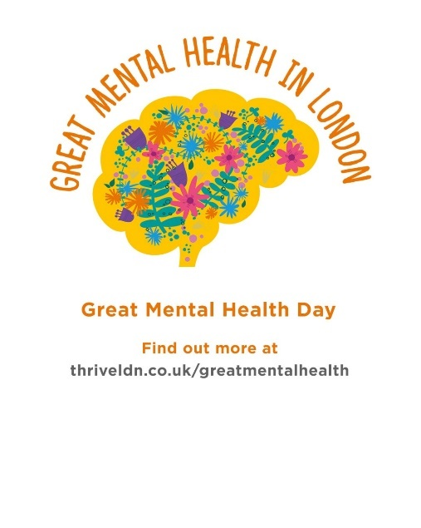
Facebook and LinkedIn | We’re delighted to be supporting Great Mental Health Day when it returns on Friday, 27 January 2023.  In a year that’s remained challenging for many of us, it has been our communities, friends and families which have played the most important role in in getting us through difficult times together. That’s why Great Mental Health Day 2023 will celebrate the power of community kindness and tell the story of how we’ve come together for one another across London.  With plans already taking shape for what promises to be an action-packed day, we’re asking you to think about how you’d like to get involved and celebrate Great Mental Health Day 2023.  Visit www.thriveldn.co.uk/greatmentalhealth to find out more about #GreatMentalHealth and how you can join in. | Alt text: A graphic of a floral brain with the words Great Mental Health in London written across the top. Below is Great Mental Health Day and the website address for more information.

