THRIVE LDN COMMUNICATIONS TOOLKIT
Getting Through This Together and wider wellbeing promotion
Updated Monday, 20 March 2023
Contents
About this toolkit 2
Getting Through This Together campaign 3
Context and introduction 3
Spring 2023 update 3
Activating the Getting Through This Together campaign 4
Suggested messaging for social media 4
Spring 2023 update – suggested content 4
1. When did you last take time for yourself? 4
2. When did you last talk to someone you care about? 6
3. How do you care for yourself and those around you? 8
4. Do you know where you can get support? 10
5. What brings you peace? 12
6. We are heard and seen when we share our stories 14
7. Sharing our stories can help others going through similar experiences. 16
8. Through creativity we can tell alternative stories about ourselves. 18
Top line message: When times are tough, it’s important that we look after our own and each other's wellbeing. 29
Core message 1: We can all do our bit to spread hope and kindness, and to help each other. 31
Core message 2: When times are tough, it’s normal to feel a bit worried, frustrated or overwhelmed. 32
Core message 3: London is full of amazing people and communities who have come together during the most challenging of times. 34
Free trauma-informed practice training 38
Thrive LDN and Money and Pensions Service money and mental health webinar 40
Updated suicide prevention messaging for digital channels 41
APPENDIX A: Getting Through This Together - key messages 45
Messaging house 45
APPENDIX B: Why is resilience important? 46
Resilience is protective of mental health. 46
Behavioural insights 47

About this toolkit
If you’d like to chat with the Thrive LDN team about making the suggested copy more relevant to your community/audiences, then please get in touch, e-mail James Ludley: james.ludley@nhs.net.
To download high quality images and assets:
- Explore the full range of Getting Through This Together assets via Google Drive.
- Download a Getting Through This Together ZIP file with all static assets (videos to be downloaded via Google Drive).
- Right click a suggested image in this toolkit and select ‘open link’ to download a full-size image to use across digital channels.

Getting Through This Together campaign

Context and introduction
Getting Through This Together is a collective campaign which aims to encourage Londoners to strengthen their social networks with family members and friends, and trusted others in their community – which a significant factor in supporting people during this period. As well as highlighting the professional support and advice services which are available.
This is the second iteration of this toolkit to support colleagues activate the campaign. We’re grateful for the support given towards London’s shared Getting Through This Together campaign to date.
This toolkit also follows Great Mental Health Day held in London at the end of January, which was designed, in part, to support the campaign and respond to increasing cost-of-living pressures.
As we enter the spring, resilience to and dealing with the economic crisis and wider threats remains a key priority and challenge for public mental health.
Getting Through This Together provides a shared narrative and campaign for London, supporting the following principles:
- Avoiding a narrative which dilutes the importance of context and collectivism and places the burden on the responsibility of individuals, which was heightened during the peak of the pandemic.
- Providing both practical support and wellbeing support, as well as highlighting how money and mental health is interlinked.
- Humanising the cost-of-living crisis by centring the lived experiences of those most impacted and amplifying their voices to influence change.
- We know that London is full of amazing communities and people, many of whom want to find ways of helping their friends, families, colleagues or communities. We can help share their stories to reinforce the message that there is support within an individual’s social and community network.

Spring 2023 update
The updated suggested copy and digital assets have been developed following a series of user testing sessions carried out by Thrive LDN and partners with Londoners, both adult and children and young people.
This iteration is designed to support colleagues continue to retain the key narrative and overarching message (see Appendix A) as we enter spring, but also:
- Promote the use of gentle questions and deeper engagement to support this at a community level.
- Share acts of support, togetherness and inclusion across London through the #ThroughTogether stories and video content.
- Signpost to the range of resources and guidance which has been developed in response to the cost-of-living crisis.
As before, the messaging for each is adaptable and, in most cases, the signposting would be best localised for specific audiences.

Activating the Getting Through This Together campaign
Our shared success of this campaign will come down to having people in each and every community who can help us amplify our messages.
- Use the suggested messaging (see below) and Getting Through This Together campaign assets across your own digital channels. [Download a Getting Through This Together ZIP file with all static assets (videos to be downloaded via Google Drive)]
- Download and use a range of Getting Through This Together printable posters.
- Let local organisations and community groups in your networks or area know about the Getting Through This Together campaign and encourage them to support it by sharing their stories of togetherness.
- You can follow Thrive LDN on Facebook, Instagram, LinkedIn and Twitter, and share our content.
- You might have ideas for content that showcases how people are ‘Getting Through This Together’ in your community or for events that bring the campaign to life - get in touch and let us know.
- You can subscribe to our regular updates and encourage others to do the same.
Ultimately, you know your community best. Can you help find the best channels and the best way to connect people with the campaign – and help us Get Through This Together?

Suggested messaging for social media
To support the Getting Through This Together campaign, we have developed suggested messaging for digital and social media channels. Please consider incorporating the below alongside any other planned communications.
- Explore the full range of Getting Through This Together assets for using across your own digital channels – you can do this via Google Drive or a ZIP file download.
- Use #ThroughTogether or tag @ThriveLDN, where you can so we are able to reshare.

Spring 2023 update – suggested content

When did you last take time for yourself?
Channel | Suggested post | Assets
Twitter | We all lead busy lives, but it’s vital to make time for yourself.  Physical health is important for good wellbeing. Exercise, a healthy diet and good quality sleep are proven to help support good mental health.  Explore self-care tips and resources: https://thriveldn.co.uk/help-yourself-and-others/self-care-and-physical-health/ | https://drive.google.com/drive/folders/16eX6qdbW0L9d5I-rnS2Lk7DVKvJhoFhl?usp=share_link
Instagram | Taking care of yourself and your physical health helps achieve good mental health and wellbeing and reduce feelings of stress.  Exercise boosts mood and self-esteem. A healthy diet and good quality sleep are proven to help you stay well, feel your best and deal with life’s difficulties. We all lead busy lives, but it’s important to make time to check in with yourself and listen to how you are feeling too.  Find free resources to support you and others for being more active, getting better quality sleep and maintaining a healthy diet:  Explore @ThriveLDN’s Help Yourself and Others section of their website. You’ll find ideas, inspiration and resources to help build your resilience and improve wellbeing.  Or visit @goodthinkinguk for lots of other resources to support wellbeing and mental health.  #ThroughTogether  #CostOfLivingSupport | https://drive.google.com/drive/folders/1Ijzql7UQ0ExvBzc1bRHRQjShXCyRwkuX?usp=share_link  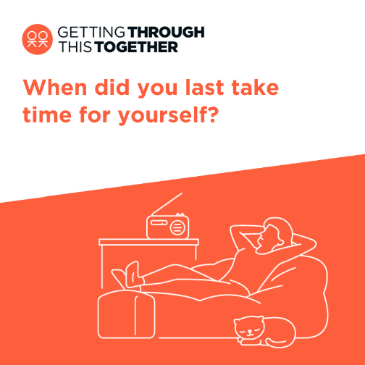
IG Story | https://thriveldn.co.uk/help-yourself-and-others/self-care-and-physical-health/  Explore self-care tips
Facebook / LinkedIn | Taking care of yourself and your physical health helps achieve good mental health and wellbeing and reduce feelings of stress.  Exercise boosts mood and self-esteem. A healthy diet and good quality sleep are proven to help you stay well, feel your best and deal with life’s difficulties. We all lead busy lives, but it’s important to make time to check in with yourself and listen to how you are feeling too.  Find free resources to support you and others for being more active, getting better quality sleep and maintaining a healthy diet: https://thriveldn.co.uk/help-yourself-and-others/self-care-and-physical-health/  Or visit Good Thinking and download their 'how to' guides. Alongside lots of other resources to support wellbeing and mental health: www.good-thinking.uk/how-guides | https://drive.google.com/drive/folders/16eX6qdbW0L9d5I-rnS2Lk7DVKvJhoFhl?usp=share_link

When did you last talk to someone you care about?
Channel | Suggested post | Assets
Twitter | Reaching out to someone could help them know that someone cares, that they are valued, and help them find the support they need.  Explore @ThriveLDN’s tips on having a supportive conversation: thriveldn.co.uk/communications/toolkits-and-resources/toolkit/thrive-ldn-mental-health-conversation-starter/ | https://drive.google.com/drive/folders/16eX6qdbW0L9d5I-rnS2Lk7DVKvJhoFhl?usp=share_link  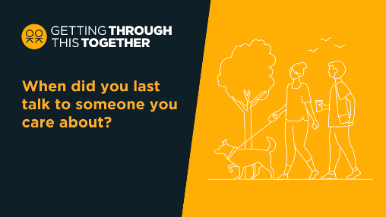
Instagram | When times are tough, it’s important that we look after our own and each other's wellbeing.  Many Londoners are speaking with family, friends, and trusted others in their community to support themselves with their wellbeing because of the impact of cost-of-living pressures.  Reaching out to someone could help them know that someone cares, that they are valued, and help them find the support they need.  Explore @ThriveLDN’s tips on having a supportive conversation - click the link in their bio.  Or visit @goodthinkinguk and download their 'how to' guides. Alongside lots of other resources to support wellbeing and mental health.  #ThroughTogether  #CostOfLivingSupport | https://drive.google.com/drive/folders/1Ijzql7UQ0ExvBzc1bRHRQjShXCyRwkuX?usp=share_link  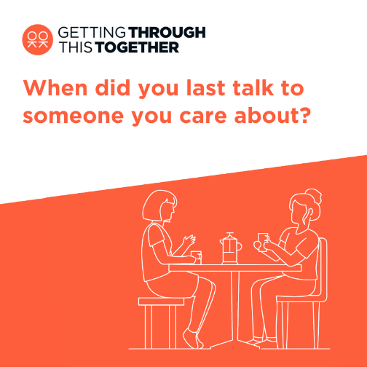
IG Story | www.thriveldn.co.uk/communications/toolkits-and-resources/toolkit/thrive-ldn-mental-health-conversation-starter  Explore Thrive LDN’s conversation starter | 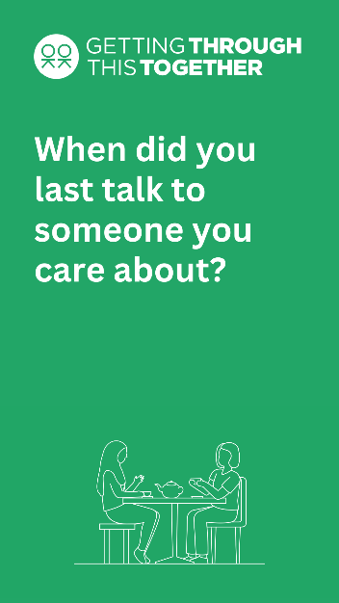
Facebook / LinkedIn | When times are tough, it’s important that we look after our own and each other's wellbeing.  Many Londoners are speaking with family, friends, and trusted others in their community to support themselves with their wellbeing because of the impact of cost-of-living pressures.  Reaching out to someone could help them know that someone cares, that they are valued, and help them find the support they need.  Explore Thrive LDN’s tips on having a supportive conversation - click the link in our bio for our conversation starter tool: www.thriveldn.co.uk/help-yourself-and-others/  Or visit Good Thinking and download their 'how to' guides. Alongside lots of other resources to support wellbeing and mental health: www.good-thinking.uk/how-guides | https://drive.google.com/drive/folders/16eX6qdbW0L9d5I-rnS2Lk7DVKvJhoFhl?usp=share_link

How do you care for yourself and those around you?
Channel | Suggested post | Assets
Twitter | Strong, supportive relationships – whether family or with the wider community and faith groups – are one of the most important factors to help us thrive and maintain good wellbeing.  Explore a range of free resources to support you to stay connected:  https://thriveldn.co.uk/help-yourself-and-others/social-networks-and-connections/ | https://drive.google.com/drive/folders/16eX6qdbW0L9d5I-rnS2Lk7DVKvJhoFhl?usp=share_link
Instagram | Staying connected is more important than ever. Strong, supportive relationships – whether family or with the wider community and faith groups – are one of the most important factors to help us thrive and maintain good wellbeing.  When times are tough, it’s important that we look after our own and each other's wellbeing.  We know so many Londoners are making a difference to those in their local community and beyond by supporting each other through the emotional pressures and challenges they may be feeling right now.  Explore @ThriveLDN’s range of free resources to support you and others to stay connected.  Or visit @goodthinkinguk and download their 'how to' guides.  #ThroughTogether  #CostOfLivingSupport | https://drive.google.com/drive/folders/1Ijzql7UQ0ExvBzc1bRHRQjShXCyRwkuX?usp=share_link  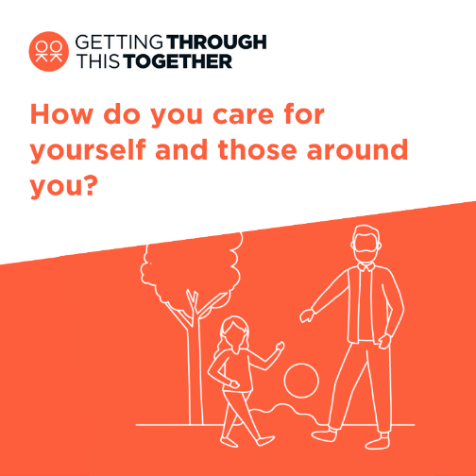
IG Story | Invite answers or link to  www.good-thinking.uk/how-guides | 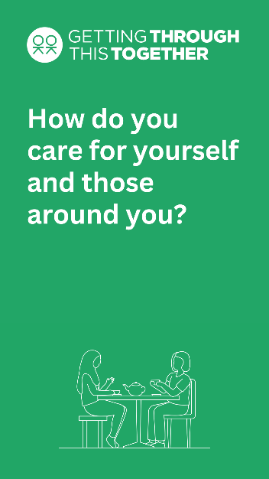
Facebook / LinkedIn | Staying connected is more important than ever. Strong, supportive relationships – whether family or with the wider community and faith groups – are one of the most important factors to help us thrive and maintain good wellbeing.  When times are tough, it’s important that we look after our own and each other's wellbeing.  We know so many Londoners are making a difference to those in their local community and beyond by supporting each other through the emotional pressures and challenges they may be feeling right now.  Explore Thrive LDN’s range of free resources to support you and others to stay connected: https://thriveldn.co.uk/help-yourself-and-others/social-networks-and-connections/  Or visit Good Thinking and download their 'how to' guides. Alongside lots of other resources to support wellbeing and mental health: www.good-thinking.uk/how-guides | https://drive.google.com/drive/folders/16eX6qdbW0L9d5I-rnS2Lk7DVKvJhoFhl?usp=share_link  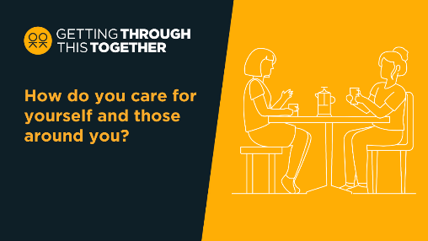

Do you know where you can get support?
Channel | Suggested post | Assets
Twitter | Whether you’re looking for yourself, or to help family, friends or others in your community, support and advice services are free and available.  Find help with the cost of living:  www.london.gov.uk/help-cost-living  Find ideas to support wellbeing:  www.thriveldn.co.uk/help-yourself-and-others/  #ThroughTogether | https://drive.google.com/drive/folders/16eX6qdbW0L9d5I-rnS2Lk7DVKvJhoFhl?usp=share_link  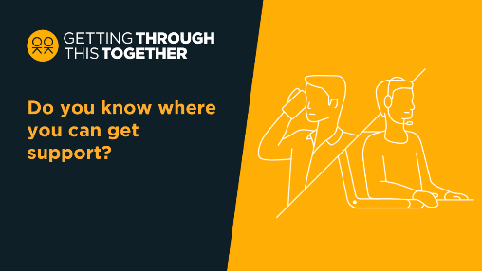
Instagram | Right now, things may feel uncertain or difficult, and it's OK to feel anxious or worried.  When times are tough, it’s important that we look after our own and each other's wellbeing.  Whether you’re looking for yourself, or to help a friend or others in your community, support and advice services are there to help.  Talk to someone you trust 💬  Take things one step at a time ☝️  Focus on what you can control 👤  Reach out to friends and family 🤝  For a range of information to support Londoners, including on money and mental health, search ‘GLA help with the cost of living online hub’.  Or find out more by following the link in @ThriveLDN’s bio.  #ThroughTogether  #CostOfLivingSupport | https://drive.google.com/drive/folders/1Ijzql7UQ0ExvBzc1bRHRQjShXCyRwkuX?usp=share_link  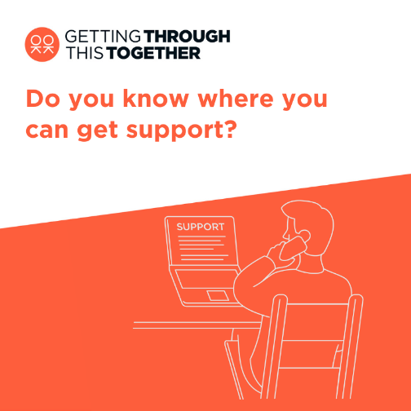
IG Story | www.london.gov.uk/help-cost-living  Cost of living support
Facebook / LinkedIn | Right now, things may feel uncertain or difficult, and it's OK to feel anxious or worried.  When times are tough, it’s important that we look after our own and each other's wellbeing.  Whether you’re looking for yourself, or to help a friend or others in your community, support and advice services are there to help.  Find more ideas by visiting: www.thriveldn.co.uk/help-yourself-and-others  Or visit Good Thinking and download their 'how to' guides. Alongside lots of other resources to support wellbeing and mental health: www.good-thinking.uk/how-guides | https://drive.google.com/drive/folders/16eX6qdbW0L9d5I-rnS2Lk7DVKvJhoFhl?usp=share_link  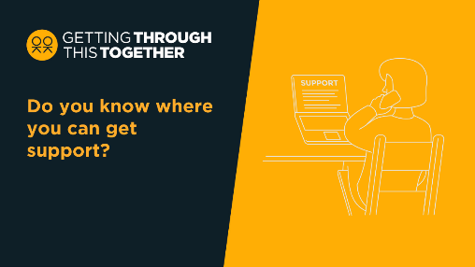

What brings you peace?
Channel | Suggested post | Assets
Twitter | Learning to accept that there are things you cannot control is a big step in learning how to manage whatever problems you may be having.  What brings you joy? Do a little more self-care than usual and be honest with yourself and others about how you’re feeling.  #ThroughTogether | https://drive.google.com/drive/folders/16eX6qdbW0L9d5I-rnS2Lk7DVKvJhoFhl?usp=share_link
Instagram | Right now, things may feel uncertain or difficult, and it's OK to feel anxious or worried.  Learning to accept that there are things that you cannot control can be a big step in learning how to manage and resolve whatever problems you may be having.  Ask yourself, what brings you joy? What brings you peace?  Talk to someone when you’re struggling, do a little more self-care than you usually do, and be honest with yourself and others about how you’re feeling.  Find ideas to support wellbeing from @ThriveLDN.  #ThroughTogether  #CostOfLivingSupport | https://drive.google.com/drive/folders/1Ijzql7UQ0ExvBzc1bRHRQjShXCyRwkuX?usp=share_link
IG Story | Find ideas to support wellbeing from @ThriveLDN.  www.thriveldn.co.uk/help-yourself-and-others/
Facebook / LinkedIn | Right now, things may feel uncertain or difficult, and it's OK to feel anxious or worried.  Learning to accept that there are things that you cannot control can be a big step in learning how to manage and resolve whatever problems you may be having.  Ask yourself, what brings you joy? What brings you peace?  Talk to someone when you’re struggling, do a little more self-care than you usually do, and be honest with yourself and others about how you’re feeling.  Find ideas to support wellbeing from @ThriveLDN:  www.thriveldn.co.uk/help-yourself-and-others/  Or visit Good Thinking and download their 'how to' guides. Alongside lots of other resources to support wellbeing and mental health: www.good-thinking.uk/how-guides | https://drive.google.com/drive/folders/16eX6qdbW0L9d5I-rnS2Lk7DVKvJhoFhl?usp=share_link

We are heard and seen when we share our stories
Channel | Suggested post | Assets
Twitter | Whatever you’re going through, you are not alone and there is nothing to be ashamed of.  Talk to someone you trust💬  Reach out to friends and family🤝  Sharing our stories and challenges will help us get through this together:  https://thriveldn.co.uk/through-together/  #ThroughTogether | https://drive.google.com/drive/folders/16eX6qdbW0L9d5I-rnS2Lk7DVKvJhoFhl?usp=share_link
Instagram | Whatever you’re going through, you are not alone and there is nothing to be ashamed of.  Talk to someone you trust 💬  Take things one step at a time ☝️  Focus on what you can control 👤  Reach out to friends and family 🤝  When times are tough, it’s important that we look after our own and each other's wellbeing.  @ThriveLDN has lots of examples on how Londoners are making a difference to those in their local community by supporting each other through the emotional pressures and challenges many are facing right now. Search #ThroughTogether.  For a range of information to support Londoners, including on money and mental health, search ‘GLA help with the cost of living online hub’.  Or find out more by exploring @goodthinkinguk’s resources and tools.  #CostOfLivingSupport | https://drive.google.com/drive/folders/1Ijzql7UQ0ExvBzc1bRHRQjShXCyRwkuX?usp=share_link
IG Story | https://thriveldn.co.uk/through-together/  When times are tough, it’s important that we look after our own and each other's wellbeing.
Facebook / LinkedIn | Whatever you’re going through, you are not alone and there is nothing to be ashamed of.  Talk to someone you trust 💬  Take things one step at a time ☝️  Focus on what you can control 👤  Reach out to friends and family 🤝  When times are tough, it’s important that we look after our own and each other's wellbeing.  Thrive LDN has lots of examples on how Londoners are making a difference to those in their local community by supporting each other through the emotional pressures and challenges many are facing right now: https://thriveldn.co.uk/through-together/  For a range of information to support Londoners, including on money and mental health, search ‘GLA help with the cost of living online hub’.  Or visit Good Thinking and download their 'how to' guides. Alongside lots of other resources to support wellbeing and mental health: www.good-thinking.uk/how-guides | https://drive.google.com/drive/folders/16eX6qdbW0L9d5I-rnS2Lk7DVKvJhoFhl?usp=share_link

Sharing our stories can help others going through similar experiences.
Channel | Suggested post | Assets
Twitter | London works best when we look out for each other.  Right now, things may feel difficult for many people. Take some time to check in with friends, family, and those in your community.  Sharing our stories can help others going through similar experiences.  #ThroughTogether | https://drive.google.com/drive/folders/16eX6qdbW0L9d5I-rnS2Lk7DVKvJhoFhl?usp=share_link  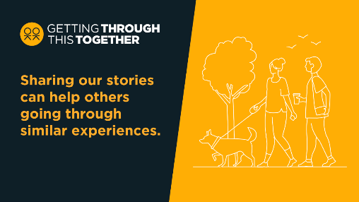
Instagram | We know that our city works best when we all look out for each other.  Right now, things may feel uncertain or difficult for many Londoners. Take some time to check in with friends, family, and those in your community.  Sharing our stories can help others going through similar experiences.  @ThriveLDN has lots of examples on how Londoners are making a difference to those in their local community by supporting each other through the emotional pressures and challenges many are facing right now. Search #ThroughTogether.  Or find out more by exploring @goodthinkinguk’s resources and tools.  #ThroughTogether  #CostOfLivingSupport | https://drive.google.com/drive/folders/1Ijzql7UQ0ExvBzc1bRHRQjShXCyRwkuX?usp=share_link
IG Story | www.thriveldn.co.uk/communications/toolkits-and-resources/toolkit/thrive-ldn-mental-health-conversation-starter  Explore Thrive LDN’s conversation starter | 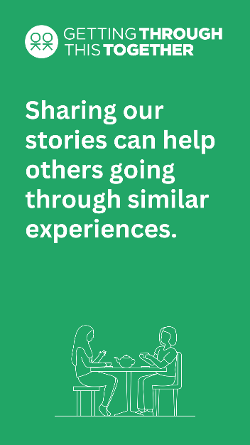
Facebook / LinkedIn | We know that our city works best when we all look out for each other.  Right now, things may feel uncertain or difficult for many Londoners. Take some time to check in with friends, family, and those in your community.  Sharing our stories can help others going through similar experiences.  Whether you’re looking for yourself, or to help a friend or others in your community, support and advice services are there to help. For more ideas visit: www.thriveldn.co.uk/help-yourself-and-others  Or visit Good Thinking and download their 'how to' guides. Alongside lots of other resources to support wellbeing and mental health: www.good-thinking.uk/how-guides | https://drive.google.com/drive/folders/16eX6qdbW0L9d5I-rnS2Lk7DVKvJhoFhl?usp=share_link  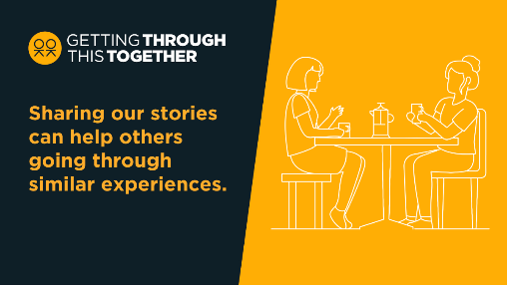

Through creativity we can tell alternative stories about ourselves.
Channel | Suggested post | Assets
Twitter | Creativity and the arts provide ways for people to have discussions around issues that can be difficult to explore in other ways. Creative activity can also help to engage people from all communities.  Support your wellbeing through creative activity: https://thriveldn.co.uk/help-yourself-and-others/creativity-and-wellbeing/ | https://drive.google.com/drive/folders/16eX6qdbW0L9d5I-rnS2Lk7DVKvJhoFhl?usp=share_link  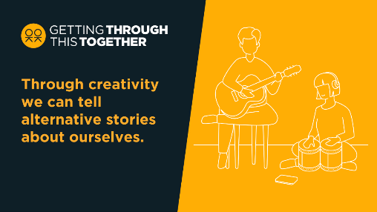
Instagram | Have you turned to creative activities to support your wellbeing?  There are so many forms creativity and culture can take, allowing people to express themselves in different ways, without having to use words if necessary.  The arts provide one of the most effective ways for people to have discussions around issues that can be difficult to explore in other ways. This can help us tackle inequalities by engaging people from all backgrounds and communities.  #ThroughTogether  #CostOfLivingSupport | https://drive.google.com/drive/folders/1Ijzql7UQ0ExvBzc1bRHRQjShXCyRwkuX?usp=share_link  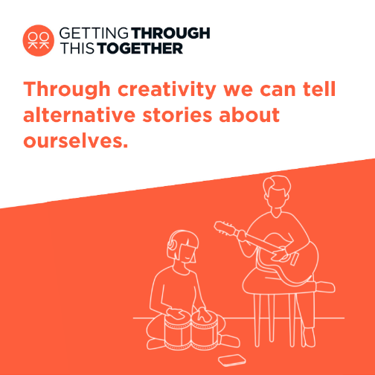
IG Story | Support your wellbeing through creative activity.  https://thriveldn.co.uk/help-yourself-and-others/creativity-and-wellbeing/ | 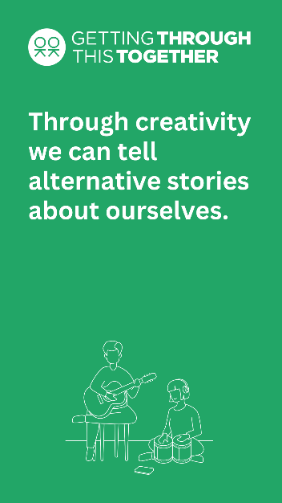
Facebook / LinkedIn | Many Londoners have turned to creative activities to support their wellbeing.  There are so many forms creativity and culture can take, allowing people to express themselves in different ways, without having to use words if necessary.  The arts provide one of the most effective ways for people to have discussions around issues that can be difficult to explore in other ways. This can help us tackle inequalities by engaging people from all backgrounds and communities.  Support your wellbeing through creative activity: https://thriveldn.co.uk/help-yourself-and-others/creativity-and-wellbeing/ | https://drive.google.com/drive/folders/16eX6qdbW0L9d5I-rnS2Lk7DVKvJhoFhl?usp=share_link

#ThroughTogether stories
Launched on Great Mental Health Day, twelve #ThroughTogether stories showcase how Londoners are making a difference to those in their local community and beyond. They tell the story of how people and organisations have been supporting each other through the emotional pressures and challenges they may be feeling right now. You can view and access the twelve stories via: thriveldn.co.uk/throughtogether
Below we have outlined some suggested social media posts for partners to consider using, to help amplify the stories and showcase the examples of community kindness can be found right across our city.
Name of group | Suggested post | Link to stills & videos
Dodgy Tickers - football exercise programme | “It’s not the time you spend kicking a ball. It’s the time before and after talking to people who are in a similar situation to you.”  Find out more about how Londoners like @dodgytickers are supporting each other right now.  #ThroughTogether  www.thriveldn.co.uk/throughtogether | Videos:  16x9  https://drive.google.com/file/d/19G3MytsAIAhn6M4cUgn6njh0iCkCfxTH/view?usp=sharing  9x16  https://drive.google.com/file/d/1CFwynLKImVW_iExt9HmBHZx6OKApo7xT/view?usp=sharing  Stills:  https://drive.google.com/file/d/1iI74E-pSMR2GAxEW8hREFsstWB1RIg-4/view?usp=sharing
St Mary’s RC school, Wimbledon | “If you’re lonely or sad, someone will come sit next to you and they’ll talk to you and basically cheer you up.”  Find out more about how pupils at @StMarysPriWim are supporting each other right now.  #ThroughTogether  www.thriveldn.co.uk/throughtogether | Videos:  16x9  https://drive.google.com/file/d/18j1cjtQH7k41_S7EswMuUcmkFwakzhp9/view?usp=sharing  9x16  https://drive.google.com/file/d/1xTEmjf_UvACDuR2S1wRTn1s7XtiD4Jbx/view?usp=sharing  Stills:  https://drive.google.com/file/d/1CqCNBEXpShra0GZ5zx7jVaq_4fHlpLCP/view?usp=sharing  https://drive.google.com/file/d/1nFI_VldI8GwLpHOezDY0voPKeldlwCeX/view?usp=sharing  https://drive.google.com/file/d/1rud2F8P3AXOdZs-JsrFwPsp_K9NIKlHp/view?usp=sharing
Bags of taste | “Feeling more confident about cooking healthy, tasty food that costs very little money & the enjoyment of eating it, makes a huge difference to people’s mental health”  Find out more about @bags_of_taste is helping Londoners to support each other right now.  #ThroughTogether  www.thriveldn.co.uk/throughtogether | Videos:  16x9  https://drive.google.com/file/d/1BMb4GSVcmUC-xmVkP60tBrvbuida79Vg/view?usp=sharing  9x16  https://drive.google.com/file/d/1ngu7ltTy9x2PfTHSOAhOLIvLMVLAtDu3/view?usp=sharing  Stills:  THRIVE_230112_BAGS_OF_TASTE_4.jpg  THRIVE_230112_BAGS_OF_TASTE_3.jpg  THRIVE_230112_BAGS_OF_TASTE_2.jpg  THRIVE_230112_BAGS_OF_TASTE_1.jpg
The Alexandra Pub | “Anybody who’s thinking about doing stuff, thinking shall I, shan’t I? Do it. Go for it. Because you’ll make a difference to people’s lives.”  Feeling inspired by @thealexsw19?  Find out more: www.thriveldn.co.uk/throughtogether  #ThroughTogether | Videos:  16x9  https://drive.google.com/file/d/1if8BdjwjXDG_ly-VyJ2xKRoKWUn10nBy/view?usp=sharing  9x16  https://drive.google.com/file/d/1JRkDfBHzO6utuU1ecBVeyCdydNi-OWQP/view?usp=sharing  Stills:  THRIVE_230109_ALEXANDRA_PUB_STILL_1.jpg  THRIVE_230109_ALEXANDRA_PUB_STILL_2.jpg  THRIVE_230109_ALEXANDRA_PUB_STILL_3.jpg
UK Mens Sheds | “Having purpose, having a project you’re involved in, having somebody around you and people who are willing to help you”  Find out more about how @UKMensSheds is helping Londoners to support each other right now.  #ThroughTogether  www.thriveldn.co.uk/throughtogether | 16x9  https://drive.google.com/file/d/1BJ4ibHZxsa4jJz8hZWtp8wgs3xDR8As4/view?usp=sharing  9x16  https://drive.google.com/file/d/1-nVU-m1DSdtXsDrU3EsCTNo7by3PYYUn/view?usp=sharing  Stills:  THRIVE_230109_MENS_SHED_1.jpg  THRIVE_230109_MENS_SHED_2.jpg  THRIVE_230109_MENS_SHED_3.jpg
My Yard | “It’s not telling a community what to do. It’s their community and we’re just there to offer a little bit of excitement.”  Find out how organisations like @myyardlondon are helping Londoners to support each other right now.  #ThroughTogether  www.thriveldn.co.uk/throughtogether | Videos:  16x9  https://drive.google.com/file/d/1jEYL8XjnQcWrIlMlHV5QQsqQHLTz3RB_/view?usp=sharing  9x16  https://drive.google.com/file/d/1bPkyVGXVIsPQNLz9s8Mi1iLjOqqEF-By/view?usp=sharing  Stills:  MY_YARD_2_4.jpg  MY_YARD_2.jpg  MY_YARD_3.jpg
Tramshed | “It’s good to have a safe space to know you can come to every week and meet new friends & musicians. It’s good to be around people that are on the same path as you.”  Find out how organisations like @Tramshed_ are helping Londoners to support each other right now.  #ThroughTogether  www.thriveldn.co.uk/throughtogether | Videos:  16X9  https://drive.google.com/file/d/17MvtY7_8JTASCw7PjpboRPnt2WkpezN4/view?usp=sharing  9X16  https://drive.google.com/file/d/1xRFQL_nXmjMZbBculKX0oWj1tPN98JA4/view?usp=sharing  Stills:  THRIVE_230112_TRAM_SHED_1.jpg  THRIVE_230112_TRAM_SHED_2.jpg  THRIVE_230112_TRAM_SHED_3.jpg  THRIVE_230112_TRAM_SHED_4.jpg  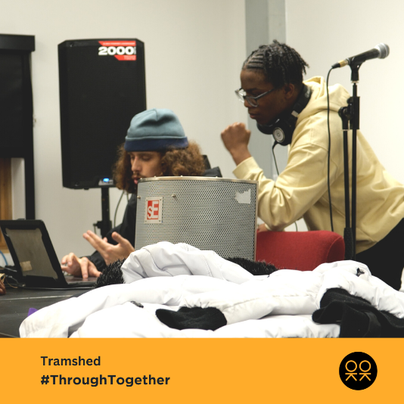
Paradox Community Centre | “A lot of attendees have said that they wouldn’t have come out of their homes if it wasn’t here.”  Find out how Londoners at @PeabodyLDN are supporting each other right now.  #ThroughTogether  www.thriveldn.co.uk/throughtogether | Videos:  16x9  https://drive.google.com/file/d/179e9_0QtfJK2rPGDP_8Y7jNY1IgSA23i/view?usp=sharing  9x16  https://drive.google.com/file/d/1W7FMJq6IqdY-l6tm5Xj9WPXsgt2GCHMP/view?usp=sharing  stills:  THRIVE_230112_PARADOX_COMMUNITY_1.jpg  THRIVE_230112_PARADOX_COMMUNITY_2.jpg
Herts Inclusive Theatre | “Our group immediately greets and welcomes someone to make them feel safe.  “It’s a simple act of kindness but it means that person might step in and then may stay.”  Find out how @HertsInclusive are helping Londoners to support each other right now.  #ThroughTogether  www.thriveldn.co.uk/throughtogether | Videos:  16X9  https://drive.google.com/file/d/17RKLO2A3wrusNL-XQq9Ilhj8maZgYUiJ/view?usp=sharing  9X16  https://drive.google.com/file/d/1BUD0j5PLSy7x-PidvvuQj-T3UYJ7_d2x/view?usp=sharing  Stills:  THRIVE_230112_HERTS_INCLUSIVE_THEATER_1.jpg  THRIVE_230112_HERTS_INCLUSIVE_THEATER_2.jpg  THRIVE_230112_HERTS_INCLUSIVE_THEATER_3.jpg
S.T.O.R.M Family Centre | “It’s about helping and empowering people and letting people reach their full potential.”  Find out how organisations like @storm100youth helping Londoners to support each other right now.  #ThroughTogether  www.thriveldn.co.uk/throughtogether | Videos:  16x9  https://drive.google.com/file/d/1X8dFfiX-M4s3xbgXhVPN1fu9OFQylPPq/view?usp=sharing  9x16  https://drive.google.com/file/d/1wn_ChfT7OTcciumCIYW7NophRImfutKg/view?usp=sharing  Stills:  THRIVE_230113_STORM_1.jpg  THRIVE_230113_STORM_2.jpg  THRIVE_230113_STORM_3.jpg  THRIVE_230113_STORM_4.jpg  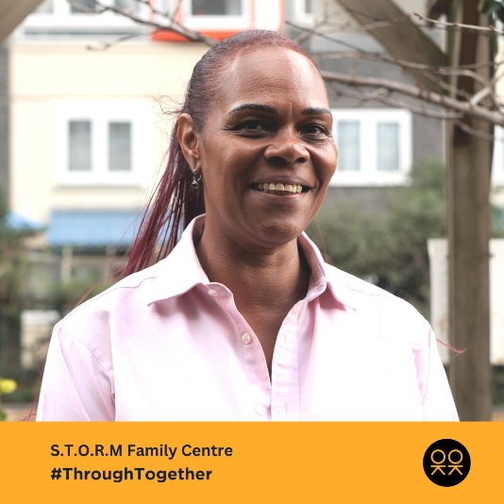
The Food Chain | “As human beings we need that love, that kind of hug, that kind of feeling from another person.”  Find out how organisations like @thefoodchain are helping Londoners to support each other right now.  #ThroughTogether  www.thriveldn.co.uk/throughtogether | Videos:  16x9  https://drive.google.com/file/d/1fbFxvRNe4J0gmsCDH3nwSQQi8J7sH5f8/view?usp=sharing  9x16  https://drive.google.com/file/d/1nP9EnX4oAjh_YeEVPx7CMFoYSIltdKPZ/view?usp=sharing  Stills:  THRIVE_230113_FOOD_CHAIN_1.jpg  THRIVE_230113_FOOD_CHAIN_2.jpg  THRIVE_230113_FOOD_CHAIN_3.jpg  THRIVE_230113_FOOD_CHAIN_4.jpg

Getting Through This Together: top line & core messages
- When using the below, you may wish to signpost to localised services/ webpages instead of using the suggested regional offers below.
- Explore the full range of Getting Through This Together assets for using across your own digital channels
- Use #ThroughTogether or tag @ThriveLDN, where you can, so we are able to reshare.

Top line message: When times are tough, it’s important that we look after our own and each other's wellbeing.
Channel | Suggested post | Suggested asset
Twitter 1 | Right now, things may feel uncertain or difficult, and it's OK to feel anxious or worried.  Whether you’re looking for yourself, or to help others, support and advice services are free and available.  Find help with the cost of living: www.london.gov.uk/help-cost-living  #ThroughTogether | 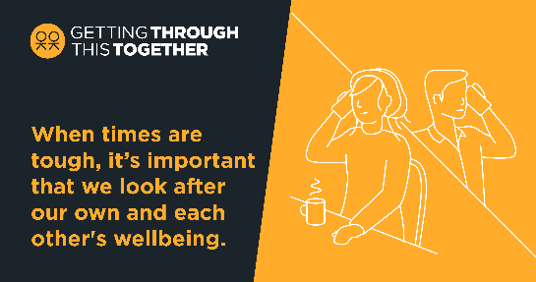  Alt text: The image shows two people having a conversation on the telephone. The Getting Through This Together logo is visible alongside text that reads: When times are tough, it’s important that we look after our own and each other's wellbeing.
Twitter 2 | Whether you’re looking for yourself, or to help family, friends or others in your community, support and advice services are free and available.  Find help with the cost of living:  www.london.gov.uk/help-cost-living  Find ideas to support wellbeing:  www.thriveldn.co.uk/help-yourself-and-others/  #ThroughTogether
Facebook / LinkedIn | Right now, things may feel uncertain or difficult, and it's OK to feel anxious or worried.  When times are tough, it’s important that we look after our own and each other's wellbeing.  Whether you’re looking for yourself, or to help a friend or others in your community, support and advice services are there to help.  Find more ideas by visiting: www.thriveldn.co.uk/help-yourself-and-others  #ThroughTogether | 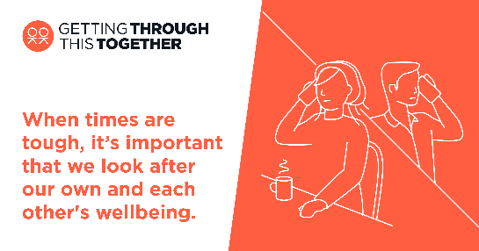  Alt text: The image shows two people having a conversation on the telephone. The Getting Through This Together logo is visible alongside text that reads: When times are tough, it’s important that we look after our own and each other's wellbeing.
Instagram | Right now, things may feel uncertain or difficult, and it's OK to feel anxious or worried.  When times are tough, it’s important that we look after our own and each other's wellbeing.  Whether you’re looking for yourself, or to help a friend or others in your community, support and advice services are there to help.  Talk to someone you trust 💬  Take things one step at a time ☝️  Focus on what you can control 👤  Reach out to friends and family 🤝  For a range of information to support Londoners, including on money and mental health, search ‘GLA help with the cost of living online hub’.  Or find out more by following the link in @ThriveLDN’s bio.  #ThroughTogether | Square (feed):  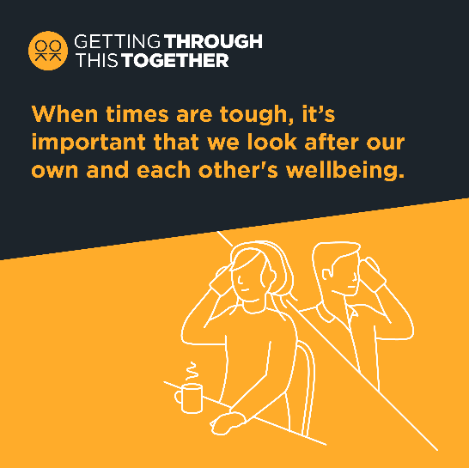  Alt text: The image shows two people having a conversation on the telephone. The Getting Through This Together logo is visible alongside text that reads: When times are tough, it’s important that we look after our own and each other's wellbeing.

Core message 1: We can all do our bit to spread hope and kindness, and to help each other.
Twitter 1 | We can all do our bit to spread hope and kindness, and to help each other.  Reaching out to someone could help them know that someone cares, that they are valued, and help them find the support they need.  See @ThriveLDN for ideas:  www.thriveldn.co.uk/help-yourself-and-others  #ThroughTogether
Twitter 2 | London works best when we all look out for each other.  Right now, things may feel uncertain or difficult for many people. Take some time to check in with friends, family, and those in your community.  Find more via @ThriveLDN:  www.thriveldn.co.uk/help-yourself-and-others  #ThroughTogether
Facebook / LinkedIn | Right now, things may feel uncertain or difficult for many Londoners. Take some time to check in with friends, family, and those in your community.  Whether you’re looking for yourself, or to help a friend or others in your community, support and advice services are there to help.  For more ideas by visiting: www.thriveldn.co.uk/help-yourself-and-others  #ThroughTogether
Instagram | London is full of amazing people and communities who have pulled together during the most challenging of times. We know that our city works best when we all look out for each other.  Right now, things may feel uncertain or difficult for many Londoners. Take some time to check in with friends, family, and those in your community.  Visit www.london.gov.uk/help-cost-living for more information and to discover support local to you.  For more ideas on looking after your own and each other’s wellbeing, follow the link in @ThriveLDN’s bio for simple tools, ideas and inspiration, tried and tested to help improve wellbeing.  #ThroughTogether

Core message 2: When times are tough, it’s normal to feel a bit worried, frustrated or overwhelmed.
Twitter 1 | Talking about financial concerns and difficulties is challenging. But you are not alone, and there is nothing to be ashamed of.  Talk to someone you trust💬  Reach out to friends and family🤝  If you need advice there is support available: www.london.gov.uk/what-we-do/communities/help-cost-living/help-if-money-worries-are-affecting-your-mental-health  #ThroughTogether
Twitter 2 | Accessing help and support for financial difficulties is really important. And doing what you can to stay well will help you deal with things better.  Talk to someone you trust 💬  Take things one step at a time ☝️  Focus on what you can control 👤  Reach out to friends & family 🤝
Twitter 3 | For some Londoners, thinking about money or debt may feel overwhelming.  If you need support and impartial advice, there are free professional services available. Ask for help if you need it.  @DebtFreeAdvice_ 0800 808 5700  @CAPuk 0800 328 0006  Or visit: www.london.gov.uk/what-we-do/communities/help-cost-living/help-if-money-worries-are-affecting-your-mental-health
Twitter 4 | If you find yourself in urgent financial or personal need, there is support and information available for you. Please seek help if you need it.  💷 @turn2us_org: 0808 802 2000  🏘️ @Shelter: 0344 515 1540  🥫 @TrussellTrust: 0808 208 2138  Or visit www.london.gov.uk/what-we-do/communities/help-cost-living/
Twitter 5 | If you’re feeling the strain financially and things seem overwhelming, you can take small steps to help you stay mentally healthy.  @GoodThinkingUK has lots of practical tips and links to organisations that can help ease the pressure: www.good-thinking.uk/articles/cost-living-crisis-how-look-after-your-mental-health  #ThroughTogether | Find relevant Good Thinking assets:  https://goodthinking-strapi.s3.eu-west-2.amazonaws.com/Good_Thinking2022_Comms_Toolkit_1300fff036.docx  Or  https://drive.google.com/drive/folders/1A-QcbmAUo1Rbxi6IUAS8kYGzBxUlZm3Z
Facebook / LinkedIn | Talking about financial concerns and difficulties is challenging. But you are not alone and there is nothing to be ashamed of.  If you need support and impartial advice, there are free professional services available.  Accessing help and support for financial difficulties is really important. But so is also doing what you can to stay well, which will help you deal with things better.  Talk to someone you trust 💬  Take things one step at a time ☝️  Focus on what you can control 👤  Reach out to friends and family 🤝  The GLA’s Help With the Cost of Living online hub contains a range of information to support Londoners, including on money and mental health: https://www.london.gov.uk/what-we-do/communities/help-cost-living  #ThroughTogether
Instagram | Talking about financial concerns and difficulties is challenging. But you are not alone and there is nothing to be ashamed of.  If you need support and impartial advice, there are free professional services available.  Accessing help and support for financial difficulties is really important. But so is also doing what you can to stay well, which will help you deal with things better.  Talk to someone you trust 💬  Take things one step at a time ☝️  Focus on what you can control 👤  Reach out to friends and family 🤝  For a range of information to support Londoners, including on money and mental health, search ‘GLA help with the cost of living online hub’.  And for more ideas on looking after your own wellbeing, @ThriveLDN has simple tools, ideas and inspiration. Follow the link in their bio.  #ThroughTogether

Core message 3: London is full of amazing people and communities who have come together during the most challenging of times.
Twitter 1 | Londoners are speaking with family, friends, and trusted others in their community to support themselves through the emotional pressures felt through the cost-of-living crisis.  @ThriveLDN has tips on having a supportive conversation: www.thriveldn.co.uk/communications/toolkits-and-resources/toolkit/thrive-ldn-mental-health-conversation-starter/  #ThroughTogether
Twitter 2 | London works best when we look out for each other.  Right now, things may feel difficult for many people. Take some time to check in with friends, family, and those in your community.  How do you care for yourself and those around you?  Let us know below 👇 #ThroughTogether
Twitter 3 | Cost-of-living pressures are putting a strain on many Londoners. The financial pressure is likely impacting on people’s mental health.  Check in with friends, family, and those in your community.  When are you next catching up with someone you care about? 👇  #ThroughTogether
Facebook / LinkedIn | London is full of amazing people and communities who have pulled together during the most challenging of times. We know that our city works best when we all look out for each other.  Right now, things may feel uncertain or difficult for many Londoners. Take some time to check in with friends, family, and those in your community.  London is full of amazing people and communities who have come together during the most challenging of times.  Whether you’re looking for yourself, or to help a friend or others in your community, support and advice services are there to help. For more ideas by visiting: www.thriveldn.co.uk/help-yourself-and-others  #ThroughTogether
Instagram | London is full of amazing people and communities who have pulled together during the most challenging of times. We know that our city works best when we all look out for each other.  Right now, things may feel uncertain or difficult for many Londoners. Take some time to check in with friends, family, and those in your community.  London is full of amazing people and communities who have come together during the most challenging of times.  For more ideas on looking after your own and each other’s wellbeing, follow the link in @ThriveLDN’s bio for simple tools, ideas and inspiration, tried and tested to help improve wellbeing.  #ThroughTogether

Thrive LDN conversation starter
We have revisited our conversation starter tool to help Londoners engage with friends, family, neighbours or those they support in your community or workplace about good mental health, wellbeing and financial worries. As well as importantly knowing the most appropriate help and advice services to signpost to for professional support.

Download the conversation starter resource (PDF):
- Cost-of-living version (November 2022)
- Covid version (January 2021)

Channel | Suggested post | Suggested asset
Twitter 1 | Talking about mental health is important, but it isn’t always easy.  @ThriveLDN's updated conversation starter tool gives you the tips and prompts to help you get your community talking about good mental health, wellbeing and financial worries.  https://thriveldn.co.uk/communications/toolkits-and-resources/toolkit/thrive-ldn-mental-health-conversation-starter/ | 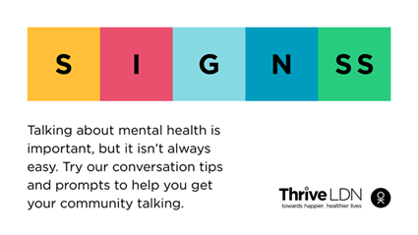  Alt Text: A graphic that highlights the conversation starter tool SIGNSS framework. The text below says “Talking about mental health is important, but it isn’t always easy. Try our conversation tips and prompts to get your community talking.”
Twitter 2 | It’s not always easy for someone to talk about how they’re feeling or share the concerns they may have. This is particularly true for financial worries.  @ThriveLDN's updated conversation starter tool gives you the prompts to get your community talking.  https://thriveldn.co.uk/communications/toolkits-and-resources/toolkit/thrive-ldn-mental-health-conversation-starter/
Instagram | Talking about mental health is important, but it isn’t always easy. @ThriveLDN's updated conversation starter tool gives you the tips and prompts to help you get your community talking about good mental health, wellbeing and financial worries.  This conversation starter tool follows a SIGNSS framework – Situation, Initiate, Guide, Nudge, and Support and Signpost – and aims to help encourage a gentle and supportive conversation.  SIGNSS outlines a set of clear stages to start, maintain and safely close a conversation about mental health. It is designed to complement what many Londoners are already doing to support those close to them or in their social networks through difficult times.  Follow the link in @ThriveLDN’s bio. | 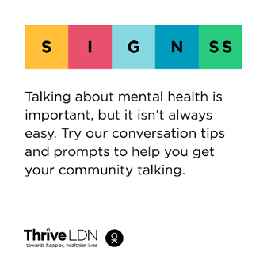  Alt Text: A graphic that highlights the conversation starter tool SIGNSS framework. The text below says “Talking about mental health is important, but it isn’t always easy. Try our conversation tips and prompts to get your community talking.”
Facebook and LinkedIn | Talking about mental health is important, but it isn’t always easy. Thrive LDN's updated conversation starter tool gives you the tips and prompts to help you get your community talking about good mental health, wellbeing and financial worries.  This conversation starter tool follows a SIGNSS framework – Situation, Initiate, Guide, Nudge, and Support and Signpost – and aims to help encourage a gentle and supportive conversation.  SIGNSS outlines a set of clear stages to start, maintain and safely close a conversation about mental health. It is designed to complement what many Londoners are already doing to support those close to them or in their social networks through difficult times.  Explore via Thrive LDN’s website: https://thriveldn.co.uk/communications/toolkits-and-resources/toolkit/thrive-ldn-mental-health-conversation-starter/ | Alt Text: A graphic that highlights the conversation starter tool SIGNSS framework. The text below says “Talking about mental health is important, but it isn’t always easy. Try our conversation tips and prompts to get your community talking.”  Accounts to tag: @thriveldn

Free trauma-informed practice training
Thrive LDN has been working with Nicola Lester Psychological Trauma Consultancy to offer free, pre-recorded online trauma-informed practice training to support individuals and organisations.
The training is offered across three levels, Bronze, Silver and Gold. At each level, participants will receive a certificate of completion and certified badge which can be used to demonstrate their knowledge and trauma informed training status. Training is free to complete and does not require registration to join. More details including the links to the courses can be found on the Thrive LDN website.
Below we have provided some suggested social copy which you may find useful to promote the training opportunity to your networks, internally and externally.
Whilst the training videos can be accessed individually, some organisations may prefer to participate in a group, either in person or online. On our website, you can also find a brief guide for facilitators to promote engagement and enhance opportunities for discussion and sharing learning.
Channel | Suggested post | Suggested asset
Twitter (1) | @ThriveLDN has been working with Nicola Lester to offer free, pre-recorded online trauma-informed practice training to support individuals and organisations. Available at Bronze, Silver & Gold levels.  Training and supporting resources can be accessed via: www.thriveldn.co.uk/trauma-informed | Download all digital assets.  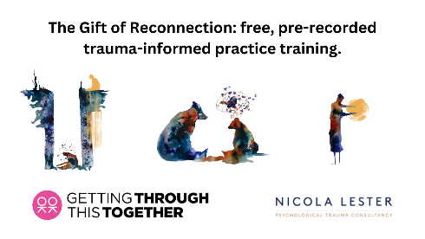  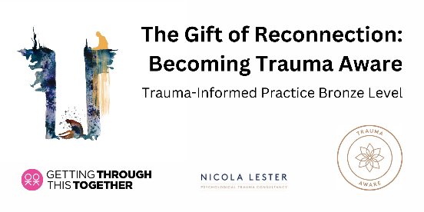  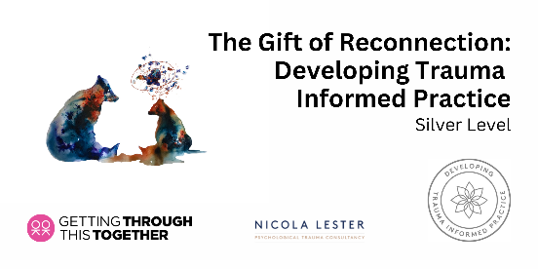  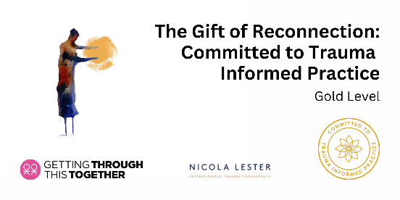
Twitter (2) | Interested in becoming more trauma aware?  Then take @ThriveLDN and Nicola Lester's free, online training and get certified at bronze, silver or gold level.  Full details about the training and supporting resources can be accessed via: www.thriveldn.co.uk/trauma-informed  #ThroughTogether
Instagram | How trauma aware are you?  @ThriveLDN has partnered with Nicola Lester Psychological Trauma Consultancy to offer free, pre-recorded online trauma-informed practice training to support individuals and organisations.  The training is offered across three levels, Bronze, Silver and Gold, with the opportunity to move up to the next level at each stage.  At each level, participants will receive a certificate of completion and certified badge which can be used to demonstrate their knowledge and trauma informed training status.  Training is free to complete and can be accessed from @ThriveLDN’s website:  www.thriveldn.co.uk/trauma-informed  Or search the link in their bio.  #TraumaInformed  #MentalHealthTraining  #ThroughTogether | Download all digital assets.  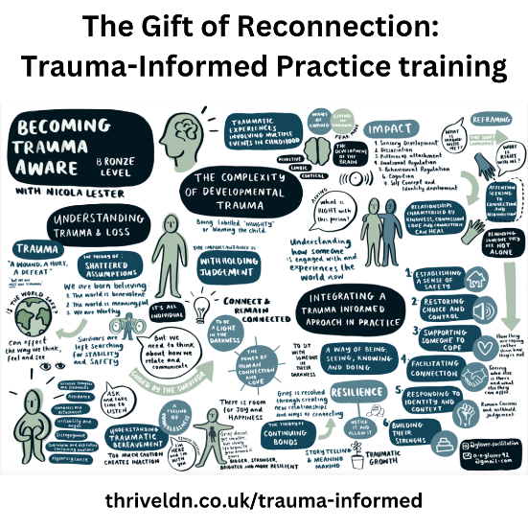  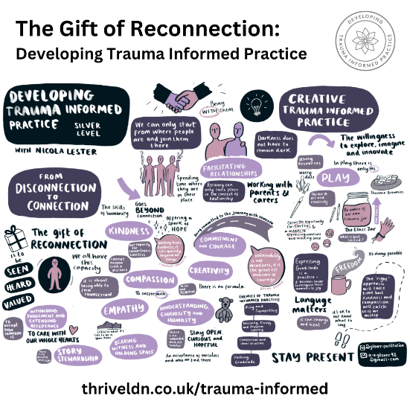
LinkedIn and Facebook | How trauma aware are you?  Thrive LDN has partnered with Nicola Lester Psychological Trauma Consultancy to offer free, pre-recorded online trauma-informed practice training to support individuals and organisations.  The training is offered across three levels, Bronze, Silver and Gold, with the opportunity to move up to the next level at each stage.  At each level, participants will receive a certificate of completion and certified badge which can be used to demonstrate their knowledge and trauma informed training status.  Training is free to complete and can be accessed from @ThriveLDN’s website:  www.thriveldn.co.uk/trauma-informed | Download all digital assets.

Thrive LDN and Money and Pensions Service money and mental health webinar
To mark Talk Money Week, Thrive LDN and the Money and Pensions Service hosted a free learning webinar on the relationship between money and mental health, and the practical ways to get support. You can watch the webinar back via YouTube.

As well as finding out more about the link between money and mental health, attendees were guided through the support and practical advice available to those they may be supporting through a tough time such as the Mental Health & Money Toolkit.

Twitter 1 | 📽️ @ThriveLDN and the @MoneyPensionsUK hosted a webinar on the relationship between money and mental health, and the practical ways to get support.  You can watch it back for advice and resources available to support those going through a tough time: https://thriveldn.co.uk/latest/news-and-blog/all/thrive-ldn-marks-talk-money-week-2022/ |  | 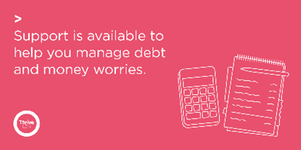  Alt text: A graphic of a calculator and note pad with the adjacent text reading support is available to help you manage debt or money worries.
Instagram | The relationship between money and mental health…  @ThriveLDN and the Money and Pensions Service recently hosted a free learning webinar on the relationship between money and mental health, and the practical ways to get support.  As well as finding out more about the link between money and mental health, attendees were guided through the support and practical advice available to those they may be supporting through a tough time such as the Mental Health & Money Toolkit.  Follow the link in @ThriveLDN’s bio to watch the webinar back via YouTube. |  | Alt text: A graphic of a calculator and note pad with the adjacent text reading support is available to help you manage debt or money worries.
Facebook and LinkedIn | The relationship between money and mental health…  @ThriveLDN and the Money and Pensions Service recently hosted a free learning webinar on the relationship between money and mental health, and the practical ways to get support.  As well as finding out more about the link between money and mental health, attendees were guided through the support and practical advice available to those they may be supporting through a tough time such as the Mental Health & Money Toolkit.  Watch back via Thrive LDN’s website: https://thriveldn.co.uk/latest/news-and-blog/all/thrive-ldn-marks-talk-money-week-2022/ |  | Alt text: A graphic of a calculator and note pad with the adjacent text reading support is available to help you manage debt or money worries.  Accounts to tag: @thriveldn

Updated suicide prevention messaging for digital channels
An important part of the suicide prevention strategy focusses on building resilience across London and supporting people so they don’t get to a point of crisis.

Additionally, the ongoing #ZeroSuicideLDN campaign is aiming to get Londoners to take free, online suicide prevention training. We’ve partnered with the Zero Suicide Alliance, who have created a training program to help people to be able to identify warning signs and to feel comfortable having conversations about suicide.
Twitter (1) | We all need to look out for one another. That's why we are supporting #ZeroSuicideLDN to encourage everyone to take free, online training to know what to do if a loved one, colleague, or stranger is in distress.  Learn to save a life today... www.thriveldn.co.uk/ZeroSuicideLDN | All #ZeroSuicideLDN assets:  https://drive.google.com/drive/u/0/folders/189EzBGDyPA96jr-Tw6-sTIh2egGI_CdE  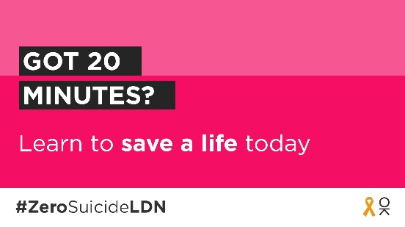
Twitter (2) | It’s never been more important to think and talk more about mental health. That’s why we are taking @Zer0Suicide’s free suicide prevention training, to learn what to do if a loved one, colleague, or stranger is at risk of suicide.  You can too. Visit 👉 www.thriveldn.co.uk/zerosuicideldn
Twitter (3) | Some people may be finding life harder than usual at the moment. It's vital we all look out for each other, in case someone may be in crisis.  That's why we are supporting the #ZeroSuicideLDN campaign. You can too, it only takes 20 minutes.  Visit 👉 www.thriveldn.co.uk/zerosuicideldn
Twitter (4) | London works best when we all work together and look after each other. 🧡  There's FREE online 20-minute training available to help us all to spot the signs when someone may be thinking about taking their life.  Visit www.thriveldn.co.uk/zerosuicideldn  #ZeroSuicideLDN
Twitter (5) | For some Londoners right now, worries over money or debt may be overwhelming. Would you be able to spot a neighbour or friend in distress? There’s FREE @Zer0Suicide online training to help.  Join the #ZeroSuicideLDN campaign by visiting: www.thriveldn.co.uk/zerosuicideldn
Twitter (6)  Witness to suicide resource and support | First Hand has been developed by @ThriveLDN, @AfterSuicideUK and @GrassrootsSP to support anyone who has witnessed the suicide of someone they do not know.  If this is you, please know that there is help and support available. You are not alone 🧡  https://supportaftersuicide.org.uk/resource/first-hand/ | 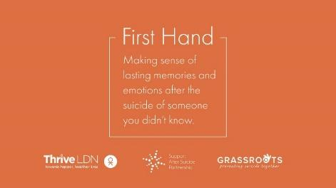
Twitter (9)  NHS urgent mental health support lines signposting | Life can be really difficult, and you might sometimes feel completely overwhelmed. But remember, a mental health emergency should be taken as seriously as a physical one.  Find your local NHS urgent mental health helpline for 24/7 advice and support.  👉 www.nhs.uk/service-search/mental-health/find-an-urgent-mental-health-helpline | 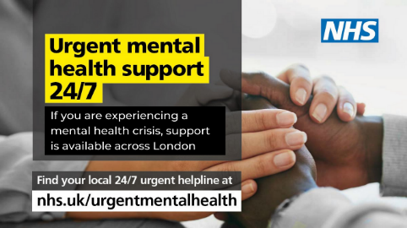  More assets: https://drive.google.com/drive/folders/1P35u0hUFqd2LTKYM6ThatE1SMA2EoHIB
Instagram | Have you got 20 minutes to learn how to save a life today?  Around 10 people a week take their own life in London. We want to encourage Londoners to take the FREE online training provided by the @zerosuicidealliance so they know what to do if a loved one, colleague or stranger is in distress.  Learn to save a life today...take the training.  Visit 👉 thriveldn.co.uk/zerosuicideldn  Or find details in @ThriveLDN bio.  #ZeroSuicideLDN #London #LifeInLondon #WeAreLDN #OKLDN #SuicidePrevention #Teamwork #Together #ZeroSuicideAlliance #Londoners #MentalHealth #OnlineTraining | More assets: https://drive.google.com/drive/u/0/folders/189EzBGDyPA96jr-Tw6-sTIh2egGI_CdE
Facebook and LinkedIn | Living and working in London can be stressful, and right now for some it may be overwhelming. Would you be able to spot a colleague or friend in distress?  That is why we want to encourage Londoners to take the Zero Suicide Alliance’s free, online training to know what to do if a loved one, colleague or stranger is in crisis.  Learn to save a life today...take the training.  Visit: www.thriveldn.co.uk/zerosuicideldn | 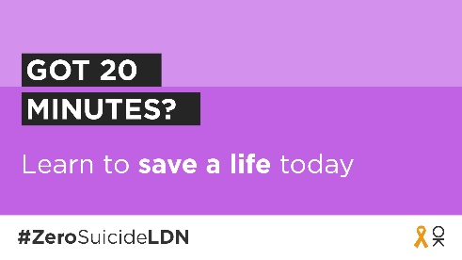  More #ZeroSuicideLDN assets: https://drive.google.com/drive/u/0/folders/189EzBGDyPA96jr-Tw6-sTIh2egGI_CdE
LinkedIn (for individuals) | I’ve taken suicide prevention training.  It’s never been more important to think and talk more about mental health. The Zero Suicide Alliance’s free suicide prevention training is a really helpful way to learn what to do if a loved one, colleague, or stranger is in a crisis or at risk of suicide.  Learn to save a life today, join me in supporting the #ZeroSuicideLDN campaign.  Visit Thrive LDN’s website for more details: www.thriveldn.co.uk/zerosuicideldn | 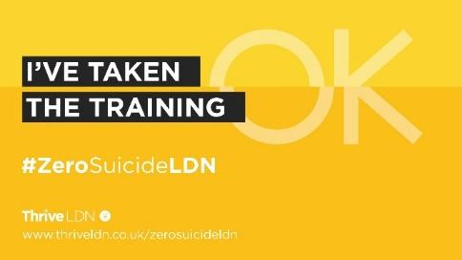  More assets:  https://drive.google.com/drive/u/4/folders/1ywBx_uVXKPh4AXorsQJqBCzyy4lKpxSc

APPENDIX A: Getting Through This Together - key messages
The below messaging house focuses attention on a predominant umbrella message (in this case: Getting through this together) and then explores key sub-messages that help to strengthen the overall narrative, support any subsequent campaign(s), and offer a route into signposting to relevant advice and support services.
A messaging house supports both the consistency and volume of messaging and signposting across London, to complement the good work already underway to support Londoners and communities at a regional, sub-regional and local level.

Messaging house
Top Line:
Getting through this together.
When times are tough, it’s important that we look after our own and each other's wellbeing.
Core message 1 | We can all do our bit to spread hope and kindness, and to help each other.
 | Reaching out to someone could help them know that someone cares, that they are valued, and help them find the support they need.
Call to action (CTA):
Accessing relevant resources, tools, ideas, and training offers to help others through tough times.
Understanding the relationship between money and mental health.
Core message 2 | When times are tough, it’s normal to feel a bit worried, frustrated or overwhelmed.
 | There are some simple things we can do to help keep ourselves well, and if you are finding it hard support and advice services are there for you.
CTA:
Individuals accessing the relevant support services they need. Normalising needing and seeking help.
Core message 3 | London is full of amazing people and communities who have come together during the most challenging of times.
 | Many Londoners are speaking with family, friends, and trusted others in their community to support themselves with their wellbeing because of the impact of cost-of-living pressures.
CTA:
Londoners sharing their stories.
Seeing acts of support, togetherness and inclusion across London through storytelling. Normalising needing and seeking help.

APPENDIX B: Why is resilience important?

Resilience is protective of mental health.
It’s about coping with adversity and maintaining core functions during difficult times. Resilience does not necessarily remove risk but focuses on building the capacity to cope with challenges and adversity. It is protective of mental health particularly in times of difficulty. Resilience is adaptive and can be transformative, especially when a return to the pre-crisis or challenge point is not possible. Individual and collective resilience are interconnected and strengthening one supports the other.
Collective resilience is the ability for populations to endure, adapt and create new ways of thinking and functioning in the context of change, uncertainty, or adversity. Resilience of collectives are underpinned by values. For example, communities that share values of participation and diversity are more likely to be trusting. Ultimately, collective resilience is impacted by the structural and environmental factors it depends on. There are several ways that collective resilience can be strengthened in the face of the cost living crises, which for many is part of continuation of crises since the COVID-19 pandemic.
Community cohesion and integration have been identified as foundations for collective resilience. Additionally, social connectedness and social capital include a sense of trust and community belonging, a sense of attachment to place, and civic participation. This framework is likely to withstand adversity, lead to adaptation during times of hardship and to recovery. On a practical level, individuals can strengthen their social networks with family members and friends, and trusted others in their community. Supporting others creates a pathway for connection and participation, which are both known to strengthen resilience. Creating opportunities to facilitate connections to social support and the wider community will aid in strengthening collective resilience.
Additionally, resilience can be built through culture, which is the space where shared narratives are created and reinterpreted. The ability for new stories to be created, told, and shared by communities and individuals in a way that is important to that community, supports both individual and collective resilience. This also provides opportunities for reframing the issue to make sense of the situation and to process. While the effect of the cost-of-living crisis is disproportionally felt, it is an experience affecting a significant part of the population.
Furthermore, collective resilience can be strengthened by supporting others. Supporting others is a potential pathway to socially connect, and create networks, both established practices that maintain good mental health. By identifying and strengthening access to different sources of support communities are able to access wider support networks and resources.

Behavioural insights
Hertfordshire County Council Behaviour Change Unit (BCU) has provided helpful advice in the context of supporting people with the increased cost-of-living pressures. Three key take-aways for communications are:
- Understand what drives stigmatisation. Ensure that the language used is non-judgemental, collaborative, engaging, free from any content that causes shock, is person-centred and normalises the behaviour.
- Focus on the help available, rather than the underlying issue causing the need for help. For example, “needing support” instead of “having money problems” or “struggling”. Use phrases such as “if this is your situation, this is the support that is available to you”.
- Any content that can generate a negative emotional response can cause people to feel angry and frustrated, which can lead them to disengage with your message. For example, avoid words like “crisis” and “emergency” and focus on the positives.
Further evidence and insights
You can also download the latest Thrive LDN evidence briefing on the cost-of-living crisis and implications for Londoners’ public mental health which outlines the emerging issues.

Campion J (2019) Public mental health: Evidence, practice and commissioning. Royal Society for Public Health.
Seaman, P. et al., Resilience for public health: Supporting transformation in people and communities. Glasgow Centre for Population Health, 2014. (PDF) Resilience for public health Supporting transformation in people and communities (researchgate.net)
Seaman, P. et al., Resilience for public health: Supporting transformation in people and communities. Glasgow Centre for Population Health, 2014. (PDF) Resilience for public health Supporting transformation in people and communities (researchgate.net)
Norris, F. et al., 2008. Community Resilience as a Metaphor, Theory, Set of Capacities, and Strategy for Disaster Readiness, American Journal of Community Psychology.
Chan et al., 2006

