Thrive LDN communications toolkit: Loneliness Awareness Week and related resources
12th – 18th June 2023
Context and introduction:
Loneliness Awareness Week is a week dedicated to raising awareness of loneliness and reducing the stigma that surrounds it. It is all about creating supportive communities by having conversations with family, friends or colleagues about loneliness.
The week was created by Marmalade Trust, a leading loneliness charity, working with all ages in the UK. They launched Loneliness Awareness Week in 2017 and has grown in momentum each year across the UK.
For Loneliness Awareness Week 2023, Marmalade Trust want to harness moments of connection and create supportive communities by having conversations with family, friends, neighbours or colleagues.
The Marmalade Trust has put together a supporter communications pack and asset bundle filled with information on how to get involved with the week as well as social media graphics and suggested copy.
Below we have also provided some suggested resources, information and social media posts to mark the week and provide signposting for anyone that may need it – including many of which reflect public mental health resources developed for London.
The resources are from both Thrive LDN and Good Thinking.
For more on the below, contact info@thriveldn.co.uk.
Contents:
- Thrive LDN conversation starter and Good Thinking how to guides
- Good Thinking, London’s digital mental health service
- Thrive LDN X Messages of Hope collaboration
- Thrive LDN Happy to Chat bench and spaces toolkit
- Signposting to further resources

Thrive LDN conversation starter
Thrive LDN’s conversation starter tool helps Londoners engage with friends, family, neighbours or those they support in the community or workplace about good mental health, wellbeing and financial worries. As well as importantly knowing the most appropriate help and advice services to signpost to for professional support.
Download the conversation starter resource (PDF):
- Cost-of-living version (November 2022)
- Covid version (January 2021)

The conversation starter tool is also embedded in the Good Thinking guides to looking out for those around you. Four tailored guides with three simple steps to help you spot the signs of poor mental health in others, check in and let them know you care and help them get the support they need.
Download the guides (PDF):
- Looking out for those around you
- Looking out for friends and colleagues at work
- Looking out for your friends – a guide to help children and young people support friends
- Looking out for children and young people – a guide for parents and carers
Channel | Suggested post | Suggested asset
Twitter 1 | Talking about mental health is important, but it isn’t always easy.  This #LonelinessAwarenessWeek explore  @ThriveLDN's conversation starter tool to find tips and prompts to help you get your community talking.  https://thriveldn.co.uk/communications/toolkits-and-resources/toolkit/thrive-ldn-mental-health-conversation-starter/ | 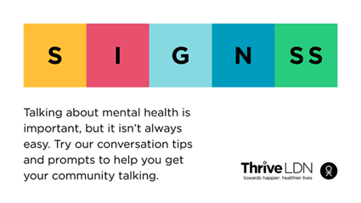  Alt Text: A graphic that highlights the conversation starter tool SIGNSS framework. The text below says “Talking about mental health is important, but it isn’t always easy. Try our conversation tips and prompts to get your community talking.”  Alt Text: Two people are walking a dog in an open green space and havening a chat. The text above them reads: When did you last talk to someone you care about?  More: https://drive.google.com/drive/folders/16eX6qdbW0L9d5I-rnS2Lk7DVKvJhoFhl?usp=share_link
Twitter 2 | It’s not always easy for someone to talk about how they’re feeling or share their concerns.  This #LonelinessAwarenessWeek why not reach out to a friend or loved one to get them talking.  Explore some ways in which you can start such conversations: www.thriveldn.co.uk/communications/toolkits-and-resources/toolkit/thrive-ldn-mental-health-conversation-starter/
Twitter 3 | Loneliness can affect us all, at any time of our lives.  Reaching out to someone could help them know that someone cares and help them find the support they need.  Explore @ThriveLDN’s tips on having a supportive conversation: thriveldn.co.uk/communications/toolkits-and-resources/toolkit/thrive-ldn-mental-health-conversation-starter/  #LonelinessAwarenessWeek
Twitter 4 | In these tough times, it's important to look out for those around you.  Remember to check in with friends, family and workmates.  @GoodThinkingUK's guides lead you through 3 easy steps to help if someone you know is struggling: https://www.good-thinking.uk/how-guides/quick-guides-support-others  #LonelinessAwarenessWeek | 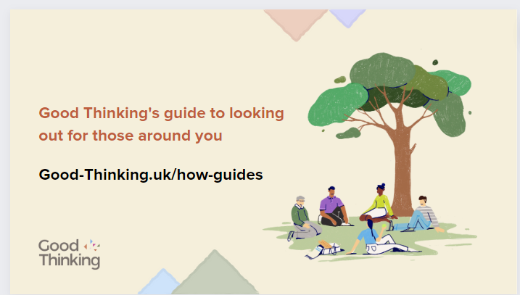  Alt Text: A graphic that highlights the Good Thinking guides to looking out for those around you. The text below says “Good Thinking’s guide to looking out for those around you” and includes a link to access the guides, “good-thinking.uk/how-guides”. Illustration of a group of people of various ages and genders sat under a tree.  Download: https://drive.google.com/drive/u/1/folders/1eegJjVGiRoAULb-uKP4zhwiqdjmsMsTA
Instagram 1 | When times are tough, it’s important that we look after our own and each other's wellbeing.  For #LonelinessAwarenessWeek 2023, we’re asking Londoners to reach out to their family, friends and trusted others to help create supportive communities and foster connection.  Reaching out to someone could help them know that someone cares, that they are valued, and help them find the support they need.  Explore @ThriveLDN’s tips on having a supportive conversation - click the link in their bio. | 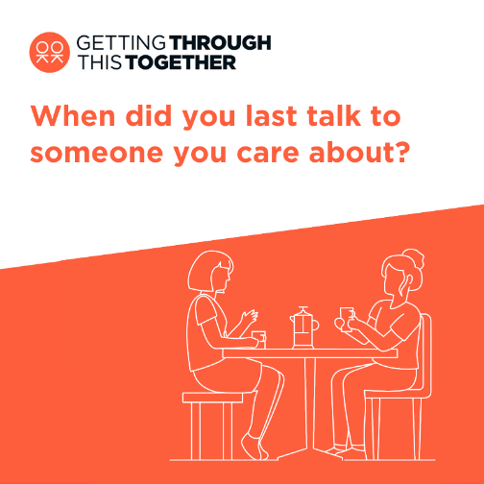  Alt Text: Two people are sat at a table and having a chat over a cup of coffee. The text above them reads: When did you last talk to someone you care about?  More: https://drive.google.com/drive/folders/1Ijzql7UQ0ExvBzc1bRHRQjShXCyRwkuX?usp=share_link
Instagram 2 | Loneliness can affect us all, at any time of our lives.  When times are tough it’s important that we look after our own and each other’s wellbeing.  This #LonelinessAwarenessWeek why not reach out to a friend or loved one to get them talking?  @ThriveLDN's updated conversation starter tool gives you the tips and prompts to help you get your community talking about good mental health, wellbeing and financial worries.  This conversation starter tool follows a SIGNSS framework – Situation, Initiate, Guide, Nudge, and Support and Signpost – and aims to help encourage a gentle and supportive conversation.  It is designed to complement what many Londoners are already doing to support those close to them or in their social networks through difficult times.  Follow the link in @ThriveLDN’s bio.  #LonelinessAwarenessWeek | 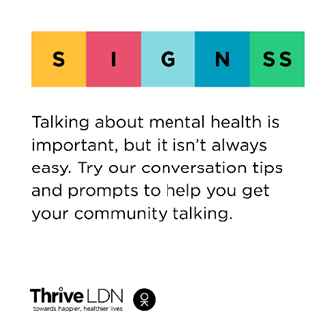  Alt Text: A graphic that highlights the conversation starter tool SIGNSS framework. The text below says “Talking about mental health is important, but it isn’t always easy. Try our conversation tips and prompts to get your community talking.”
Instagram 3 | In these tough times, it's important to look out for those around you.  Remember to check in with friends, family and workmates.  @goodthinkinguk's guides lead you through 3 simple steps to help if someone you know is struggling - including tips on starting those difficult conversations from @thriveldn and #MentalWellbeing support and resources for you to share.  good-thinking.uk/how-guides/quick-guides-support-others  #LonelinessAwarenessWeek | 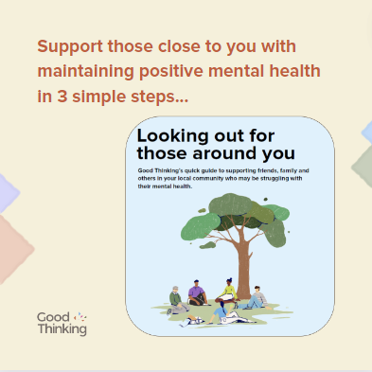  Alt Text: A graphic that highlights the Good Thinking guides to looking out for those around you. The text below says “Support those close to you with maintaining positive mental wellbeing in 3 simple steps”. Illustration of a group of people of various ages and genders sat under a tree.  Download: https://drive.google.com/drive/u/1/folders/1eegJjVGiRoAULb-uKP4zhwiqdjmsMsTA
Facebook and LinkedIn | Loneliness can affect us all, at any time of our lives.  When times are tough it’s important that we look after our own and each other’s wellbeing.  This #LonelinessAwarenessWeek why not reach out to a friend or loved one to get them talking?  @ThriveLDN's updated conversation starter tool gives you the tips and prompts to help you get your community talking about good mental health, wellbeing and financial worries.  This conversation starter tool follows a SIGNSS framework – Situation, Initiate, Guide, Nudge, and Support and Signpost – and aims to help encourage a gentle and supportive conversation.  It is designed to complement what many Londoners are already doing to support those close to them or in their social networks through difficult times.  Explore via Thrive LDN’s website: https://thriveldn.co.uk/communications/toolkits-and-resources/toolkit/thrive-ldn-mental-health-conversation-starter/  #LonelinessAwarenessWeek | Alt Text: A graphic that highlights the conversation starter tool SIGNSS framework. The text below says “Talking about mental health is important, but it isn’t always easy. Try our conversation tips and prompts to get your community talking.”

Good Thinking, London’s digital mental health service
Channel | Suggested post | Assets
Twitter | One in 12 Londoners experience loneliness.  This #LonelinessAwarenessWeek explore @GoodThinkingUK’s wellbeing tips and tools to help you cope:  https://www.good-thinking.uk/advice/how-to-cope-loneliness | 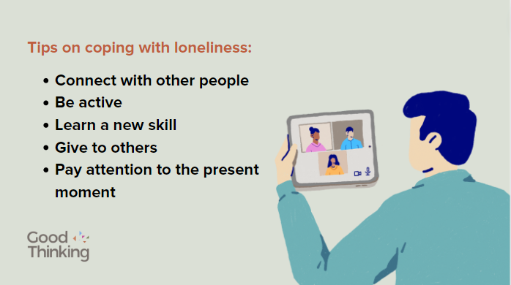  Alt Text: A graphic with Good Thinking’s tips on coping with loneliness. The text below says “Connect with other people. Be active. Learn a new skill. Give to others. Pay attention to the present moment”. Illustration of a male using a tablet for a video call with three people of various genders.  https://drive.google.com/drive/u/1/folders/1eegJjVGiRoAULb-uKP4zhwiqdjmsMsTA
Instagram | One in 12 Londoners experience loneliness.  This #LonelinessAwarenessWeek explore @goodthinkinguk’s wellbeing tips and tools to help you cope:  good-thinking.uk/advice/how-to-cope-loneliness | 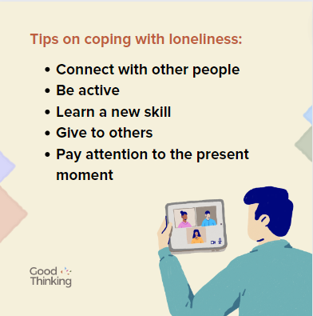  Alt Text: A graphic with Good Thinking’s tips on coping with loneliness. The text below says “Connect with other people. Be active. Learn a new skill. Give to others. Pay attention to the present moment”. Illustration of a male using a tablet for a video call with three people of various genders.  Download: https://drive.google.com/drive/u/1/folders/1eegJjVGiRoAULb-uKP4zhwiqdjmsMsTA
Facebook / LinkedIn | One in 12 Londoners experience loneliness.  This #LonelinessAwarenessWeek explore @GoodThinkingUK’s wellbeing tips and tools to help you cope:  https://www.good-thinking.uk/advice/how-to-cope-loneliness | Alt Text: A graphic with Good Thinking’s tips on coping with loneliness. The text below says “Connect with other people. Be active. Learn a new skill. Give to others. Pay attention to the present moment”. Illustration of a male using a tablet for a video call with three people of various genders.  Download: https://drive.google.com/drive/u/1/folders/1eegJjVGiRoAULb-uKP4zhwiqdjmsMsTA
Twitter | If you or someone you know is struggling this #LonelinessAwarenessWeek, @GoodThinkingUK is available 24/7 with free NHS-approved advice and resources to boost your mental wellbeing.  Visit www.good-thinking.uk/low-mood for tools to help you cope if you’re feeling down or isolated. | 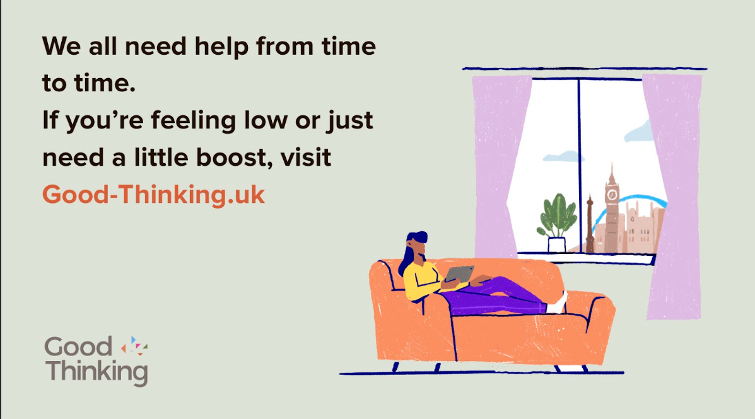  Alt text: A graphic that highlights the Good Thinking digital mental wellbeing service. The text below says “We all need help from time to time. If you’re feeling low or just need a little boost, visit good-thinking.uk”. Illustration of a person sat with their feet up on a sofa using a tablet and a window in the background with a view of London landmarks.  Download: https://drive.google.com/drive/u/1/folders/1bkOzOgz-ePmej_AnmqmtNCN1jBMBjwcA
Instagram | We all need help from time to time.  If you or someone you know is struggling this #LonelinessAwarenessWeek, @goodthinkinguk is available 24/7 with free NHS-approved advice and resources to boost your mental wellbeing.  Visit www.good-thinking.uk/low-mood for tools to help you cope if you’re feeling down or isolated. | 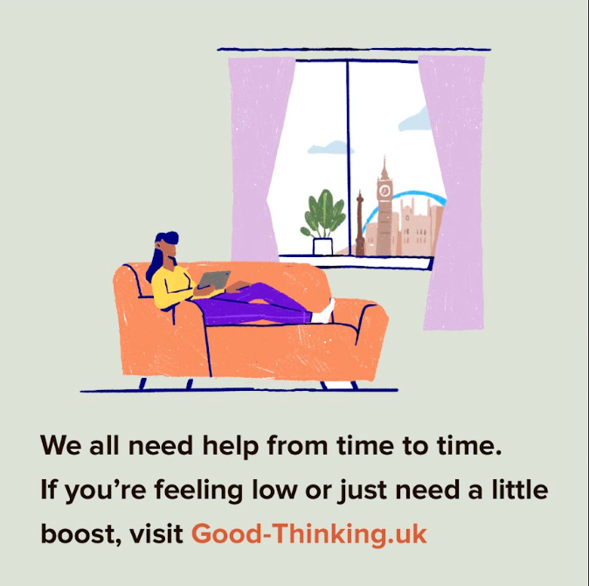  Alt text: A graphic that highlights the Good Thinking digital mental wellbeing service. The text below says “We all need help from time to time. If you’re feeling low or just need a little boost, visit good-thinking.uk”. Illustration of a person sat with their feet up on a sofa using a tablet and a window in the background with a view of London landmarks.  Download: https://drive.google.com/drive/u/1/folders/1AVAVEHpE5djKxBb5-fMGpbqXH-2Yyc70
Facebook / LinkedIn | We all need help from time to time.  If you or someone you know is struggling this #LonelinessAwarenessWeek, @goodthinkinguk is available 24/7 with free NHS-approved advice and resources to boost your mental wellbeing.  Visit www.good-thinking.uk/low-mood for tools to help you cope if you’re feeling down or isolated. | Alt text: A graphic that highlights the Good Thinking digital mental wellbeing service. The text below says “We all need help from time to time. If you’re feeling low or just need a little boost, visit good-thinking.uk”. Illustration of a person sat with their feet up on a sofa using a tablet and a window in the background with a view of London landmarks.  https://drive.google.com/drive/u/1/folders/1bkOzOgz-ePmej_AnmqmtNCN1jBMBjwcA

Thrive LDN X Messages of Hope collaboration
During Mental Health Awareness Week 2023, Thrive LDN and Messages of Hope launched a new collaboration as part of the Getting Through This Together campaign which aims to encourage Londoners to come together and support those around them that may be having a difficult time.

The collaboration involves sharing messages submitted anonymously by Londoners through a new Instagram account, @throughtogether to encourage the conversation around mental health and help to break the stigma that surrounds it.

The collaboration began during World Mental Health Day 2022 with 100s of submissions received from Londoners, sharing their messages of advice, encouragement and wellbeing wisdoms to others.

Channel | Suggested post | Assets (all launch assets here)
Instagram 1 | London works best when we all look out for each other.  A new collaboration from @Thrive LDN and @messagesof.hope will see anonymous messages from Londoners shared daily to spread hope, togetherness and break the stigma around mental health.  Follow @ThroughTogether to find out more.  #ThroughTogether #LonelinessAwarenessWeek | 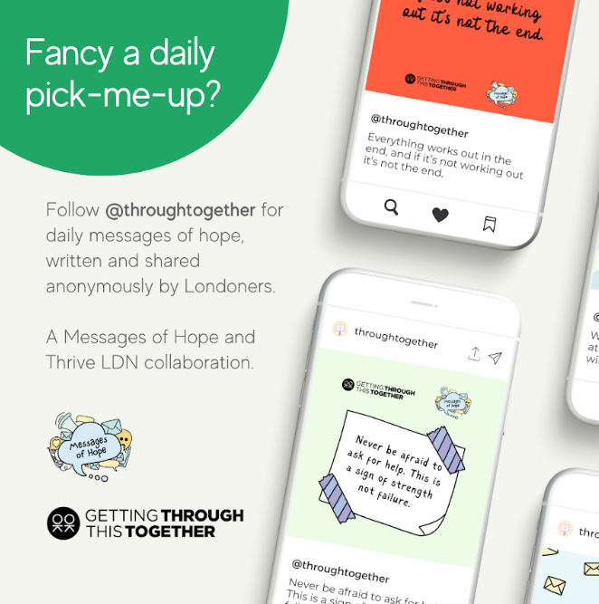  Alt text: This is a promotional graphic. In the top left, inside a semi-circle with green block colour reads the following in white text: Fancy a daily pick-me-up? Elsewhere there are graphics of mobile phones to showcase some example posts from the account. There is a message to the left of these that reads: Follow @throughtogether for daily messages of hope, written and shared anonymously by Londoners.
Instagram 2 | London works best when we are all on each other’s side.  A new collaboration from Thrive LDN and Messages of Hope is asking Londoners to explore the anonymous messages of hope, advice and encouragement shared by fellow Londoners.  Follow @ThroughTogether to find out how you can get involved.  #ThroughTogether #LonelinessAwarenessWeek | 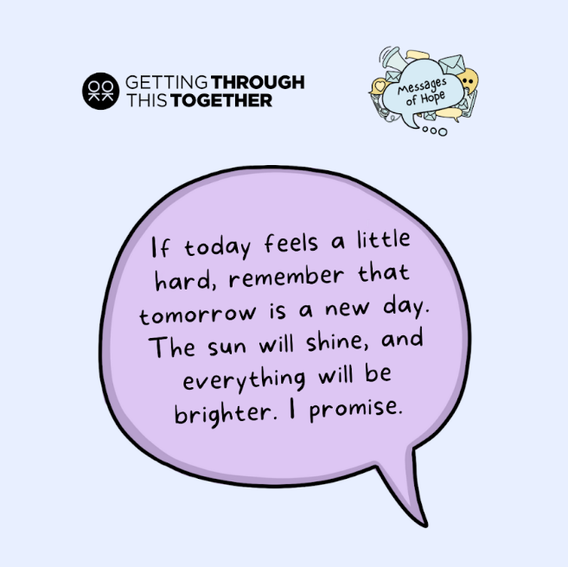  Alt text: Inside a purple speech bubble on a light blue backdrop reads the following message: If today feels a little hard, remember that tomorrow is a new day. The sun will shine, and everything will be brighter. I promise.
Instagram 3 | It’s OK to not feel OK during challenging times.  New collaboration @ThroughTogether has received hundreds of messages from Londoners sharing hope, advice and encouragement for anyone that might be struggling.  To find out more follow @ThroughTogether and receive a daily pick-me-up in doing so.  #ThroughTogether #LonelinessAwarenessWeek | 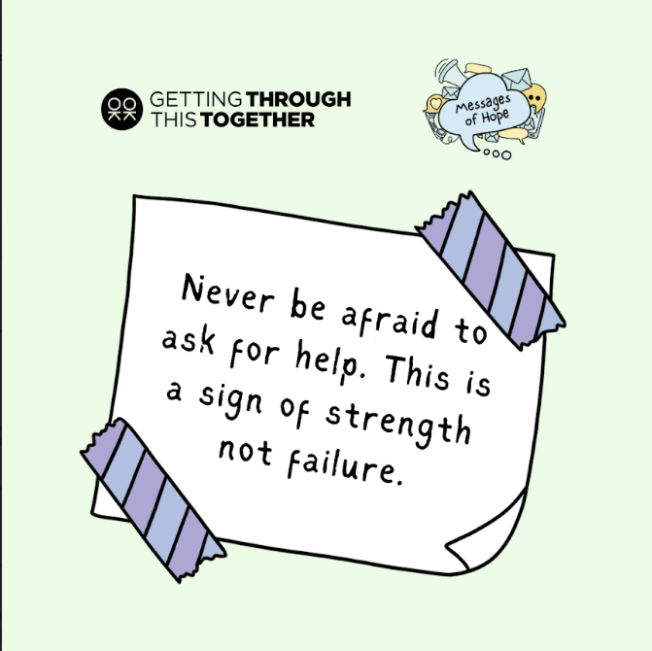  Alt text: On a piece of paper that is taped to a green background reads the following message: Never be afraid to ask for help. This is a sign of strength not failure.
Instagram 4 | An exciting new collaboration from @ThriveLDN and @messagesof.hope will see Londoners’ messages of hope, advice and encouragement shared daily on social media.  The collaboration aims to encourage conversations around mental health and wellbeing among Londoners, as well as provide support to those that may be struggling right now.  Hundreds of anonymous messages have been submitted from Londoners, many who have experienced their own difficulties.  To find out more follow @ThroughTogether and receive a daily pick-me-up in doing so.  #ThroughTogether | 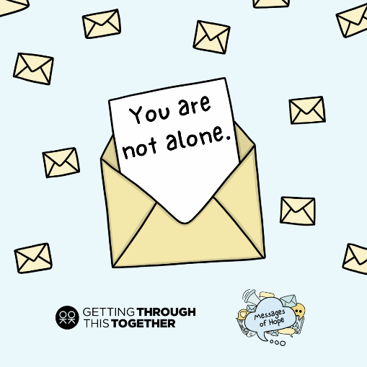  Alt text: A piece of paper is popping out of a yellow envelope with a simple message that reads: You’re not alone. There are other sealed envelopes drawn in the background.

Thrive LDN Happy to Chat bench and spaces toolkit
‘Happy to Chat’ or community benches are designed to help combat loneliness and encourage community interaction.
The bench becomes a public asset which anyone can use to take time out of their day to reflect. They provide opportunity to connect with people and perhaps start a conversation about how they are feeling
Thrive LDN has developed a Happy to Chat Bench and Spaces Toolkit to provide ideas and insights for anyone who wants to create their own bench or space.
For Children’s Mental Health Week 2023 earlier this year, Thrive LDN worked with pupils and teachers at St Mary’s Primary School, Wimbledon to learn more about the benches they’ve created in school playground where children can come and talk to others if they’re feeling sad or lonely. In this short video the pupils tell us how the initiative supports them or others who may need to seek help from others at the school.
Download the Happy to Chat benches toolkit (pdf) :
- https://thriveldn.co.uk/wp-content/uploads/2023/02/Thrive-LDN-Happy-to-Chat-benches-and-spaces-a-toolkit.pdf

Twitter 1 | Moments of connection can make us feel less lonely.  This #LonelinessAwarenessWeek explore @ThriveLDN happy to chat bench toolkit to help build connection in your community  https://thriveldn.co.uk/wp-content/uploads/2023/02/Thrive-LDN-Happy-to-Chat-benches-and-spaces-a-toolkit.pdf | Videos:  16x9  https://drive.google.com/file/d/18j1cjtQH7k41_S7EswMuUcmkFwakzhp9/view?usp=sharing  9x16  https://drive.google.com/file/d/1xTEmjf_UvACDuR2S1wRTn1s7XtiD4Jbx/view?usp=sharing  Still:  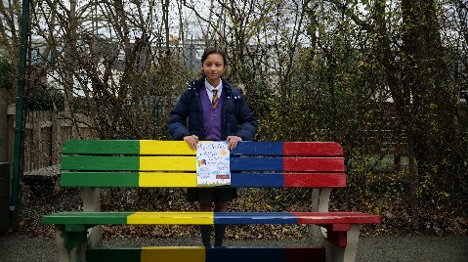  Right click to download.  Alt text: A young girl stands behind a colour bench in the playground. She is holding a piece of paper which reads: The Chitter Chat Bench.
Twitter 2 | Happy to Chat benches are designed to help combat loneliness and encourage community interaction.  Explore @ThriveLDN tips and ideas for how to create your own  https://thriveldn.co.uk/wp-content/uploads/2023/02/Thrive-LDN-Happy-to-Chat-benches-and-spaces-a-toolkit.pdf  #LonelinessAwarenessWeek
Twitter 3 | “If you’re lonely or sad, someone will come sit next to you and they’ll talk to you and basically cheer you up.”  Find out more about how pupils at @StMarysPriWim are supporting each other right now.  #LonelinessAwarenessWeek
Instagram | Moments of connection can make us feel less lonely.  ‘Happy to Chat’ or community benches are designed to help combat loneliness and encourage community interaction.  The bench becomes a public asset which anyone can use to take time out of their day to reflect. They provide opportunity to connect with people and perhaps start a conversation about how they are feeling.  This #LonelinessAwarenessWeek, why not explore @ThriveLDN guide to creating your own happy to chat bench or space in your local community.  Find out more via the link in their bio. | 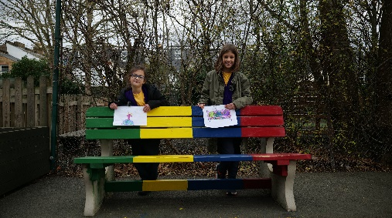  Right click to download.  Alt text: Two young girls stand behind a colour bench in the playground. They are holding a piece of paper each which reads: The Chitter Chat Bench and their design for the chat bench logo.
Facebook | Moments of connection can make us feel less lonely.  ‘Happy to Chat’ or community benches are designed to help combat loneliness and encourage community interaction.  The bench becomes a public asset which anyone can use to take time out of their day to reflect. They provide opportunity to connect with people and perhaps start a conversation about how they are feeling.  This #LonelinessAwarenessWeek, why not explore Thrive LDN’s guide to creating your own happy to chat bench or space in your local community.  Find out more: https://thriveldn.co.uk/wp-content/uploads/2023/02/Thrive-LDN-Happy-to-Chat-benches-and-spaces-a-toolkit.pdf. | Right click to download.  Alt text: A young girl stands behind a colour bench in the plyground. She is holding a piece of paper which reads: The Chitter Chat Bench.

Signposting to further resources
Channel | Suggested post | Assets
Twitter | Strong, supportive relationships – whether family or with the wider community and faith groups – are one of the most important factors to help us thrive.  This #LonelinessAwarenessWeek explore a range of free resources to support you to stay connected:  https://thriveldn.co.uk/help-yourself-and-others/ | Alt Text: Two people are chatting over a cup of tea. The text above them reads: How do you care for yourself and those around you?  More: https://drive.google.com/drive/folders/16eX6qdbW0L9d5I-rnS2Lk7DVKvJhoFhl?usp=share_link
Twitter | London works best when we look out for each other.  This #LonelinessAwarenessWeek take some time to check in with friends, family, and those in your community.  Sharing our stories can help others going through similar experiences.  #ThroughTogether | 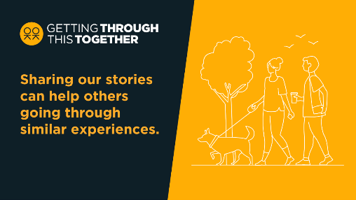  Alt Text: Two people are walking a dog in an open green space and havening a chat. The text above them reads: Sharing our stories can help others going through similar experiences.  More: https://drive.google.com/drive/folders/16eX6qdbW0L9d5I-rnS2Lk7DVKvJhoFhl?usp=share_link
Facebook / LinkedIn | Staying connected is more important than ever. Strong, supportive relationships – whether family or with the wider community and faith groups – are one of the most important factors to help us thrive and maintain good wellbeing.  When times are tough, it’s important that we look after our own and each other's wellbeing.  This #LonelinessAwarenessWeek, explore Thrive LDN’s range of free resources to support you and others to stay connected: https://thriveldn.co.uk/help-yourself-and-others/social-networks-and-connections/  Or visit Good Thinking and download their 'how to' guides. Alongside lots of other resources to support wellbeing and mental health: www.good-thinking.uk/how-guides | 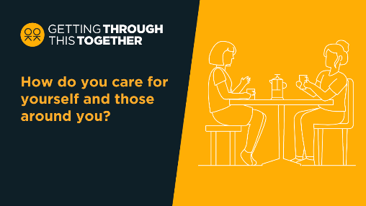  Alt Text: Two people are chatting over a cup of tea. The text above them reads: How do you care for yourself and those around you?  More: https://drive.google.com/drive/folders/16eX6qdbW0L9d5I-rnS2Lk7DVKvJhoFhl?usp=share_link
Instagram | Staying connected is more important than ever. Strong, supportive relationships – whether family or with the wider community and faith groups – are one of the most important factors to help us thrive and maintain good wellbeing.  We know so many Londoners are making a difference to those in their local community and beyond by supporting each other through the emotional pressures and challenges they may be feeling right now.  This #LonelinessAwarenessWeek explore @ThriveLDN’s range of free resources to support you and others to stay connected.  Or visit @goodthinkinguk and download their 'how to' guides. | 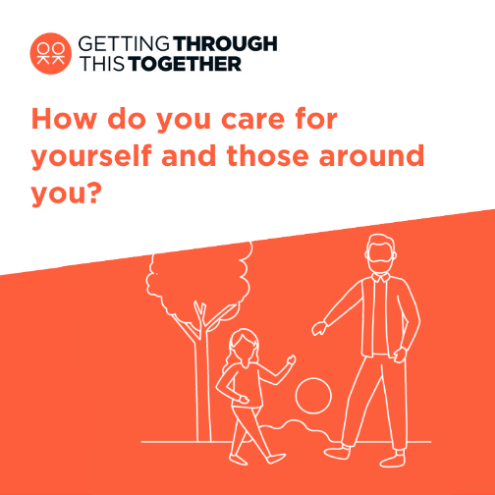  Alt Text: An older person is playing sports with a young person in an open green space. The text above them reads: How do you care for yourself and those around you?  More: https://drive.google.com/drive/folders/1Ijzql7UQ0ExvBzc1bRHRQjShXCyRwkuX
Instagram | We know that our city works best when we all look out for each other.  Right now, things may feel uncertain or difficult for many Londoners. Take some time to check in with friends, family, and those in your community.  Sharing our stories can help others going through similar experiences.  @ThriveLDN has lots of examples on how Londoners are making a difference to those in their local community by supporting each other through the emotional pressures and challenges many are facing right now.  Search #ThroughTogether.  Or find out more by exploring @goodthinkinguk’s resources and tools.  #ThroughTogether #LonelinessAwarenessWeek | Alt Text: Two people are chatting over a cup of tea. The text above them reads: How do you care for yourself and those around you?  More: https://drive.google.com/drive/folders/1Ijzql7UQ0ExvBzc1bRHRQjShXCyRwkuX?usp=share_link
Instagram and Twitter | #LonelinessAwarenessWeek's a good opportunity to share the @TheAlexSW19 thinking: “Anybody who’s thinking about doing stuff, thinking shall I, shan’t I? Do it. Go for it. Because you’ll make a difference to people’s lives.”  Find out more: www.thriveldn.co.uk/throughtogether  #ThroughTogether | Videos:  16x9  https://drive.google.com/file/d/1if8BdjwjXDG_ly-VyJ2xKRoKWUn10nBy/view?usp=sharing  9x16  https://drive.google.com/file/d/1JRkDfBHzO6utuU1ecBVeyCdydNi-OWQP/view?usp=sharing  Stills:  THRIVE_230109_ALEXANDRA_PUB_STILL_1.jpg  THRIVE_230109_ALEXANDRA_PUB_STILL_2.jpg  THRIVE_230109_ALEXANDRA_PUB_STILL_3.jpg
Instagram and Twitter | “As human beings we need that love, that kind of hug, that kind of feeling from another person.”  Find out how organisations like @thefoodchain has been helping Londoners living with HIV to support each other: www.thriveldn.co.uk/throughtogether  #LonelinessAwarenessWeek  #ThroughTogether | Videos:  16x9  https://drive.google.com/file/d/1fbFxvRNe4J0gmsCDH3nwSQQi8J7sH5f8/view?usp=sharing  9x16  https://drive.google.com/file/d/1nP9EnX4oAjh_YeEVPx7CMFoYSIltdKPZ/view?usp=sharing  Stills:  THRIVE_230113_FOOD_CHAIN_1.jpg  THRIVE_230113_FOOD_CHAIN_2.jpg  THRIVE_230113_FOOD_CHAIN_3.jpg  THRIVE_230113_FOOD_CHAIN_4.jpg

