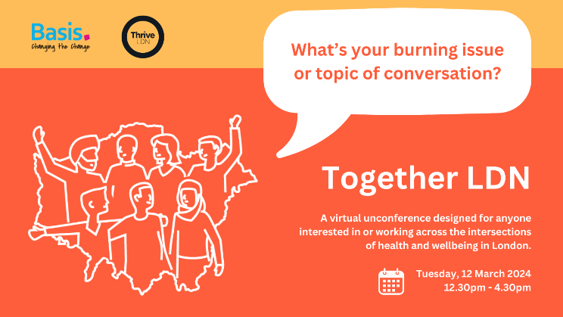

Together LDN Unconference

Plain text event agenda for Tuesday 12th March 2024
#TogetherLDN

This document includes:
- Pages 1 - 2: Information and the timings for the online Zoom event.
- Pages 3 - 5: Tips for engaging conversations, how to join the event and accessibility information.

Important information:

- Online event being held via Zoom on Tuesday 12th March 2024
- The event starts at 12:30pm until 4:30pm
- The Zoom link for the event is https://basis-co-uk.zoom.us/j/83784844847
- Contact email for the event is info@thriveldn.co.uk
- Event details are available via this link

About this event
In recognition of the huge personal, organisational and community challenges Londoners are facing, staying connected is more important than ever. Strong, supportive relationships – whether family or with the wider community and faith groups – are one of the most important factors to help us thrive.
On Tuesday 12th March we are inviting everyone interested in the intersections of health and wellbeing to come together, to be part of the Together LDN unconference to join a collective conversation, exchange ideas and reflection.
The online event is organised around a series of spontaneous curated conversations, decided by attendees, to strengthen collaboration across the capital and collectively push boundaries and develop action planning for the year ahead.

This initiative funded by the Mayor of London is being delivered by Thrive LDN, London’s public mental health partnership, in collaboration with Basis.
What you can expect
An unconference offers a unique structure where the content and discussions are driven by you, the participants. While a framework is in place, the sessions themselves are shaped by your interests, questions, and expertise.
Throughout the event, attendees are invited to propose topics or something you'd like to share. If there are too many, we'll vote on the most popular, and then you will have space to convene.
What do we mean by ‘conversations’?
We are using this term to describe creative and reflective ways in which to engage audience members at this event. Conversations can be creative (show, don’t tell) and do not need to be formally structured (for example, the conversation host might come with a question and attendees will contribute).

About the online Zoom space
Zoom facilitation on the day is provided by Basis.

Basis’s mission is to help public sector organisations tackle messy problems. Since 2019, they have been recognised by their clients and peers as one of the Financial Times UK’s Leading Management Consultants.

Online timings
12:30pm – 12:50pm Welcome and introduction: online attendees join the Zoom session, where the facilitator introduces the event online structure.
12:50pm – 13:25pm Marketplace 1: invitation to propose conversation topics. Conversation proposals gathered and voted for.
13:30pm – 13:55pm Round 1: Curated discussion sessions: curated sessions take place, attendees can join any session and can move between sessions.
13:55pm – 14:05pm Break
14:05 – 14:30 Round 2: Curated discussion sessions: curated sessions take place, attendees can join any session and can move between sessions.
14:30pm – 14:55pm Marketplace 2: invitation to propose conversation topics. Conversation proposals gathered and voted for.
15:00pm – 15:25pm Round 3: Curated discussion sessions: curated sessions take place, attendees can join any session and can move between sessions.
15:25pm – 15:35pm Break
15:35pm – 16:05pm Round 4: Curated discussion sessions: curated sessions take place, attendees can join any session and can move between sessions.
16:10pm – 16:30pm Summary and close

Tips for engaging conversations
Conversations at an unconference are driven by you, the participants. While we aim to keep the day as free flowing and relaxed as possible, there are a few key ingredients we aim to include to make the day as engaging as possible.

Below we’ve included some tips and ideas for making the most of your conversations on the day. However, please don’t worry or feel pressured to prepare anything before the event, these are meant to spark conversation and ideas to keep the day flowing.
- Conversations are convened with purpose, allowing attendees to feel engaged, informed, reflective and able to ask questions and exchange;
- Conversations are held for 25 minutes, you might finish earlier, that is no problem;
- Conversations typically allow for up to 20 people to attend. More than 20 makes it difficult for everyone to have the opportunity to share amongst the group;
- Someone from Basis or Thrive LDN will join the conversation to facilitate and hold the space for different voices as well as record key parts of the conversation;
- On Zoom you can utilise the ‘share screen’ function (if you’re not sure how – just ask one of us!). You could play music through audio sharing or you could ask your online attendees to write or draw something and share on camera.
- This is not a marketplace to sell your project (even though we are sure it’s fantastic!)
- We ask that ideas are understandable to everyone, consider that we are all coming from different fields, so it’s best to avoid jargon or technical language!
Example formats of conversations:
- Show and tell
How my organisation approached a multi-agency health partnership, what have been our learnings and how are we moving forward?
- My big question
What does the health/ voluntary and community sector need to understand about integrated care systems to collaborate and work together?
- Learn how to do X
I am a trauma-informed health practitioner and I want to share the 5 principles behind this work.
- Fishbowl conversation
How do the spaces and contexts we deliver our practice and programmes marginalise Londoners – how can we be more inclusive?
- Lightning talk on hot topic (5 mins followed by whole group discussions)
If I had XX money to support cross-sector collaboration in my borough, what would I do?

How to join the event
We want you to have the best possible experience so please do bear the following in mind.
- Join from a laptop or desktop (if you are able to), not a mobile device like a phone or tablet as this might limit your ability to engage fully.
- Please join from a quiet location and please try to have a headset and microphone so that you can hear and be heard.
- If you are able and feel comfortable enough to, please enable your camera so that we can see each other as this adds to everyone’s experience.
Diversity, equity and inclusion information for the event
Provided by Thrive LDN and Basis on the 7th March 2024, and will be updated as any additional information is provided
The unconference sessions will be held via Zoom, to ensure that everyone can attend the event. The session will be held on one Zoom account, with a lead facilitator introducing the set-up of the online session, then groups will go into breakout spaces to be part of a blend of curated discussions and more open discussions.
Closed captioning will be enabled throughout sessions, and the lead facilitator will support with moderating conversations and ensuring that attendees follow the code of conduct for the day.
We will ask speakers to speak loudly and clearly.
Programme
We acknowledge that the format could be particularly challenging for neurodiverse people, in that it will be a busy event, with multiple sessions happening simultaneously. There will also be people having their own 1-1 conversations or smaller group conversations, which is encouraged, but this means that overall, we anticipate the sessions will feel loud and tangled at times.
What will we do to make things easier for people to join in on the day?
- In advance of the day, we will provide as much detail of the programme as possible, noting that there will be plenty of space on the day for attendees to call their own sessions, so this information will only be available last minute to other attendees.
For deaf and hard of hearing attendees
- We will explore what we can offer to individuals to support their access needs on a case-by-case basis. Please include this information when you register to attend the conference, and we will contact you, or you can email us at info@thriveldn.co.uk
Mental Health Resources
We understand that some of the topics covered at the event could be difficult or upsetting. We encourage you to feel supported to do whatever you need to keep yourself well. Please see a list of useful resources below
- Samaritans. To talk about anything that is upsetting you, you can contact Samaritans 24 hours a day, 365 days a year. You can call 116 123 (free from any phone), email jo@samaritans.org or visit some branches in person. You can also call the Samaritans Welsh Language Line on 0808 164 0123 (7pm–11pm every day).
- SANEline. If you're experiencing a mental health problem or supporting someone else, you can call SANEline on 0300 304 7000 (4.30pm–10.30pm every day).
- National Suicide Prevention Helpline UK. Offers a supportive listening service to anyone with thoughts of suicide. You can call the National Suicide Prevention Helpline UK on 0800 689 5652 (6pm to midnight every day).
- Shout. If you would prefer not to talk but want some mental health support, you could text SHOUT to 85258. Shout offers a confidential 24/7 text service providing support if you are in crisis and need immediate help.
- Mind. If racism is affecting your mental health, contact Mind for support and help.
- Switchboard. If you identify as gay, lesbian, bisexual or transgender, you can call Switchboard on 0300 330 0630 (10am–10pm every day), email chris@switchboard.lgbt or use their webchat service. Phone operators all identify as LGBT+.
If you live in England, you can call a local NHS urgent mental health helpline for support during a mental health crisis. Anyone can call these helplines, at any time.
These helplines offer similar support to a crisis team. The NHS website has more information on urgent mental health helplines, including how to find your local helpline.

