THRIVE LDN COMMS TOOLKIT:
World Suicide Prevention Day 2024. Tuesday, 10 September 2024
Updated Wednesday, 31 July 2024
About this toolkit
In this toolkit you can access the latest #ZeroSuicideLDN campaign and suicide prevention in London assets for digital channels alongside a series of suggested messages for digital and non-digital communications.
We have split this across messages that can be shared in the lead to WSPD, for on the day itself, and beyond. We have also included suggested messaging which can be used by anyone who completes the training who may wish to encourage others in their network to do so.
Further information/ support
If you’d like support using the graphics or want to chat with the Thrive LDN team about making the suggested copy more relevant to your community/audiences, then please get in touch, e-mail James Ludley on james.ludley@nhs.net; info@thriveldn.co.uk.
Contents
In this document (Ctrl + Click on link to go directly to that section):
- Context and introduction
- Update: #ZeroSuicideLDN campaign and suicide prevention in London
- Digital assets
Download a suite of static and videos to use with our suggested social media copy:
- All #ZeroSuicideLDN assets (via Google Drive)
- Screensavers (via Google Drive)
- Posters – inc localised and translated (via Google Drive)

ZIP files with all assets:
- Social statics (ZIP containing JPGs – 9MB)
- Social videos (ZIP containing MP4s - 92MB)
- #ZeroSuicideLDN and World Suicide Prevention Day
- For posting on World Suicide Prevention Day - Tuesday, 10 September 2024
- For posting any time before or after World Suicide Prevention Day
- For promoting the training upon completion (anytime)
- Standard text for newsletters and/or offline copy
- Expert-led wellbeing advice video content
- Taken from the #ThroughTogether campaign, relevant public health expert advice in the context of World Suicide Prevention Day.
- Support with money worries (cost-of-living signposting)
- Suggested social media posts support signposting to relevant services that will support Londoners with money worries.
- Thrive LDN conversation starter and Good Thinking ‘how to’ guides
- Tools to help Londoners engage with friends, family, neighbours or those they support in the community or workplace about good mental health, wellbeing and financial worries. The conversation starter tool is also embedded in the Good Thinking guides to looking out for those around you which have been tailored for children and young people, parents and carers, and employers.
- Free trauma-informed practice training
- Thrive LDN has been working with Nicola Lester Psychological Trauma Consultancy to offer free, online trauma-informed practice training to support individuals and organisations. The training is offered across three levels, Bronze, Silver and Gold. At each level, participants receive a certificate of completion and certified badge which can be used to demonstrate their knowledge and trauma informed training status.
- Resilience and conflict resolution training workshops
- Thrive LDN has worked with Healthy Dialogues to develop a series of free online workshops designed to meet the expressed challenges faced by anyone who is in a professional role supporting others. The workshops covered topics such understanding stress and resilience, developing personal awareness, developing our coping strategies. Alongside building communication skills crucial for de-escalating conflicts and investigating.
- Context and introduction
World Suicide Prevention Day (WSPD) takes place annually on 10 September.
It was established in 2003 in conjunction between The International Association for Suicide Prevention (IASP) and the World Health Organisation (WHO). It is a significant advocacy and communication-based event aimed at reaching national organisations, governments and the general public, giving a singular message that suicide can be prevented.
The theme for WSPD 2024, selected by IASP, is ‘change the narrative’ using #StartTheConversation. Find out more general information about the campaign.
- Update: #ZeroSuicideLDN campaign and suicide prevention in London
Five years ago on World Suicide Prevention Day 2019, a citywide #ZeroSuicideLDN campaign was launched by the Mayor of London and partners to encourage Londoners to access the Zero Suicide Alliance’s free, online suicide prevention training.
Since then, more than 400,000 people across the capital have completed the ZSA’s training. This is a fantastic, collective achievement. Thank you to all London partners for continuing to support sharing this important training offer and promoting the campaign.
However, we can’t be complacent. We want to continue to build on this momentum and mark World Suicide Prevention Day 2024 - five years since launching the citywide #ZeroSuicideLDN campaign - to remind everyone that there has never been a more important time to encourage Londoners to learn how to support those around them who may be in crisis.
Digital assets to support the campaign
In this toolkit you can access the latest campaign assets for digital channels alongside a series of suggested messages for digital and non-digital communications.
We have split this across messages that can be shared in the lead to WSPD, for on the day itself, and beyond. We have also included suggested messaging which can be used by anyone who completes the training who may wish to encourage others in their network to do so.
Cost-of-living considerations
Financial resilience and feelings of control relating to finance have a profound impact on people’s wellbeing. For many, there continues to be extreme challenges posed by the increases to the cost-of-living, which in turn means more Londoners will be considered vulnerable to suicide.
It therefore remains more important than ever to encourage many more Londoners to play their part in looking out for others by supporting the #ZeroSuicideLDN campaign.
To support partners, we have also adapted and included some wider signposting in the context of the current challenges for the public mental health response in London, including cost-of-living and accessing NHS urgent mental health support lines. By thinking and talking more about our mental health and how this is impacted on the environment around us, we can break the stigma surrounding suicide and mental health.
About the Zero Suicide Alliance
The Zero Suicide Alliance (ZSA) is UK based and hosted by Mersey Care NHS Foundation Trust and funded via Mersey Cares NHS Charity. The Alliance is a collaborative of National Health Service trusts, businesses and individuals who are all committed to suicide prevention and beyond. The Alliance is ultimately concerned with improving support for people contemplating suicide by raising awareness of and promoting free suicide prevention training which is accessible to all.
- #ZeroSuicideLDN digital assets
Download #ZeroSuicideLDN resources
Explore a suite of static and video assets to use with our suggested social media copy. We have created these in square, wide and tall dimensions to support across social and digital channels. When posting the static images, please add or adapt accordingly the alt-text copy as included below. This helps to make content more accessible. If you’re unsure how to add alt-text, see info below for Facebook, Instagram, X/Twitter and LinkedIn. All resources are available to download via:
- All #ZeroSuicideLDN assets (via Google Drive)
- Screensavers (via Google Drive)
- Posters – inc localised and translated (via Google Drive)

ZIP files with all assets:
- Social statics (ZIP containing JPGs – 9MB)
- Social videos (ZIP containing MP4s - 92MB)
- Suggested social copy for World Suicide Prevention Day
For posting/scheduling on World Suicide Prevention Day: Tuesday, 10 September 2024
Suggested assets
For ease, we’ve included some suggested assets alongside the suggested copy (below). To download a suggested graphic right click, then ‘open link’ to download.
Alt text for static assets
When posting the static images, please add or adapt accordingly the alt-text copy as included below. This helps to make content more accessible. If you’re unsure how to add alt-text, see info below for Facebook, Instagram, X/Twitter and LinkedIn.
Channel | Suggested copy | Example assets and links for more
Twitter (1)  Add 1B as a thread/ comment to initial post (1A) | (1A)  Today is #WorldSuicidePreventionDay and we're supporting the #ZeroSuicideLDN campaign.  Join the 400,000+ Londoners who have taken @Zer0Suicide’s free, online suicide prevention training.  Together, #StartTheConversation to break the stigma surrounding suicide and mental health.  (1B)  London works best when we look out for each other.  Join the #ZeroSuicideLDN campaign here: www.thriveldn.co.uk/zerosuicideldn | VIDEOS  01 New timelapse video  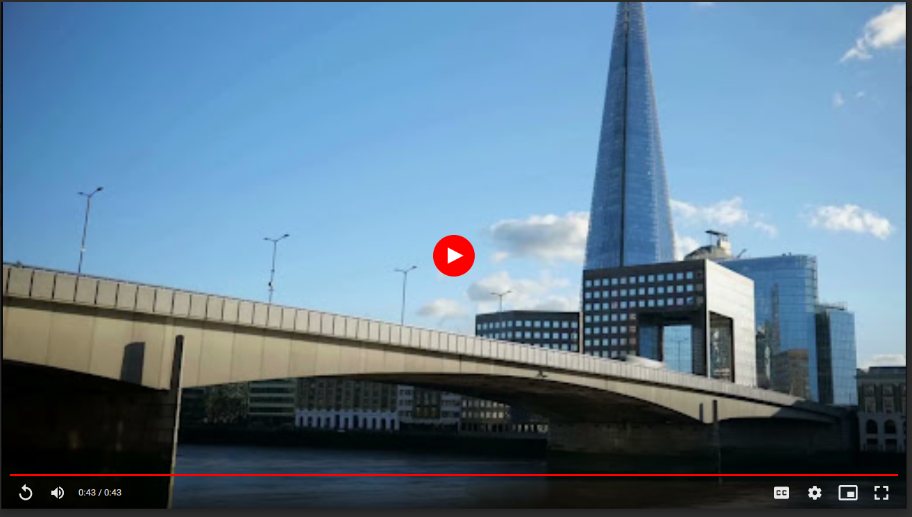  Download  02 ‘Got 20 minutes’ video graphic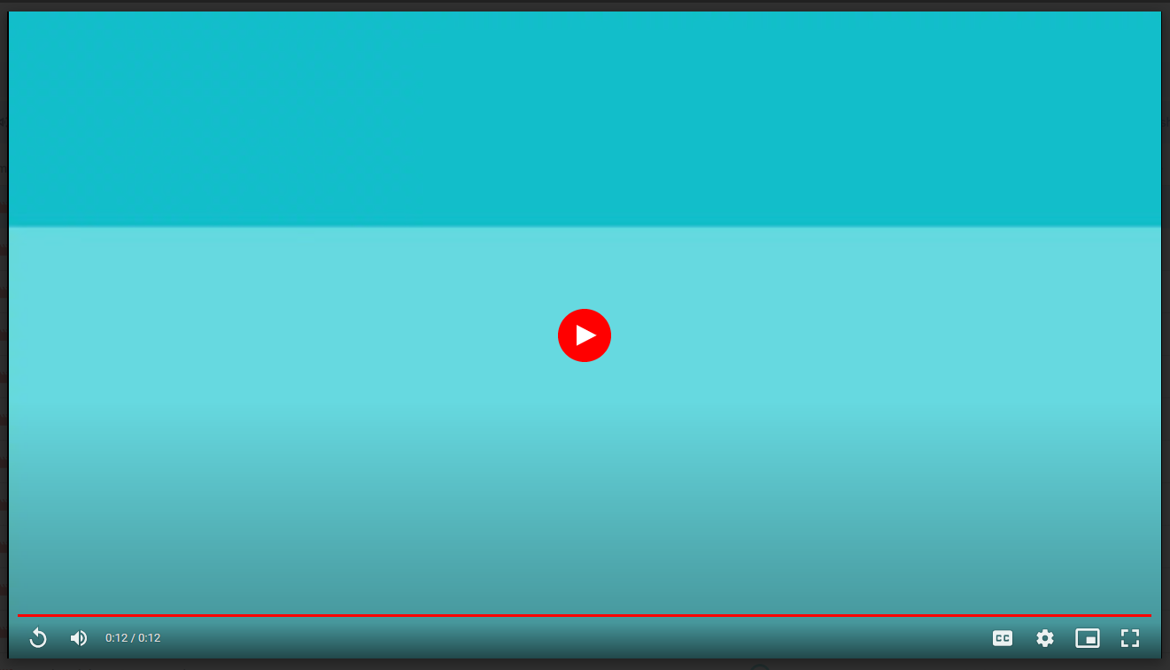  Download  STILL GRAPHICS  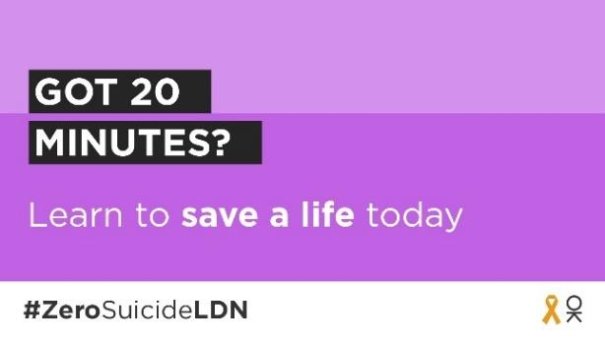  Alt text: On a purple background reads the text: Got 20 minutes? Learn to save a life today. Along the bottom is the campaign hashtag - #ZeroSuicideLDN – and an orange ribbon next to the Thrive LDN OK logo.  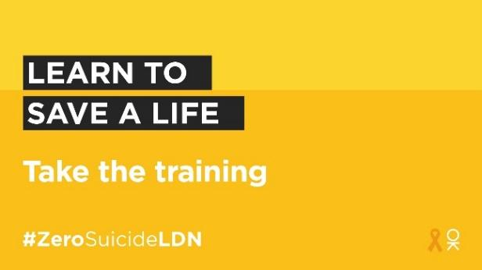  Alt text: On a yellow background reads the text: Learn to save a life. Take the training. Along the bottom is the campaign hashtag - #ZeroSuicideLDN – and an orange ribbon next to the Thrive LDN OK logo.  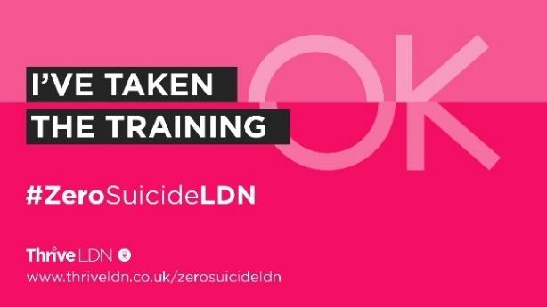  Alt text: On a two-tone pink background reads the text: I’ve taken the training #ZeroSuicideLDN. At the bottom is Thrive LDN’s logo and website details: thriveldn.co.uk slash Zero Suicide LDN. The Thrive LDN OK watermark is visible in the background of the asset, with the OK slightly unaligned through the middle horizontality where there is a change of colour tone.  Full range of #ZeroSuicideLDN assets via Google Drive:  https://drive.google.com/drive/folders/189EzBGDyPA96jr-Tw6-sTIh2egGI_CdE?usp=drive_link
Twitter (2) | Today is #WorldSuicidePreventionDay.  If you’ve got 20 minutes spare, then join us in taking the free @Zer0Suicide online training: http://zerosuicidealliance.com/training  When you’ve completed it, share your certificate. Together we can break the stigma and save a life.  #StartTheConversation
Twitter (3) | Today is #WorldSuicidePreventionDay.  Today you can support the #ZeroSuicideLDN campaign by taking free, online training to know what to do if a loved one, colleague or stranger is feeling suicidal.  It only takes 20 minutes. #StartTheConversation  Visit: www.zerosuicidealliance.com/training
Twitter (4) | Today is #WorldSuicidePreventionDay and you can make a difference.  Take 20 mins to complete FREE online training from @Zer0Suicide and learn how to support someone struggling. Let's break the stigma and save lives.  www.zerosuicidealliance.com/training  #ZeroSuicideLDN  #StartTheConversation
Twitter (5) | Around 10 people a week take their own life in London.  This #WorldSuicidePreventionDay you can learn how to save a life with free, online suicide prevention training.  London works best when we look out for each other. Join the #ZeroSuicideLDN campaign: www.thriveldn.co.uk/zerosuicideldn
Twitter (6) | Are you one of the 400,000 Londoners who has completed online free suicide prevention training since the @MayorofLondon launched #ZeroSuicideLDN in 2019?  Help us share the campaign and encourage more Londoners to join us. We can all help save a life.  www.thriveldn.co.uk/zerosuicideldn
Twitter (7) | #WorldSuicidePreventionDay is a good opportunity for us all to remember that a mental health emergency should be taken as seriously as a physical one.  If you need urgent help for your mental health, get help by calling 111 or visiting NHS 111 online: https://111.nhs.uk/triage/check-your-mental-health-symptoms | 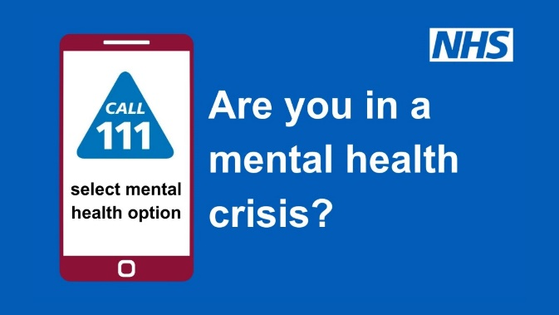  Alt text: A promotional graphic of NHS 111: a mobile phone is to the left of the image, on screen reads "Call 111 select mental health option". Next to the phone reads: Are you in a mental health crisis? The NHS logo is top right of the screen.
Instagram | Today for #WorldSuicidePreventionDay we're supporting the #ZeroSuicideLDN campaign with @ThriveLDN and the @zerosuicidealliance.  We know that living and working in London can be stressful, and right now for some it may be overwhelming. That is why we want to encourage Londoners to take free, online training to know what to do if a loved one, colleague or stranger is in crisis.  Together we can break the stigma surrounding suicide and mental health.  Learn to save a life today...  Visit 👉 thriveldn.co.uk/ZeroSuicideLDN  Or find details in @ThriveLDN bio.  #ZeroSuicideLDN #ThroughTogether  #ThriveLDN #ZeroSuicideAlliance  #Londoners #MentalHealth  #London #LifeInLondon  #WeAreLDN #OKLDN  #SuicidePrevention #OnlineTraining | VIDEO  01 New timelapse video  Download  STILL IMAGE  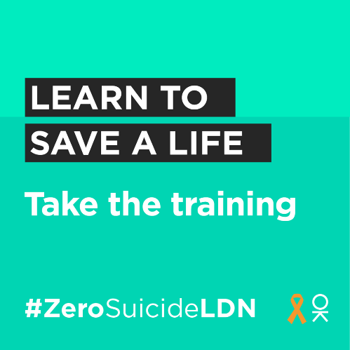  Alt text: On a light green background reads the text: Learn to save a life. Take the training. Along the bottom is the campaign hashtag - #ZeroSuicideLDN – and an orange ribbon next to the Thrive LDN OK logo.  Instagram stories  9x16 video  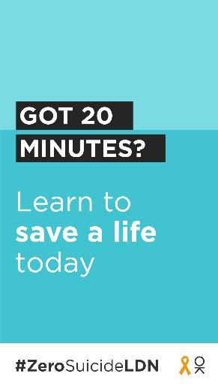  Full range of #ZeroSuicideLDN assets via Google Drive:  https://drive.google.com/drive/folders/189EzBGDyPA96jr-Tw6-sTIh2egGI_CdE?usp=drive_link
Facebook and LinkedIn | Today for #WorldSuicidePreventionDay we're supporting the #ZeroSuicideLDN campaign with Thrive LDN and the Zero Suicide Alliance.  Learn to save a life today...  We know that living and working in London can be stressful, and right now for some it may be overwhelming. That is why we want to encourage Londoners to take free, online training to know what to do if a loved one, colleague or stranger is in crisis.  Find out more and take the training today: www.thriveldn.co.uk/ZeroSuicideLDN  Are you one of the 400,000 Londoners who has already completed the Zero suicide Alliance’s free online training since #ZeroSuicideLDN campaign launched in 2019?  Help us share the campaign and encourage more Londoners to join us. We can all help save a life.  Together we can break the stigma surrounding suicide and mental health. | VIDEOS  01 New timelapse video  Download  02 ‘Got 20 minutes’ video graphic  Download  STILL GRAPHICS  Alt text: On a purple background reads the text: Got 20 minutes? Learn to save a life today. Along the bottom is the campaign hashtag - #ZeroSuicideLDN – and an orange ribbon next to the Thrive LDN OK logo.  Full range of #ZeroSuicideLDN assets via Google Drive:  https://drive.google.com/drive/folders/189EzBGDyPA96jr-Tw6-sTIh2egGI_CdE?usp=drive_link
LinkedIn  For individuals, can be adapted for other channels | Today is #WorldSuicidePreventionDay.  I’ve just taken free, online suicide prevention training.  It’s never been more important to think and talk more about mental health. The Zero Suicide Alliance’s free suicide prevention training is a really helpful way to learn what to do if a loved one, colleague, or stranger is in a crisis or at risk of suicide.  Learn to save a life today, join me in supporting the #ZeroSuicideLDN campaign.  Join me and take the training now: https://zerosuicidealliance.com/training  #ZeroSuicideLDN | Alt text: On a yellow background reads the text: Learn to save a life. Take the training. Along the bottom is the campaign hashtag - #ZeroSuicideLDN – and an orange ribbon next to the Thrive LDN OK logo.  Full range of #ZeroSuicideLDN assets via Google Drive:  https://drive.google.com/drive/folders/189EzBGDyPA96jr-Tw6-sTIh2egGI_CdE?usp=drive_link

For posting any time before or after World Suicide Prevention Day
Suggested assets
For ease, we’ve included some suggested assets alongside the suggested copy (below). To download a suggested graphic right click, then ‘open link’ to download.
Alt text for static assets
When posting the static images, please add or adapt accordingly the alt-text copy as included below. This helps to make content more accessible. If you’re unsure how to add alt-text, see info below for Facebook, Instagram, X/Twitter and LinkedIn.
Channel | Suggested copy | Example assets and links for more
Twitter (1) | We all need to look out for one another. That's why we are supporting #ZeroSuicideLDN to encourage everyone to take free, online training to know what to do if a loved one, colleague, or stranger is in crisis.  Learn to save a life today...  www.thriveldn.co.uk/ZeroSuicideLDN | Full range of #ZeroSuicideLDN assets via Google Drive:  https://drive.google.com/drive/folders/189EzBGDyPA96jr-Tw6-sTIh2egGI_CdE?usp=drive_link  VIDEOS  01 New timelapse video  Download  02 ‘Got 20 minutes’ video graphic  Download  STILL GRAPHICS  Alt text: On a purple background reads the text: Got 20 minutes? Learn to save a life today. Along the bottom is the campaign hashtag - #ZeroSuicideLDN – and an orange ribbon next to the Thrive LDN OK logo.  Alt text: On a yellow background reads the text: Learn to save a life. Take the training. Along the bottom is the campaign hashtag - #ZeroSuicideLDN – and an orange ribbon next to the Thrive LDN OK logo.
Twitter (2) | It’s never been more important to think and talk more about mental health. That’s why we are taking @Zer0Suicide’s free suicide prevention training, to learn what to do if a loved one, colleague, or stranger is at risk of suicide.  You can too. 🧡  https://zerosuicidealliance.com/training
Twitter (3) | Some people may be finding life harder than usual at the moment. It's vital we all look out for each other, in case someone may be in crisis.  That's why we are supporting the #ZeroSuicideLDN campaign. You can too, it only takes 20 minutes.  Visit 👉 www.thriveldn.co.uk/zerosuicideldn
Twitter (4) | London works best when we all work together and look after each other. 🧡  There's FREE online 20-minute training available to help us all to spot the signs when someone may be thinking about taking their life.  Visit https://zerosuicidealliance.com/training  #ZeroSuicideLDN
Twitter (5) | For some Londoners right now, worries over money or debt may be overwhelming. Would you be able to spot a neighbour or friend in distress? There’s FREE @Zer0Suicide online training to help.  Visit https://zerosuicidealliance.com/training  #ZeroSuicideLDN
Twitter (6)  Witness to suicide resource and support | First Hand has been developed by @ThriveLDN, @AfterSuicideUK and @GrassrootsSP to support anyone who has witnessed the suicide of someone they do not know.  If this is you, please know that there is help and support available. You are not alone 🧡  https://supportaftersuicide.org.uk/resource/first-hand/ | 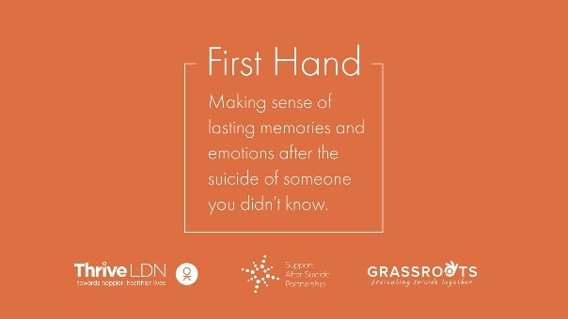  Alt text: On an orange background reads the following text: First Hand, making sense of lasting memories and emotions after the suicide of someone you didn’t know. Along the bottom sit Thrive LDN, Support after Suicide and Grassroots’ logos.
Twitter (9)  NHS urgent mental health support lines signposting | Life can be really difficult, and you might sometimes feel completely overwhelmed. But remember, a mental health emergency should be taken as seriously as a physical one.  If you need urgent help for your mental health, visit NHS 111 online:  https://111.nhs.uk/triage/check-your-mental-health-symptoms | Alt text: A promotional graphic of NHS 111: a mobile phone is to the left of the image, on screen reads "Call 111 select mental health option". Next to the phone reads: Are you in a mental health crisis? The NHS logo is top right of the screen.
Instagram | Have you got 20 minutes to learn how to save a life today?  Around 10 people a week take their own life in London. We want to encourage Londoners to take the FREE online training provided by the @zerosuicidealliance so they know what to do if a loved one, colleague or stranger is in crisis.  Learn to save a life today... take the training.  Visit thriveldn.co.uk/zerosuicideldn  Or find details in @ThriveLDN bio.  #ZeroSuicideLDN  #ThroughTogether | VIDEO  01 New timelapse video  Download  STILL IMAGE  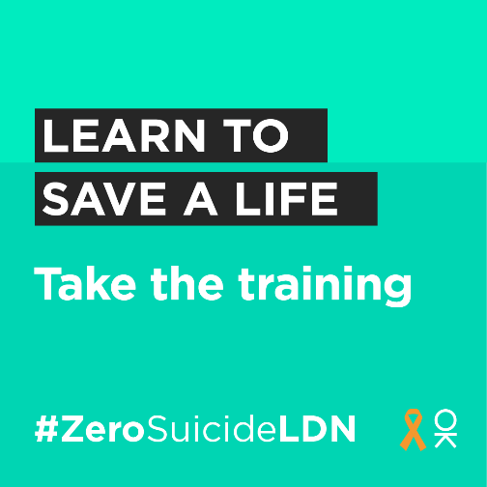  Alt text: On a light green background reads the text: Learn to save a life. Take the training. Along the bottom is the campaign hashtag - #ZeroSuicideLDN – and an orange ribbon next to the Thrive LDN OK logo.  Full range of #ZeroSuicideLDN assets via Google Drive:  https://drive.google.com/drive/folders/189EzBGDyPA96jr-Tw6-sTIh2egGI_CdE?usp=drive_link
Facebook and LinkedIn | Living and working in London can be stressful, and right now for some it may be overwhelming. Would you be able to spot a colleague or friend in distress?  That is why we want to encourage Londoners to take the Zero Suicide Alliance’s free, online training to know what to do if a loved one, colleague or stranger is in crisis.  Learn to save a life today... take the training.  Visit: www.thriveldn.co.uk/zerosuicideldn | VIDEOS  01 New timelapse video: Download  STILL GRAPHICS  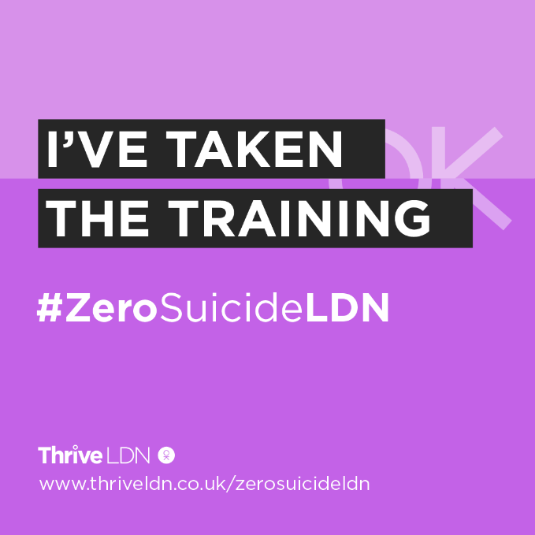  Full range of #ZeroSuicideLDN assets via Google Drive:  https://drive.google.com/drive/folders/189EzBGDyPA96jr-Tw6-sTIh2egGI_CdE?usp=drive_link

For posting on completion of the training – can be posted anytime
Suggested assets
For ease, we’ve included some suggested assets alongside the suggested copy (below). To download a suggested graphic right click, then ‘open link’ to download.
Alt text for static assets
When posting the static images, please add or adapt accordingly the alt-text copy as included below. This helps to make content more accessible. If you’re unsure how to add alt-text, see info below for Facebook, Instagram, X/Twitter and LinkedIn.
Channel | Suggested copy | Example assets and links for more
Twitter (1) | I’ve just taken @Zer0Suicide’s free suicide prevention training 🧡  Join me and the 400,000+ Londoners to learn how to support a loved one, colleague or stranger in crisis. Together we can break the stigma surrounding suicide and mental health.  Visit: https://zerosuicidealliance.com/training | VIDEOS  ‘Got 20 minutes’ video graphic. Download  I’ve taken the training video  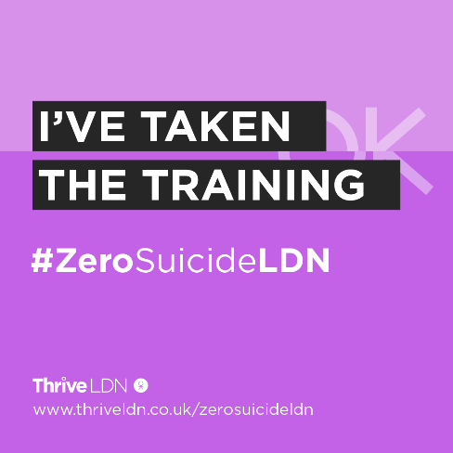  Download  STILL IMAGE  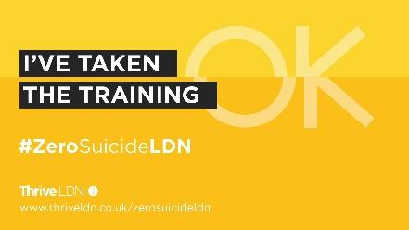  Alt text: On a two-tone pink background reads the text: I’ve taken the training #ZeroSuicideLDN. At the bottom is Thrive LDN’s logo and website details: thriveldn.co.uk slash Zero Suicide LDN. The Thrive LDN OK watermark is visible in the background of the asset, with the OK slightly unaligned through the middle horizontality where there is a change of colour tone.  Full range of #ZeroSuicideLDN assets via Google Drive:  https://drive.google.com/drive/folders/189EzBGDyPA96jr-Tw6-sTIh2egGI_CdE?usp=drive_link
Twitter/ Linkedin (2) | It’s never been more important to think and talk more about mental health.  That’s why I’ve taken Zero Suicide Alliance’s free suicide prevention training to learn how to support someone in crisis.  It only takes 20 minutes. Will you join me?  👉 https://zerosuicidealliance.com/training
Twitter/ Linkedin (3) | Around 10 people a week take their own life  in London.  It only takes 20 minutes to take Zero Suicide Alliance’s free suicide prevention training to learn how to save a life.  I’ve taken the training. Will you?  www.thriveldn.co.uk/zerosuicideldn
Twitter/ Linkedin (4) | Got 20 minutes? Why not use it to learn how to save a life?  I’ve just completed Zero Suicide Alliance’s training to learn how to support someone who may be in crisis.  Join me and learn to save a life today: www.thriveldn.co.uk/zerosuicideldn
Facebook LinkedIn/ | I’ve taken suicide prevention training.  It’s never been more important to think and talk more about mental health. The Zero Suicide Alliance’s free suicide prevention training is a really helpful way to learn what to do if a loved one, colleague, or stranger is in a crisis or at risk of suicide.  Learn to save a life today, join me in supporting the #ZeroSuicideLDN campaign.  Visit Thrive LDN’s website for more details: www.thriveldn.co.uk/zerosuicideldn
Instagram | I’ve taken @zerosuicidealliance’s free, suicide prevention training to support the #ZeroSuicideLDN campaign.  It’s never been more important to think and talk more about mental health. The training only takes 20 minutes and is a really helpful way to learn what to do if a loved one, colleague, or stranger is in a crisis or at risk of suicide.  Together we can break the stigma surrounding suicide and mental health.  Join me and learn to save a life today...  Visit thriveldn.co.uk/zerosuicideldn  Or find details in @ThriveLDN and @zerosuicidealliance bio. | STILL IMAGE (1x1 format)  Alt text: On a two-tone purple background reads the text: I’ve taken the training #ZeroSuicideLDN. At the bottom is Thrive LDN’s logo and website details: thriveldn.co.uk slash Zero Suicide LDN. The Thrive LDN OK watermark is visible in the background of the asset, with the OK slightly unaligned through the middle horizontality where there is a change of colour tone.  VIDEO (9x16 format)  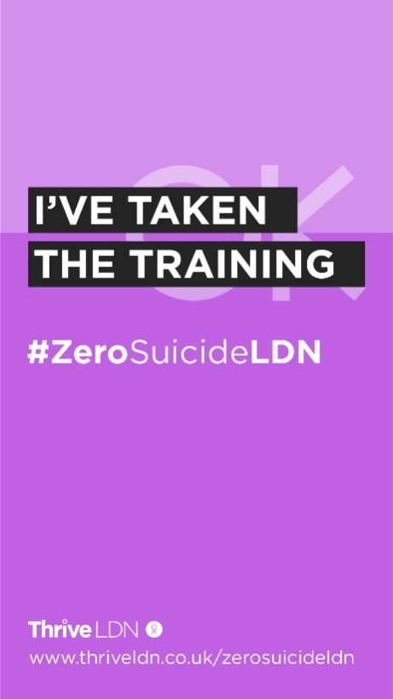  Full range of #ZeroSuicideLDN assets via Google Drive:  https://drive.google.com/drive/folders/189EzBGDyPA96jr-Tw6-sTIh2egGI_CdE?usp=drive_link

Standard text for newsletters and/or offline copy
This standard text can be adapted for websites, e-newsletters and other bulletins. Localise and adapt text in red.
Website copy  675 words | [Headline]More than 400,000 Londoners play their part in the #ZeroSuicideLDN campaign  DN. YouTube embed: https://www.youtube.com/watch?v=MFh5uaaSDg8 OR static image.  Suicide is the leading cause of death in people aged 15–29, and the biggest killer of men under 49 in the UK. In London, the sad truth is suicide is the cause of death of around 10 Londoners every week.  Launched five years ago in September 2019 by the Mayor of London, the citywide #ZeroSuicideLDN campaign has now supported more than 400,000 people across the capital access free, online suicide prevention training.  Developed by the Zero Suicide Alliance, the free, online training takes around 20 minutes to complete and is designed to show how to have a direct and honest conversation about suicide and mental health with friends and family. The training also helps to break the stigma of talking about mental health, suicidal thoughts and bereavement.  During the last twelve months, on average 1 in 4 (25 per cent) of the total number of completed training sessions each month are being done by those living or working in London. #ZeroSuicideLDN campaign organisers, Thrive LDN, have praised how this demonstrates the spirit of Londoners to play their part in looking out for other Londoners. As well as showcasing the collective effort to from London partners to support the citywide campaign.  Marking World Suicide Prevention Day 2024, [Local spokesperson] said: “[Organisation/Borough] supports the #ZeroSuicideLDN campaign and we want to help it go even further. World Suicide Prevention Day is an opportunity to remember that it has never been more important for each of us to think and talk more about mental health and wellbeing.  “Please take the free 20-minute online training and then tell your friends, colleagues, and family about it too. Together, by encouraging even more Londoners to take the Zero Suicide Alliance’s free online training, we can support people to talk openly about suicide and mental health.”  The campaign is led by London’s public health partnership, Thrive LDN. Marking the campaign’s five-year anniversary, Thrive LDN director, Dan Barrett, thanked everyone who has supported the campaign. Barrett also stressed how ‘it remains more important than ever’ to encourage many more to take the training to help break down the stigma of talking about suicide and mental health.  In a 2023 survey by the charity Mind, more than one in three UK adults (36 per cent) said they never make space in their day or the time to speak about their mental health. Yet nearly 8 in 10 who responded (78 per cent) said that their mental health has been affected by cost-of-living crisis – this was worse for those with existing mental health problems (94 per cent).  Dan Barrett, Thrive LDN director, commented: “It is very encouraging to see the number of people who have taken the training since the #ZeroSuicideLDN campaign was launched five years ago. However, a lot has happened since which makes people more vulnerable to suicide or crisis.  “For many Londoners it remains a challenging and uncertain time with increased cost-of-living pressures being felt unevenly across the capital. Debt is a significant risk factor of suicide. Financial concerns are not always commonly discussed. Many people may feel a sense of shame about their situation or do not typically discuss personal finance with others. Therefore, the training remains relevant and more important than ever.”  Cllr Dr Jacqui Dyer MBE, mental health equalities advisor for NHS England and co-lead of Thrive LDN, said: “We know that living and working in London can be stressful, and right now for some it may be overwhelming. That is why we want to encourage as many people as possible to take free, online training to know what to do if a loved one, colleague or stranger is in crisis.  “By doing so, we are working towards a city that is stigma free, where people can have a more direct and honest conversation about suicide with fellow Londoners in a safe and sensitive way. Especially considering the challenges so many Londoners – and particularly those from marginalised and racialised communities – have faced in recent years.”  To find out more about these resources and the suicide prevention training, visit www.thriveldn.co.uk/zerosuicideldn.
Newsletter copy  113 words | This World Suicide Prevention Day take free, online training and be prepared to save a life  We know that living and working in London can be stressful, and right now for some it may be overwhelming considering the many challenges so many Londoners face.  That is why we want to encourage Londoners to support the #ZeroSuicideLDN campaign and take free, online training to know what to do if a loved one, colleague or stranger is in crisis.  World Suicide Prevention Day is an opportunity to remember that it has never been more important for each of us to think and talk more about mental health and wellbeing. For full details visit: www.thriveldn.co.uk/zerosuicideldn.

- #ThroughTogether expert-led wellbeing advice video content
The following expert-led videos were recorded in December 2023. The full set of videos can be viewed on the Thrive LDN website, many included winter wellbeing advice. For the purposes of this updated toolkit, we have included four below which are ‘evergreen’ content and tine into World Suicide Prevention Day messaging.

How to get urgent help for your mental health
Channel | Suggested post | Assets
Twitter/X | In urgent need of mental health support?  Ysabella Hawkings, Public Health Principal at @NewhamLondon, guides you to #NHS services, helplines, & texting options.  Find the help you need, when you need it.  #MentalHealthHelp | https://drive.google.com/file/d/1PX1s7mP2_4waWTEzD9jCkrhoIOj307da/view?usp=drive_link
Instagram | Urgent mental health support is within reach.  Ysabella Hawkings, Public Health Principal at @NewhamLondon points you to NHS services, helplines, and more.  Don't wait to seek the help you deserve.  #MentalHealthResources #ImmediateSupport #ThroughTogether | https://drive.google.com/file/d/1T_tmE9YSkorJKCkn8iWyBUYzaUOPW9Up/view?usp=drive_link
Facebook / LinkedIn | Ysabella Hawkings, Public Health Principal for Newham Council, highlights the importance of accessing urgent mental health support.  From NHS services to dedicated helplines, know where to turn in times of need.  #MentalHealthAwareness #ThroughTogether | https://drive.google.com/file/d/1PX1s7mP2_4waWTEzD9jCkrhoIOj307da/view?usp=drive_link

How to manage feeling overwhelmed
Channel | Suggested post | Assets
Twitter/X | Feeling swamped?  Ysabella Hawkings, Public Health Principal for @NewhamLondon, shares top tips to tackle feelings of being overwhelmed.  Boost your activity, chat it out, and jot down thoughts. Simple steps for a calmer you.  #MentalWellness #StressManagement | https://drive.google.com/file/d/1iAkfGKpuDvUZjv_k5rCQInsAbkl-2fEm/view?usp=drive_link
Instagram | Overwhelmed?  You're not alone.  Ysabella Hawkings, Public Health Principal at @NewhamLondon, offers easy yet effective strategies:  Move more, talk it out, and write down your feelings 📝💬  Discover peace in action.  #OverwhelmedHelp #WellnessTips #MentalHealthTips #ThroughTogether | https://drive.google.com/file/d/1TLCAhxQg1EOzbMUULi3Z7yTGvOWtNuDo/view?usp=drive_link
Facebook / LinkedIn | Navigate feelings of being overwhelmed with guidance from Ysabella Hawkings, Public Health Principal at Newham Council.  Her tips: increase physical activity, engage in conversations, and document your emotions, are pathways to managing stress and enhancing wellbeing.  #ThroughTogether | https://drive.google.com/file/d/1iAkfGKpuDvUZjv_k5rCQInsAbkl-2fEm/view?usp=drive_link

Tips for supporting other people's mental health
Channel | Suggested post | Assets
Twitter/X | Want to support someone's mental health?  Ysabella Hawkings of @NewhamLondon shares essential tips on making a difference.  Your understanding and action can light up someone's world.  #ThroughTogether | https://drive.google.com/file/d/1mleYHnD3Arx_evcQnlqV5zieapJxdRMn/view?usp=sharing
Instagram | Helping others with their mental health starts with simple, thoughtful actions 🌟  Ysabella Hawkings, from @NewhamLondon, outlines key ways to be a supportive presence in someone's life.  Let's spread kindness and understanding.  #SupportOthers #MentalHealthAwareness #ChampionMentalHealth #ThroughTogether | https://drive.google.com/file/d/19GNiXdfAXaUdSWe6pYQ83saw9hiX5PFW/view?usp=drive_link
Facebook / LinkedIn | Supporting mental health is crucial in every community.  Ysabella Hawkings, Public Health Principal at Newham Council, provides valuable tips on how we can assist others in navigating their mental health challenges.  Join us in creating a supportive environment for all.  #ThroughTogether | https://drive.google.com/file/d/1mleYHnD3Arx_evcQnlqV5zieapJxdRMn/view?usp=sharing

Essential skills for supporting other people’s mental health
Channel | Suggested post | Assets
Twitter/X | Unlock the power of empathy and active listening.  @DrPamelaNkyi reveals essential skills for supporting others' mental health. Equip yourself to be a beacon of support.  #ThroughTogether | https://drive.google.com/file/d/1ZufhDUGH4EjBbIEnP3t8ZTvHfSeIC2qe/view?usp=drive_link
Instagram | Ready to make a difference? 🌟  @drpam_1 shares key skills to support mental wellbeing in others. From active listening to understanding boundaries, become the empathetic support your community needs.  #SupportiveSkills #EmpathyMatters #ThroughTogether #ChampionMentalHealth | https://drive.google.com/file/d/1Jdi7ZbD1288b9DRIj3C5oe2EmqKt7M6l/view?usp=drive_link
Facebook / LinkedIn | Empower your support skills with Dr. Pamela Nkyi's guide on essential mental health techniques.  Learn about active listening, empathy, and setting boundaries to effectively aid those around you.  Enhance your ability to contribute positively to others' well-being.  #ProfessionalDevelopment #MentalHealthAwareness #ChampionMentalHealth #ThroughTogether | https://drive.google.com/file/d/1ZufhDUGH4EjBbIEnP3t8ZTvHfSeIC2qe/view?usp=drive_link

- Support with money worries (cost-of-living signposting)
We are encouraging partners to signpost to information on how to manage financial anxiety and uncertainty, alongside resources which support mental health and wellbeing. The below suggested social media posts support signposting to relevant services that will support Londoners with money worries. Please consider incorporating these alongside any other planned communications on this topic/ area or when aligning with suicide prevention communications.
In summary:
- Financial resilience and feelings of control relating to finance have a profound impact on people’s wellbeing.
- Employment and financial security have a two-way relationship with overall mental health, with stable, consistent employment and the ability to save money act as protectors of mental health whereas debt, unemployment, and financial instability act as some of the main barriers to emotional wellbeing.
- The challenges posed by the cost-of-living crisis are being felt unevenly across London, exposing differences of vulnerability across geographies and social groups. As such, more Londoners will be considered vulnerable to suicide.
- In response to this it is vital for London to take a public mental health approach to its response to ensure that the wellbeing of Londoners is prioritised alongside the growth of London’s economy.
Support with money worries (below links could be localised)
Channel | Suggested copy | Example assets
Twitter – Debt Free Advice | For some Londoners right now, worrying about money may feel overwhelming or leaving you feeling very anxious.  If you are worried about money or need free, impartial advice, @DebtFreeAdvice_’s advice line is there to help.  Call 0800 808 5700 or visit www.debtfreeadvice.com | 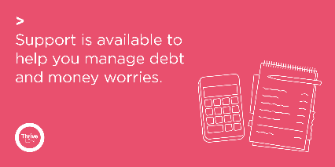  Alt text: Graphic reads: Support is available to help you manage debt and money worries. Alongside a line drawing of a calculator and note pad.  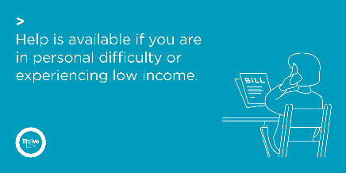  Alt text: Graphic reads: Help is available if you are in personal difficulty or experiencing low income. Alongside a line drawing of a person on the phone with a document in front of them with the word ‘Bill’ written on it.
Twitter – supporting debt and money worries 1 | For some Londoners right now, worries over money or debt may be overwhelming.  If you are worried about money or need impartial advice, there is support available. Ask for help if you need it.  @DebtFreeAdvice_ 0800 808 5700  @CAPuk 0800 328 0006  Or visit www.nhs.uk/mental-health/advice-for-life-situations-and-events/how-to-cope-with-financial-worries/
Twitter – supporting debt and money worries 2 | Talking about financial concerns and difficulties is challenging. But you are not alone, and there is nothing to be ashamed of.  Talk to someone you trust💬  Reach out to friends and family🤝  If you need advice there is support available: www.london.gov.uk/what-we-do/communities/help-cost-living/help-if-money-worries-are-affecting-your-mental-health  #ThroughTogether
Twitter – supporting debt and money  worries 3 | Accessing help and support for financial difficulties is really important. And doing what you can to stay well will help you deal with things better.  Talk to someone you trust 💬  Take things one step at a time ☝️  Focus on what you can control 👤  Reach out to friends & family 🤝
Twitter – personal difficulty | If you find yourself in urgent financial or personal need, there is support and information available for you. Please seek help if you need it.  💷 @turn2us_org: 0808 802 2000  🏘️ @Shelter: 0344 515 1540  🥫 @TrussellTrust: 0808 208 2138  Or visit www.london.gov.uk/what-we-do/communities/help-cost-living/
Twitter – Good Thinking resources | If you’re feeling the strain financially and things seem overwhelming, you can take small steps to help you stay mentally healthy.  @GoodThinkingUK has lots of practical tips and links to organisations that can help ease the pressure: www.good-thinking.uk/articles/cost-living-crisis-how-look-after-your-mental-health  #ThroughTogether | 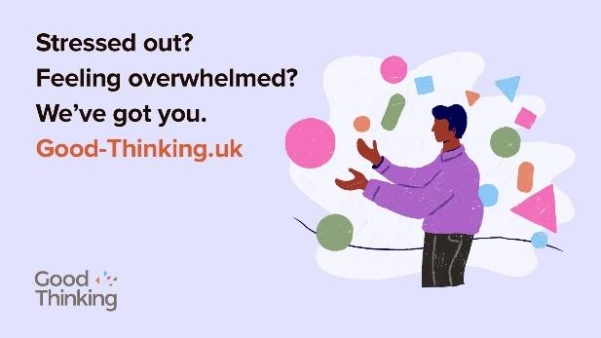  Alt text: A person is juggling with shapes to the right of the graphic. To the left the text reads: Stressed out? Feeling overwhelmed? We’ve got you. Good-Thinking.uk.  Find more relevant Good Thinking assets:  https://drive.google.com/drive/folders/1A-QcbmAUo1Rbxi6IUAS8kYGzBxUlZm3Z
Instagram | For some Londoners right now, worrying about money may feel overwhelming or leaving you feeling very anxious.  If you are worried about money or need free, impartial advice, @debtfreeadvice’s advice line is there to help.  Call 0800 808 5700 or visit debtfreeadvice.com  If you find yourself in urgent financial or personal need, there is support and information available for you. Please seek help if you need it.  💷 @turn2us_org: 0808 802 2000  🏘️ @sheltercharity: 0344 515 1540  🥫 @trusselltrust: 0808 208 2138  Find more advice by searching ‘GLA Cost of Living Hub’. | 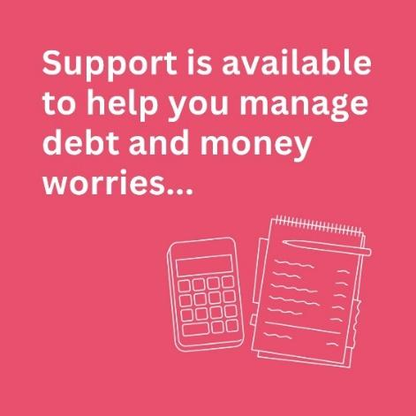  Alt text: Graphic reads: Support is available to help you manage debt and money worries. Alongside a line drawing of a calculator and note pad.  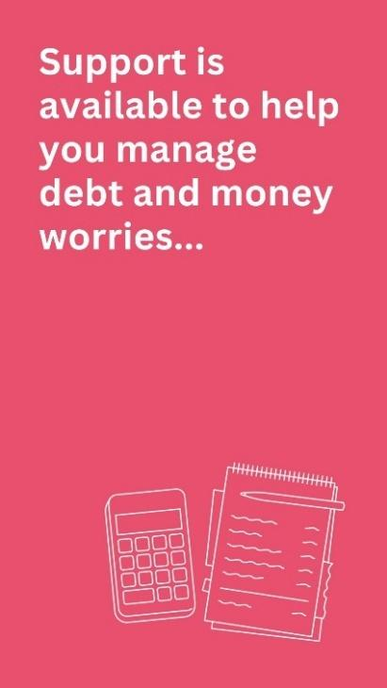
Instagram | Talking about financial concerns and difficulties is challenging. But you are not alone and there is nothing to be ashamed of.  If you need support and impartial advice, there are free professional services available.  Accessing help and support for financial difficulties is really important. But so is also doing what you can to stay well, which will help you deal with things better.  Talk to someone you trust 💬  Take things one step at a time ☝️  Focus on what you can control 👤  Reach out to friends and family 🤝  For a range of information to support Londoners, including on money and mental health, search ‘GLA help with the cost of living online hub’.  And for more ideas on looking after your own wellbeing, @ThriveLDN has simple tools, ideas and inspiration. Follow the link in their bio.  #ThroughTogether
Facebook / LinkedIn | For some Londoners right now, worrying about money may feel overwhelming or leaving you feeling very anxious.  If you are worried about money or need free, impartial advice is available. Debt Free Advice is there to help.  Call free on 0800 808 5700 or visit: www.debtfreeadvice.com  The GLA has published a Help With the Cost of Living online hub which contains a range of information to support Londoners, including on money and mental health: https://www.london.gov.uk/what-we-do/communities/help-cost-living | Alt text: Graphic reads: Support is available to help you manage debt and money worries. Alongside a line drawing of a calculator and note pad.
Facebook / LinkedIn | Talking about financial concerns and difficulties is challenging. But you are not alone and there is nothing to be ashamed of.  If you need support and impartial advice, there are free professional services available.  Accessing help and support for financial difficulties is really important. But so is also doing what you can to stay well, which will help you deal with things better.  Talk to someone you trust 💬  Take things one step at a time ☝️  Focus on what you can control 👤  Reach out to friends and family 🤝  The GLA’s Help With the Cost of Living online hub contains a range of information to support Londoners, including on money and mental health: https://www.london.gov.uk/what-we-do/communities/help-cost-living

- Thrive LDN conversation starter
Thrive LDN’s conversation starter tool helps Londoners engage with friends, family, neighbours or those they support in the community or workplace about good mental health, wellbeing and financial worries. As well as importantly knowing the most appropriate help and advice services to signpost to for professional support.
Download the conversation starter resource (PDF):
- Cost-of-living version (November 2022)
- Covid version (January 2021)

The conversation starter tool is also embedded in the Good Thinking guides to looking out for those around you. Four tailored guides with three simple steps to help you spot the signs of poor mental health in others, check in and let them know you care and help them get the support they need.
Download the guides (PDF):
- Looking out for those around you
- Looking out for friends and colleagues at work
- Looking out for your friends – a guide to help children and young people support friends
- Looking out for children and young people – a guide for parents and carers

Channel | Suggested post | Suggested asset
Twitter 1 | Talking about mental health is important, but it isn’t always easy.  Explore @ThriveLDN's conversation starter tool to find tips and prompts to help you get your community talking.  https://thriveldn.co.uk/communications/toolkits-and-resources/toolkit/thrive-ldn-mental-health-conversation-starter/ | 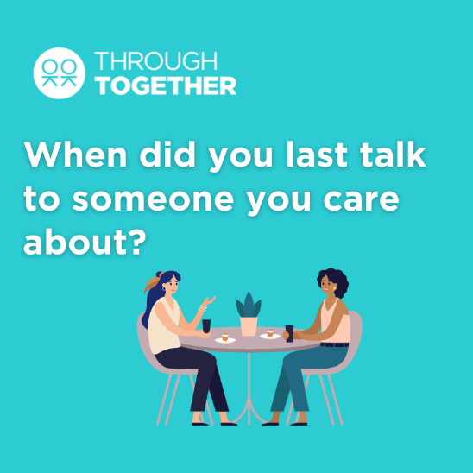  Alt Text: Two people are sat together eating and drinking, above them a question reads: When did you last talk to someone you care about?  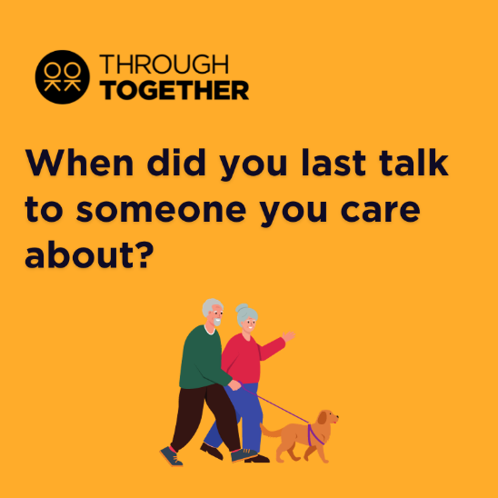  Alt Text: Two people are walking a dog and having a chat. The text above them reads: When did you last talk to someone you care about?  More assets:  https://drive.google.com/drive/folders/1zbwJXFRtyFv2FjPLly-zx1q7TtelJ8LB?usp=drive_link
Twitter 2 | It’s not always easy for someone to talk about how they’re feeling or share their concerns.  Why not reach out to a friend or loved one to get them talking.  Explore some ways in which you can start such conversations: www.thriveldn.co.uk/communications/toolkits-and-resources/toolkit/thrive-ldn-mental-health-conversation-starter/
Twitter 3 | Reaching out to someone could help them know that someone cares and help them find the support they need.  Explore @ThriveLDN’s tips on having a supportive conversation: thriveldn.co.uk/communications/toolkits-and-resources/toolkit/thrive-ldn-mental-health-conversation-starter/
Twitter 4 | In these tough times, it's important to look out for those around you.  Remember to check in with friends, family and workmates.  @GoodThinkingUK's guides lead you through 3 easy steps to help if someone you know is struggling: https://www.good-thinking.uk/how-guides/quick-guides-support-others | Download: https://drive.google.com/drive/u/1/folders/1eegJjVGiRoAULb-uKP4zhwiqdjmsMsTA  Alt Text: A graphic that highlights the Good Thinking guides to looking out for those around you. The text below says “Good Thinking’s guide to looking out for those around you” and includes a link to access the guides, “good-thinking.uk/how-guides”. Illustration of a group of people of various ages and genders sat under a tree.
Twitter 5 | Starting a conversation about mental health with your child can be tough.  @GoodThinkingUK's guide leads you through 3 easy steps to help you check in and get them the support they need: https://www.good-thinking.uk/how-guides/quick-guides-support-others  Let them know you are there for them ❤️ | 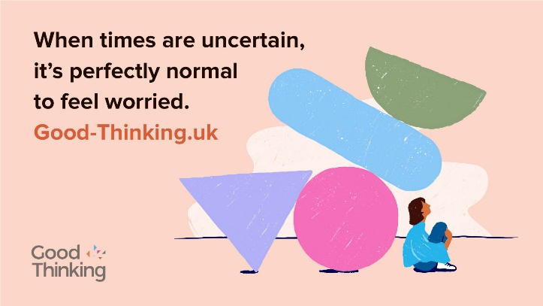  Alt Text: A graphic that highlights the Good Thinking guide for parents and carers to looking out for children and young people. Illustration of a family sat together on a sofa.  Find relevant Good Thinking assets: https://www.good-thinking.uk/campaign-hub
Instagram 1 | When times are tough, it’s important that we look after our own and each other's wellbeing.  Reaching out to someone could help them know that someone cares, that they are valued, and help them find the support they need.  Explore @ThriveLDN’s tips on having a supportive conversation - click the link in their bio.  #ThroughTogether  #ZeroSuicideLDN | 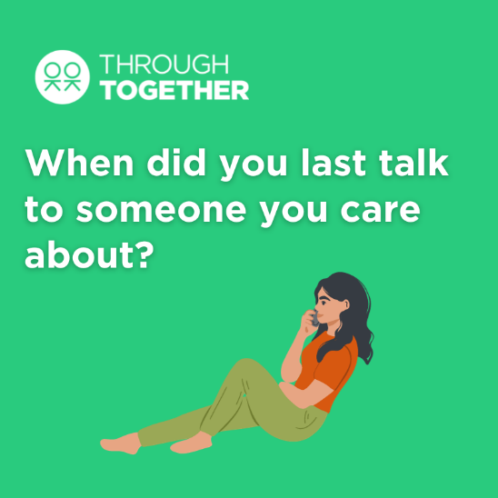  Alt Text: A person is sat on the floor and holding a phone to their ear. The text above them reads: When did you last talk to someone you care about?  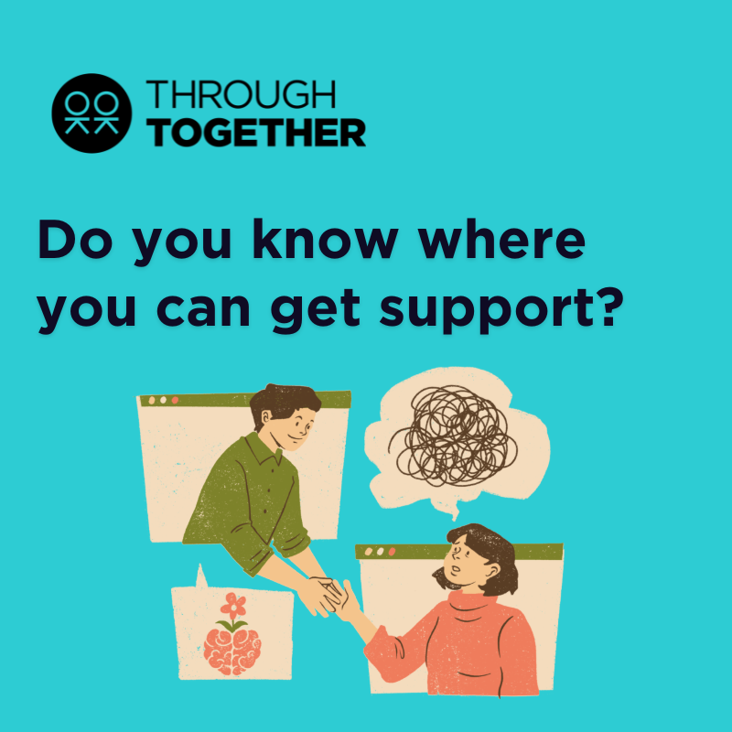  Alt Text: A graphic designed to encourage people to open up about their mental health which asks the question: “Do you know where you can get support?”  More assets: https://drive.google.com/drive/folders/1igesfW3KI-kKzdtyMrEdpcbGz_i5xiTv?usp=sharing
Instagram 2 | Loneliness can affect us all, at any time of our lives.  When times are tough it’s important that we look after our own and each other’s wellbeing.  @ThriveLDN's conversation starter tool gives you the tips and prompts to help you get your community talking about good mental health, wellbeing and financial worries.  This conversation starter tool follows a SIGNSS framework – Situation, Initiate, Guide, Nudge, and Support and Signpost – and aims to help encourage a gentle and supportive conversation.  It is designed to complement what many Londoners are already doing to support those close to them or in their social networks through difficult times.  Follow the link in @ThriveLDN’s bio.  #ThroughTogether  #ZeroSuicideLDN
Instagram 3 | In tough times, it's important to look out for those around you.  Remember to check in with friends, family and workmates.  @goodthinkinguk's guides lead you through three simple steps to help if someone you know is struggling - including tips on starting those difficult conversations from @thriveldn and #MentalWellbeing support and resources for you to share.  good-thinking.uk/how-guides/quick-guides-support-others  #ThroughTogether  #ZeroSuicideLDN | 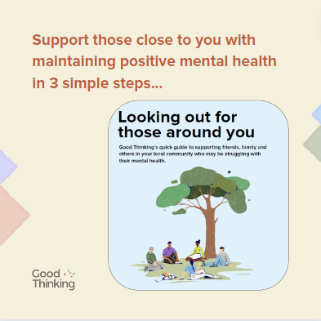  Alt Text: A graphic that highlights the Good Thinking guides to looking out for those around you. The text below says “Support those close to you with maintaining positive mental wellbeing in 3 simple steps”. Illustration of a group of people of various ages and genders sat under a tree.  Find relevant Good Thinking assets: https://www.good-thinking.uk/campaign-hub
Facebook and LinkedIn | When times are tough it’s important that we look after our own and each other’s wellbeing.  @ThriveLDN's updated conversation starter tool gives you the tips and prompts to help you get your community talking about good mental health, wellbeing and financial worries.  This conversation starter tool follows a SIGNSS framework – Situation, Initiate, Guide, Nudge, and Support and Signpost – and aims to help encourage a gentle and supportive conversation.  It is designed to complement what many Londoners are already doing to support those close to them or in their social networks through difficult times.  Explore via Thrive LDN’s website: https://thriveldn.co.uk/communications/toolkits-and-resources/toolkit/thrive-ldn-mental-health-conversation-starter/ | 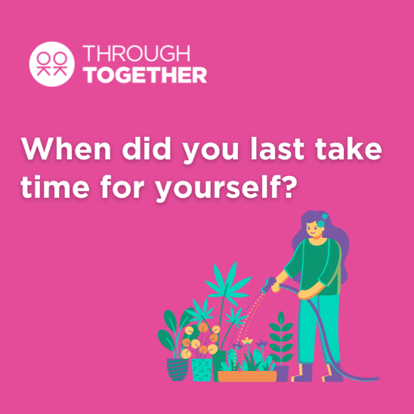  Alt Text: A person tending to their garden or plants. The graphic asks the question: “When did you last take time for yourself?”  More assets: https://drive.google.com/drive/folders/1igesfW3KI-kKzdtyMrEdpcbGz_i5xiTv?usp=sharing

- Free trauma-informed practice training
Thrive LDN has been working with Nicola Lester Psychological Trauma Consultancy to offer free, online trauma-informed practice training to support individuals and organisations.
The training is offered across three levels, Bronze, Silver and Gold. At each level, participants receive a certificate of completion and certified badge which can be used to demonstrate their knowledge and trauma informed training status. Training is free to complete and does not require registration to join.
More details including the links to the courses can be found on the Thrive LDN website.
Below we have provided some suggested copy for digital channels which you may find useful to promote the training opportunity to your networks, internally and externally.
Whilst the training videos can be accessed individually, some organisations may prefer to participate in a group, either in person or online. On our website, you can also find a brief guide for facilitators to promote engagement and enhance opportunities for discussion and sharing learning.
Channel | Suggested post | Suggested asset
Twitter (1) | Access free, online trauma-informed practice training from @ThriveLDN and Nicola Lester designed to support individuals and organisations. Work your way through Bronze, Silver & Gold levels.  Training and supporting resources can be accessed via: www.thriveldn.co.uk/trauma-informed | Video:  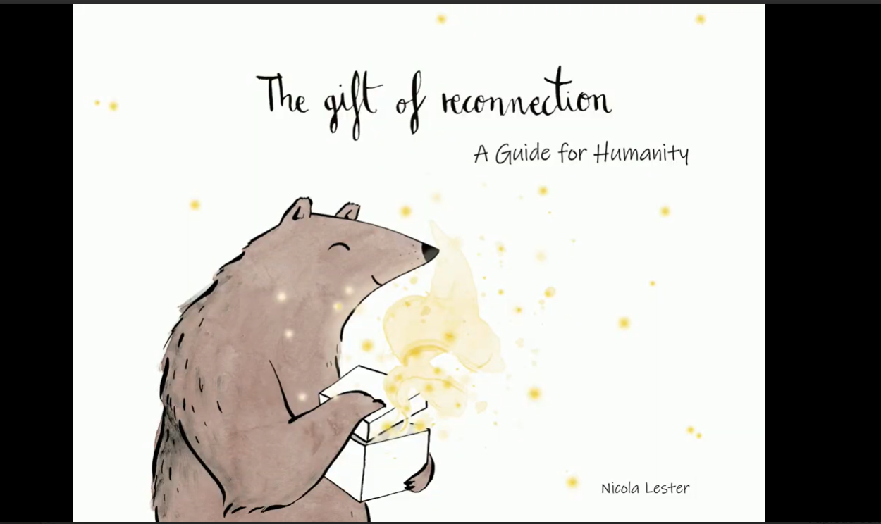  Static images: All available via Google Drive.  Alt text: The free trauma-informed practice training is playing on a laptop that is standing open at a desk.  You can also download a collection of illustrations and quotes from the training to support promotion. We have included two below as an example. Download the illustrated quotations [ZIP, 5.4MB]  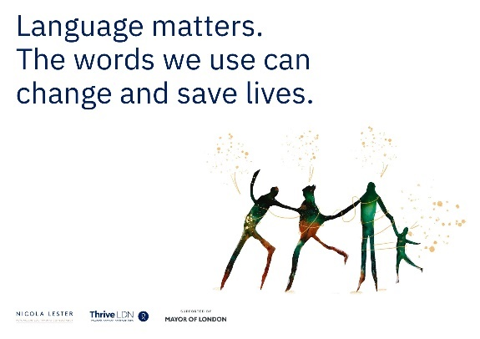  Alt text: An illustration of four people holding hands, one of which is a child, sits next to the test: Language matters. The words we use can change and save lives.  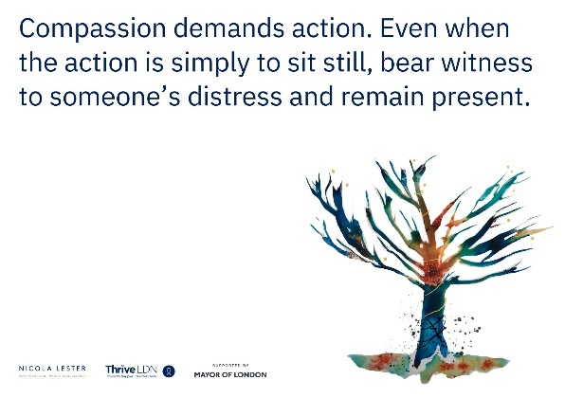  Alt text: An illustration of a bear tree next to the text: Compassion demands action. Event when the action is simply to sit still, bear witness to someone’s distress and remain present.
Twitter (2) | Interested in becoming more trauma aware?  Then take @ThriveLDN and Nicola Lester’s free, online training and get certified at bronze, silver and gold level.  Full details about the training and supporting resources can be accessed via: www.thriveldn.co.uk/trauma-informed  #ThroughTogether
LinkedIn and Facebook | How trauma aware are you?  Thrive LDN has partnered with Nicola Lester Psychological Trauma Consultancy to offer free, pre-recorded online trauma-informed practice training to support individuals and organisations.  The training is offered across three levels, Bronze, Silver and Gold, with the opportunity to move up to the next level at each stage.  At each level, participants will receive a certificate of completion and certified badge which can be used to demonstrate their knowledge and trauma informed training status.  Training is free to complete and can be accessed from @ThriveLDN’s website:  www.thriveldn.co.uk/trauma-informed
Instagram | How trauma aware are you?  @ThriveLDN has partnered with Nicola Lester Psychological Trauma Consultancy to offer free, pre-recorded online trauma-informed practice training to support individuals and organisations.  Training is free to complete and can be accessed from @ThriveLDN’s website. Search the link in their bio.  It is offered across three levels, Bronze, Silver and Gold, with the opportunity to move up to the next level at each stage.  At each level, participants will receive a certificate of completion and certified badge which can be used to demonstrate their knowledge and trauma informed training status.  #TraumaInformed  #MentalHealthTraining  #ThroughTogether | 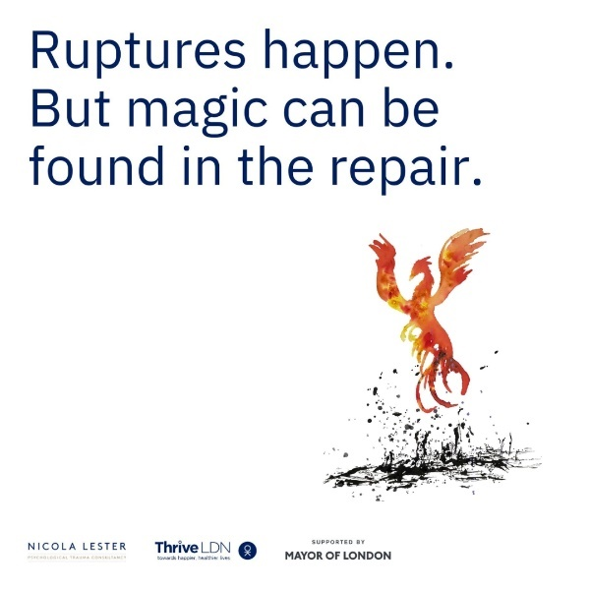  Alt text: An illustration of a phoenix rising from the flames with the text: Ruptures happen. But magic can be found in the repair.  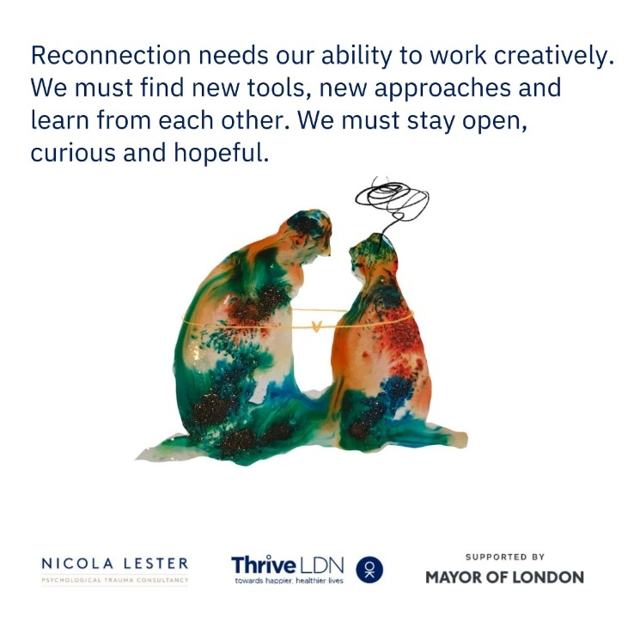  Alt text: An illustration of two people kneeling, facing each other. Above the head of the person on the right-hand side is an illustrative squiggle and thoughts. The text reads: Reconnection needs our ability to work creatively. We must find new tools, new approaches and learn from each other. We must stay open, curious and hopeful.  Alt text: An illustration of a person within a person, with the text above reading: There is no formula for reconnection, only a collection of the most intrinsic qualities of what it means to be human.  We have also produced aid memories for each level which can be downloaded:  Bronze  Silver  Gold  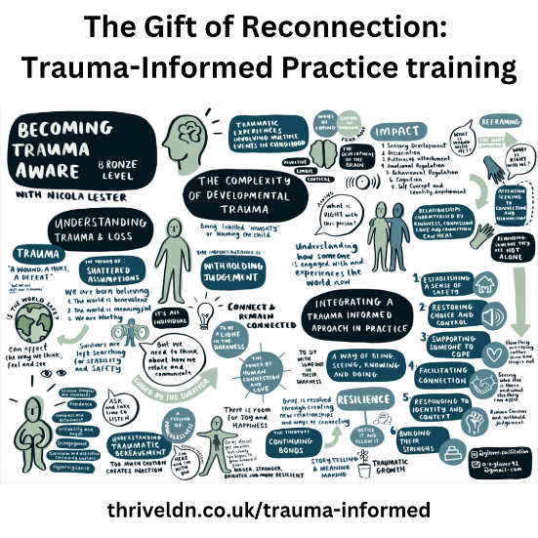  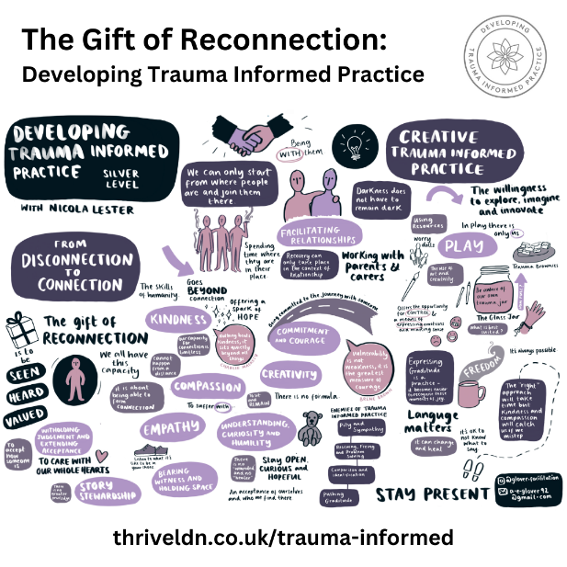  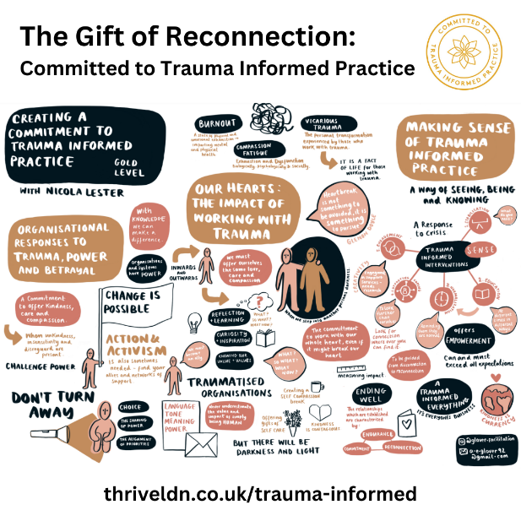

- Resilience and conflict resolution training workshops

In February and March 2024, Thrive LDN worked with Healthy Dialogues, with support and funding from the Mayor of London, to offer a series of free online workshops designed to meet the expressed challenges faced by anyone who is in a professional role supporting others.

The workshops covered topics such understanding stress and resilience, developing personal awareness, developing our coping strategies. Alongside building communication skills crucial for de-escalating conflicts and investigating. These online workshops are designed to meet the expressed challenges faced by anyone who is in a professional role supporting others.

Resilience workshop 1

In this workshop, we will look at why resilience is important in the workplace and how to develop and enhance our resilience. We will also delve into the different ways stress can impact our levels of resilience.
Access for free: https://thriveldn.co.uk/communications/toolkits-and-resources/toolkit/resilience-and-conflict-resolution-workshops-for-londons-frontline-and-community-workers/#resilience_workshop_1

Resilience workshop 1 downloads:
Understanding stress and resilience slide deck
Understanding stress and resilience worksheet
Understanding stress and resilience transcript (19/02/24)

Channel | Suggested post | Assets
X/Twitter | Discover the impacts of stress and learn strategies to enhance resilience with this recorded workshop, delivered by @HDialogues_UK.  Access for free via the @ThriveLDN website: https://thriveldn.co.uk/communications/toolkits-and-resources/toolkit/resilience-and-conflict-resolution-workshops-for-londons-frontline-and-community-workers/ | Alt text: Resilience spelt out of small letter blocks, sat on a table in front of a house plant.  Download image  Download all assets  Resilience workshop 1 - Understanding stress and resilience with Healthy Dialogues (BSL)
Instagram | In today's fast-paced world, mastering stress management and resilience is key.  Access for free this workshop which explores the core of workplace resilience, crafted by @HealthyDialogues and supported by @ThriveLDN.  Discover why resilience is essential in supporting other and how stress can affect your performance.  It’s perfect for team leaders and members alike, this workshop equips you with the tools to boost your resilience and uplift your team.  #ResilienceTraining #ProfessionalGrowth #ConflictResolution #ThriveLDN | 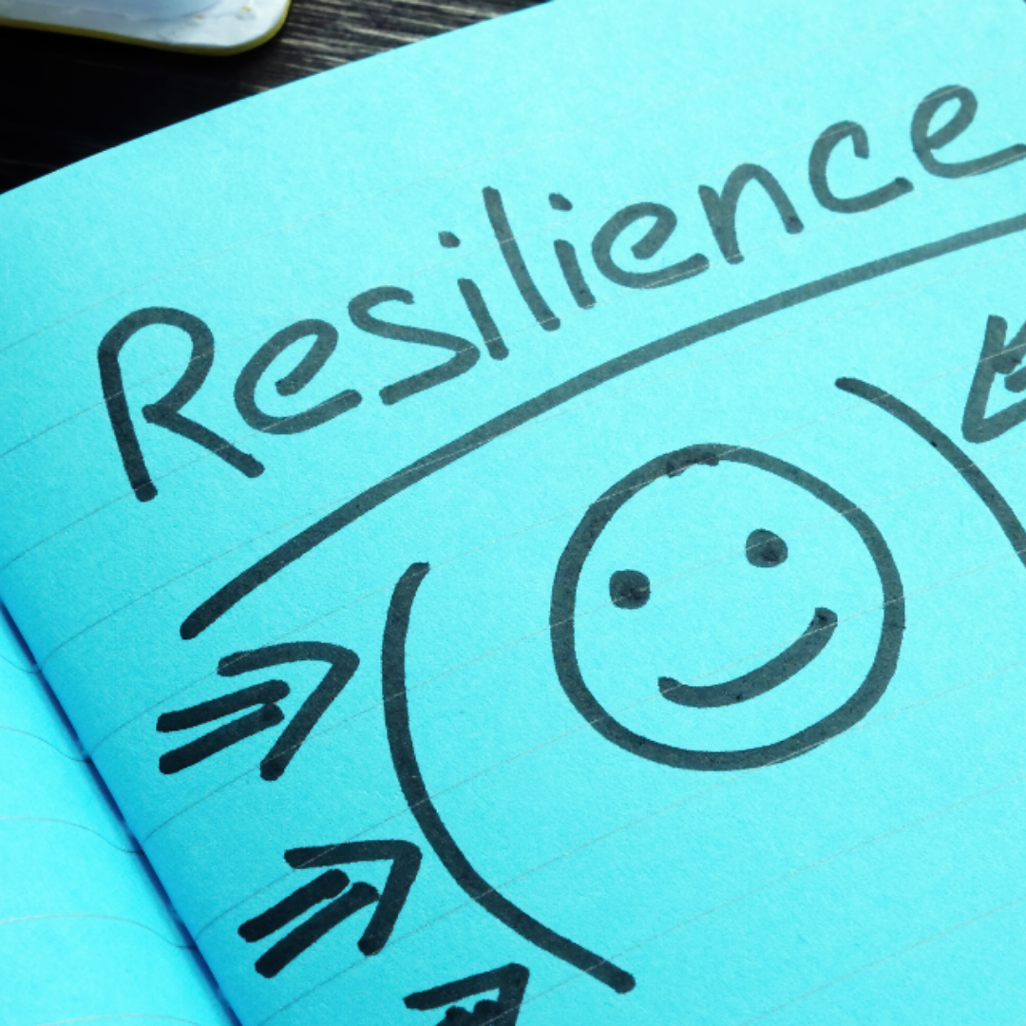  Alt text: Resilience is handwritten on a note pad in black pen on blue paper. Underneath is a smally face and arrows pointing to the face.  Download image  Download all assets  Resilience workshop 1 - Understanding stress and resilience with Healthy Dialogues (BSL)
LinkedIn/  Facebook | In this insightful workshop, developed by Healthy Dialogues and supported by Thrive LDN, jump into the essentials of workplace resilience.  Learn why resilience is a key skill in supporting others and how stress can impact your ability to maintain it.  Whether you're leading a team or part of one, this workshop is designed to equip you with the tools you need to enhance your resilience and support your colleagues effectively.  Access for free via the Thrive LDN website: https://thriveldn.co.uk/communications/toolkits-and-resources/toolkit/resilience-and-conflict-resolution-workshops-for-londons-frontline-and-community-workers/ | Alt text: Resilience spelt out of small letter blocks, sat on a table in front of a house plant.  Download image  Download all assets  Resilience workshop 1 - Understanding stress and resilience with Healthy Dialogues (BSL)

Resilience workshop 2
In this workshop, we will look at how negative thoughts can impact our wellbeing and what we can do to reframe these thoughts. We will also identify the strengths we have and how we can use them to enhance our resilience.
Access for free: https://thriveldn.co.uk/communications/toolkits-and-resources/toolkit/resilience-and-conflict-resolution-workshops-for-londons-frontline-and-community-workers/#resilience_workshop_2

Resilience workshop 2 downloads:
Developing personal awareness slide deck
Developing personal awareness worksheet
Developing personal awareness transcript (26/02/24)

X/Twitter | Discover how to reframe challenges and leverage your strengths for greater resilience in this second workshop  by @HDialogues_UK in partnership with @ThriveLDN. | Alt text: Resilience spelt out of small letter blocks, sat on a table in front of a house plant.  Download image  Download all assets  Resilience workshop 2 - Developing personal awareness with Healthy Dialogues (BSL)
Instagram | In the second Resilience Workshop, delivered by @HealthyDialogues in partnership with @ThriveLDN, dive into how negative thoughts can impact your wellbeing and what you can do to turn them around.  Discover your strengths and learn to harness them for greater resilience.  Whether you’re a leader or a team player, this session is packed with insights to elevate your mental game. 🧠✨  #ResilienceTraining #ProfessionalGrowth #ConflictResolution #ThriveLDN | Alt text: Resilience is handwritten on a note pad in black pen on blue paper. Underneath is a smally face and arrows pointing to the face.  Download image  Download all assets  Resilience workshop 2 - Developing personal awareness with Healthy Dialogues (BSL)
LinkedIn/ Facebook | In the second part of this workshop series, created by Healthy Dialogues and supported by Thrive LDN, explore the profound impact that negative thoughts can have on our wellbeing.  Learn practical strategies to reframe these thoughts and discover the strengths that can help you build resilience.  This workshop is an invaluable resource for anyone looking to enhance their mental resilience. Whether you are guiding a team or are an integral part of one, understanding how to harness your inner strengths and adjust your mindset can significantly improve your professional and personal life.  For more workshops on Resilience, visit https://thriveldn.co.uk/communications/toolkits-and-resources/toolkit/resilience-and-conflict-resolution-workshops-for-londons-frontline-and-community-workers/ | Alt text: Resilience spelt out of small letter blocks, sat on a table in front of a house plant.  Download image  Download all assets  Resilience workshop 2 - Developing personal awareness with Healthy Dialogues (BSL)

Resilience workshop 3
In this workshop, we will look at different coping strategies and how to identify our own coping strategies and use them to develop our resilience. We will also look at how we can incorporate mindfulness exercises into our coping toolkit.
Access for free: https://thriveldn.co.uk/communications/toolkits-and-resources/toolkit/resilience-and-conflict-resolution-workshops-for-londons-frontline-and-community-workers/#resilience_workshop_3

Resilience workshop 3 downloads:
Developing personal awareness slide deck
Developing personal awareness transcript (04/03/24)

X/Twitter | Discover powerful coping strategies in the third Resilience Workshop delivered by @HDialogues_UK and supported by @ThriveLDN.  Learn how to identify and use your personal strategies and integrate mindfulness into your daily routine. | Alt text: Resilience spelt out of small letter blocks, sat on a table in front of a house plant.  Download image  Download all assets  Resilience workshop 3 - Developing our coping strategies (BSL)
Instagram | Dive into different strategies and learn how to identify what works best for you in this third workshop by Healthy Dialogues in partnership with Thrive LDN.  This session is your gateway to a more resilient you as you discover how mindfulness can become a key part of your resilience toolkit.  #ResilienceTraining  #ProfessionalGrowth #ConflictResolution #ThriveLDN | .  Alt text: Resilience is handwritten on a note pad in black pen on blue paper. Underneath is a smally face and arrows pointing to the face.  Download image  Download all assets  Resilience workshop 3 - Developing our coping strategies (BSL)
LinkedIn/ Facebook | Watch the third empowering session from our series with Healthy Dialogues, supported by Thrive LDN.  In this workshop, explore a variety of coping strategies and learn how to pinpoint and effectively utilize the ones that work best for you. Additionally, you’ll be guided through incorporating mindfulness exercises into your daily routine to further enhance your resilience.  This workshop is perfect for anyone looking to deepen their understanding of resilience and develop a more mindful approach to challenges.  Whether you're leading a team or looking to improve your personal coping mechanisms, these insights will be invaluable.  For more workshops on Resilience, visit https://thriveldn.co.uk/communications/toolkits-and-resources/toolkit/resilience-and-conflict-resolution-workshops-for-londons-frontline-and-community-workers/ | Alt text: Resilience spelt out of small letter blocks, sat on a table in front of a house plant.  Download image  Download all assets  Resilience workshop 3 - Developing our coping strategies (BSL)

Conflict Resolution Workshop
In this workshop, we will delve into the prevalent causes of workplace conflict. We look at essential communication skills crucial for de-escalating conflicts and investigate personal coping strategies for managing one’s response to conflict. You will explore common causes of conflict, communication methods to assist de-escalation and personal coping strategies.
Access for free: https://thriveldn.co.uk/communications/toolkits-and-resources/toolkit/resilience-and-conflict-resolution-workshops-for-londons-frontline-and-community-workers/#conflict_resolution

Conflict Resolution downloads:
Conflict resolution workshop slide deck
Conflict resolution workshop transcript (21/02/24)
X/Twitter | Explore the roots of workplace conflict with this Conflict Resolution Workshop, delivered by @HDialogues_UK and supported by Thrive LDN.  Master essential communication skills for de-escalation and personal coping strategies.  https://www.youtube.com/watch?v=MOsJpuLfm9k | Alt text: Conflict Resolution is written on a post it note that sits on top of a sheet of paper, on the paper is a sketch of two hands about to touch and a series of cogs beneath them  Download image  Download all assets  Introduction to conflict resolution with Healthy Dialogues (BSL)
Instagram | Discover this Conflict Resolution Workshop, crafted by @HealthyDialogues in partnership with @ThriveLDN. Learn the common causes, explore critical communication techniques for de-escalation, and gain personal coping strategies.  Empower yourself to handle conflicts calmly and effectively.  #ConflictManagement #PeacefulWorkplace #ConflictResolution #ThriveLDN | Alt text: Conflict Resolution is written on a post it note that sits on top of a sheet of paper, on the paper is a sketch of two hands about to touch and a series of cogs beneath them  Download image  Download all assets  Introduction to conflict resolution with Healthy Dialogues (BSL)
LinkedIn/ Facebook | Conflict is a common part of professional life, but managing it effectively is essential for a harmonious workplace.  We’re proud to share this comprehensive workshop on Conflict Resolution, developed by Healthy Dialogues and supported by Thrive LDN.  This session delves into the prevalent causes of workplace conflict, equips you with essential communication skills for de-escalation, and explores personal coping strategies to maintain your composure under pressure.  Whether you're a team leader or a team member, understanding and resolving conflicts effectively can lead to better collaboration and a more positive work environment.  For more workshops like this, https://thriveldn.co.uk/communications/toolkits-and-resources/toolkit/resilience-and-conflict-resolution-workshops-for-londons-frontline-and-community-workers/ | Alt text: Conflict Resolution is written on a post it note that sits on top of a sheet of paper, on the paper is a sketch of two hands about to touch and a series of cogs beneath them  Download image  Download all assets  Introduction to conflict resolution with Healthy Dialogues (BSL)

