SUGGESTED COPY FOR
GREAT MENTAL HEALTH DAY 2025
Updated 12 December 2024
About this toolkit
This document outlines the suggested copy across owned communication channels or as part of planned communications in the lead up Great Mental Health Day 2025, taking place on Friday, 31 January 2025.
By utilising the copy shared here through your digital channels and planned communications, you can help us raise awareness and spread the word about Great Mental Health Day 2025 with your networks, encouraging them to share with families, friends, neighbours, and colleagues.
We will release an updated communications toolkit in January 2025 with suggested social copy for use on the day itself.
Access the full Supporter’s Pack for Great Mental Health Day 2025 via the Thrive LDN website. This outlines how you or your organisation can get involved with Great Mental Health Day events and activities.
If you have any questions about this toolkit, please get in touch with the Thrive LDN communications team via info@thriveldn.co.uk.
Contents
Promoting local support services and organisations 2
Digital assets 2
Key Messages 2
How Great Mental Health Day is supporting Londoners 3
Further information 3
SOCIAL MEDIA COPY 4
For sharing in the run up to the GMHD 4
COPY FOR OTHER DIGITAL CHANNELS 8
Newsletter (short form) article 8
Website (long form) article 9

Promoting local support services and organisations
One of the main aims of Great Mental Health Day is to encourage Londoners to connect with their local community and the brilliant local services and support that exist for them all year round.
We want Great Mental Health Day to provide an opportunity to promote local support services, charities or organisations in your area who make a difference to Londoners’ mental health and wellbeing. The day is also a great opportunity to celebrate and amplify the voices of those who have made an impact in your community.
In previous years, the use of #GreatMentalHealth across social media by local services and organisations has allowed Londoners to find out more about the support available to them.
Below are some suggestions for how you may wish to do this across your digital and social media networks:
- Spotlighting local organisations or services on your social media profiles or websites using #GreatMentalHealth
- Resharing or reposting content from local organisations or services in the lead up to or on Friday 31st January using #GreatMentalHealth
- Developing short blog posts or features on local organisations making a difference for publication your website or for use in newsletters
- Encouraging local residents to submit videos or written contributions explaining what #GreatMentalHealth means to them for resharing on Friday 31st January
- Let us know about the organisations you’d like to feature on our interactive map by emailing info@thriveldn.co.uk
Or more simply, on Friday, 31 January you can support the day by asking and/or answering the following question on your social media channels: What does #GreatMentalHealth mean to your community?

Digital assets
A range of digital assets will be made available in the Thrive LDN Google Drive folder. Here you’ll also find borough specific logos.
We’ll be adding to this as we get closer towards the day itself with social media tiles, posters, and more. Register for updates.
If you can’t access Google Drive, please let the team know and we can help facilitate alternative options: info@thriveldn.co.uk

Key Messages
- Great Mental Health Day returns on Friday,31st January 2024.
- The aim of Great Mental Health Day is to get us talking about our mental health and wellbeing and to raise awareness of the local support services and resources that are available to Londoners all year round.
- The day encourages Londoners to come together through local events and initiatives, sharing stories, experiences, and exploring ways to support individual and community wellbeing.
- The theme for Great Mental Health Day 2025 is ‘small actions for others’. ​ When times are tough, it’s important that we look after our own and each other's wellbeing. We all need community. We all need connection. And in a world where those who face the greatest disadvantages in life also face the greatest risks to their mental health, we need these safe spaces more than ever. ​
We want the day to equip and empower Londoners to share and explore ideas around the small actions which contribute to a more supportive, caring, and compassionate community. ​
- Londoners and London partners can get involved using the hashtag #GreatMentalHealth to share their own stories, experiences and plans for the day across all social media platforms.
- The Thrive LDN website (www.thriveldn.co.uk/greatmentalhealth) will host information about any events that are taking place as part of the day through an interactive map where Londoners can find local services and support. Alongside outlining a range of free learning and training opportunities that can be accessed at any time.

How Great Mental Health Day is supporting Londoners
While we recognise the benefit of awareness days, we also acknowledge the concerns around the number of them, the lack of longevity, or how they may reduce meaningful advocacy around a topic.
Our focus for Great Mental Health Day, building on Haringey’s Great Mental Health programme’s initial aims, has always been to create an opportunity for Londoners to talk openly about their mental health, encourage people to connect with their local community and to help amplify and promote the brilliant local services and support that exist for Londoners all year round.
Great Mental Health Day has also helped Londoners to feel more confident in promoting and sharing the resources that already exist among their local communities. For example, when asked what impact they thought GMHD had on Londoners, respondents told us it left them “feeling supported, connected and not alone” and stated that they felt the day is “a chance for all of us to get involved with the brilliant mental health organisations and services our city has to offer”. You can read more about the impact of Great Mental Health Day in Thrive LDN’s published annual impact reports.

Further information
- Find out more about Great Mental Health Day by exploring our FAQs.
- Sign up for news, updates and stories about the day.

SOCIAL MEDIA COPY
All links in the suggested copy below signpost to the landing page on Thrive LDN’s website but please feel free to update and localise for your own plans.
A range of digital assets will be made available in the Thrive LDN Google Drive folder. Here you’ll also find borough specific logos.

For sharing in the run up to the GMHD
Channel | Suggested copy | Suggested digital asset (right click to download the suggested image)
Instagram | We’re delighted to be supporting London’s Great Mental Health Day when it returns on Friday, 31 January 2025.  We know that London is full of amazing people who devote attention and energy to supporting others in their communities, families, and networks.  This is so important because when times are tough, it’s crucial that we look after our own and each other's wellbeing.  We all need community. We all need connection.  This #GreatMentalHealth Day we want to recognise organisations across our area and those in our communities who make a difference to others.  In the comments below, tag or mention someone to show your appreciation and tell us how they’re supporting your community’s wellbeing | 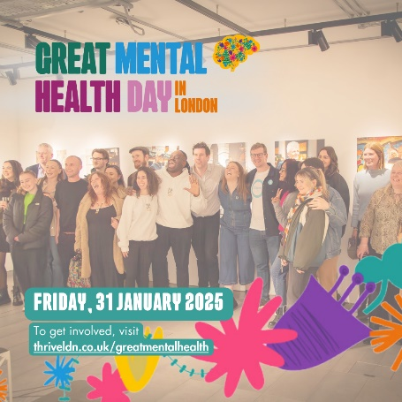  Alt text: A picture of a group of people stood for a photo, behind them is a gallery of images and the setting looks like a community or event space. The image also has the Great Mental Health Day logo overlaid top left and at the bottom the date, Friday, 31 January 2025 and the words 'To get involved, visit: thriveldn.co.uk/greatmentalhealth'.
Instagram 2 | We’re excited for Great Mental Health Day when it returns on Friday, 31 January 2025.  When times are tough, it’s important that we look after our own and each other's wellbeing.  #GreatMentalHealth Day aims to support all of us to break down the barriers we face when asking for help. And to spotlight the amazing organisations offering support near to where you live.  Great Mental Health Day 2025 will also be a chance to explore more about the power of our small actions which contribute to more supportive, caring and compassionate communities.  We all need community. We all need connection. And in a world where those who face the greatest disadvantages in life also face the greatest risks to their mental health, we need these safe spaces more than ever.  With plans taking shape, we’re asking you to think about how you’d like to get involved.  To find out more about #GreatMentalHealth, follow @ThriveLDN or visit thriveldn.co.uk/greatmentalhealth | 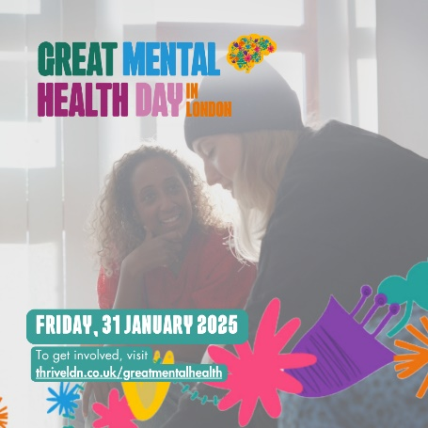  Alt text: A picture two people sat together and having what appears to be a friendly and positive exchange. The image also has the Great Mental Health Day logo overlaid top left and at the bottom the date, Friday, 31 January 2025 and the words 'To get involved, visit: thriveldn.co.uk/greatmentalhealth'.
Instagram story | Add the following link to a GMHD 9x16 ratio graphic:  https://thriveldn.co.uk/greatmentalhealth  Read more about using the Instagram link sticker. | 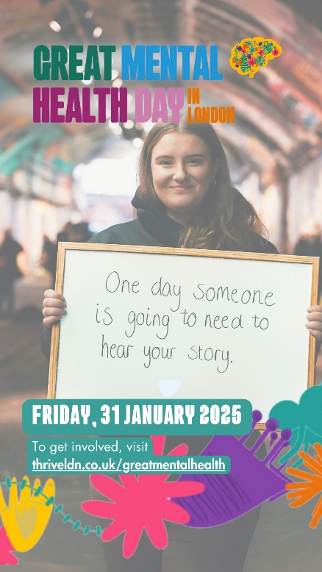
Facebook and LinkedIn 1 | We’re delighted to be supporting London’s Great Mental Health Day when it returns on Friday, 31 January 2025.  We know that London is full of amazing people who devote attention and energy to supporting others in their communities, families, and networks.  This is so important because when times are tough, it’s crucial that we look after our own and each other's wellbeing.  We all need community. We all need connection.  This #GreatMentalHealth Day we want to recognise organisations across our area and those in our communities who make a difference to others.  In the comments below, tag or mention someone to show your appreciation and tell us how they’re supporting your community’s wellbeing 👇 | 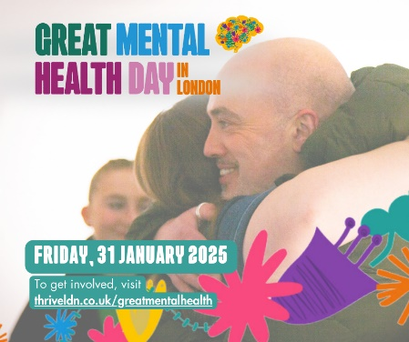  Alt text: A picture of two people embracing is the focus of this image. The image also has the Great Mental Health Day logo overlaid top left and at the bottom the date, Friday, 31 January 2025 and the words 'To get involved, visit: thriveldn.co.uk/greatmentalhealth'.
Facebook and LinkedIn 2 | We’re excited for Great Mental Health Day when it returns on Friday, 31 January 2025.  When times are tough, it’s important that we look after our own and each other's wellbeing.  #GreatMentalHealth Day aims to support all of us to break down the barriers we face when asking for help. And to spotlight the amazing organisations offering support near to where you live.  Great Mental Health Day 2025 will also be a chance to explore more about the power of our small actions which contribute to more supportive, caring and compassionate communities.  We all need community. We all need connection. And in a world where those who face the greatest disadvantages in life also face the greatest risks to their mental health, we need these safe spaces more than ever.  With plans already taking shape, we’re asking you to think about how you’d like to get involved.  To find out more about #GreatMentalHealth, visit https://thriveldn.co.uk/great-mental-health-day-in-london/ | 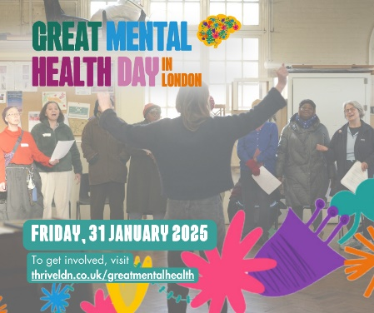  Alt text: A picture of a choir, the conductor has their back to the camera and the choir is visible having formed a U shape and they are in full voice. The image also has the Great Mental Health Day logo overlaid top left and at the bottom the date, Friday, 31 January 2025 and the words 'To get involved, visit: thriveldn.co.uk/greatmentalhealth'.
X/Twitter | London's #GreatMentalHealth Day is back on Friday, 31 January.  🗺️ Learn more about the great local initiatives and support services that are available right across London.  📅 Mark the day by taking free training or attending a local or virtual event with fellow Londoners to mark the day: www.thriveldn.co.uk/greatmentalhealth | 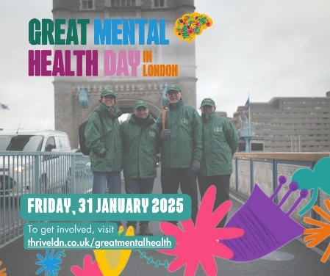  Alt text: A picture of the Bridge Watch volunteers stood on Tower Bridge in London. There are four in the photo and they are dressed in their branded green coats and hats. The image also has the Great Mental Health Day logo overlaid top left and at the bottom the date, Friday, 31 January 2025 and the words 'To get involved, visit: thriveldn.co.uk/greatmentalhealth'.
X/Twitter 2 (two part thread) | [Post 1]  The countdown to #GreatMentalHealth Day has begun!  We all need community. We all need connection. This year we’re exploring the power of small actions for others. We want you to help us spotlight the people and organisations who are devoting energy to those in your community.  [Post 2]  When times are tough, it’s important that we look after our own and each other's wellbeing.  This #GreatMentalHealth Day, why not take some free training, explore local support groups, or attend a virtual event with fellow Londoners to mark the day.  www.thriveldn.co.uk/greatmentalhealth | 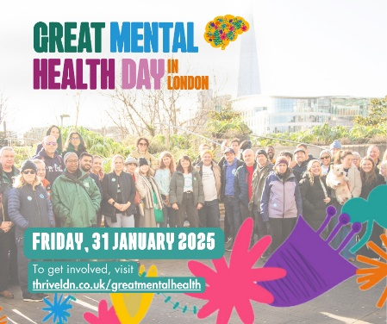  Alt text: A picture of a group stood outside together in the winter sun, the background is clearly a London landmark and the group is visibly a diverse range of people. The image also has the Great Mental Health Day logo overlaid top left and at the bottom the date, Friday, 31 January 2025 and the words 'To get involved, visit: thriveldn.co.uk/greatmentalhealth'.
BlueSky  (Note, tagging needs to be checked once text is pasted) | #GreatMentalHealth Day returns on Fri 31 Jan 2025.  We all need community. We all need connection.  Help us spotlight the people and organisations who are devoting energy to support those in our community.  See @thriveldn.bsky.social for more about the day. www.thriveldn.co.uk/greatmentalhealth | 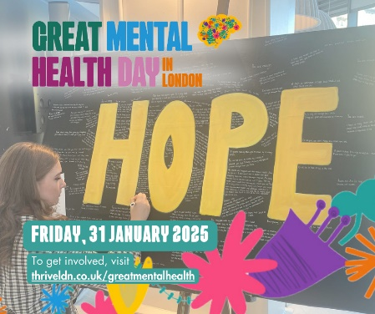  Alt text: A picture of a young person writing on a large board with the word HOPE in yellow prominently displayed. Around the word HOPE is a series of other, non-legible messages of support people have added. The image also has the Great Mental Health Day logo overlaid top left and at the bottom the date, Friday, 31 January 2025 and the words 'To get involved, visit: thriveldn.co.uk/greatmentalhealth'.
Bluesky 2 | London's #GreatMentalHealth Day returns on Friday, 31 January.  🗺️ Learn more about the great local initiatives and support services that are available right across London.  📅 Mark the day by taking free training or attending an event with fellow Londoners.  www.thriveldn.co.uk/greatmentalhealth

COPY FOR OTHER DIGITAL CHANNELS
All links in the suggested copy below signpost to the landing page on Thrive LDN’s website but please feel free to update and localise for your own plans. The text in red can be adapted and localised further.
A range of digital assets will be made available in the Thrive LDN Google Drive folder. Here you’ll also find borough specific logos.

Newsletter (short form) article
Newsletter  (circa 140 words) | On Friday, 31 January 2025, Great Mental Health Day will take place across London.  Now in its fourth year, Great Mental Health Day is a London-wide initiative to get us talking about our mental health and wellbeing and to raise awareness of the local support available to Londoners all year round.  Great Mental Health Day serves as a vital reminder to pause, reflect, and acknowledge that when times are tough, it’s important that we look after our own and each other's wellbeing.  To mark the day, [borough/local area/organisation], we are [local example…]. As well taking the opportunity to celebrate and learn from the organisations across the region and those in our communities who are devoting energy and compassion to others.  For more details about the day visit Thrive LDN’s website or search ‘Great Mental Health Day London’.

Website (long form) article
Newsletter  (circa 360 words) | SAVE THE DATE FOR LONDON’S GREAT MENTAL HEALTH DAY 2025  On Friday, 31 January 2025, Great Mental Health Day will take place across London.  Now in its fourth year, Great Mental Health Day is a London-wide initiative to get us talking about our mental health and wellbeing and to raise awareness of the local support available to Londoners all year round.  Great Mental Health Day is also an opportunity to celebrate and learn from the organisations across the region and those in our communities who are devoting energy and compassion to others.  Having strong, supportive relationships – whether family and support structures or from wider community and faith groups – is one of the most important things we can do to support our wellbeing.  We all need community. We all need connection. And in a world where those who face the greatest disadvantages in life also face the greatest risks to their mental health, we need these safe spaces more than ever.  In [borough/local area/organisation], we are [local example…].  You can also get involved by exploring the Great Mental Health Day interactive map on Thrive LDN’s website, access free training and webinars, or use the hashtag #GreatMentalHealth to share their own stories, experiences and plans for the day across all social media platforms.  [Spokesperson] said: “Great Mental Health Day serves as a vital reminder to pause, reflect, and acknowledge that when times are tough, it’s important that we look after our own and each other's wellbeing.  “We know that London is full of amazing communities and people, many of whom want to find ways of helping their friends, families, colleagues, or communities. Great Mental Health Day is an opportunity to come together and explore ideas around the small actions which contribute to a more supportive, caring, and compassionate community.  “I/We encourage as many people as possible to get involved in Great Mental Health Day 2025. Whether it's participating in community events in [borough/local area], joining online discussions, or simply reaching out to friends and neighbours, every small action counts.”  For more details about the day visit Thrive LDN’s website or search ‘Great Mental Health Day London’.

