SUGGESTED COPY FOR
GREAT MENTAL HEALTH DAY 2025
ON THE DAY
Updated 29 January 2025
About this toolkit
This document outlines the suggested copy across owned communication channels or as part of planned communications for posting on Great Mental Health Day 2025, taking place on Friday, 31 January 2025.
Access the full Supporter’s Pack for Great Mental Health Day 2025 via the Thrive LDN website. This outlines how you or your organisation can get involved with Great Mental Health Day events and activities.
If you have any questions about this toolkit, please get in touch with the Thrive LDN communications team via info@thriveldn.co.uk.

SOCIAL MEDIA COPY
All links in the suggested copy below signpost to the landing page on Thrive LDN’s website but please feel free to update and localise for your own plans.
A range of digital assets will be made available in the Thrive LDN Google Drive folder. Here you’ll also find borough specific logos.

Suggested copy for posting on the day
Channel | Suggested copy | Suggested digital asset (right click to download the suggested image)
Instagram | We are delighted to be supporting London’s Great Mental Health Day.  Today for #GreatMentalHealth Day we want to recognise organisations across our area and those in our communities who make a difference to others.  In the comments below, tag or mention someone to show your appreciation and tell us how they’re supporting your community’s wellbeing  We know that London is full of amazing people who devote attention and energy to supporting others in their communities, families, and networks.  This is so important because when times are tough, it’s crucial that we look after our own and each other's wellbeing.  We all need community. We all need connection.  #ThroughTogether | 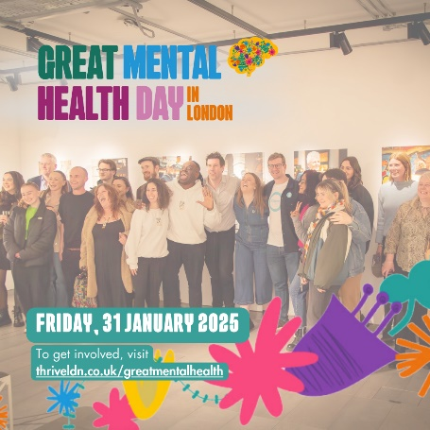  Alt text: A picture of a group of people stood for a photo, behind them is a gallery of images and the setting looks like a community or event space. The image also has the Great Mental Health Day logo overlaid top left and at the bottom the date, Friday, 31 January 2025 and the words 'To get involved, visit: thriveldn.co.uk/greatmentalhealth'.
Instagram story | Add the following link to a GMHD 9x16 ratio graphic:  https://thriveldn.co.uk/greatmentalhealth  Read more about using the Instagram link sticker. | 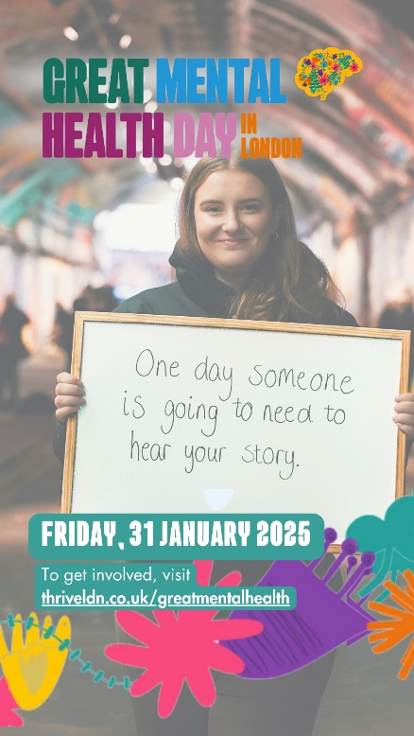
Facebook and LinkedIn 1 | We’re delighted to be supporting London’s Great Mental Health Day which is taking place today.  We know that London is full of amazing people who devote attention and energy to supporting others in their communities, families, and networks.  This is so important because when times are tough, it’s crucial that we look after our own and each other's wellbeing.  We all need community. We all need connection.  Today, for #GreatMentalHealth Day, we want to recognise organisations across our area and those in our communities who make a difference to others.  In the comments below, tag or mention someone to show your appreciation and tell us how they’re supporting your community’s wellbeing 👇  To find out more about #GreatMentalHealth, visit https://thriveldn.co.uk/great-mental-health-day-in-london/ | 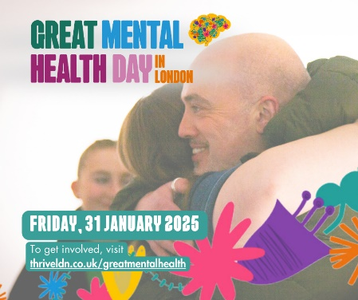  Alt text: A picture of two people embracing is the focus of this image. The image also has the Great Mental Health Day logo overlaid top left and at the bottom the date, Friday, 31 January 2025 and the words 'To get involved, visit: thriveldn.co.uk/greatmentalhealth'.
X/Twitter | Today is London's Great Mental Health Day!  🗣️ Today, open up to someone in your network about how you’ve been feeling.  🗺️ And learn more about the #GreatMentalHealth initiatives and support services that are available right across London.  www.thriveldn.co.uk/greatmentalhealth | 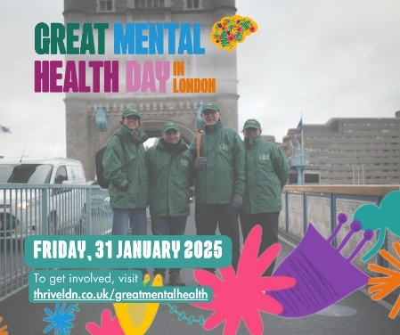  Alt text: A picture of the Bridge Watch volunteers stood on Tower Bridge in London. There are four in the photo and they are dressed in their branded green coats and hats. The image also has the Great Mental Health Day logo overlaid top left and at the bottom the date, Friday, 31 January 2025 and the words 'To get involved, visit: thriveldn.co.uk/greatmentalhealth'.
X/Twitter 2 (three part thread) | [Post 1]  Happy Great Mental Health Day, London!  When times are tough, it’s important that we look after our own and each other's wellbeing. It’s vital that we continue to work together to break down the stigma surrounding mental health.  Here's what you can do today...  [Post 2]  We all need community. We all need connection. This year we’re exploring the power of small actions for others.  Today, for #GreatMentalHealth Day, spotlight the people and organisations who are devoting energy to those in your community. Tag or share details by replying below  [Post 3]  🗺️ Learn more about the great local initiatives and support services that are available right across London.  📅 Mark the day by taking free training or attending an event with fellow Londoners.  www.thriveldn.co.uk/greatmentalhealth | 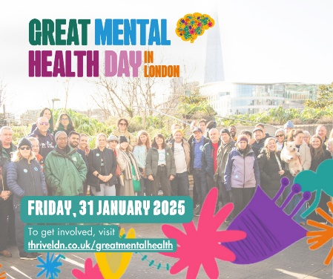  Alt text: A picture of a group stood outside together in the winter sun, the background is clearly a London landmark and the group is visibly a diverse range of people. The image also has the Great Mental Health Day logo overlaid top left and at the bottom the date, Friday, 31 January 2025 and the words 'To get involved, visit: thriveldn.co.uk/greatmentalhealth'.
BlueSky  (Note, tagging needs to be checked once text is pasted) | Happy #GreatMentalHealth!  We all need community. We all need connection.  Help us spotlight the people and organisations who are devoting energy to support those in our community.  See @thriveldn.bsky.social for more about the day. www.thriveldn.co.uk/greatmentalhealth | 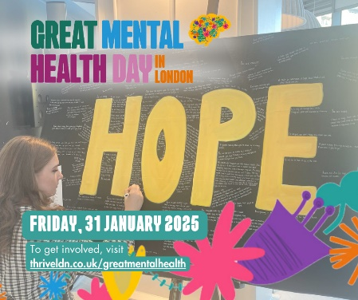  Alt text: A picture of a young person writing on a large board with the word HOPE in yellow prominently displayed. Around the word HOPE is a series of other, non-legible messages of support people have added. The image also has the Great Mental Health Day logo overlaid top left and at the bottom the date, Friday, 31 January 2025 and the words 'To get involved, visit: thriveldn.co.uk/greatmentalhealth'.
Bluesky 2 | Today is #GreatMentalHealth Day. We’re supporting a citywide conversation that promotes understanding, empathy, and support.  🗺️ Learn more about the great local initiatives and support services that are available right across London.  www.thriveldn.co.uk/greatmentalhealth

Key Messages
- Great Mental Health Day returns on Friday,31st January 2024.
- The aim of Great Mental Health Day is to get us talking about our mental health and wellbeing and to raise awareness of the local support services and resources that are available to Londoners all year round.
- The day encourages Londoners to come together through local events and initiatives, sharing stories, experiences, and exploring ways to support individual and community wellbeing.
- The theme for Great Mental Health Day 2025 is ‘small actions for others’. ​ When times are tough, it’s important that we look after our own and each other's wellbeing. We all need community. We all need connection. And in a world where those who face the greatest disadvantages in life also face the greatest risks to their mental health, we need these safe spaces more than ever. ​
We want the day to equip and empower Londoners to share and explore ideas around the small actions which contribute to a more supportive, caring, and compassionate community. ​
- Londoners and London partners can get involved using the hashtag #GreatMentalHealth to share their own stories, experiences and plans for the day across all social media platforms.
- The Thrive LDN website (www.thriveldn.co.uk/greatmentalhealth) will host information about any events that are taking place as part of the day through an interactive map where Londoners can find local services and support. Alongside outlining a range of free learning and training opportunities that can be accessed at any time.

How Great Mental Health Day is supporting Londoners
While we recognise the benefit of awareness days, we also acknowledge the concerns around the number of them, the lack of longevity, or how they may reduce meaningful advocacy around a topic.
Our focus for Great Mental Health Day, building on Haringey’s Great Mental Health programme’s initial aims, has always been to create an opportunity for Londoners to talk openly about their mental health, encourage people to connect with their local community and to help amplify and promote the brilliant local services and support that exist for Londoners all year round.
Great Mental Health Day has also helped Londoners to feel more confident in promoting and sharing the resources that already exist among their local communities. For example, when asked what impact they thought GMHD had on Londoners, respondents told us it left them “feeling supported, connected and not alone” and stated that they felt the day is “a chance for all of us to get involved with the brilliant mental health organisations and services our city has to offer”. You can read more about the impact of Great Mental Health Day in Thrive LDN’s published annual impact reports.

